**PRACTICAL FILE**

**OF**

**“Introduction to Programming Methodology using C ”**

**(13060112)**



**FACULTY OF ENGINEERING AND TECHNOLOGY**

**Submitted by**

**Name: Aman**

**Reg. no.:241306050**

**BCA 1st Sem (AI/ML)**

**Submitted to:**

**Ms. Simmi Madaan**

**Assistant professor, CSE**

**FEAT**

**INDEX**

|  |  |  |  |  |
| --- | --- | --- | --- | --- |
| **S.No** | **Name of the Program** | **Date** | **Page No.** | **Signature** |
| 1 | Program to Convert Celsius to Fahrenheit | 16/09/2024 | 1 |  |
| 2 | Program to Find the Greatest Number Among Three Numbers | 16/09/2024 | 2 |  |
| 3 | Program to Determine the Size of Data Types in C | 23/09/2024 | 3 |  |
| 4 | Program to Check Whether a Character is a Vowel or Consonant | 23/09/2024 | 4 |  |
| 5 | Program to Display an Inverse Triangle Pattern | 23/09/2024 | 5 |  |
| 6 | Program to Display a Pyramid Pattern | 30/09/2024 | 6 |  |
| 7 | Program to Calculate the Average Marks of 50 Students | 30/09/2024 | 7-8 |  |
| 8 | Program to Find the Factorial of a Number Using a Function | 30/09/2024 | 9-10 |  |
| 9 | Program to Count Characters in a String | 07/09/2024 | 11 |  |
| 10 | Program to Find the Smallest Value Among Three Numbers | 07/10/2024 | 12 |  |
| 11 | Program to Calculate Compound Interest | 07/10/2024 | 13 |  |
| 12 | Program to Find the Area of a Circle | 14/10/2024 | 14 |  |
| 13 | Program to Check if a Year is a Leap Year | 14/10/2024 | 15 |  |
| 14 | Program to Calculate Simple Interest | 14/10/2024 | 16 |  |
| 15 | Program to Display Sizes of Different Data Types | 28/10/2024 | 17 |  |
| 16 | Program to Find the Sum of Natural Numbers up to N | 28/10/2024 | 18 |  |
| 17 | Program to Print Multiplication Tables up to N | 04/11/2024 | 19 |  |
| 18 | Program to Swap Two Numbers Using Call by Value and Call by Reference | 11/11/2024 | 20 |  |
| 19 | Program to Sort an Array in Ascending Order Using Bubble Sort | 11/11/2024 | 21 |  |
| 20 | Program to Perform Matrix Addition for 2x2 Arrays | 25/112024 | 22 |  |
| 21 | Program to Find the Transpose of a Matrix for 2x2 Arrays | 25/11/2024 | 23 |  |
| 22 | Program to Calculate Factorial Using Recursion | 02/12/2024 | 24 |  |
| 23 | Program to Print Fibonacci Series | 02/12/2024 | 25 |  |
| 24 | Program to Perform Matrix Multiplication for 2x2 Arrays | 02/12/2024 | 26-27 |  |
| 25 | Menu-driven program for string operations Basic operations | 16/12/2024 | 28-30 |  |
| 26 | Program to perform Array of Pointers Displaying a List of Fruits | 16/12/2024 | 31 |  |
| 27 | Program to Implement Pointer to Array Example Accessing an Integer Array | 16/12/2024 | 32 |  |
| 28 | Program to Implement Binary Search | 23/12/2024 | 33 |  |
| 29 | Program to Perform Insertion in an Array | 23/12/2024 | 34 |  |
| 30 | Program to Implement Linear Search | 23/12/2024 | 35 |  |

**Program 1**

**Write a program to convert temperature from Celsius to Fahrenheit by taking input from the user.**

#include<stdio.h>

int main() {

float c, f;

printf("Enter the Celsius degree: ");

scanf("%f", &c);

f = (c * 9.0 / 5.0) + 32.0;

printf("The calculated Fahrenheit is: %f\n", f);

return 0;

}

**OUTPUT**

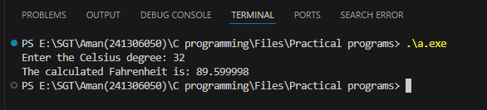

**Program 2**

**Write a program to find the greatest number among 3 numbers given by the user.**

#include <stdio.h>

int main() {

int a, b, c;

printf("Enter the value of a: ");

scanf("%d", &a);

printf("Enter the value of b: ");

scanf("%d", &b);

printf("Enter the value of c: ");

scanf("%d", &c);

if (a >= b && a >= c) {

printf("The greatest number is: %d\n", a);

}

else if (b >= a && b >= c) {

printf("The greatest number is: %d\n", b);

} else {

printf("The greatest number is: %d\n", c);

}

return 0;

}

**Output** 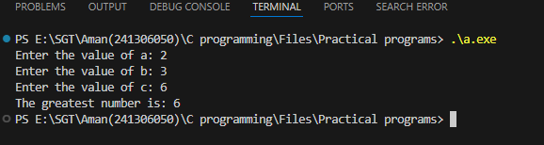

**Program 3**

**C Program to Find the Size of int, float, double and char**

#include <stdio.h>

int main() {

printf("Size of int: %zu bytes\n", sizeof(int));

printf("Size of float: %zu bytes\n", sizeof(float));

printf("Size of double: %zu bytes\n", sizeof(double));

printf("Size of char: %zu bytes\n", sizeof(char));

return 0;

}

**Output** 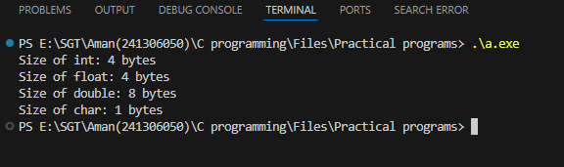

**Program 4**

**C Program to Check Whether a Character is a Vowel or Consonant.**

#include <stdio.h>

int main() {

char ch;

printf("Enter a character: ");

scanf(" %c", &ch);

if (isalpha(ch)) {

char lowerCh = tolower(ch);

if (lowerCh == 'a' || lowerCh == 'e' || lowerCh == 'i' || lowerCh == 'o' || lowerCh == 'u') {

printf("%c is a vowel.\n", ch);

} else {

printf("%c is a consonant.\n", ch);

}

} else {

printf("%c is not an alphabetic character.\n", ch);

}

return 0;

}

**Output .**

**Case-1 Case-2 Case-3**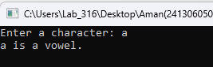

**Program 5**

**Write a program to display inverse triangle pattern.**

#include <stdio.h>

int main(){

int rows,i,j;

printf("number of rows = ");

scanf("%d",&rows);

for(i=1;i<=rows;i++)

{

then j will print numbers from 5 to1*/

for(j=5;j>=i;j--)

{ printf("%d",j);

} printf("\n");

}

return 0;

}

**Output**

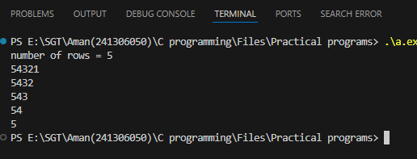

**Program 6**

**Write a program to display pyramid pattern.**

#include <stdio.h>

int main()

{

int i,j,k,rows;

printf("enter the rows = ");

scanf("%d",&rows);

/* i is for the number of rows i=1 to i=rows*/

for(i=1;i<=rows;i++){

/* j is to maintain the space from the left side

so that it starts printing from the middle*/

for(j=rows;j>=i;j--){

printf(" ");

}/*k is to print the value inti piramid form it'll work as

if i =2, k<=2*2-1 i.e. k<=3 so it'll print three "*" in second row*/

for(k=1;k<=2*i-1;k++){

printf("*");

}

printf("\n");

}

return 0;

}

**Output**

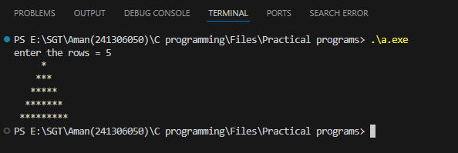

**Program 7**

**Write a program to input marks of 50 students using an array**

**and display and display the average marks.**

#include <stdio.h>

int main(){

int i,sum=0,avg;

int array[50];

for(i=0;i<50;i++){

printf("Enter the marks of student %d ",i+1);

scanf("%d",&array[i]);

}

for(i=0;i<50;i++){

sum+=array[i];

avg = sum/50;

}

printf("\nsum of total 50 students maths marks is :- %d\n",sum);

printf("avg marks are:- %d ",avg);

return 0;

}

**OUTPUT**

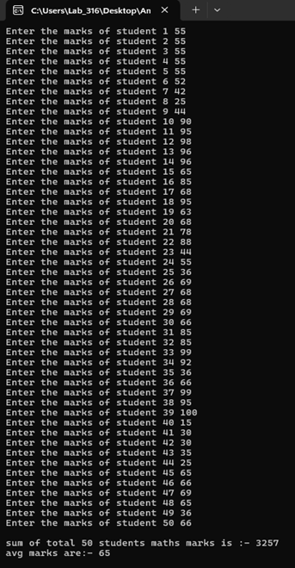

**Program 8**

**write a program to take number users and print its factorial.**

#include <stdio.h>

int main() {

int num, i;

long long int factorial;

while (1) {

printf("Enter an integer (or -1 to stop): ");

if (scanf("%d", &num) != 1) {

printf("Invalid input. Please enter a valid integer.\n");

while (getchar() != '\n');

continue;

}

if (num == -1) {

printf("Program terminated.\n");

break;

}

if (num < 0) {

printf("Factorial is not defined for negative numbers.\n");

} else if (num > 20) {

printf("Number too large! Factorial exceeds the limit of long long int.\n");

} else {

factorial = 1;

for (i = 1; i <= num; ++i) {

factorial *= i;

}

printf("Factorial of %d = %lld\n", num, factorial);

}

}

return 0; }

**Output**

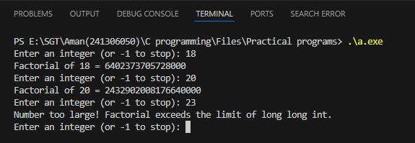

**Using Function of Factorial**

#include <stdio.h>

long long int factorial(int num) {

long long int fact = 1;

int i;

for (i = 1; i <= num; ++i) {

fact *= i;

}

return fact;

}

int main() {

int num;

while (1) {

printf("Enter an integer (or -1 to stop): ");

if (scanf("%d", &num) != 1) {

printf("Invalid input. Please enter a valid integer.\n");

while (getchar() != '\n');

continue;

}

if (num == -1) {

printf("Program terminated.\n");

break;

}

if (num < 0) {

printf("Factorial is not defined for negative numbers.\n");

} else if (num > 20) {

printf("Number too large! Factorial exceeds the limit of long long int.\n");

} else {

printf("Factorial of %d = %lld\n", num, factorial(num));

}

}

return 0;}

**Output**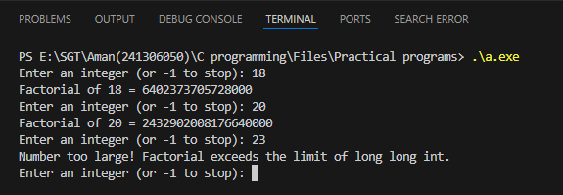

**Program 9**

**String Characters Count**

#include <stdio.h>

#include <string.h>

int main()

{

char str[100];

int len;

printf("Enter a sentence: ");

fgets(str, sizeof(str), stdin);

str[strcspn(str, "\n")] = '\0';

len = strlen(str);

printf("The Length of Your Sentence is %d\n", len);

return 0;

}

**OUTPUT**

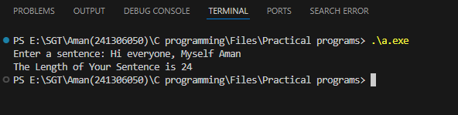

**Program 10**

**Write a Program to find the smallest value from three values**

#include <stdio.h>

int main()

{

    int a,b,c;

    printf("value of a= ");

    scanf("%d",&a);

     printf("value of b= ");

    scanf("%d",&b);

     printf("value of c= ");

    scanf("%d",&c);

    if ((a<b)&&(a<c))

    { printf("a is smallest =%d",a);

    }

    else if ((b<a)&&(b<c))

    { printf("b is smallest=%d",b);

    }

    else

    {  printf ("c is smallest =%d",c);}

    return 0;

}

**Output**

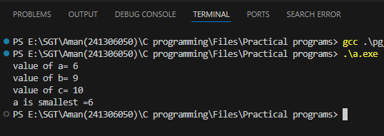

**Program 11**

**Write a Program to find the compound interest:**

#include <stdio.h>

#include <math.h>

int main()

{

    float p,r,t,CI;

    printf("value of p= ");

    scanf("%f",&p);

     printf("value of r= ");

    scanf("%f",&r);

     printf("value of t= ");

    scanf("%f",&t);

    CI=p*pow(1+r/100,t);

    printf("compound interest=%.2f",CI);

    return 0;

}

**Output**

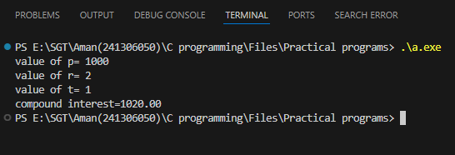

**Program 12**

**Write a Program to find the area of the circle.**

#include <stdio.h>

#include <math.h>

int main()

{

float radius , area;

printf("value of radius= ");

scanf("%f",&radius);

area=acos(-1) *radius *radius;

printf(" area=%.2f",area);

return 0;

}

**Output**

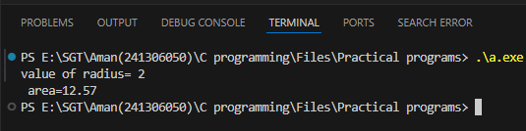

**Program 13**

**Write a Program to find the leap year**

 #include <stdio.h>

int main() {

    int year;

    printf("enter the year=");

    scanf("%d",&year);

    if (year%4==0)

    {

        printf("it is leap year");

    }

    else

    {

        printf("it is not a leap year");

    }

    return 0;

}

**Output**

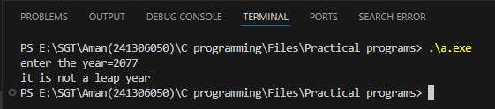

**Program 14**

**Write a Program to find the simple interest:**

#include <stdio.h>

int main()

{

    float p,r,t,SI;

    printf("value of p= ");

    scanf("%f",&p);

     printf("value of r= ");

    scanf("%f",&r);

     printf("value of t= ");

    scanf("%f",&t);

    SI= (p*r*t)/100;

    printf("simple interest=%.2f",SI);

    return 0;

}

**Output**

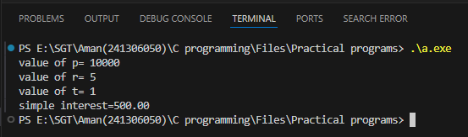

**Program 15**

**Display size of data types**

#include <stdio.h>

int main() {

printf("Size of int: %zu bytes\n", sizeof(int));

printf("Size of float: %zu bytes\n", sizeof(float));

printf("Size of double: %zu bytes\n", sizeof(double));

printf("Size of char: %zu byte\n", sizeof(char));

return 0;

}

**Output**

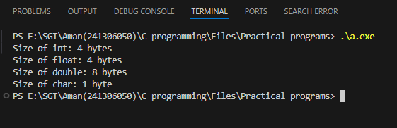

**Program 16  
Write a Program to print sum of 1 to $n^{th}$ numbers using for loop**

#include <stdio.h>

int main() {

int i,j;

printf("Enter number to sumup");

scanf("%d",&j);

int sum = 0;

for (i = 1; i <= j; i++) {

sum += i;

}

printf("Sum of the first %d natural numbers: %d\n",j, sum);

}

**Output**  
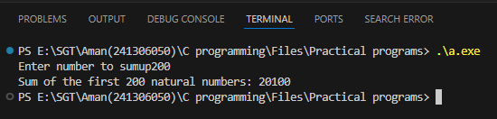

**Program 17**

**Write a Program to print multiplication table of first n natural numbers using for loop in table structure**

#include<stdio.h>

int main(){

int i,j,l;

printf("enter no. till you want to print=");

scanf("%d",&l);

printf("tables from 1 to %d\n",l);

for(j=1;j<=10;j++){

for(i=1;i<=l;i++)

{

printf("%d\t",j*i);

}

printf("\n");

}

return 0;

}

**Output**

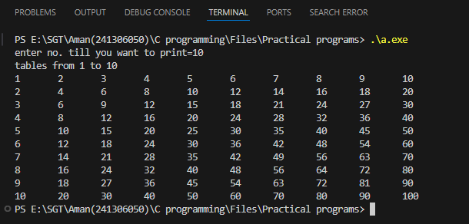

**Program 18**

**WRITE A PROGRAM TO PRINT THE ADDRESS AND THE VALUE OF THE VARIABLE USING CALL BY VALUE AND CALL BY REFERENCE**

int swap(int *x, int *y);

#include <stdio.h>

int main(){

int a,b,c,d;

printf(" enter the value a =");

scanf("%d",&a);

printf(" enter the value of b =");

scanf("%d",&b);

swap(&a,&b);

}

int swap(int *x, int *y){

int temp;

temp=x;

x=y;

y=temp;

printf("the address of x=%d and y=%d\n",x,y);

printf("the value of x=%d and y=%d",*x,*y);

return 0;

}

**OUTPUT**

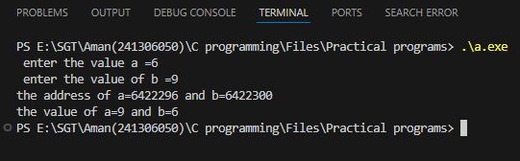

**Program 19**

**Write a Program to Sorting Array into Ascending Order**

**(Using Bubble Sort)**

#include <stdio.h>

int main() {

int n;

printf("Enter the number of elements ");

scanf("%d", &n);

int arr[n];

int r;

printf("Enter the elements of the array ");

for (r=0;r<n;r++)

{

scanf("%d", &arr[r]);

}

int i, j;

for (i=0;i<n;i++)

{

for (j=0;j<n-i-1;j++)

{

if (arr[j] > arr[j+1])

{

int temp = arr[j];

arr[j] = arr[j+1];

arr[j+1] = temp;

}

}

}

printf("Sorted array is ");

for (i=0;i<n;i++)

{

printf("%d ", arr[i]);

}

return 0;

}

**Output**

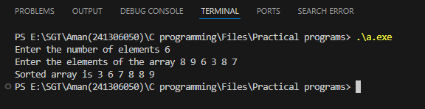

**Program 20**

**Write a program to perform matrix addition on 2D Arrays**

#include <stdio.h>

int main() {

int i, j;

int matrix1[2][2], matrix2[2][2], result[2][2];

printf("Enter elements of the first 2x2 matrix:\n");

for (i = 0; i < 2; i++) {

for (j = 0; j < 2; j++) {

printf("Enter element at [%d][%d]: ", i + 1, j + 1);

scanf("%d", &matrix1[i][j]);

}

}

printf("Enter elements of the second 2x2 matrix:\n");

for (i = 0; i < 2; i++) {

for (j = 0; j < 2; j++) {

printf("Enter element at [%d][%d]: ", i + 1, j + 1);

scanf("%d", &matrix2[i][j]);

}}

// Calculate the sum of the matrices

for (i = 0; i < 2; i++) {

for (j = 0; j < 2; j++) {

result[i][j] = matrix1[i][j] + matrix2[i][j];

}}

printf("\nThe sum of the two matrices is:\n");

for (i = 0; i < 2; i++) {

for (j = 0; j < 2; j++) {

printf("%d ", result[i][j]);

}

printf("\n");}

return 0; }

**Output**

**Program 21**

**Write a program to perform Matrix transpose on 2D Array.**

#include<stdio.h>

int main() {

    int i,j;

    int matrix[2][2],transpose[2][2];

    printf("Enter elements of the 2x2 matrix:\n");     for(i=0;i<2;i++) {         for(j=0;j<2;j++) {

            printf("Enter element at [%d][%d]: ",i+1,j+1);             scanf("%d",&matrix[i][j]);

        }

    }

    for(i=0;i<2;i++) {         for(j=0;j<2;j++) {

            transpose[j][i]=matrix[i][j];

        }

    }

    printf("\nThe transpose of the matrix is:\n");     for(i=0;i<2;i++) {         for(j=0;j<2;j++) {

            printf("%d ",transpose[i][j]);

        }

        printf("\n");

    }

    return 0; }

**OUTPUT**

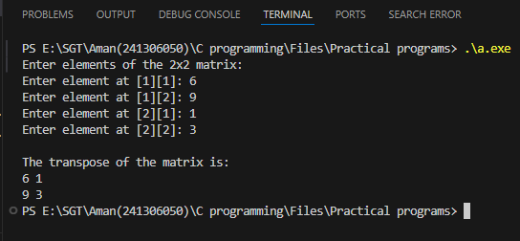

**Program 22**

**WRITE A PROGRAM TO FIND THE FACTORIAL USING**

**RECURSION**

int factorial(int num);

#include<stdio.h>

int main()

{

int n, num;

printf("enter a positive number = ");

scanf("%d",&n);

if(num<0){

printf("factorial of negative nums are not defined ");

}

else{

printf("the factorial of %d is %d",n,factorial(n));

}

return 0;

}

int factorial(int num) {

if(num == 0||num == 1){

return 1;}

else{

return num*factorial(num-1);

}}

**Output**

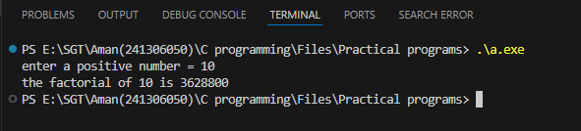

**Program 23**

**WRITE A PROGRAM TO PRINT THE FIBONACCI**

**SERIES**

int fibseries(int num);

#include<stdio.h>

int main(){

int n;

printf("enter the number of elements");

scanf("%d",&n);

printf("fabonacci series ");

printf("%d %d ",0,1);

fibseries(n);

return 0;

}

int fibseries(int n){

static int n1=0,n2=1,n3;

if(n>0){

n3=n1+n2;

n1=n2;

n2=n3;

printf("%d ",n3);

fibseries(n-1);

}

return 0;

}

**OUTPUT**

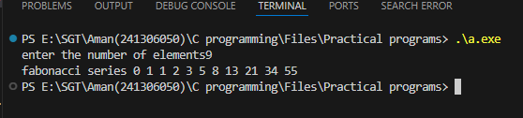

**Program 24**

**WRITE A PROGRAM TO PERFORM MATRIX MULTIPLICATION IN 2D ARRAY**

#include <stdio.h>

int main()

{

int A[2][2],B[2][2],C[2][2],i,j,k;

printf("Enter the elements of the first matrix\n");

for(i=0;i<2;i++)

{

for(j=0;j<2;j++){

printf("Enter element [%d][%d] ",i+1,j+1);

scanf("%d",&A[i][j]);

}}

printf("Enter the elements of the second matrix\n");

for(i=0;i<2;i++)

{

for(j=0;j<2;j++){

printf("Enter element [%d][%d] ",i+1,j+1);

scanf("%d",&B[i][j]);

}}

for(i=0;i<2;i++)

{

for(j=0;j<2;j++){

C[i][j]=0;

for(k=0;k<2;k++){

C[i][j]+=A[i][k]*B[k][j];

}}}

printf("Multiplication of the matrix \n");

for(i=0;i<2;i++)

{

for(j=0;j<2;j++){

printf("%d\t",C[i][j]);

}

printf("\n");

}

return 0;}

**OUTPUT**

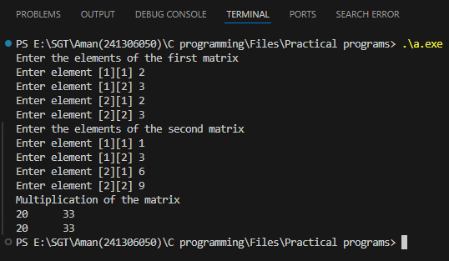

**Program 25**

**Write a menu driven program to implement the following**

**string operations:**

* **Calculate length of a string**
* **Concatenate at the end of a given string**
* **Copy one string to another**
* **Compare contents of two strings**

#include <stdio.h>

#include <string.h>

int main() {

char str1[100], str2[100], str3[100];

int choice, i;

do {

printf("\nMenu:\n");

printf("1. Calculate length of a string\n");

printf("2. Concatenate at the end of a given string\n");

printf("3. Copy one string to another\n");

printf("4. Compare contents of two strings\n");

printf("5. Exit\n");

printf("Enter your choice: ");

scanf("%d", &choice);

switch (choice) {

case 1:

printf("Enter a string: ");

scanf("%s", str1);

for (i = 0; str1[i] != '\0'; i++);

printf("Length of the string: %d\n", i);

break;

case 2:

printf("Enter the first string: ");

scanf("%s", str1);

printf("Enter the second string to concatenate: ");

scanf("%s", str2);

for (i = 0; str1[i] != '\0'; i++);

int j;

for (j = 0; str2[j] != '\0'; j++, i++) {

str1[i] = str2[j];

}

str1[i] = '\0';

printf("Concatenated string: %s\n", str1);

break;

case 3:

printf("Enter a string to copy: ");

scanf("%s", str1);

for (i = 0; str1[i] != '\0'; i++) {

str2[i] = str1[i];

}

str2[i] = '\0';

printf("Copied string: %s\n", str2);

break;

case 4:

printf("Enter the first string: ");

scanf("%s", str1);

printf("Enter the second string: ");

scanf("%s", str2);

for (i = 0; str1[i] != '\0' && str2[i] != '\0'; i++) {

if (str1[i] != str2[i]) {

break;

}

}

if (str1[i] == '\0' && str2[i] == '\0') {

printf("Strings are equal\n");

} else {

printf("Strings are not equal\n");

}

break;

case 5:

printf("Exiting program.\n");

break;

default:

printf("Invalid choice. Try again.\n");

}

} while (choice != 5);

return 0;}

**OUTPUTS**

**Case 1**

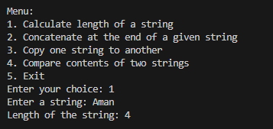

**Case 2**

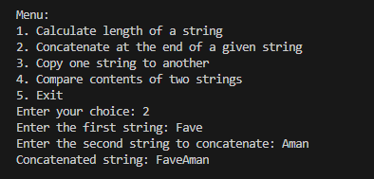

**Case 3**

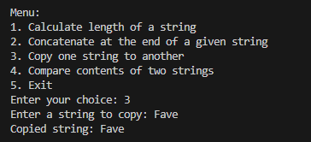

**Case 4**

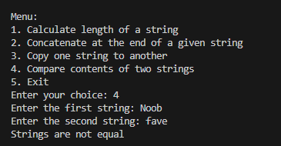

**Program 26**

**Array of Pointers Example Displaying a List of Fruits**

#include <stdio.h>

int main() {

const char *fruits[] = {"Apple", "Banana", "Cherry", "Date"};

int n = sizeof(fruits) / sizeof(fruits[0]);

printf("Array of Pointers Example:\n");

for (int i = 0; i < n; i++) {

printf("Fruit %d: %s\n", i + 1, fruits[i]);

}

return 0;

}

**OUTPUT**

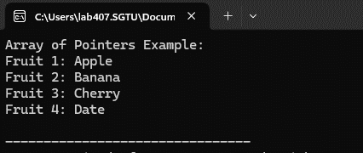

**Program 27**

**Pointer to Array Example Accessing an Integer Array**

#include <stdio.h>

int main() {

int numbers[5] = {1, 2, 3, 4, 5};

int (*ptr)[5] = &numbers;

printf("Pointer to Array Example:\n");

for (int i = 0; i < 5; i++) {

printf("Element %d: %d\n", i + 1, (*ptr)[i]);

}

return 0;

}

**OUTPUT**

**Program 28**

**Program to Implement Binary Search**

#include <stdio.h>

int binarySearch(int arr[], int size, int key) {

int low = 0, high = size - 1, mid;

while (low <= high) {

mid = (low + high) / 2;

if (arr[mid] == key) {

return mid;

} else if (arr[mid] < key) {

low = mid + 1;

} else {

high = mid - 1;

}}

return -1;

}

int main() {

int arr[] = {10, 20, 30, 40, 50, 60, 70, 80, 90};

int size = sizeof(arr) / sizeof(arr[0]);

int key;

printf("Enter the element to search: ");

scanf("%d", &key);

int result = binarySearch(arr, size, key);

if (result != -1) {

printf("Element %d found at index %d.\n", key, result);

} else {

printf("Element %d not found in the array.\n", key);

}

return 0;}

**OUTPUT**

**Program 29**

**Program to Perform Insertion in an Array**

#include <stdio.h>

int main() {

int arr[100], n, pos, value;

printf("Enter the number of elements: ");

scanf("%d", &n);

printf("Enter %d elements: ", n);

for (int i = 0; i < n; i++) {

scanf("%d", &arr[i]);

}

printf("Enter the position to insert the new element: ");

scanf("%d", &pos);

printf("Enter the value to insert: ");

scanf("%d", &value);

for (int i = n; i >= pos; i--) {

arr[i] = arr[i - 1];

}

arr[pos - 1] = value;

printf("Array after insertion: ");

for (int i = 0; i <= n; i++) {

printf("%d ", arr[i]);

}

return 0;

}

**OUTPUT**

**Program 30**

**Program to Implement Linear Search**

#include <stdio.h>

int main() {

int arr[100], n, key, found = 0;

printf("Enter the number of elements: ");

scanf("%d", &n);

printf("Enter %d elements: ", n);

for (int i = 0; i < n; i++) {

scanf("%d", &arr[i]);

}

printf("Enter the element to search: ");

scanf("%d", &key);

for (int i = 0; i < n; i++) {

if (arr[i] == key) {

printf("Element %d found at index %d.\n", key, i);

found = 1;

break;

}

}

if (!found) {

printf("Element %d not found in the array.\n", key);

}

return 0;

}

**OUTPUT**