Food Delivery Web Application
A Project Synopsis Report Submitted To

SAGE UNIVERSITY, INDORE

Bachelor of Technology
In
Computer Science & Technology

Institute of Advance Computing Core
SAGE University
Bypass Road, Kailod Kartal, Indore
Madhya Pradesh – 452020
June – July 2026

Submitted By: Aman Kumar Submitted To: Naman Arora
Enrollment No. : 23ADV3CST1012 Sign:

Feedo: A Food Delivery Web Application

1. Statement about the Problem:
In the present digital world, customers prefer ordering food online instead of visiting restaurants or placing orders through phone calls. Local restaurants also need a digital platform where they can display menus, receive orders, manage availability, and reach more customers.
Delivery partners also require a system to view assigned orders and update delivery status. Administrators need a central dashboard to monitor users, restaurants, orders, revenue, and delivery records. Therefore, there is a need for a complete food delivery web application that connects customers, restaurants, delivery partners, and administrators through a single platform.

2. Problem Statement:
The project aims to develop Feedo, a full-stack food delivery web application that allows customers to browse local restaurants, view menus, add food items to cart, apply promo codes, place orders, make payments, and track orders in real time. The system will also provide dashboards for restaurant owners to manage menus, orders, inventory, and availability. Delivery partners will be able to view assigned orders and update delivery progress. Admins will be able to view analytics such as revenue, order volume, popular items, users, restaurants, and delivery records.

3. Objective and Scope of the Project:
The main objective of Feedo is to build a responsive and user-friendly food delivery platform similar to modern online food ordering systems.
The objectives of the project are:
- To connect customers with local restaurants for online food ordering.
- To provide restaurant listings with menus, ratings, and delivery time estimates.
- To provide cart and checkout with address input, promo code, delivery tip, scheduled order, real-time order tracking and payment options.
- To provide restaurant owners with tools to manage menus, orders, inventory, and availability.
- To provide delivery partners with a dashboard for assigned orders and delivery status updates.
The scope of this project includes customer ordering, restaurant management, delivery management, payment processing, order tracking, reviews, loyalty rewards, and admin analytics. The final system will help customers order food easily, help restaurants manage online orders, help delivery partners organize deliveries, and help admins monitor platform activity.

4. Methodology:
First, the frontend screens will be designed using React, Tailwind CSS, and Bootstrap. Then the backend will be created using Node.js and Express.js. MongoDB will be used to store users, restaurants, menus, orders, payments, delivery records, reviews, promo codes, and loyalty points.
The development process will include:
- Requirement analysis and project planning.
- UI design for customer, restaurant, delivery partner, and admin sections.
- Frontend development using React components, React Router, hooks, and state management for cart, forms, filters, dashboards, and order tracking.
- Database integration using MongoDB.
- Backend API development using Node.js and Express.js.
- Real-time order tracking using Socket.io.
- Map-based delivery tracking using Leaflet.js or Google Maps API.
- Payment gateway integration using Razorpay or Stripe.
- Mobile responsiveness, and deployment.

5. Process Description:
The system will have four main users: customer, restaurant owner, delivery partner, and admin.
The customer logs in, browses restaurants, selects a restaurant, views the menu, filters food items, adds items to the cart, applies promo code, enters address, selects payment method, adds delivery tip, schedules the order if needed, and places the order. After the order is placed, the restaurant receives it and updates the status. A delivery partner is assigned and shares live location. The customer tracks the order on a map until delivery. After delivery, the customer can give ratings and reviews and earn loyalty points.

6. Order Flow / Flowchart:
Customer Login → Browse Restaurants → Select Restaurant → View Menu → Add Items To Cart → Apply Promo Code → Checkout → Make Payment / COD → Order Placed → Restaurant Accepts Order → Delivery Partner Assigned → Live Tracking → Order Delivered → Rating and Review

7. Use Case Description:
Customer: Browse restaurants, order food, pay, track order, review food.
Restaurant Owner: Manage menu, accept orders, update stock and availability.
Delivery Partner: View assigned orders, update delivery status, share location.
Admin: Manage users, restaurants, orders, revenue, and analytics.

8. Data Flow Diagram
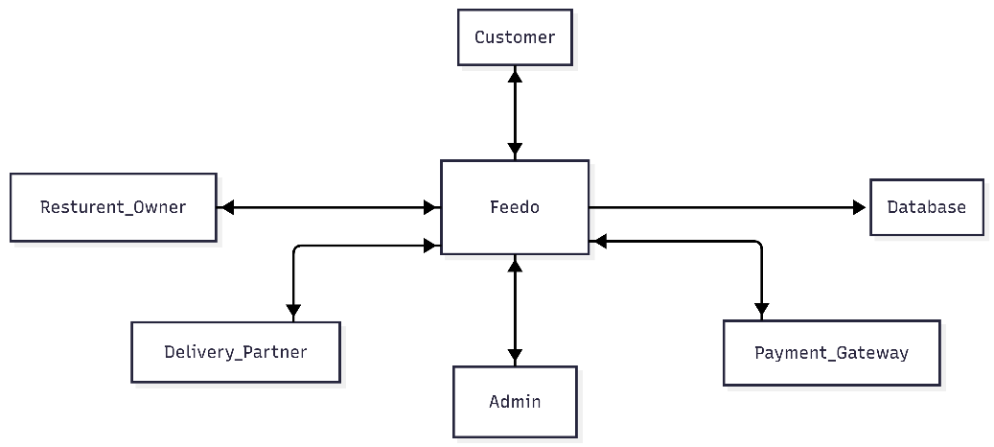

9. Hardware Requirements:
Processor | Intel i3 or above
RAM | Minimum 4 GB
Storage | Minimum 2 GB free space
Internet | Required
Device | Laptop/Desktop/Mobile for testing

10. Software Requirements:
Software / Technology | Purpose
React.js | Component-based frontend, cart state, checkout forms, tracking UI, dashboards
Tailwind CSS | Custom responsive styling
Bootstrap | Ready UI components and responsive layout
React Router | Page routing and navigation
Node.js | Backend runtime
Express.js | Backend API framework
MongoDB | Database
Socket.io | Real-time order tracking
Razorpay / Stripe | Payment gateway
Leaflet.js / Google Maps API | Map-based tracking
Chart.js / Recharts | Admin analytics
Visual Studio Code | Code editor
Postman | API testing
GitHub | Version control

11. Resources and Limitations:
Resources required for the project include sample restaurant data, menu images, user data, database storage, payment gateway test account, map API, and internet connection. The system will require React and Node.js development tools, MongoDB database, and browser support.
Limitations of the project are that the payment gateway will initially work in test mode, real-time delivery location may be simulated during development, push notifications depend on browser permission, and large-scale production-level scaling may not be fully implemented in the academic version.

12. Future Work of this Project:
In the future, Feedo can be improved by adding a Android and iOS mobile application. AI-based food recommendations can be added based on customer preferences and order history. Advanced delivery route optimization can be implemented to reduce delivery time. Chat support between customer, restaurant, and delivery partner can also be added. Other future improvements include refund management, GST invoice generation, restaurant settlement reports, subscription meal plans, voice search, and multi-city support.

13. Schedule of the Project:
Week | Activity
Week 1 | Requirement analysis, synopsis, and SRS preparation
Week 2 | UI planning, database design, and project setup
Week 3 | Customer frontend pages: home, restaurant listing, menu
Week 4 | Cart, checkout, promo code, tip, and scheduled order
Week 5 | Backend setup, authentication, restaurant and menu APIs
Week 6 | Order, payment, and delivery APIs
Week 7 | Restaurant dashboard and delivery partner dashboard
Week 8 | Real-time tracking, map integration, and notifications
Week 9 | Admin dashboard, analytics, reviews, and loyalty rewards
Week 10 | Responsiveness, deployment, documentation

14. Conclusion:
Feedo is a complete food delivery web application that connects customers, restaurants, delivery partners, and administrators on a single platform. It provides online food ordering, cart and checkout, payment gateway, live order tracking, restaurant dashboard, delivery dashboard, admin analytics, promo codes, scheduled orders, dietary filters, ratings and reviews, loyalty rewards, push notifications, delivery tip, and split payment.
The project is useful because it demonstrates real-world full-stack web development using React, Tailwind CSS, Bootstrap, Node.js, Express.js, MongoDB, Socket.io, and payment gateway integration. The system stands out because it combines customer ordering, restaurant management, delivery tracking, and business analytics in one complete platform.

15. References / Bibliography:
[1] React Official Documentation, “Learn React,” https://react.dev/learn
[2] Tailwind CSS Documentation, “Installation,” https://tailwindcss.com/docs/installation
[3] Bootstrap Documentation, “Getting Started,” https://getbootstrap.com/docs/5.3/getting-started/introduction/
[4] Express.js Documentation, “Express - Node.js Web Application Framework,” https://expressjs.com/
[5] MongoDB Documentation, “MongoDB Manual,” https://www.mongodb.com/docs/
[6] Socket.IO Documentation, “Socket.IO v4 Documentation,” https://socket.io/docs/v4/
[7] Razorpay Documentation, “Payment Gateway Web Integration,” https://razorpay.com/docs/payments/payment-gateway/web-integration/standard/
[8] Leaflet Documentation, “Leaflet Reference,” https://leafletjs.com/reference.html
[9] Chart.js Documentation, “Chart.js Documentation,” https://www.chartjs.org/docs/latest/

