Name : Aman
Cource : BCA
Section : E2
University Roll No : 2221126
Class Roll No : 22401919
Semester : 4

PROGRAM 1 : WRITE a python program to check if a value entered by a user is palindrome or not.

num=int(input("Enter a number:"))
temp=num
rev=0
while(num>0):
dig=num%10
rev=rev*10+dig
num=num//10
if(temp==rev):
print("The number is palindrome!")
else:
print("Not a palindrome!")
print("Program created by:Aman \n Course:BCA \n Section:E2 \n Roll No:08");

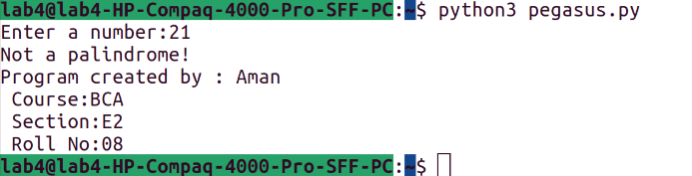

PROGRAM 2 : Write a python program to check if a value entered by a user is armsstrong or not.

num = int(input("Enter 3-digit number : "))
sum = 0
temp = num

while temp > 0:
digit = temp % 10
sum += digit * digit * digit
temp = temp//10
if sum==num:
print('It is an Armstrong number')
else:

print('It is not an Armstrong number')
print("Program created by:Aman \n Course:BCA \n Section:E2 \n Roll No:08");
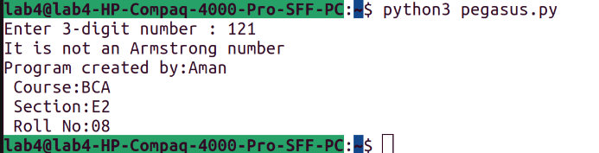
PROGRAM 3 : Consider a number entered by a user. now calculate the factorial of this number.

num = 7
factorial = 1
if num < 0:
print("Sorry, factorial does not exist for negative numbers")
elif num == 0:
print("The factorial of 0 is 1")
else:
for i in range(1,num + 1):
factorial = factorial*i
print("The factorial of",num,"is",factorial)
print("Program created by:Aman \n Course:BCA \n Section:E2 \n Roll No:08");

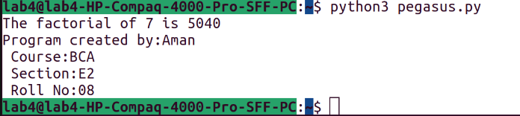
PROGRAM 4 : Write a python program to print the fibonacci sequence upto the range entered by the user is a perfect number or not.

nterms = int(input("How many terms? "))
n1, n2 = 0, 1
count = 0
if nterms <= 0:
print("Please enter a positive integer")
elif nterms == 1:
print("Fibonacci sequence upto",nterms,":")
print(n1)
else:
print("Fibonacci sequence:")
while count < nterms:
print(n1)
nth = n1 + n2
n1 = n2
n2 = nth
count += 1
print("Program created by:Aman \n Course:BCA \n Section:E2 \n Roll No:08");

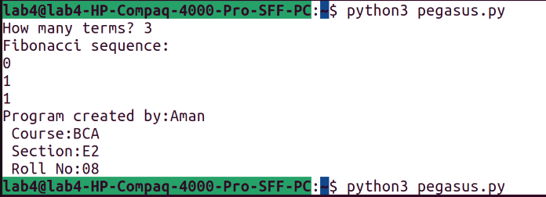
PROGRAM 5 : Write a python program to check if a value entered by a user is a perfect or not.

n = int(input("Enter any number: "))
sum1 = 0
for i in range(1, n):
if(n % i == 0):
sum1 = sum1 + i
if (sum1 == n):
print("The number is a Perfect number!")
else:
print("The number is not a Perfect number!")
print("Program created by:Aman \n Course:BCA \n Section:E2 \n Roll No:08");

