**WIREFRAME**

**GROCERIES WEBSITE**

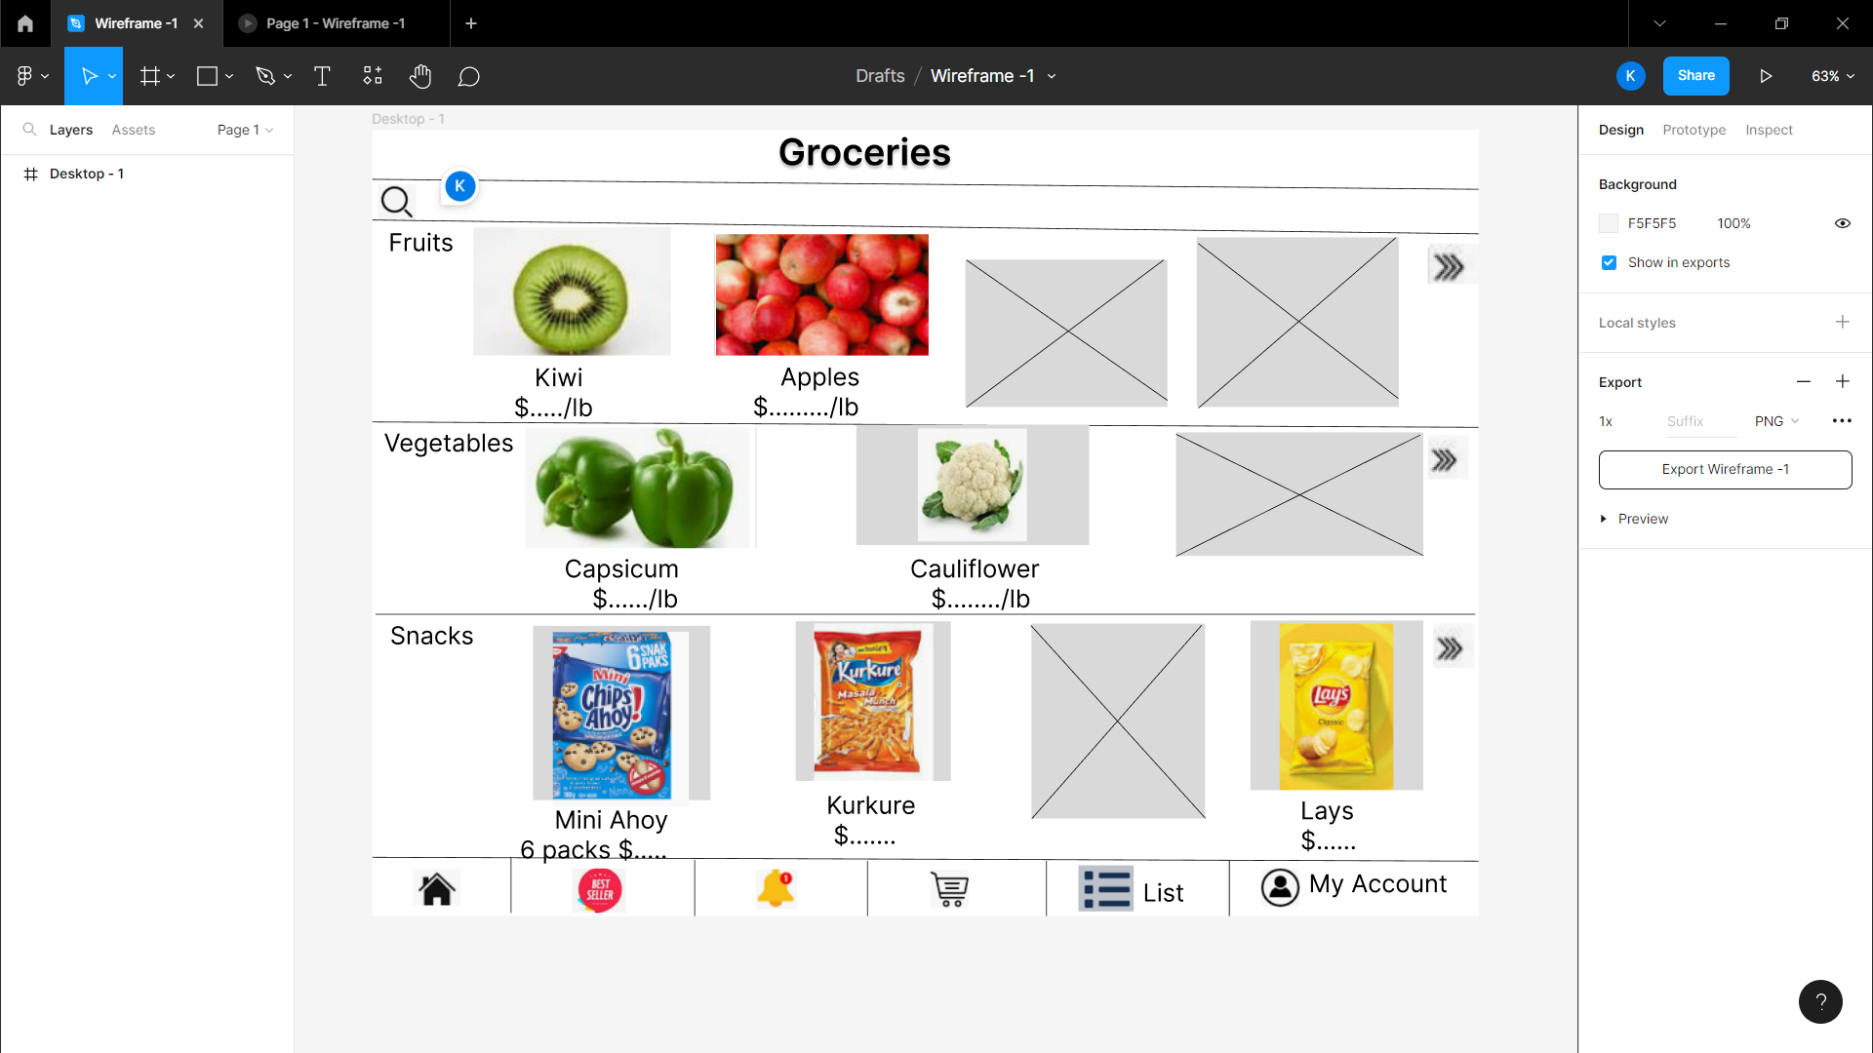

**S**

**Persona**

**Background-**

The users name – Elizabeth

Job – working at bell and housewife

Working at same company for ten years

**Demographics-**

Location – Downtown

Age – 28

Gender – female

Income-$180,000

Bio – married with two children

**Identifiers-**

* *The purpose of the visit to the website* – she remains busy in her work a, house-keeping and in her children so she has less time to buy things such as groceries for her home .
* Best Quality of products
* Variety of products available such as national and international .
* **Delivery at home** option will save her time as she can spent time with family.
* Things that will persuade her to visit website –

attractive offers such as -

* combo plans to buy products
* buy one get one free
* 50% off

Interests – working on laptop all time , playing with children .