SQL-ASSIGNMENT – 10

1. write a query that produce all the pair of salespeople who are living in the same city . Exclude the combination of salespeople with themselves as well as duplicate rows with the order reversed.
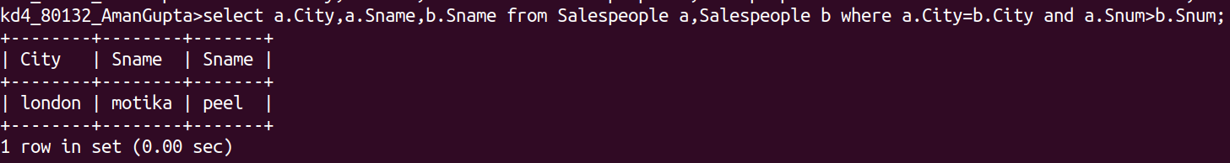

2. write a query that produce the names and cities of all customers with sames rating as hoffman.

