SQL – ASSIGNMENT -04

1. Write a select command that produces the order number, amount,
and date for all rows in the Orders table.

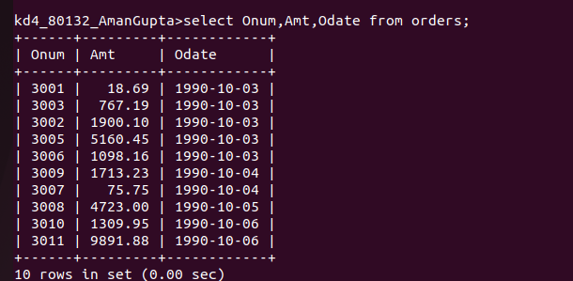

2. Write a query that produces all rows from the Customers table fro which the salesperson’s number is 1001.
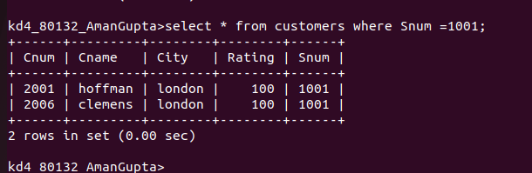

3. Write a query that displays the salespeople table with the columns in the following order : city, sname, snum, comm.
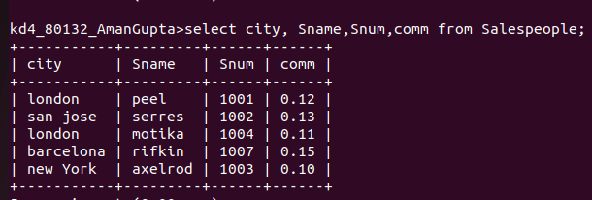

4. Wite a select command that produces the rating followed by the name of each customers in sanjose.

