SQL- ASSIGNMENT – 05

1. write a query that will give you all orders for more than Rs. 1000.

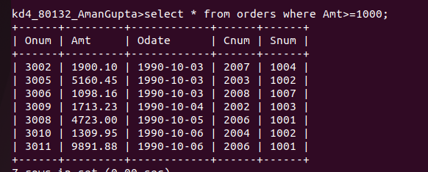

2. write a query that will give you the names and cities of all salespeople in london with a commission above .10 .

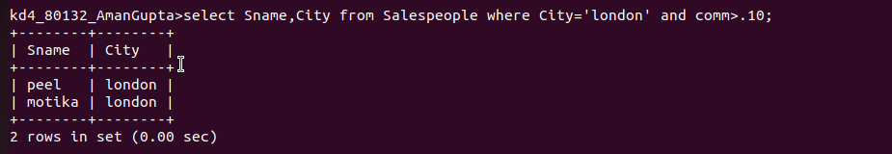

3. write a query on the customers table whose output will exclude all customers with a rating <=100, unless they are located in rome.


4. what will be the output from the following query?

Select * from orders
where (amt <1000 or
not (odate = ‘1990-10-03’
and cnum > 2023 ));
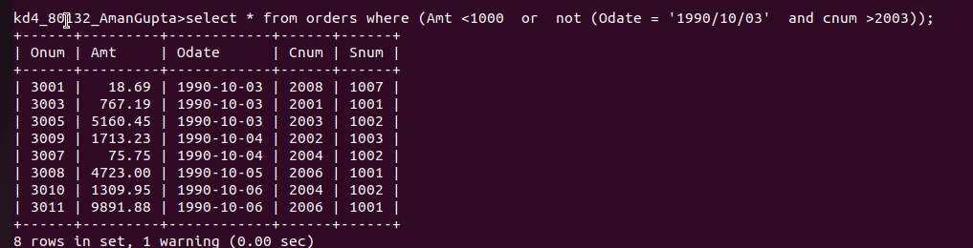

5. what will be the output of the following query?

Select * from orders where
not ((odate = ‘1990-10-03’ or snum >1006 ) and amt >= 1500));

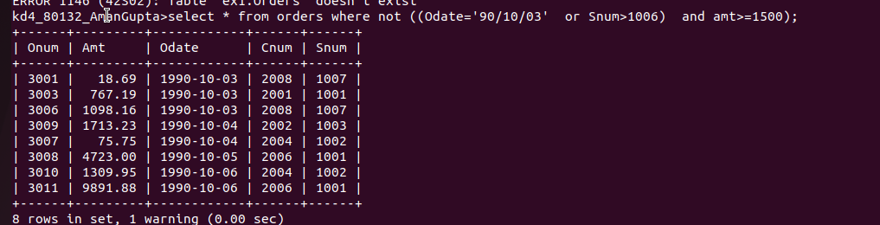

6. what is a simpler way to write this query?


