SQL -ASSIGNMENT- 06

1. write two different queries that would produce all orders taken on october 3rd or 4th , 1990.

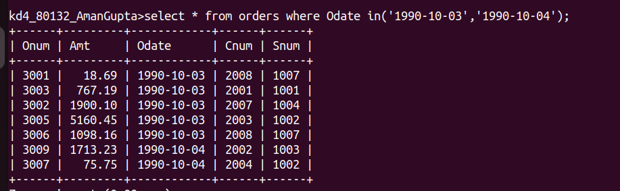

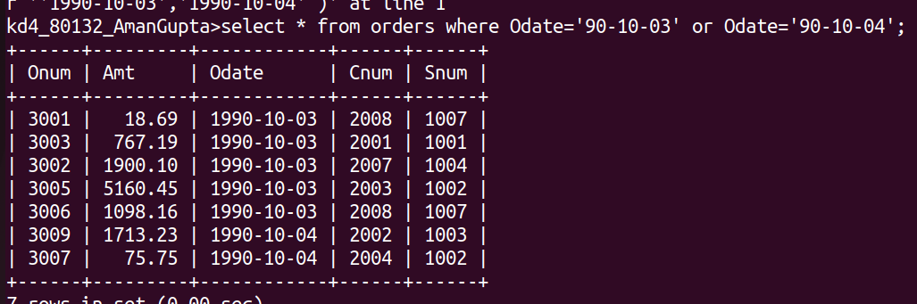

2. write a query that selects all of the customers services by peel or motika .(hint: the snum field relates the two table to one another).

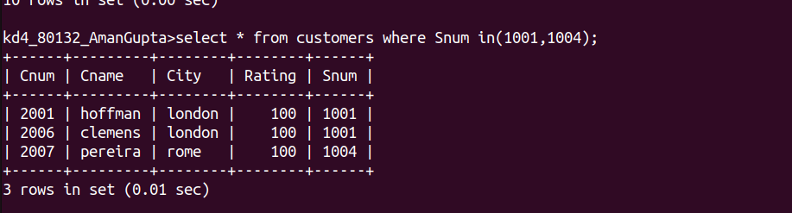

3. write a query that will produce all the customers whose name begin with a letter from ‘A’ to ‘G’.

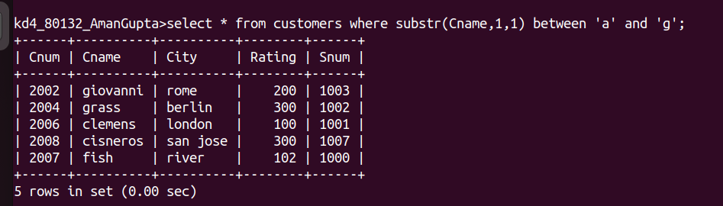
4. write a query that selects all customers whose names begin with the letter ‘C’.

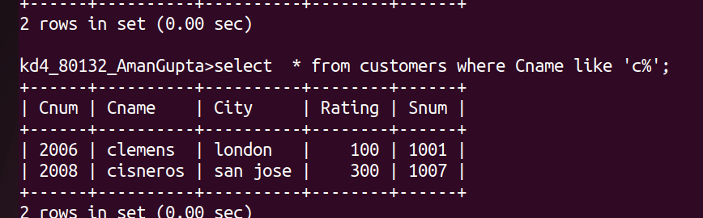

5. write a query that selects all orders except those with zero or null in the amt field.
