SQL -ASSIGNMENT – 07

1. write a query that counts all orders for october 3.

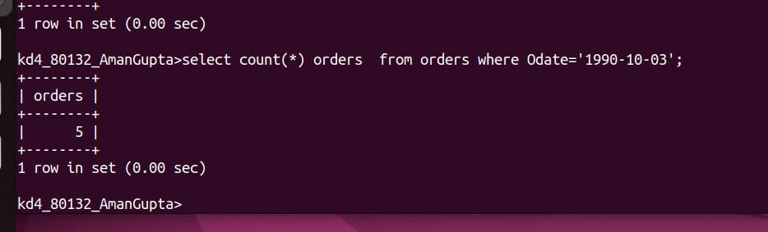

2. write a query that counts the number of different non-null city values in the customers table.

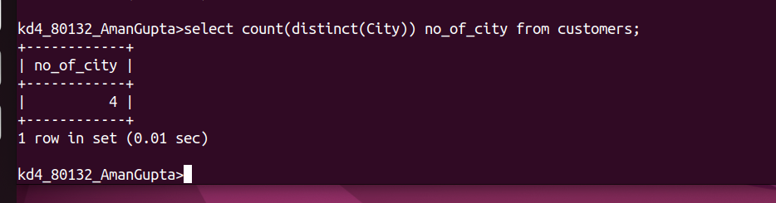

3.write a query that selects each customers smallest order.

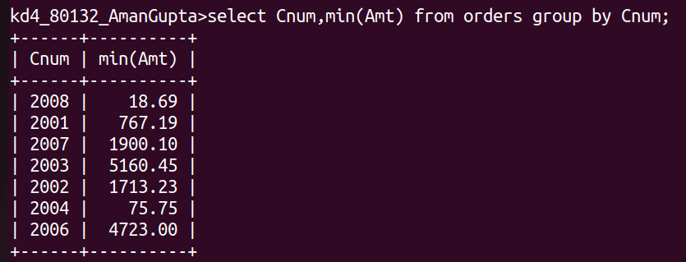

4. write a query that selects the first customers in alphabetical order, whose name begin with G.

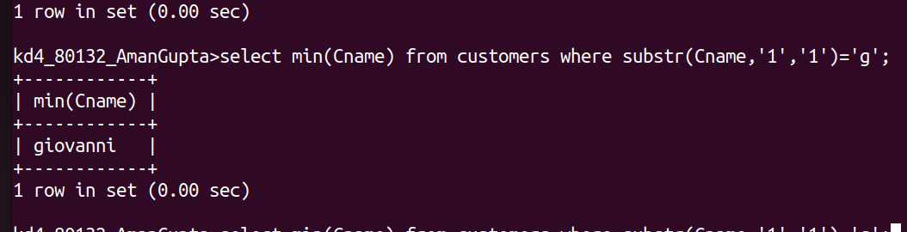

5. write a query that selects the highest rating in each city.

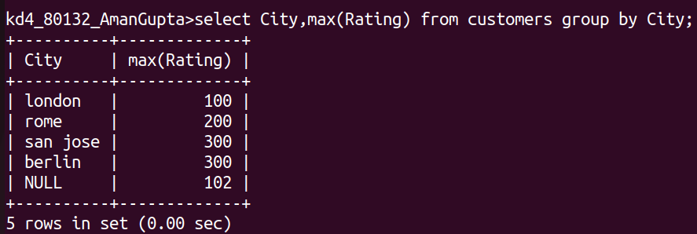

6. write a query that counts the number of salespeople registering orders for each day . (if a salespeople has more than one order on a givenday, he or she should be counted only once.)

