SQL -ASSIGNMENT -08

1. Assume each salesperson has a 12% commission . Write a query on the orders table that will produce the order number, the salespeople number , and the amount of the salesperson’s commission for that order.

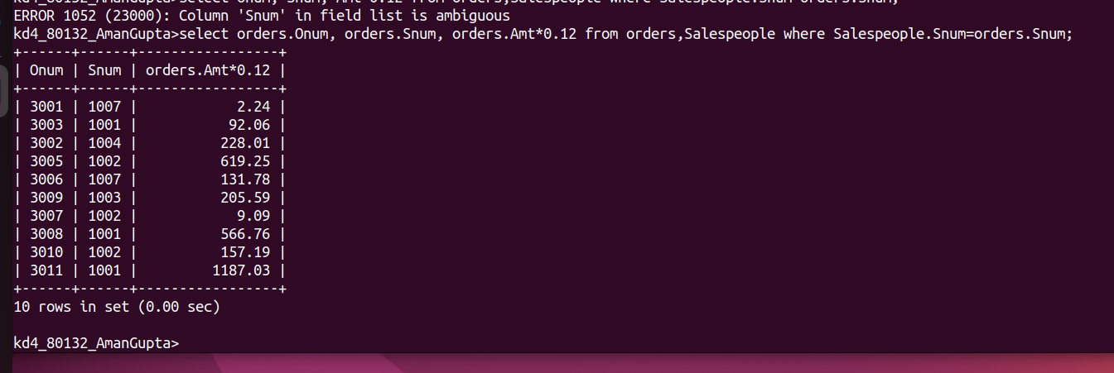

2. write a query on the customers table that will find the highest rating in each city . Put the output in this form:
for the city (city), the highest rating is : (rating)

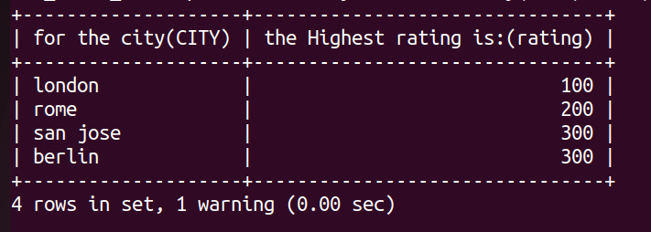

3.write a query that lists customers in descending order of rating. Output the rating field first, followed by the customers name and number.

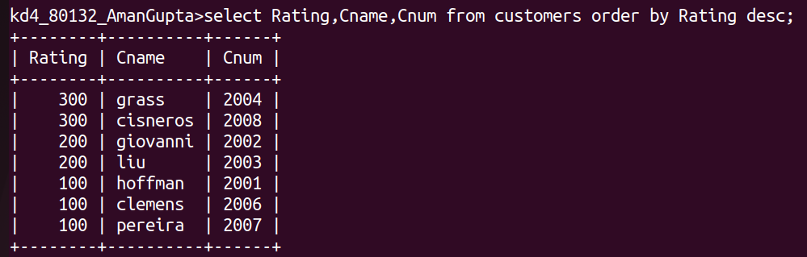

4. write a query that totals the orders for each day and places the result in descending orders.
