SQL ASSIGNMENT – 13

1. create a union of two queries that shows the names ,cities,and rating of all customers. Those with rating of 200 or greater will also have the word ‘high rating’, while other will have the word ‘low rating’.

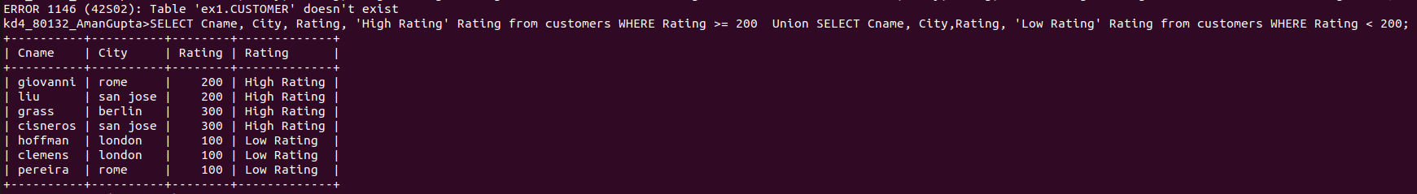

2.write a command that produces the names and the number of salespeople and each customers with more than one current order. Put the results in alphabetical order.

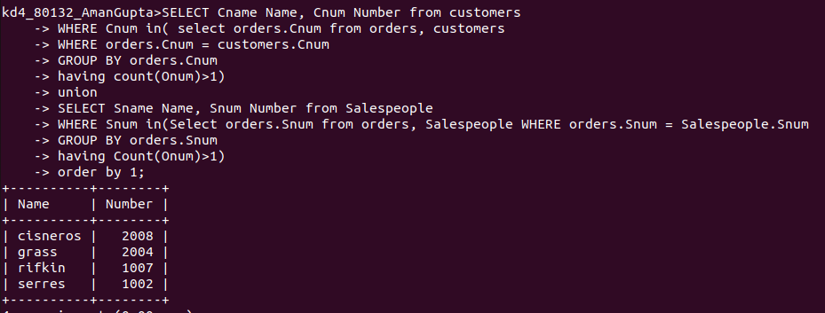

3. form a union of three queries . Have the first select the Snum of all salespeople in san jose the second, the cnum of all the customers in sanjose , and the third the onums of all orders on october 3. retain duplicates between the last two queries but eliminates any redundancies between either of them and the first.
Note: in the sample table as given , there would bee no redundancy .this is besides the point.

