SQL-ASSIGNMENT -09

1. write a query that lists each order number followed by the name of the customer who made the order.

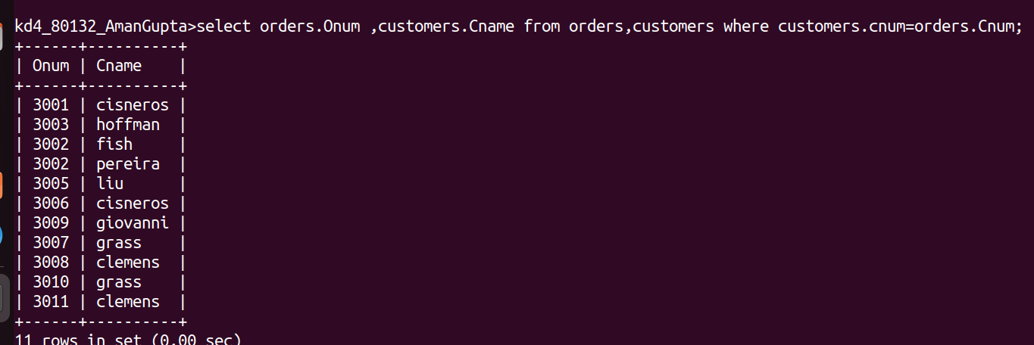

2. write a query that gives the names of both the salesperson and the customer for each order along with the order number .

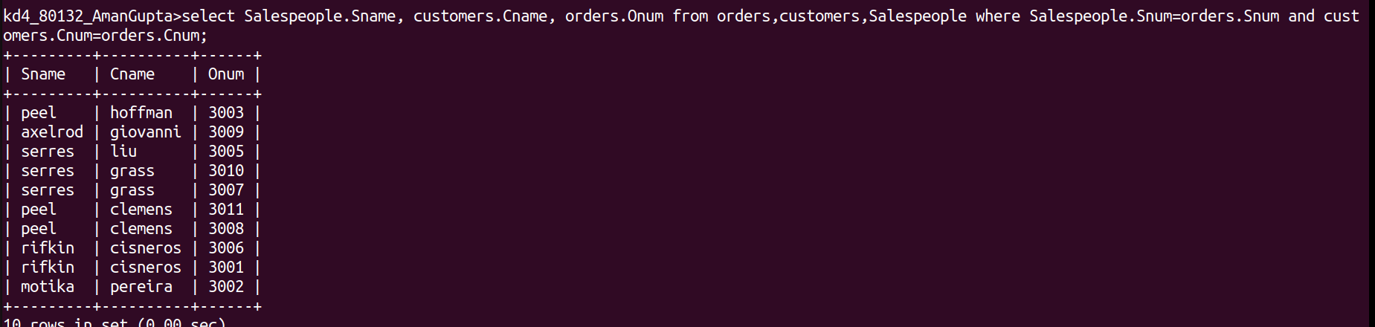

3.write a query that produce all customers serviced by salespeople with a commission above 12% output the customer names , the salesperson name, the salesperson rate of commission .

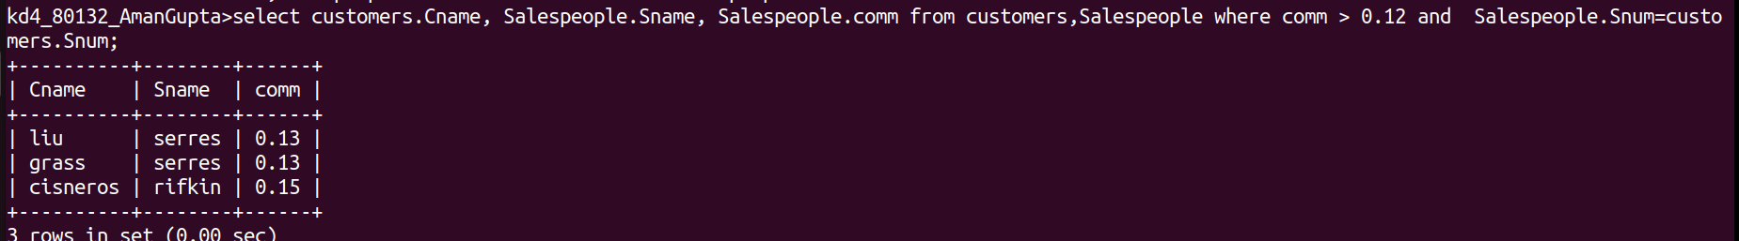

4.write a query that calculates the amount of the salespeople commission on each order by a customer with rating above 100.

