SQL-ASSIGNMENT -11

1. write a query that uses a subquery to obtain all orders for the customers named cisneros. Assume you do not know his customer number.

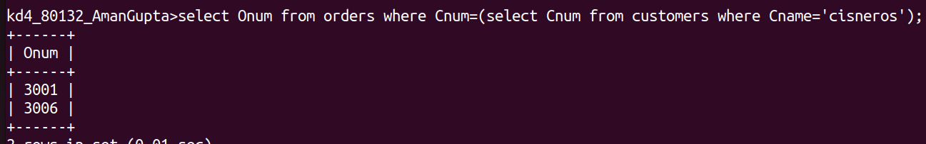

2. write a query that produces the name and rating of all the customers who have above average orders.
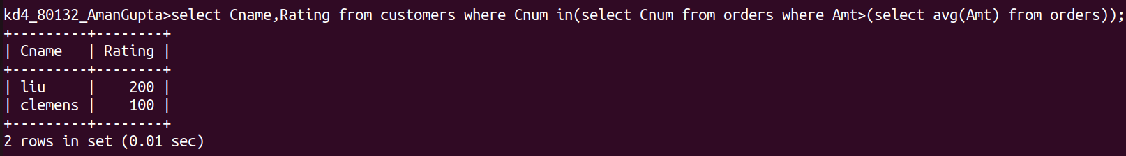

3. write a query taht selects the total amount in orders for each salespeople for whom this total is greater than the amount of the largest order of the table.

