SQL-ASSIGNMENT-12

1. write a query that selects all customers whose rating are equal to or greater than any of serres.

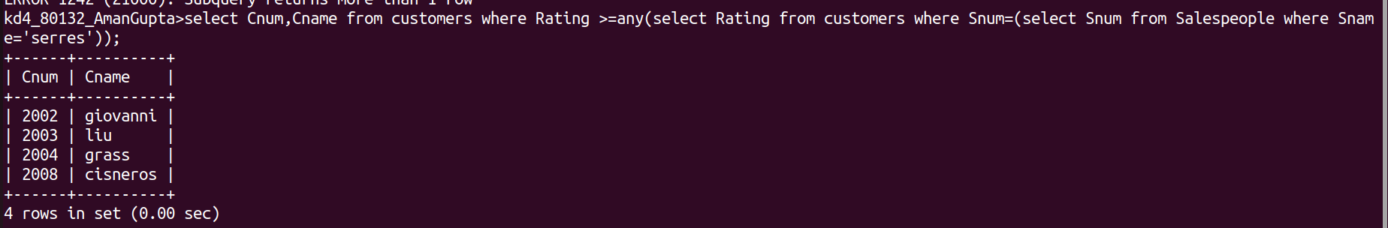

2. write a query using ANY or ALL that will find all the salespeople who have no customers located their city.

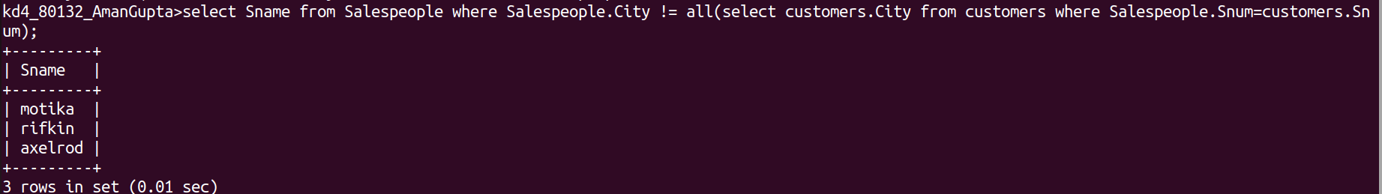

3. write a query that select all the orders for amount greater than any of the customers in london.

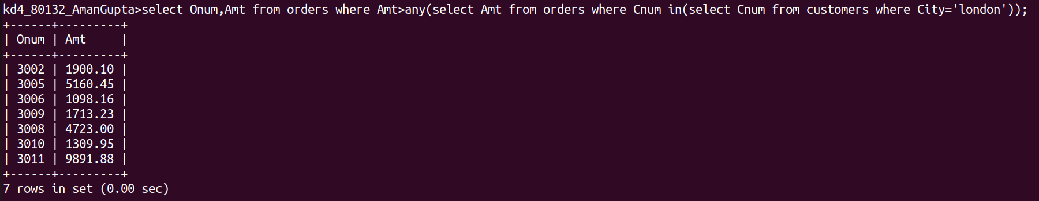

4. write a query that select all the orders for amount greater than any of the customers in london. (using min() or max()).
