SQL-ASSIGNMENT-14

1. write a command that puts the following values in their given order, into the salespeople table : city – san jose, name -blanco, comm – null, cnum- 1100.

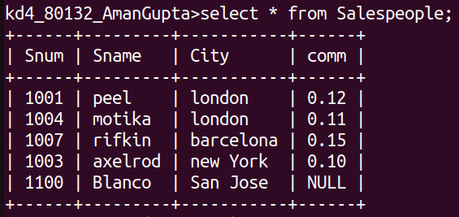

2. write a command that removes all the order from customer clemens from the orders table.

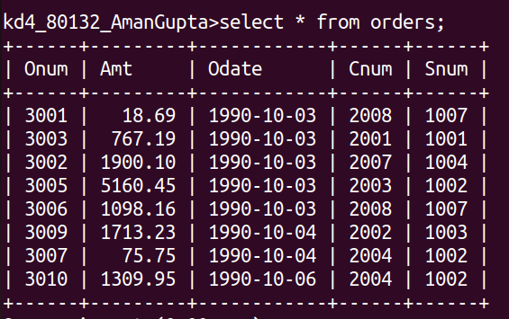

3. write a command that increases the rating of all customers in rome by 100.

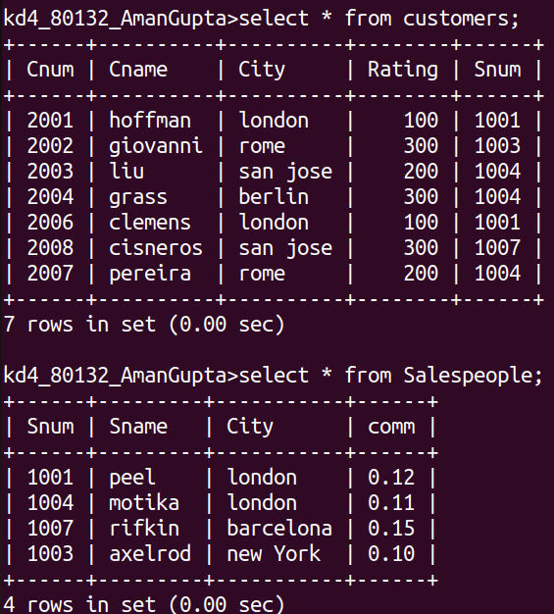

4. Salesperson ‘serres’ has left the company. Assign her customers to
motika.
