

**Tilak Maharashtra Vidyapeeth, Pune**

Department of Computer Science

A PROJECT REPORT

ON

### Handwriting Recognition System

By

AMAN YADAV- 04421001453

ANURAG VARMA- 04421002767

Towards The Partial Fulfillment of the

## Bachelor of Computer Application

**Kirandevi Saraf Institute**

**Mumbai**

**Tilak Maharashtra Vidyapeeth, Pune**

#### Department of Computer Science

[2023-2024]



**Tilak Maharashtra Vidyapeeth, Pune**

Department of Computer Science

##### **CERTIFICATE**

This is to certify that the project

“*Handwriting recognition system”*

Has been satisfactorily completed by

AMAN YADAV

ANURAG VARMA

Towards The Partial Fulfillment of the ‘Bachelor of Computer Application’,

For the Academic Year [2023-2024] at Kirandevi Saraf Institute, Mumbai,

Tilak Maharashtra Vidyapeeth, Pune (Department of Computer Science),

And it is approved.

###### Project Guide Examiner Head of Department

Kirandevi Saraf Institute

Mumbai



**Tilak Maharashtra Vidyapeeth, Pune**

Department of Computer Science

##### **ACKNOWLEDGEMENT**

With immense please we are presenting “Handwriting Recognition System” Project report as part of the curriculum of ‘Bachelor of Computer Application’. We wish to thank all the people who gave us unending support.

I / we express my / our profound thanks to our head of department Ms. “Urvi Pal”, project guide and project incharge Ms. “Shraddha Kokate” and all those who have indirectly guided and helped us in preparation of this project.

AMAN YADAV

ANURAG VARMA

**INDEX**

|  |  |  |
| --- | --- | --- |
| **SR NO.** | **Topics** | **PAGE NO.** |
| **1.** | **SYNOPSIS** | **1** |
| **2.** | **OBJECTIVES** | **2** |
| 2.1 | FUNCTIONAL REQUIREMENT | 4 |
| 2.2 | NON-FUNCTIONAL | 6 |
| **3** | **HARDWARE AND SOFTWARE REQUIREMENTS** | **8** |
| **4** | **FEASIBILITY STUDY** | **11** |
| **5** | **PROBLEM DEFINATION** | **18** |
| **6** | **SCOPE OF SYSTEM** | **20** |
| **7** | **METHODOLOGY** | **22** |
| **8** | **SYSTEM ARCHITECTURE** | **25** |
| 8.1 | ER DIAGRAM | 25 |
| 8.2 | USE CASE DIAGRAM | 28 |
| 8.3 | SEQUENCE DIAGRAM | 32 |

|  |  |  |
| --- | --- | --- |
| 8.4 | CLASS DIAGRAM | 36 |
| 8.5 | ACTIVITY DIAGRAM | 41 |
| 8.6 | DATA FLOW DIAGRAM | 46 |
| 8.7 | DATA DICTIONARY | 51 |
| 8.8 | GANTT CHART | 55 |
| **9** | **SYSTEM STUDY** | **57** |
| **10** | **SCREENSHOTS** | **60** |
| **11** | **TESTING** | **67** |
| 11.1 | BLACK BOX TESTING | 67 |
| 11.2 | WHITE BOX TESTING | 69 |
| **12** | **COST BENEFIT ANALYSIS** | **71** |
| **13** | **FUTURE ANHANCEMENT** | **73** |
| **14** | **BIBLOGRAPHY** | **76** |

**Handwriting Recognition System**

1. **Synopsis**

**Synopsis of Handwriting recognition system:**

Handwriting recognition system is a pivotal component of our final year Computer Science project, offering a solution tailored to accurately interpret handwritten text. This system integrates a Python backend API with a frontend built on React.js and styled using Tailwind CSS. Through this cohesive amalgamation of technologies, we have developed a straightforward yet efficient platform for recognizing handwritten content.

At its core, the system excels in processing input images containing handwritten text. By harnessing the power of machine learning algorithms, it adeptly extracts pertinent features from these images and employs trained models to decode the textual content. This capability empowers users to effortlessly convert handwritten documents into digital text with precision and reliability.

User interaction with the system is facilitated through an intuitive web-based interface. Here, users can seamlessly upload images of handwritten text for processing. Upon submission, the system promptly analyzes the uploaded images and returns the recognized text to the user. This streamlined interaction flow enhances usability and convenience for individuals grappling with handwritten documents.

Our project serves as a testament to the practical application of machine learning techniques in addressing real-world challenges. By delivering a dependable solution for handwriting recognition, our system underscores the potential of technology to streamline tasks traditionally reliant on manual transcription. Furthermore, it underscores the significance of user-centric design in crafting accessible and user-friendly software solutions.

1. **Objective**

**Objectives of Handwriting recognition system:**

The handwriting recognition system we've developed is a pivotal component of our project, offering a solution tailored to accurately interpret handwritten text. Integrating a Python backend API with a frontend built on React.js and styled using Tailwind CSS, we've created a straightforward yet efficient platform for recognizing handwritten content. Our primary objectives with this project are twofold: firstly, to demonstrate the practical application of machine learning algorithms in accurately interpreting handwritten text, showcasing their potential in real-world scenarios. Secondly, to create a user-friendly interface that simplifies the process of uploading and processing handwritten documents, enhancing accessibility and usability for a diverse range of users.

**It also Includes:**

* **Develop a robust handwriting recognition system** leveraging machine learning algorithms to accurately interpret handwritten text, showcasing the practical application of advanced technology in document digitization and accessibility enhancement.
* **Prioritize user experience** by designing an intuitive and seamless interface for uploading and processing handwritten documents, focusing on user-centric design principles to enhance usability and accessibility for a diverse range of users.
* **Improve User Experience:** Enhance the user interface and user experience of the system to make it more intuitive, responsive, and accessible across different devices and platforms, improving user satisfaction and adoption.
* **Integrate with External Systems:** Implement integration capabilities with external systems and applications such as document management systems, cloud storage platforms, and productivity tools, enabling seamless data exchange and interoperability.
* **Optimize Performance:** Optimize system performance, scalability, and responsiveness to handle large volumes of handwritten documents efficiently, ensuring quick processing and response times even under heavy loads.
* **Enhance Security:** Implement robust security measures such as data encryption, user authentication, access control, and audit logging to protect sensitive handwritten content and user information from unauthorized access, tampering, or breaches.
* **Provide Customization Options:** Allow users to customize recognition settings and preferences, such as text formatting, language settings, and recognition thresholds, to tailor the system to their specific requirements and preferences.
* **Enable Offline Recognition:** Develop offline recognition capabilities to allow users to perform handwriting recognition tasks without requiring an internet connection, enhancing flexibility and accessibility in offline environments.
* **Facilitate Collaboration:** Introduce collaboration features such as document sharing, version control, and real-time collaboration tools to facilitate teamwork and collaboration among users working on shared handwritten documents.
* **Support Handwriting Styles:** Extend recognition support to different handwriting styles, including print, cursive, and specialized fonts, accommodating diverse writing styles and preferences among users.
* **Ensure Regulatory Compliance:** Ensure compliance with relevant data protection regulations and standards, such as GDPR, HIPAA, and CCPA, to protect user privacy and data security while handling sensitive handwritten content.

**Functional Requirements of Handwriting recognition system:**

**1. Image Upload:** The system should allow users to upload images containing handwritten text for processing.

**2. Text Extraction:** The system should be able to extract text from the uploaded images accurately.

**3. Handwriting Recognition:** Implement machine learning algorithms to recognize and interpret handwritten text, ensuring high accuracy and reliability.

**4. Language Support:** Provide support for recognizing handwriting in multiple languages to cater to diverse user needs.

**5. Error Handling:** Implement robust error handling mechanisms to address issues such as low image quality, unclear handwriting, or unexpected input.

**6. Real-Time Processing:** Ensure timely processing of uploaded images to provide users with prompt results.

**7. User Interface:** Develop a user-friendly interface that facilitates easy interaction for uploading images, viewing recognition results, and providing feedback.

**8. Compatibility:** Ensure compatibility with various devices and browsers to allow users to access the system from different platforms seamlessly.

**9. Integration:** Provide integration capabilities to allow seamless integration with other applications or systems where handwriting recognition functionality is required.

**10. Security:** Implement measures to protect user data and ensure the confidentiality and integrity of uploaded images and recognition results.

**11. Batch Processing:** The system should support batch processing of multiple documents simultaneously, allowing users to upload and process multiple handwritten documents in a single operation. This feature enhances efficiency and scalability, especially when dealing with large volumes of documents.

**12. Feedback Mechanism:** Implement a feedback mechanism that enables users to provide corrections or annotations to the recognition results. Users should have the ability to review and edit the recognized text, correct any errors, and provide feedback to improve the accuracy of future recognition attempts.

**13. Integration with External Systems:** Enable integration with external systems, applications, or platforms to facilitate seamless data exchange and interoperability. The system should provide APIs or integration points that allow other software systems to upload documents for recognition, retrieve recognition results, or trigger recognition tasks programmatically.

**14. Language Support:** Ensure support for multiple languages and writing systems to accommodate diverse user needs and document types. The system should be capable of recognizing handwriting in different languages, scripts, and character sets, including Latin, Cyrillic, Chinese, Arabic, and others.

**15. Real-Time Recognition:** Provide real-time recognition capabilities that allow users to capture handwritten content using digital input devices such as stylus or touchscreens, with immediate feedback on the recognized text. Real-time recognition enables interactive applications such as digital note-taking, white-boarding, or form filling.

**16. Scalability and Performance:** Design the system to be scalable and capable of handling increasing loads and user interactions over time. The system should be able to scale horizontally by adding more computational resources or nodes to accommodate growing user bases, document volumes, and processing demands. Additionally, optimize system performance to ensure timely response and processing of recognition tasks, even during peak usage periods.

**Non-Functional Requirements of Handwriting recognition system:**

**1. Accuracy:** Ensure high accuracy in recognizing handwritten text to minimize errors and provide reliable results to users.

**2. Performance:** The system should process images and recognize text within acceptable time frames, even under high load conditions, to maintain responsiveness and user satisfaction.

**3. Scalability:** Design the system to scale efficiently to handle increasing numbers of users and uploaded images without significant degradation in performance.

**4. Usability:** Create an intuitive and user-friendly interface that is easy to navigate and understand, catering to users with varying levels of technical proficiency.

**5. Reliability:** Ensure the system operates reliably under normal conditions and can recover gracefully from failures to minimize downtime and disruption to users.

**6. Security:** Implement robust security measures to protect user data and ensure the confidentiality and integrity of uploaded images and recognition results.

**7. Compatibility:** Ensure compatibility with a wide range of devices, browsers, and operating systems to maximize accessibility for users.

**8. Maintainability:** Design the system with modular and well-documented code to facilitate ease of maintenance and future enhancements.

**9. Adaptability:** Build the system with flexibility to accommodate changes in handwriting styles, languages, or input formats, ensuring long-term relevance and usability.

**10. Accessibility:** Ensure the system is accessible to users with disabilities, complying with relevant accessibility standards and guidelines to promote inclusivity.

**11. Accuracy and Precision:** Ensure high accuracy and precision in handwriting recognition results, with minimal errors and discrepancies between the original handwritten content and the recognized text. The system should strive to achieve a high level of accuracy across different handwriting styles, sizes, and complexities.

**12. Performance and Response Time:** Optimize system performance to deliver fast and responsive user experiences, with quick processing times for recognition tasks and minimal latency in displaying results. The system should aim to provide near-real-time feedback to users, especially during interactive or time-sensitive scenarios.

**13. Scalability and Elasticity:** Design the system to be scalable and elastic, capable of dynamically adapting to changes in user demand, workload fluctuations, and resource requirements. The system should scale seamlessly to accommodate increasing numbers of users, documents, and processing tasks without compromising performance or reliability.

**14. Reliability and Availability:** Ensure high reliability and availability of the system, with minimal downtime or disruptions to service. Implement redundancy, failover mechanisms, and disaster recovery strategies to mitigate the impact of hardware failures, software bugs, or other unexpected events on system availability and continuity of service.

**15. Security and Privacy:** Implement robust security measures to protect sensitive user data, documents, and recognition results from unauthorized access, manipulation, or disclosure. The system should employ encryption, access controls, authentication mechanisms, and data encryption techniques to safeguard confidentiality, integrity, and privacy of information.

**16. Usability and User Experience:** Prioritize usability and user experience in the design and implementation of the system, with intuitive interfaces, clear feedback, and user-friendly interactions. The system should be accessible to users of varying technical backgrounds and abilities, with support for assistive technologies and accessible design principles. Additionally, provide comprehensive documentation, tutorials, and support resources to help users effectively utilize the system's features and functionalities.

1. **Hardware and Software requirements**

**Software Specifications:**

**Front-end:**

**React.js** is a powerful JavaScript library for building user interfaces, renowned for its simplicity, efficiency, and flexibility. Developed by Facebook, React.js facilitates the creation of interactive and dynamic web applications by employing a component-based architecture. With React.js, developers can break down complex UIs into reusable components, promoting code reusability and maintainability. Its virtual DOM (Document Object Model) efficiently updates only the necessary components when data changes, enhancing performance and responsiveness. Additionally, React.js embraces a declarative programming paradigm, allowing developers to describe the desired UI state and React.js handles the underlying updates automatically. With a vast ecosystem of libraries, tools, and community support, React.js continues to be a preferred choice for building modern, high-performance web applications.

**Tailwind CSS** is a utility-first CSS framework that enables developers to rapidly build modern and responsive web designs with ease. Unlike traditional CSS frameworks, Tailwind CSS provides a comprehensive set of utility classes that directly apply styling properties, eliminating the need for writing custom CSS. With Tailwind, developers can efficiently create complex layouts and design patterns by composing classes directly within HTML elements, promoting a highly readable and maintainable codebase. Tailwind's utility-first approach empowers developers to quickly prototype and iterate on designs, while its modular architecture allows for easy customization and theming. Additionally, Tailwind's responsive design utilities enable seamless adaptation to various screen sizes and devices, ensuring a consistent user experience across platforms. Overall, Tailwind CSS offers a pragmatic and efficient approach to building modern web interfaces, making it a popular choice among developers for its simplicity and flexibility.

**Firebase** is a comprehensive platform developed by Google that offers a wide range of services for building and scaling web and mobile applications. It provides developers with a suite of tools to handle various aspects of application development, including authentication, real-time database, cloud storage, hosting, analytics, and more.

One of the core features of Firebase is its Realtime Database, which is a NoSQL cloud database that allows developers to store and sync data in real-time between clients. This makes it ideal for building collaborative applications such as chat apps, collaborative editing tools, and real-time dashboards.

Firebase also offers Authentication services, allowing developers to easily integrate user authentication into their applications using methods such as email/password, social logins (Google, Facebook, Twitter, etc.), and phone authentication.

In addition to these features, Firebase provides Cloud Functions, which allow developers to run server-side code in response to events triggered by Firebase features and HTTPS requests. This enables developers to build powerful backend logic without managing servers.

**Hardware Specifications:**

**Back-end:**

**Python** is a versatile and powerful programming language widely used for developing web applications, including APIs (Application Programming Interfaces). Python's simplicity, readability, and extensive ecosystem of libraries make it an ideal choice for building robust and scalable APIs. With frameworks like Flask and Django, developers can rapidly create APIs that interact with databases, handle HTTP requests, and serve data to client applications. Python's expressive syntax and dynamic typing facilitate quick development and iteration, while its support for asynchronous programming enables efficient handling of concurrent requests in high-traffic environments. Additionally, Python's extensive standard library and third-party packages provide comprehensive support for tasks such as data serialization, authentication, and security, streamlining API development. Overall, Python's versatility and ecosystem make it a popular choice for building APIs, enabling developers to create efficient and feature-rich web services with ease.

**Software Requirements:**

* Windows 10
* Python
* React js
* Tailwind

**Hardware Requirements:**

* Processor: i3
* Hard Disk: 5 GB
* Memory: 2GB RAM

1. **Feasibility Study**

**Feasibility study of Handwriting recognition system:**

The feasibility study of implementing a handwriting recognition system using technologies like Python, React.js, and Firebase indicates promising prospects for success. Firstly, from a technical standpoint, the availability of robust libraries and frameworks in Python for machine learning and image processing streamlines the development process. Moreover, the integration of React.js for frontend development ensures a modern and responsive user interface, facilitating user interaction with the system. Additionally, leveraging Firebase as a backend service provides scalable and reliable cloud infrastructure, minimizing the need for extensive server management and ensuring seamless data synchronization across devices. These technological advantages enhance the feasibility of the project by offering a solid foundation for building a functional and efficient handwriting recognition system.

Furthermore, from a market perspective, the increasing demand for digitization and automation across various industries underscores the relevance and potential impact of a handwriting recognition system. With applications ranging from document digitization and archival to accessibility enhancements for individuals with disabilities, the project addresses pressing needs in both commercial and societal contexts. Additionally, the accessibility of the proposed solution, enabled by web-based deployment and user-friendly interfaces, ensures broad adoption potential among users with varying technical backgrounds. Moreover, the availability of open-source tools and resources in the selected technologies fosters collaboration and community support, further bolstering the feasibility and sustainability of the project.

**Study Points:**

**1. Market Demand:** Analyze market trends and potential user demographics to identify the demand for handwriting recognition solutions in various sectors.

**2. Scalability and Reliability:** Evaluate Firebase's scalability and reliability features to ensure seamless handling of increasing user loads and data volumes.

**3. Cost Analysis:** Estimate development costs, including infrastructure, licensing, and maintenance, to determine the financial feasibility of the project.

**4. Regulatory Compliance:** Consider regulatory requirements related to data privacy and security, especially concerning the handling of sensitive handwritten documents.

**5. Competitive Landscape:** Conduct a competitive analysis to understand existing solutions and identify opportunities for differentiation and value proposition.

**Types of feasibility study:**

* **Economical Feasibility**
* **Technical Feasibility**
* **Operational Feasibility**
* **Schedule Feasibility**
* **Legal Feasibility**

**Economical Feasibility:** The economical feasibility of implementing a handwriting recognition system using Python, React.js, and Firebase presents several key considerations. Initially, the cost-effectiveness of utilizing open-source tools and frameworks in the development process significantly reduces upfront expenses. Both Python and React.js boast extensive libraries and community support, eliminating the need for costly proprietary software licenses. Additionally, leveraging Firebase as a backend service offers a pay-as-you-go pricing model, enabling scalability while minimizing infrastructure overheads. Furthermore, the project's potential for enhancing productivity and efficiency through automation can result in long-term cost savings for organizations reliant on manual transcription processes. By streamlining document digitization and data entry tasks, the system can reduce labor costs and improve operational efficiency over time. However, it's crucial to conduct a thorough cost-benefit analysis to assess the project's overall economic viability accurately. Factors such as development time, maintenance expenses, and potential revenue generation opportunities should be carefully evaluated to ensure that the benefits outweigh the costs and justify investment in the project.

**Technical Feasibility:** The technical feasibility of implementing a handwriting recognition system using Python, React.js, Firebase, and a Python backend API is solid. Python offers a wide range of libraries and tools for machine learning, image processing, and backend development, making it well-suited for building the core functionality of the system. React.js provides a straightforward and efficient way to create interactive user interfaces, while Firebase offers scalable cloud infrastructure for storing data and handling real-time updates. Additionally, incorporating a Python backend API ensures seamless communication between the frontend and backend components of the system, enabling efficient data processing and retrieval. Overall, the combination of these technologies provides a strong foundation for developing a functional handwriting recognition system with minimal technical hurdles.

**Operational Feasibility:** The operational feasibility of implementing a handwriting recognition system using Python, React.js, Firebase, and a Python backend API is promising, with several factors supporting its viability.

**1. User Acceptance:** The system's user-friendly interface, powered by React.js, ensures ease of use for both technical and non-technical users. Its intuitive design facilitates seamless interaction, enabling users to upload handwritten documents effortlessly.

**2. Integration Capability:** The integration of Firebase as a backend service simplifies data management and synchronization, reducing the operational complexity of the system. The Python backend API further enhances interoperability, allowing seamless integration with other applications or systems as needed.

**3. Scalability:** Firebase's scalable infrastructure ensures that the system can accommodate increasing user demand and data volumes over time. This scalability is crucial for handling fluctuations in usage patterns and ensuring consistent performance during peak periods.

**4. Maintenance and Support:** The use of well-established technologies like Python, React.js, and Firebase ensures access to comprehensive documentation, tutorials, and community support. This availability of resources facilitates system maintenance and troubleshooting, minimizing operational downtime.

**5. Training and User Adoption:** Providing adequate training and support to users is essential for the successful adoption of the system. With clear documentation and user guides, coupled with responsive customer support, users can quickly learn how to utilize the system effectively.

**Schedule Feasibility:** The schedule feasibility of implementing a handwriting recognition system using Python, React.js, Firebase, and a Python backend API depends on various factors such as the scope of the project, available resources, and the complexity of the required functionalities. However, a general outline of the development process can help assess its feasibility within a given timeframe:

**1. Planning and Requirements Gathering:** Allocate sufficient time for planning and gathering requirements, including defining the system's features, user interface design, and technical specifications. This phase may involve conducting stakeholder meetings, user interviews, and feasibility studies to establish project goals and objectives.

**2. Development of Backend API:** Begin by developing the Python backend API, which will handle data processing, interaction with the machine learning models, and communication with the frontend. This stage involves designing API endpoints, implementing data storage and retrieval mechanisms, and ensuring integration with Firebase for data storage and synchronization.

**3. Frontend Development with React.js:** Concurrently, start developing the frontend user interface using React.js. Design responsive UI components, implement features for uploading handwritten images, and integrate with the backend API for data retrieval and display.

**4. Integration and Testing:** Once both the backend API and frontend UI are developed, allocate time for integration testing to ensure seamless communication between the frontend and backend components. Test functionality, performance, and user experience across different devices and browsers to identify and address any issues or inconsistencies.

**Legal Feasibility:** Legal feasibility of implementing a handwriting recognition system involves ensuring compliance with relevant laws, regulations, and intellectual property rights.

**Some key considerations include:**

**1. Data Privacy:** Ensure that the system complies with data privacy regulations such as the General Data Protection Regulation (GDPR) in the European Union or the California Consumer Privacy Act (CCPA) in the United States. This includes obtaining consent for data collection and processing, implementing appropriate security measures to protect user data, and providing transparency regarding how user data is used.

**2. Intellectual Property Rights:** Ensure that the system does not infringe on any intellectual property rights, including patents, copyrights, and trademarks. This may involve conducting a thorough review of existing patents and trademarks related to handwriting recognition technology and ensuring that the system's implementation does not violate any existing patents or copyrights.

**3. Accessibility Compliance:** Ensure that the system complies with accessibility standards such as the Web Content Accessibility Guidelines (WCAG), making the system accessible to users with disabilities. This may involve providing alternative text for images, ensuring keyboard accessibility, and testing the system with assistive technologies.

**4. Regulatory Compliance:** Ensure that the system complies with any industry-specific regulations or standards that may apply, such as healthcare regulations (e.g., Health Insurance Portability and Accountability Act - HIPAA) if the system is used in a healthcare setting. This may involve implementing additional security measures or obtaining certifications or accreditations as required by law.

**Consent and User Permissions:** Obtain explicit consent from users for the collection, processing, and use of their handwritten data for recognition purposes. Clearly communicate the purposes, scope, and implications of data processing to users and obtain their informed consent before processing their handwritten content.

Children's Online Privacy Protection Act (COPPA) Compliance: Ensure compliance with COPPA regulations if the handwriting recognition system collects, processes, or stores handwritten content from children under the age of 13. Implement age verification mechanisms, parental consent requirements, and child-friendly privacy notices to comply with COPPA requirements and protect children's privacy rights.

**Accuracy and Fairness:** Mitigate the risk of algorithmic bias and discrimination in handwriting recognition results by ensuring fairness, transparency, and accountability in algorithm development and deployment. Conduct regular audits, bias assessments, and fairness evaluations to identify and address biases or disparities in recognition outcomes based on factors such as race, gender, ethnicity, or socioeconomic status.

**Data Retention and Deletion:** Establish data retention policies and procedures to govern the storage, retention, and deletion of handwritten data processed by the system. Define retention periods, data storage limits, and deletion mechanisms to ensure compliance with data protection laws and minimize the risk of data breaches or unauthorized access.

**Cross-Border Data Transfers:** Consider the legal implications of cross-border data transfers if the handwriting recognition system processes or stores data in multiple jurisdictions. Ensure compliance with data transfer mechanisms such as standard contractual clauses (SCCs), binding corporate rules (BCRs), or adequacy decisions to facilitate lawful data transfers between regions with different data protection laws.

**Third-Party Services and APIs:** Evaluate the legal risks and liabilities associated with using third-party services, APIs, or libraries in the handwriting recognition system. Conduct due diligence on third-party providers, review their terms of service, privacy policies, and data processing practices, and ensure compliance with legal requirements when integrating third-party components into the system.

**Ethical Considerations:** Address ethical considerations and societal impacts associated with the use of handwriting recognition technology, such as privacy concerns, surveillance risks, and implications for individual autonomy and freedom of expression. Consider the ethical principles of fairness, transparency, accountability, and social responsibility when designing, deploying, and governing the system.

**Incident Response and Breach Notification:** Develop incident response plans and breach notification procedures to respond promptly and effectively to security incidents, data breaches, or unauthorized access to handwritten data. Establish protocols for notifying affected individuals, regulatory authorities, and other stakeholders in accordance with legal requirements and best practices for data breach response.

**Legal Disclaimers and Limitations of Liability:** Include legal disclaimers, terms of use, and limitations of liability in user agreements, terms of service, or end-user license agreements (EULAs) governing the use of the handwriting recognition system. Clearly outline the rights, responsibilities, warranties, and disclaimers applicable to users and the system provider to mitigate legal risks and liabilities.

**Continuous Compliance Monitoring:** Implement mechanisms for continuous compliance monitoring and auditing to ensure ongoing adherence to legal requirements, regulatory standards, and industry best practices. Regularly review and update policies, procedures, and technical controls to address evolving legal and regulatory developments and mitigate emerging risks to legal compliance.

1. **Problem Definition**

**Problem Definition:**

The problem at hand involves the need for an efficient and accurate solution to convert handwritten text into digital format. Traditional methods of transcribing handwritten documents are time-consuming and error-prone, hindering productivity and accessibility. Additionally, there is a growing demand for digitizing handwritten content in various industries, including education, healthcare, and administrative tasks. The lack of an efficient solution to automate this process results in inefficiencies, delays, and potential errors in data transcription.

To address this problem, the project aims to develop a handwriting recognition system that can accurately interpret handwritten text and convert it into digital format. The system will utilize machine learning algorithms to analyze images of handwritten text, extract relevant features, and generate digital text output. By automating the transcription process, the system will enhance productivity, streamline document digitization, and improve accessibility for users dealing with handwritten documents. Additionally, the system will provide a user-friendly interface for uploading handwritten images, viewing recognition results, and providing feedback, ensuring ease of use and adoption across various user demographics.

Overall, the problem definition highlights the need for a technological solution to streamline the process of converting handwritten text into digital format, addressing inefficiencies and improving accessibility in various industries. The proposed handwriting recognition system aims to provide an efficient and accurate solution to this problem, leveraging machine learning algorithms and user-friendly interfaces to enhance productivity and user experience.

Limited Accessibility to Handwritten Content: In many organizations and industries, handwritten documents and notes remain prevalent, leading to challenges in accessing and processing this valuable information. Traditional methods of transcribing handwritten content into digital format are often time-consuming, error-prone, and inefficient. As a result, organizations face difficulties in leveraging handwritten content for data analysis, decision-making, and knowledge management purposes, hindering productivity and innovation.

Inconsistencies in Recognition Accuracy: Existing handwriting recognition systems often struggle with inconsistencies in recognition accuracy, especially when dealing with diverse handwriting styles, variations in writing quality, and different languages. The lack of robust recognition algorithms and image processing techniques contributes to low accuracy rates and frequent errors in text extraction, leading to frustration among users and reduced trust in the system's capabilities.

Complexity of Document Management: Handwritten documents pose unique challenges in document management, including organization, storage, retrieval, and archival. Without efficient tools and systems in place, organizations struggle to maintain a centralized repository of digitized handwritten content, resulting in fragmented data storage, duplication of efforts, and difficulty in locating and accessing relevant information when needed.

Privacy and Security Concerns: Handwritten content often contains sensitive and confidential information, such as personal details, financial records, and legal documents. Ensuring the privacy and security of such information during the digitization process is critical to prevent unauthorized access, data breaches, and compliance violations. However, existing handwriting recognition systems may lack robust security features and encryption mechanisms, exposing organizations to potential risks and liabilities.

Scalability and Performance Challenges: As the volume of handwritten documents continues to grow, scalability and performance become critical factors in the effective operation of handwriting recognition systems. Without scalable architecture and optimized algorithms, systems may struggle to handle large volumes of documents efficiently, leading to processing delays, system slowdowns, and degraded user experience, especially during peak usage periods.

Cost and Resource Constraints: Developing and implementing a robust handwriting recognition system requires significant investment in terms of technology infrastructure, software development, machine learning models, and ongoing maintenance. Many organizations face budgetary constraints and resource limitations, making it challenging to allocate sufficient resources for developing and deploying an effective handwriting recognition solution. Without adequate funding and support, organizations may struggle to address the aforementioned challenges and realize the full potential of handwriting recognition technology.

1. **Scope of System**

**Scope of System:**

The handwriting recognition system aims to provide a comprehensive solution for converting handwritten text into digital format efficiently and accurately. The scope of the system includes the following key components and functionalities:

**1. Image Upload:** Users will be able to upload images containing handwritten text through a user-friendly web interface. The system will support various image formats and provide feedback on successful uploads.

**2. Text Extraction:** The system will employ machine learning algorithms to analyze the uploaded images and extract handwritten text accurately. This process will involve preprocessing the images, identifying individual characters or words, and generating digital text output.

**3. Handwriting Recognition:** Leveraging trained models and algorithms, the system will recognize and interpret handwritten text with high accuracy. It will consider factors such as handwriting style, size, and orientation to ensure reliable recognition results.

**4. User Interface:** The system will feature an intuitive and responsive user interface built using React.js and Tailwind CSS. Users will be able to interact with the system seamlessly, upload images, view recognition results, and provide feedback.

**5. Real-Time Processing:** The system will process uploaded images and generate recognition results in real-time, providing users with prompt feedback. It will handle multiple concurrent requests efficiently to maintain responsiveness and performance.

**6. Integration with Backend API:** The frontend interface will communicate with a Python backend API to facilitate data processing, storage, and retrieval. The backend API will handle image processing, text extraction, and communication with external services such as Firebase for data storage.

**7. Scalability and Reliability:** The system will be designed to scale horizontally to accommodate increasing user loads and data volumes. It will feature robust error handling mechanisms and ensure data integrity and security throughout the processing pipeline.

**8. Documentation and Support:** The system will include comprehensive documentation and user guides to assist users in uploading images, understanding recognition results, and providing feedback. Additionally, user support channels will be available to address any questions or issues that may arise.

Overall, the scope of the handwriting recognition system encompasses all aspects of converting handwritten text into digital format, from image upload and text extraction to recognition and user interaction. The system aims to provide a reliable, efficient, and user-friendly solution for digitizing handwritten documents, addressing the needs of various industries and user demographics.

1. **Methodology**

The methodology for the handwriting recognition system project involves a structured approach to design, development, and implementation. The project will follow a sequential process consisting of the following key phases:

**1. Requirements Gathering:** The project will begin with a thorough analysis of requirements, including identifying user needs, system functionalities, and technical specifications. This phase will involve stakeholder meetings, user interviews, and feasibility studies to establish project goals and objectives.

**2. Design Phase:** Once requirements are gathered, the design phase will commence, focusing on designing the system architecture, user interface, and data flow. This phase will involve creating wireframes, mockups, and architectural diagrams to visualize system components and interactions.

**3. Development:** With the design finalized, the development phase will begin, where the system components will be implemented according to the design specifications. The frontend interface will be built using React.js and Tailwind CSS, while the backend functionality will be implemented using Python and relevant libraries for machine learning and image processing.

**4. Testing and Validation:** Throughout the development process, rigorous testing and validation will be conducted to ensure the system meets quality standards and functional requirements. This will involve unit testing, integration testing, and user acceptance testing to identify and address any issues or bugs.

**5. Deployment:** Once testing is complete and the system meets all requirements, it will be deployed to a production environment. The deployment phase will involve configuring the system for production use, optimizing performance, and ensuring scalability and reliability.

**6. Documentation and Training:** Comprehensive documentation will be prepared to document the system architecture, functionalities, and usage instructions. User training materials and tutorials will also be provided to familiarize users with the system's features and functionalities.

**7. Maintenance and Support:** Following deployment, ongoing maintenance and support will be provided to address any issues, implement updates, and incorporate user feedback. Regular monitoring and performance tuning will ensure the system remains reliable and efficient over time.

Overall, the methodology for the handwriting recognition system project emphasizes a systematic and iterative approach to design, development, and deployment, with a focus on meeting user needs, ensuring quality, and providing ongoing support and maintenance.

**Data Collection and Preprocessing:** The methodology begins with the collection of a diverse dataset of handwritten documents encompassing various writing styles, languages, and content types. This dataset serves as the foundation for training and evaluating machine learning models for handwriting recognition. The collected data undergoes preprocessing steps such as image enhancement, noise reduction, and normalization to ensure consistency and quality before being used for training.

**Model Selection and Training:** Next, suitable machine learning models and algorithms are selected for handwriting recognition, considering factors such as model complexity, performance metrics, and computational efficiency. Convolutional Neural Networks (CNNs) and Recurrent Neural Networks (RNNs) are commonly used for image-based recognition tasks due to their ability to capture spatial and temporal dependencies in data. The selected models are trained on the preprocessed dataset using techniques such as transfer learning and fine-tuning to optimize performance and generalization.

**Feature Extraction and Representation**: Handwriting recognition involves extracting relevant features and patterns from handwritten images to facilitate accurate recognition. Feature extraction techniques such as histogram of oriented gradients (HOG), scale-invariant feature transform (SIFT), and local binary patterns (LBP) are applied to extract discriminative features from handwritten images. These features are then represented in a suitable format for input to the machine learning models, such as feature vectors or image embedding.

**Model Evaluation and Validation:** The trained models are evaluated and validated using appropriate performance metrics such as accuracy, precision, recall, and F1-score. The evaluation process involves partitioning the dataset into training, validation, and test sets to assess the generalization ability and robustness of the models. Cross-validation techniques such as k-fold cross-validation are employed to ensure unbiased estimation of model performance and minimize overfitting.

**Hyperparameter Tuning and Optimization:** Hyperparameters play a crucial role in determining the performance and behavior of machine learning models. Hyperparameter tuning techniques such as grid search, random search, and Bayesian optimization are employed to search the hyperparameter space and identify optimal configurations that maximize model performance. Additionally, model optimization techniques such as gradient descent optimization algorithms and regularization methods are applied to improve convergence speed and prevent overfitting.

**System Integration and Deployment:** Once the handwriting recognition models are trained and validated, they are integrated into the system architecture alongside other components such as user interface, data storage, and APIs. The integrated system undergoes rigorous testing, including unit testing, integration testing, and end-to-end testing, to ensure functionality, reliability, and performance. Upon successful testing, the system is deployed to production environments and made accessible to users through web-based or mobile interfaces.

**Continuous Monitoring and Improvement:** Post-deployment, the handwriting recognition system undergoes continuous monitoring and performance evaluation to detect and address any issues or anomalies in real-time. Monitoring metrics such as recognition accuracy, processing speed, and system uptime are tracked to identify areas for improvement and optimization. Feedback from users and stakeholders is collected and incorporated into iterative development cycles to enhance system functionality, usability, and user satisfaction over time.

1. **System Architecture(Diagram)**
2. **ER Diagram**

An Entity-Relationship (ER) diagram is a graphical representation used in database design to model the relationships between entities and their attributes in a system. It consists of three main components: entities, attributes, and relationships.

1. Entities: Entities represent the main objects or concepts in the system being modeled. Each entity is typically depicted as a rectangle in the diagram and represents a set of similar objects. For example, in a university database, entities could include students, courses, professors, and departments.

2. Attributes: Attributes describe the properties or characteristics of entities. They are represented as ovals connected to their respective entities by lines. Attributes provide detailed information about each entity and help define its properties. For example, attributes of a student entity could include student ID, name, date of birth, and GPA.

3. Relationships: Relationships depict how entities are related to each other in the database. They are represented as lines connecting two entities and are labeled to indicate the nature of the relationship. Relationships define the associations between entities and may include one-to-one, one-to-many, or many-to-many relationships. For example, a relationship between the student and course entities could indicate that a student can enroll in multiple courses, forming a one-to-many relationship.

Cardinality: Cardinality describes the number of instances of one entity that can be associated with another entity through a relationship. It specifies the minimum and maximum number of occurrences allowed in a relationship. Cardinality constraints are often indicated using notations such as "1" (one), "0..1" (zero or one), "" (zero or more), and "1.." (one or more).

Keys: Keys are attributes or combinations of attributes that uniquely identify each instance of an entity within a database. They ensure data integrity and provide a means for referencing and retrieving specific records. Primary keys are designated as the main identifier for an entity, while foreign keys establish relationships between entities.

Normalization: ER diagrams can also depict the normalization process, which involves organizing data into separate tables to reduce redundancy and improve data integrity. Normalization helps ensure that each piece of data is stored in only one place, minimizing the risk of data anomalies such as insertion, update, or deletion anomalies.

Hierarchical Structure: ER diagrams often exhibit a hierarchical structure, with entities at the top level representing major categories or concepts, and sub-entities representing more specific or specialized instances within those categories. This hierarchical organization helps in managing complexity and understanding the relationships between different levels of abstraction.

Normalization Levels: ER diagrams can depict the different levels of normalization achieved in the database schema. Normalization levels, such as first normal form (1NF), second normal form (2NF), and third normal form (3NF), are stages of database design aimed at reducing data redundancy and improving data integrity. ER diagrams can illustrate how entities are organized and related to achieve various levels of normalization.

**Symbol Used in ER Diagram**

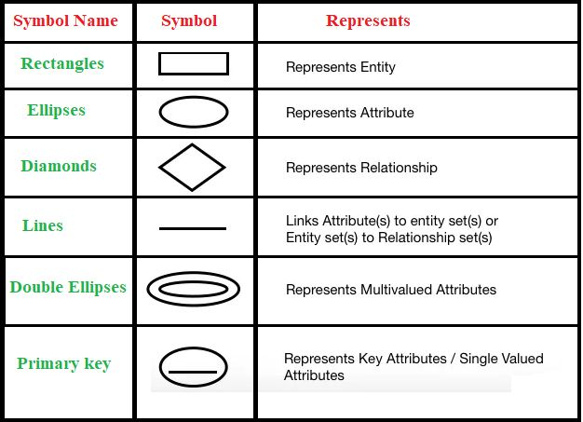

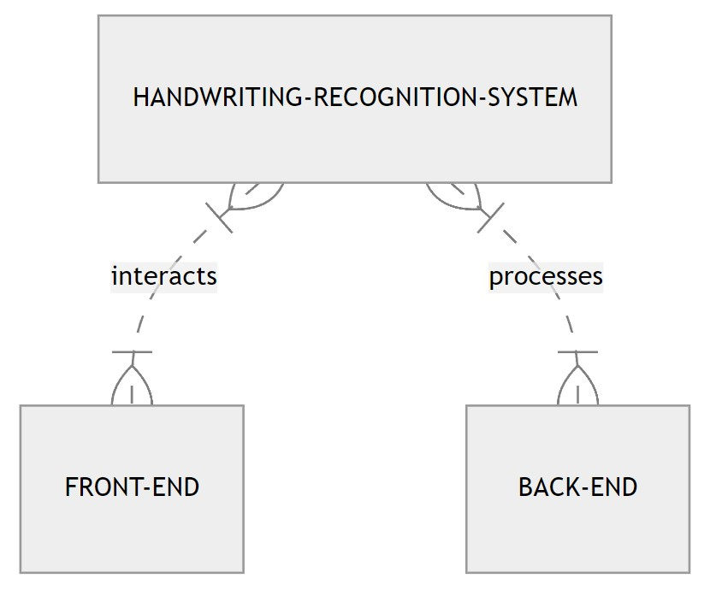

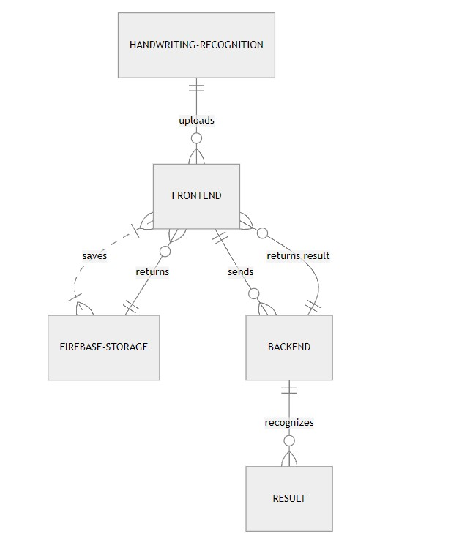

1. **Use Case Diagram**

A Use Case Diagram is a visual representation that illustrates how users interact with a system and the various functionalities or use cases that the system provides. It consists of actors, use cases, and the relationships between them.

**1. Actors:** Actors represent the users or external systems that interact with the system being modeled. An actor can be a person, another system, or even an external device. Actors are depicted as stick figures or icons outside the system boundary. Each actor represents a role played by a user or entity that interacts with the system. For example, in a banking system, actors could include customers, bank tellers, and administrators.

**2. Use Cases:** Use cases represent the functionalities or tasks that the system provides to its users. They describe the interactions between actors and the system to achieve specific goals or objectives. Use cases are depicted as ovals inside the system boundary and are labeled with descriptive names that indicate the actions or tasks they represent. For example, in a banking system, use cases could include "Withdraw Funds," "Deposit Funds," "Transfer Money," and "Check Account Balance."

**3. Relationships:** Relationships between actors and use cases are depicted as lines connecting them, indicating that an actor interacts with one or more use cases. Relationships may include associations, dependencies, or generalizations, depending on the nature of the interaction between actors and use cases. For example, a customer actor may be associated with the "Withdraw Funds" and "Check Account Balance" use cases, indicating that customers can perform these actions.

Use Case Diagrams provide a high-level overview of the system's functionality and the interactions between users and the system. They are useful for communicating system requirements, identifying user needs, and validating the scope of the system. Additionally, Use Case Diagrams serve as a foundation for further system analysis and design activities, such as defining detailed requirements, designing user interfaces, and implementing system functionality.

**Symbol Used in Use Case Diagram**

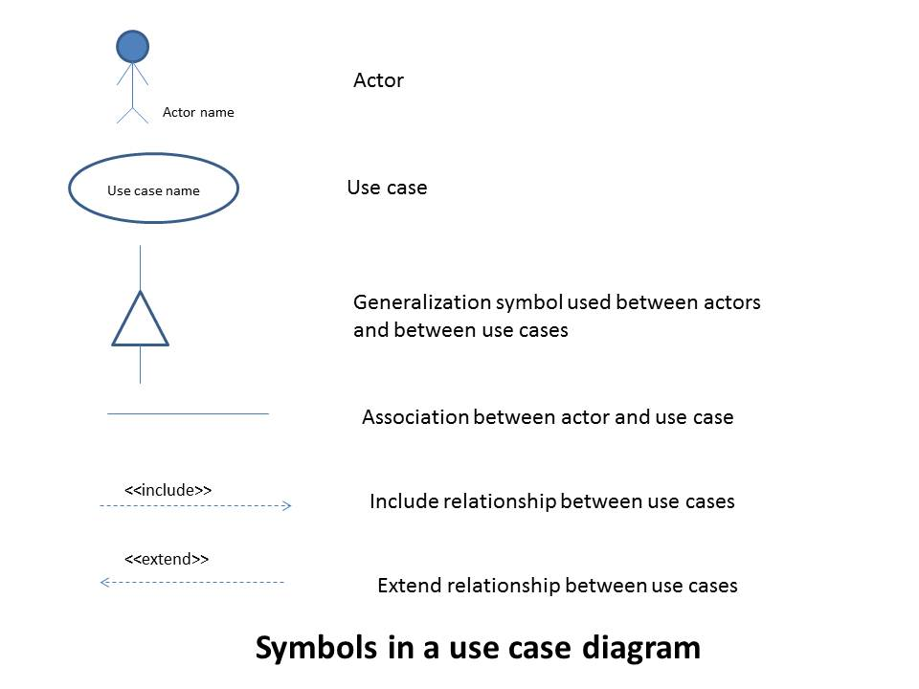

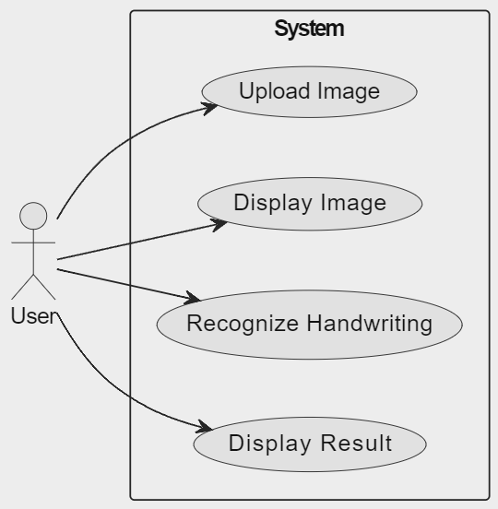

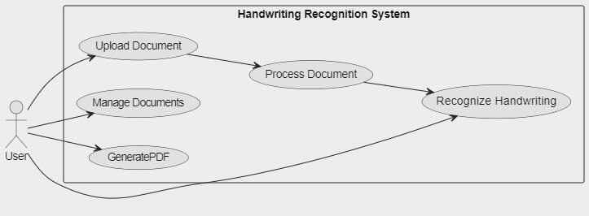

1. **Sequence Diagram**

A Sequence Diagram is a type of interaction diagram that depicts the interactions between objects or components in a system over time. It illustrates the sequence of messages exchanged between objects to accomplish a specific task or scenario. Sequence diagrams are particularly useful for visualizing the dynamic behavior of a system and understanding how different components collaborate to achieve desired outcomes.

**Key components of a Sequence Diagram include:**

**1. Lifelines:** Lifelines represent the objects or components involved in the interaction. Each lifeline is depicted as a vertical dashed line, typically labeled with the name of the object it represents. Lifelines extend vertically to indicate the duration of the object's existence during the sequence of interactions.

**2. Messages:** Messages represent the communication or interaction between objects in the system. They are depicted as horizontal arrows or lines between lifelines, indicating the flow of information or control between objects. Messages may be synchronous (denoted by solid arrows), asynchronous (denoted by dashed arrows), or self-referential (looping back to the same lifeline).

**3. Activation Boxes:** Activation boxes represent the periods of time during which an object is actively processing a message. They are depicted as boxes along the lifeline, spanning the duration of the object's activity in response to a message. Activation boxes provide insight into the sequence and duration of operations performed by objects in the system.

**4. Return Messages:** Return messages depict the response or result of a previous message. They are depicted as arrows or lines returning from the recipient object back to the sender object, indicating the flow of control or data between objects.

Sequence diagrams help developers and system analysts visualize the flow of interactions between objects in a system, identify potential bottlenecks or dependencies, and validate the correctness of system behavior. They are valuable tools for understanding the dynamic aspects of system behavior and for communicating system requirements and design decisions to stakeholders. Additionally, sequence diagrams serve as blueprints for implementing and testing system functionality, providing a visual roadmap for developers to follow during the software development process.

**Symbol Used in Sequence Diagram**

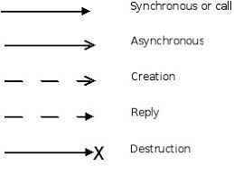

**Sequence Diagram**

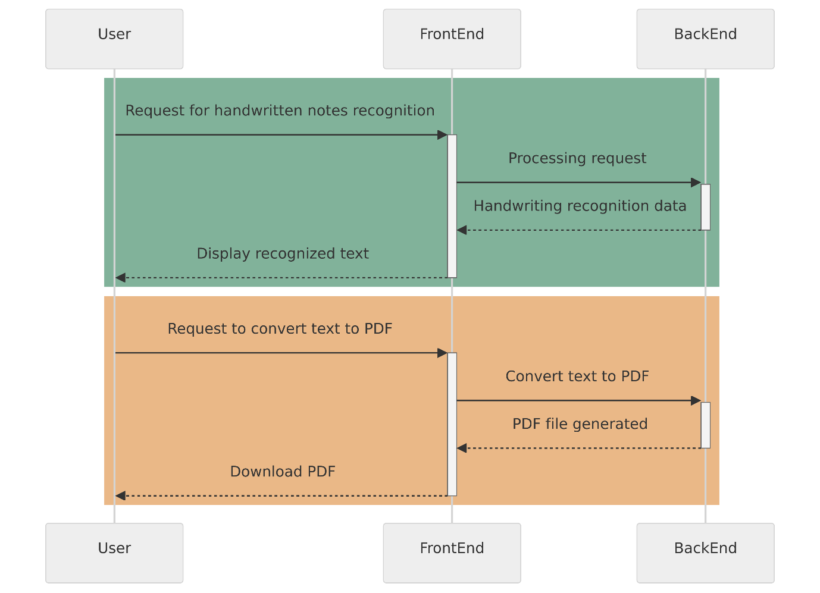

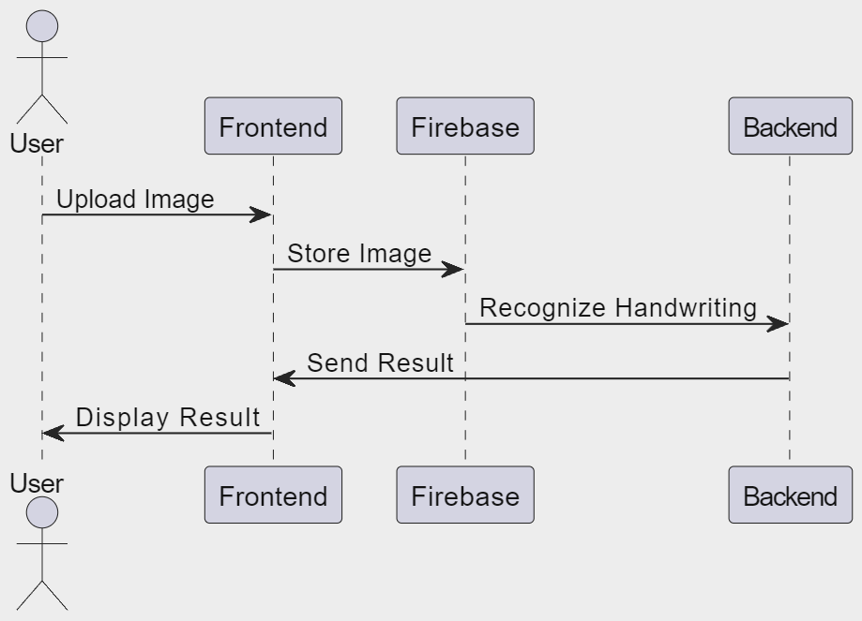

1. **Class Diagram**

A Class Diagram is a type of static structure diagram in the Unified Modeling Language (UML) that illustrates the structure and relationships of classes within a system. It provides a visual representation of the classes, their attributes, methods, and associations, as well as the inheritance and composition relationships between classes.

Key components of a Class Diagram include:

**1. Classes:** Classes represent the blueprint or template for creating objects in a system. They encapsulate data (attributes) and behavior (methods) related to a specific concept or entity within the system. Classes are depicted as rectangles with three compartments: the top compartment contains the class name, the middle compartment contains the class attributes, and the bottom compartment contains the class methods.

**2. Attributes:** Attributes represent the properties or characteristics of a class. They describe the state of an object and are typically depicted as name-value pairs within the middle compartment of a class rectangle. Attributes may have data types, visibility modifiers (e.g., public, private, protected), and multiplicity indicators to specify the number of instances associated with each attribute.

**3. Methods:** Methods represent the behaviors or operations that objects of a class can perform. They define the functionality or actions that objects can exhibit and are typically depicted as name (parameter list): return type within the bottom compartment of a class rectangle. Methods may also have visibility modifiers and other qualifiers to specify access control and behavior.

**4. Associations:** Associations represent relationships between classes and describe how objects of one class are connected to objects of another class. Associations are depicted as lines connecting class rectangles, with optional labels indicating the role or nature of the association. Associations may have multiplicity indicators to specify the number of instances associated with each end of the relationship.

**5. Inheritance:** Inheritance represents the "is-a" relationship between classes, where one class (subclass or derived class) inherits attributes and methods from another class (superclass or base class). Inheritance relationships are depicted as solid-line arrows pointing from the subclass to the superclass, indicating that the subclass inherits from the superclass.

**6. Composition and Aggregation:** Composition and aggregation represent the "has-a" relationship between classes, where one class contains or owns another class as part of its structure. Composition implies a strong ownership relationship, where the contained class cannot exist independently of the container class, while aggregation implies a weaker relationship, where the contained class can exist independently. Composition and aggregation relationships are depicted as diamond-shaped arrows pointing from the container class to the contained class.

**Class diagrams** serve as blueprints for designing object-oriented systems, providing a visual representation of the system's structure and relationships. They help developers and system architects understand the organization of classes within a system, identify dependencies and associations between classes, and guide the implementation and maintenance of software systems. Additionally, class diagrams facilitate communication among stakeholders by providing a common visual language for discussing system design and requirements.

**Symbol Used in Class Diagram**

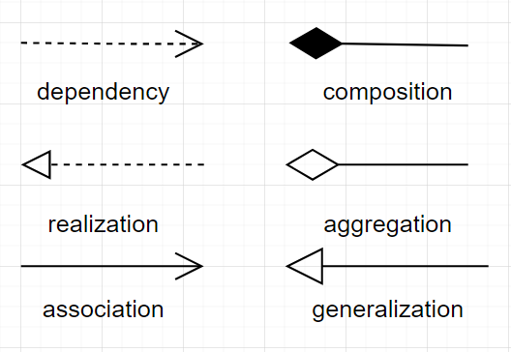

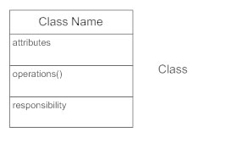

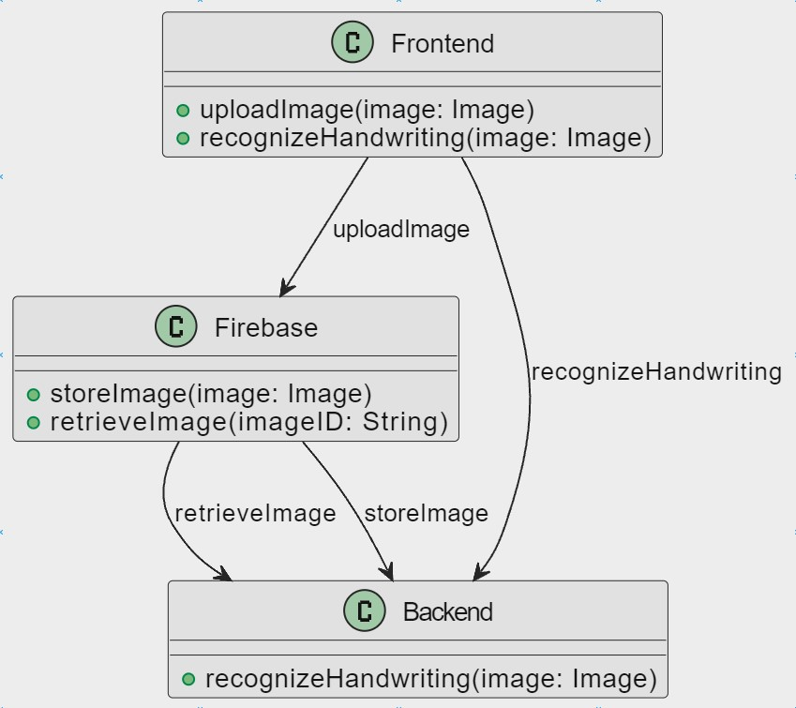

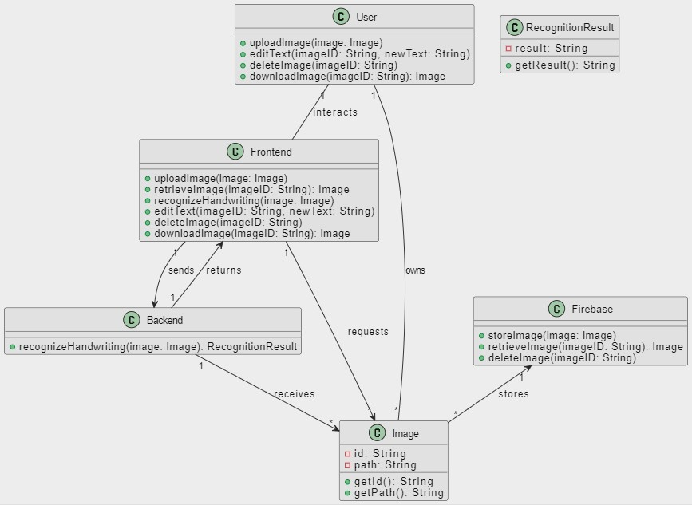

1. **Activity Diagram**

An Activity Diagram is a type of behavior diagram in the Unified Modeling Language (UML) that illustrates the flow of activities or actions within a system or process. It provides a visual representation of the sequence of activities, decision points, and control flows involved in completing a specific task or scenario.

**Key components of an Activity Diagram include:**

**1. Activities:** Activities represent the tasks or actions performed as part of a process or workflow. Each activity is depicted as a rounded rectangle with a label describing the action to be performed. Activities may include actions such as "start," "end," "perform task," "make decision," or "send message."

**2. Control Flow:** Control flow arrows indicate the sequence of activities and the order in which they are performed. Control flow arrows connect activities, showing the direction of execution from one activity to another. They depict the logical flow of control within the system, indicating the progression of activities from start to finish.

**3. Decision Nodes:** Decision nodes represent decision points or branching points within the process flow where alternative paths or conditions may be encountered. Decision nodes are depicted as diamonds, with control flow arrows branching out from them to represent different possible outcomes based on the evaluation of conditions or criteria.

**4. Merge Nodes:** Merge nodes indicate points in the process flow where multiple control flow paths converge back into a single path. Merge nodes are depicted as diamonds with multiple incoming control flow arrows and a single outgoing control flow arrow, indicating the consolidation of alternative paths.

**5. Fork and Join Nodes:** Fork nodes represent points in the process flow where multiple concurrent activities or threads are initiated simultaneously. Fork nodes are depicted as solid bars, with multiple outgoing control flow arrows branching out to represent the parallel execution of activities. Join nodes indicate points where multiple concurrent paths converge back into a single path. Join nodes are depicted as solid bars with multiple incoming control flow arrows and a single outgoing control flow arrow, indicating the synchronization of parallel paths.

**6. Swimlanes:** Swimlanes are optional visual partitions that divide activities into separate lanes or groups based on the responsibilities or roles of different actors or systems involved in the process. Swimlanes help organize and clarify the allocation of activities to different entities or subsystems within the system.

Activity diagrams help stakeholders understand the sequence of actions and decision points involved in completing a process or workflow. They are useful for modeling business processes, software workflows, and system behaviors, providing insights into system functionality, control flow, and decision logic. Activity diagrams facilitate communication among stakeholders, identify opportunities for optimization or improvement, and serve as a basis for implementing and testing system functionality.

**Symbol Used in Activity Diagram**

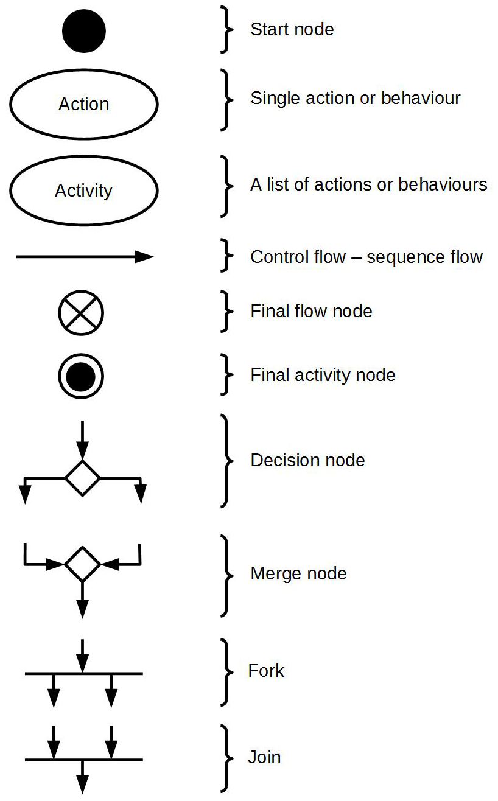

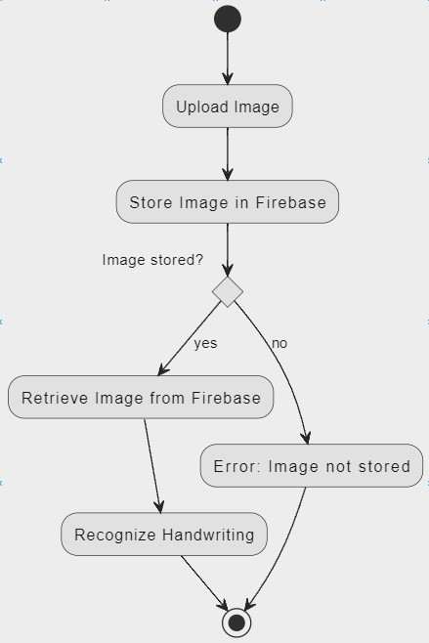

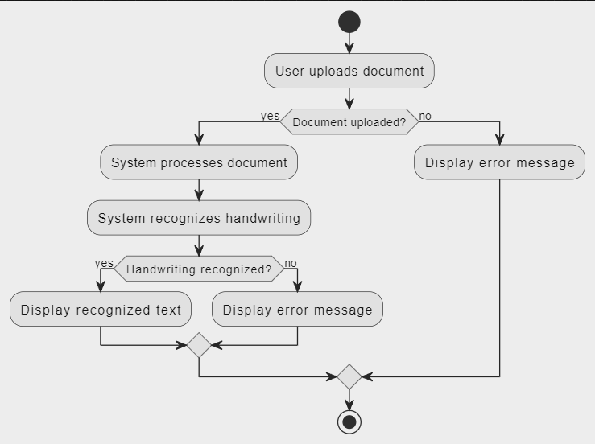

1. **Data Flow Diagram**

A Data Flow Diagram (DFD) is a graphical representation that illustrates the flow of data within a system. It provides a visual overview of how data moves through various processes, stores, and external entities within a system. DFDs are commonly used in system analysis and design to model the functional aspects of a system and to communicate system requirements to stakeholders.

**Key components of a Data Flow Diagram include:**

1. Processes: Processes represent the functions or activities that transform input data into output data within the system. Each process is depicted as a rectangle with a descriptive label indicating the function performed by the process. Processes may include data manipulation, calculations, or other operations that result in changes to the data flowing through the system.

**2. Data Flows:** Data flows represent the movement of data between processes, stores, and external entities within the system. They are depicted as arrows indicating the direction of data flow, with labels describing the type of data being transmitted. Data flows represent the inputs, outputs, and intermediate data within the system and illustrate how data is transformed and processed as it moves through the system.

**3. Data Stores:** Data stores represent the repositories or storage locations where data is persisted within the system. They are depicted as rectangles with two parallel lines at the top and bottom, indicating that data is stored within the store. Data stores may represent databases, files, or other storage mechanisms where data is maintained for later retrieval or processing.

**4. External Entities:** External entities represent the sources or destinations of data external to the system being modeled. They represent entities such as users, systems, or devices that interact with the system but are not part of the system itself. External entities are depicted as rectangles with descriptive labels indicating their role or function in the system.

**5. Data Flow Labels:** Data flow labels provide additional information about the data being transmitted between processes, stores, and external entities. They describe the contents, format, or significance of the data being transferred and help clarify the purpose of each data flow within the system.

Data Flow Diagrams help stakeholders understand the flow of data within a system, identify data dependencies and interactions, and analyze the functional requirements of the system. They serve as a visual representation of the system's data processing logic, illustrating how data moves through the system and how it is transformed and stored at various stages. DFDs are valuable tools for system analysts, designers, and developers to model system behavior, communicate system requirements, and guide system development and implementation efforts.

**Symbol Used in Data Flow Diagram**

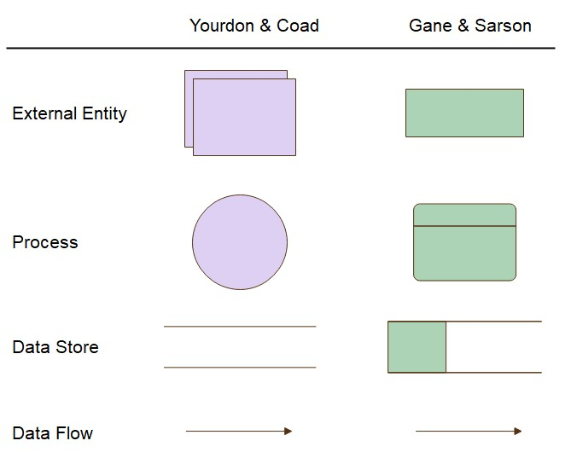

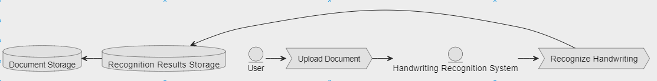



1. **Data Dictionary**

A Data Dictionary is a centralized repository that provides detailed descriptions of data elements used within a system. It includes information such as the names, definitions, data types, and usage guidelines for each data element. Additionally, it may contain metadata about data sources, data formats, and relationships between data elements. The Data Dictionary serves as a reference guide for stakeholders, helping to ensure consistency, accuracy, and understanding of data across the system. It facilitates effective data management, documentation, and communication among project teams, enabling better decision-making and system development.

**A few points on Data Dictionary**

**1. Entity Name:** List the name of each entity in the system, such as User, Document, or Recognition Result.

**2. Entity Description:** Provide a brief description or definition of each entity, explaining its purpose and significance in the system.

**3. Attributes:** Identify and list all attributes associated with each entity, including both primary and secondary attributes.

**4. Attribute Description:** Describe each attribute's meaning, data type, length, format, and any constraints or validations applied to it.

**5. Primary Key:** Specify the primary key attribute(s) for each entity, which uniquely identifies individual records within the entity.

**6. Foreign Keys:** Identify any foreign key attributes that establish relationships between entities, referencing primary keys from other related entities.

**7. Relationships:** Define the relationships between entities, indicating the cardinality and optionality of each relationship (e.g., one-to-one, one-to-many, many-to-many).

**8. Relationship Description:** Provide a brief description of each relationship, explaining its purpose and significance in connecting entities.

**9. Data Types:** Define the data types used for each attribute, such as integer, string, date, boolean, or custom data types specific to your system's requirements.

**10. Length and Format:** Specify the length and format constraints for attributes that store textual or alphanumeric data, such as maximum character length or allowed character set.

**11. Constraints:** List any constraints or validations applied to attributes, such as unique constraints, null-ability constraints, or range validations.

**12. Default Values:** Specify default values for attributes that have predefined or default values assigned when records are created.

**13. Indexes:** Identify attributes or combinations of attributes that are indexed to improve query performance or enforce data integrity.

**14. Normalization:** Ensure that the data dictionary reflects the principles of database normalization, with entities and attributes organized to minimize redundancy and dependency.

**15. Data Integrity Rules:** Define any data integrity rules or business rules that govern the validity and consistency of data stored in the system.

**16. Data Lifecycle:** Describe the lifecycle of data within the system, including data creation, modification, retrieval, deletion, and archival processes.

**17. Security Requirements:** Specify any security requirements or access controls applied to entities or attributes to protect sensitive or confidential data.

**18. Auditing and Logging:** Outline mechanisms for auditing and logging data changes or access events, including time-stamping, user identification, and action tracking.

**19. Versioning and History:** Consider requirements for versioning and maintaining historical data, allowing users to track changes and revert to previous states of data.

**20. Documentation and Maintenance:** Document the data dictionary comprehensively and keep it up-to-date with any changes or modifications to the system's data model. Ensure that stakeholders have access to the data dictionary and understand its contents to support system maintenance and development efforts.

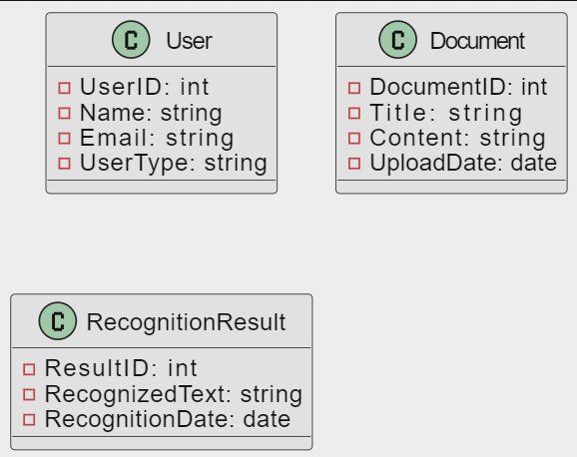

1. **Gantt Chart**

A Gantt chart is a type of bar chart that illustrates a project schedule, showing the start and finish dates of various project tasks or activities. It provides a visual representation of project timelines, dependencies, and progress over time. Gantt Charts typically consist of horizontal bars representing individual tasks or activities, with the length of each bar indicating the duration of the task and its position on the chart indicating its start and end dates.

**Key components of a Gantt chart include:**

**1. Tasks or Activities:** Each task or activity in the project is represented by a horizontal bar on the Gantt chart. The name of the task is typically displayed on the left side of the chart, and the duration of the task is represented by the length of the bar. Tasks may be grouped into phases or categories for better organization.

**2. Start and Finish Dates:** The start and finish dates of each task are indicated by the position of the corresponding bar on the Gantt chart. The left end of the bar represents the start date, while the right end represents the finish date. This allows project managers and team members to quickly see when each task is scheduled to begin and end.

**3. Dependencies:** Dependencies between tasks are represented by connecting lines or arrows on the Gantt chart. These lines indicate the order in which tasks must be completed and any dependencies or relationships between them. For example, a task may be dependent on the completion of another task before it can start.

**4. Milestones:** Milestones are significant points or events in the project timeline, such as project kick-off, major deliverables, or project completion. They are represented by diamond-shaped markers on the Gantt chart and provide key reference points for tracking project progress.

**Gantt Charts** are widely used in project management to plan, schedule, and track project activities. They help project managers and team members visualize project timelines, identify critical path tasks, and monitor progress against planned deadlines. Gantt Charts also facilitate communication and collaboration among project stakeholders by providing a clear, visual representation of project schedules and dependencies. Additionally, Gantt Charts can be used to allocate resources, adjust project schedules, and identify potential bottlenecks or delays in the project timeline.

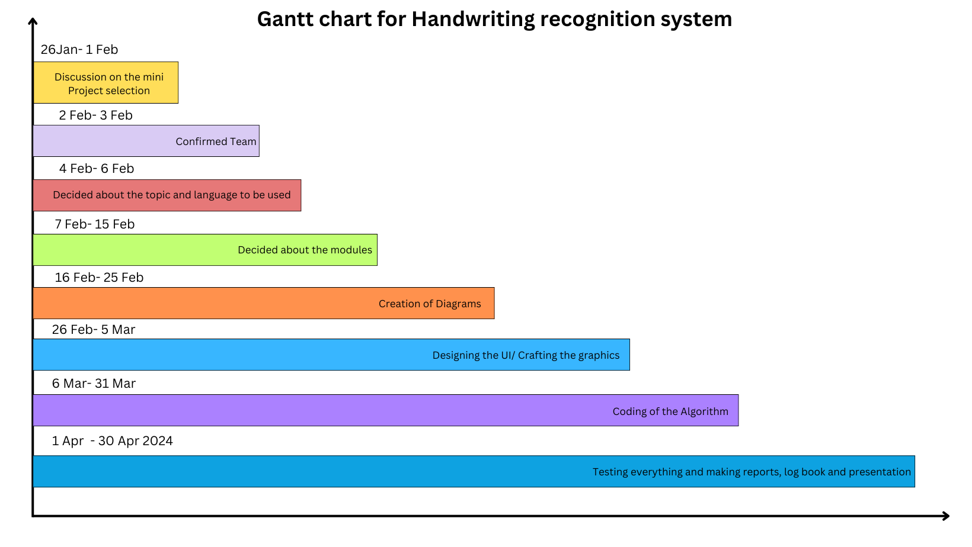

1. **System Study**

**System Study for Handwriting Recognition System:**

The system study for the Handwriting Recognition System involves a comprehensive analysis of the current processes, requirements, and constraints to identify the needs and objectives of the system. The system study phase includes the following key activities:

**1. Requirement Analysis:** Conduct interviews and surveys with stakeholders to gather requirements for the handwriting recognition system. Identify the specific functionalities, features, and performance criteria expected from the system. Determine the types of handwritten content to be recognized, such as letters, numbers, symbols, or handwritten text.

**2. User Analysis:** Identify the users and their roles within the system, including administrators, end-users, and system operators. Analyze the user tasks, preferences, and expectations to ensure that the system meets their needs and provides a user-friendly experience. Consider factors such as user skill levels, accessibility requirements, and preferred input methods.

**3. Process Analysis:** Analyze the current processes involved in handling handwritten content, including data entry, transcription, and document management. Identify inefficiencies, bottlenecks, and pain points in the existing processes that can be addressed or improved by the handwriting recognition system. Consider the workflow of users interacting with handwritten documents and how the system can streamline or automate these processes.

**4. Technology Assessment:** Evaluate existing technologies and tools for handwriting recognition, including machine learning algorithms, image processing techniques, and optical character recognition (OCR) software. Assess the suitability of these technologies for the specific requirements and constraints of the project, considering factors such as accuracy, speed, scalability, and compatibility with existing systems.

**5. Feasibility Study:** Conduct a feasibility study to assess the technical, operational, economic, and legal feasibility of implementing the handwriting recognition system. Evaluate the project's viability based on available resources, technology constraints, budget considerations, and regulatory requirements. Identify potential risks and challenges that may impact the success of the project and develop mitigation strategies.

**6. Requirements Specification:** Document the requirements gathered from stakeholders in a comprehensive requirements specification document. Define the functional and non-functional requirements of the handwriting recognition system, including input/output formats, performance criteria, security requirements, and user interface design guidelines. Ensure that the requirements are clear, concise, and unambiguous to guide the subsequent phases of system development.

**User Requirements Analysis**: The system study begins with a comprehensive analysis of user requirements to understand the needs, preferences, and expectations of potential users. This involves conducting surveys, interviews, and focus group discussions with stakeholders from various user groups, including researchers, educators, students, administrators, and professionals. The goal is to gather insights into the specific features, functionalities, and usability aspects desired by users for the handwriting recognition system.

**Market Analysis:** A thorough examination of the market landscape is conducted to assess the demand, competition, and trends in the field of handwriting recognition technology. This involves analyzing existing handwriting recognition solutions, their features, pricing models, and customer feedback. Market research helps identify gaps, opportunities, and potential niches for the proposed handwriting recognition system, guiding strategic decision-making and positioning in the market.

**Technology Assessment:** The system study includes an evaluation of relevant technologies, tools, and frameworks available for developing the handwriting recognition system. This involves assessing the capabilities, performance, scalability, and compatibility of various programming languages, libraries, and platforms suitable for implementing machine learning algorithms, image processing techniques, and user interfaces. Technology assessment ensures the selection of appropriate technologies aligned with project requirements and objectives.

**Feasibility Analysis:** A feasibility study is conducted to assess the technical, economic, and operational feasibility of developing and deploying the handwriting recognition system. Technical feasibility involves evaluating the technical capabilities, resources, and infrastructure required to implement the proposed solution. Economic feasibility assesses the cost-effectiveness and return on investment (ROI) of the project, considering factors such as development costs, potential revenue streams, and cost savings. Operational feasibility examines the practicality and viability of integrating the system into existing workflows, processes, and organizational structures.

**Risk Assessment:** A risk assessment is conducted to identify potential risks, challenges, and uncertainties that may impact the success of the handwriting recognition project. This involves analyzing various risk factors such as technical complexity, resource constraints, market dynamics, regulatory compliance, and security vulnerabilities. Risk mitigation strategies are developed to mitigate identified risks and uncertainties, ensuring proactive management and mitigation throughout the project lifecycle.

**Legal and Ethical Considerations:** The system study includes an assessment of legal and ethical considerations relevant to the development and deployment of the handwriting recognition system. This involves ensuring compliance with data protection regulations, intellectual property rights, privacy laws, and ethical guidelines governing the collection, processing, and storage of handwritten content and user data. Legal and ethical considerations are integrated into the design and implementation of the system to uphold transparency, accountability, and trustworthiness.

**Scalability and Performance Analysis:** An analysis of scalability and performance requirements is conducted to determine the system's ability to handle increasing volumes of handwritten documents and user interactions over time. This involves estimating the anticipated workload, peak usage scenarios, and performance benchmarks for the system. Scalability and performance considerations guide architectural decisions, resource allocation, and optimization strategies to ensure that the system can scale seamlessly and deliver optimal performance under varying workloads and conditions.

**User Interface Design:** The system study encompasses the design and evaluation of the user interface (UI) for the handwriting recognition system. This involves creating wireframes, prototypes, and mockups to visualize the user interface design and gather feedback from stakeholders. Usability testing and heuristic evaluation techniques are employed to assess the intuitiveness, accessibility, and effectiveness of the UI in meeting user needs and preferences. User interface design principles and best practices are applied to create a user-friendly and engaging interface that enhances user experience and satisfaction.

**Data Management and Security:** An analysis of data management and security requirements is conducted to ensure the integrity, confidentiality, and availability of data within the handwriting recognition system. This involves defining data schemas, storage mechanisms, access controls, and encryption protocols to protect sensitive handwritten content and user information from unauthorized access, manipulation, or loss. Data backup and recovery strategies are implemented to safeguard against data corruption, system failures, and security breaches, ensuring data resilience and continuity of operations.

**Stakeholder Engagement:** Throughout the system study, active engagement with stakeholders is maintained to gather feedback, address concerns, and foster collaboration in the development and implementation of the handwriting recognition system. Stakeholders including users, project sponsors, domain experts, developers, and quality assurance teams are involved in decision-making processes, requirements prioritization, and validation activities. Stakeholder engagement fosters transparency, accountability, and ownership among all parties involved, contributing to the success and sustainability of the handwriting recognition project.

1. **Screenshots**

**Home Page**

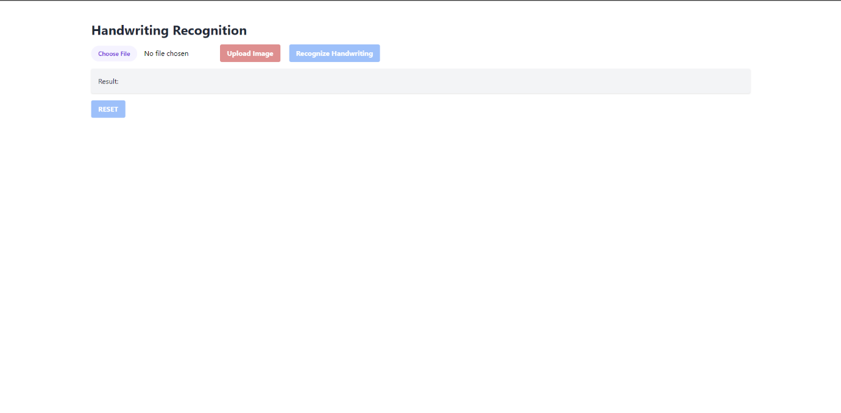

**Uploading Document**

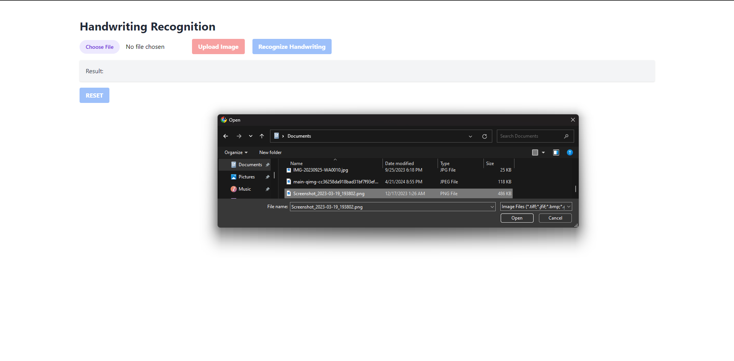

**Document Acceptance**

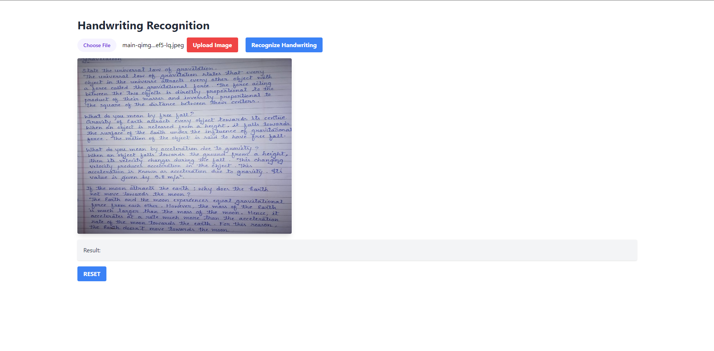

**Process Completion**

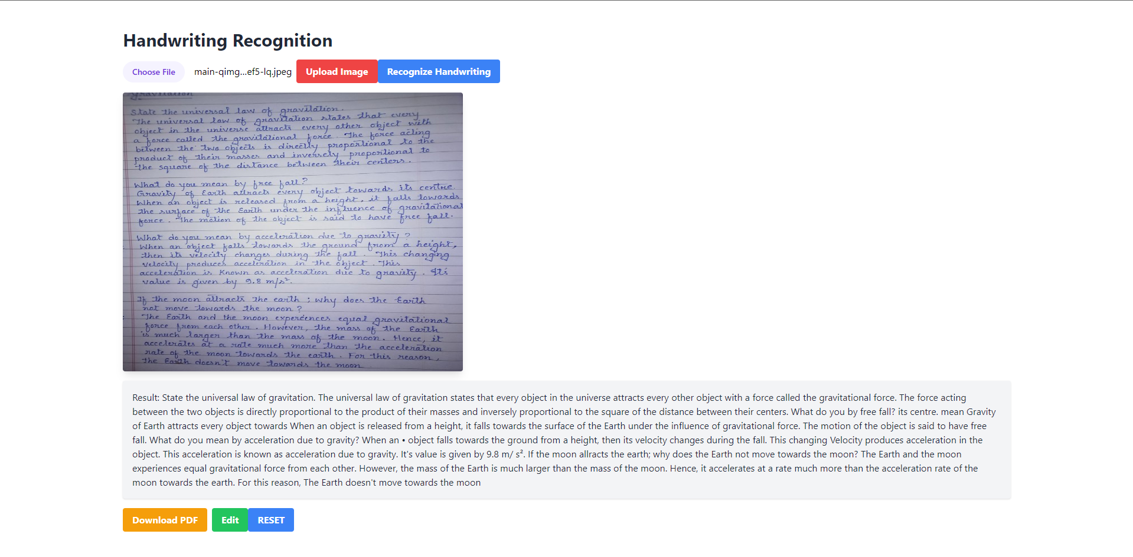

**Edit Text**



**Converted the Document into PDF Format**



**Reset**



1. **Testing**

**11.1**

**Black Box Testing**

Black Box Testing is a software testing technique that focuses on examining the functionality of a system without knowledge of its internal structure or implementation details. In other words, testers approach the system as a "black box," where they are only concerned with the inputs, outputs, and behavior of the system, rather than its internal workings. This testing technique is also known as specification-based testing or behavioral testing.

**Key characteristics of Black Box Testing include:**

**1. Focus on Functional Requirements:** Black Box Testing primarily verifies whether the system meets its functional requirements as specified in the software requirements specification (SRS) or other documentation. Testers design test cases based on expected inputs, outputs, and system behavior defined in the requirements.

**2. Independence from Internal Code:** Testers do not have access to the source code or internal structure of the system being tested. They interact with the system through its external interfaces, such as user interfaces, APIs, or command-line interfaces, and observe the system's responses to different inputs.

**3. Test Case Design:** Test cases for Black Box Testing are derived from various sources, including functional requirements, use cases, user stories, and other system documentation. Testers design test cases to cover different scenarios, boundary conditions, and error conditions to ensure thorough test coverage.

**4. Test Techniques:** Black Box Testing employs various test techniques to design test cases and validate system functionality. Common techniques include equivalence partitioning, boundary value analysis, decision table testing, state transition testing, and error guessing.

**5. Test Oracles:** Testers use expected outcomes or criteria known as test oracles to evaluate the correctness of the system's behavior. Test oracles may be derived from requirements documents, specifications, or domain knowledge. Test results are compared against expected outcomes to determine whether the system behaves as expected.

**6. Advantages:** Black Box Testing offers several advantages, including independence from implementation details, early detection of functional defects, and suitability for integration and system-level testing. It allows testers to focus on user perspectives and ensures that the system meets user requirements and expectations.

**7. Limitations:** Despite its advantages, Black Box Testing has limitations, including limited coverage of internal code paths, reliance on documented requirements (which may be incomplete or ambiguous), and difficulty in reproducing and diagnosing defects without access to internal code.

Overall, Black Box Testing is a valuable testing technique for validating the functionality, usability, and correctness of software systems from an external perspective. When combined with other testing techniques such as White Box Testing and Gray Box Testing, it provides comprehensive test coverage and helps ensure the quality and reliability of software products.

**11.2**

**White Box Testing**

White Box Testing, also known as Clear Box Testing or Structural Testing, is a software testing technique that focuses on examining the internal structure, code, and logic of a software application. Unlike Black Box Testing, where testers are only concerned with the external behavior of the system, White Box Testing involves analyzing the internal workings of the system to validate its correctness, efficiency, and robustness.

**Key characteristics of White Box Testing include:**

**1. Access to Internal Code**: Testers have access to the source code, architecture, and design of the software application being tested. They can review the code, understand its structure, and analyze the implementation details to design test cases.

**2. Test Case Design:** Test cases for White Box Testing are based on the internal structure of the software application, including code paths, decision points, loops, and error handling mechanisms. Testers design test cases to exercise specific code segments, conditions, and branches to ensure thorough test coverage.

**3. Code Coverage Metrics:** White Box Testing aims to achieve high code coverage by exercising all code paths and statements within the software application. Testers use code coverage metrics such as statement coverage, branch coverage, path coverage, and condition coverage to measure the effectiveness of test cases and identify areas of the code that have not been adequately tested.

**4. Test Techniques:** White Box Testing employs various test techniques to analyze the internal structure and behavior of the software application. Common techniques include control flow testing, data flow testing, branch testing, path testing, and mutation testing. These techniques help identify defects related to control flow, data flow, boundary conditions, and error handling in the code.

**5. Integration with Development:** White Box Testing is often integrated into the software development process, allowing developers to perform unit testing and code reviews as part of the development lifecycle. Testers collaborate closely with developers to identify, fix, and prevent defects early in the development process, reducing the cost and effort of fixing defects later.

**6. Advantages:** White Box Testing offers several advantages, including early detection of defects, thorough test coverage of code paths, improved code quality and maintainability, and optimization of code performance and efficiency. It helps identify issues related to code logic, design flaws, and implementation errors before the software is deployed to production.

**7. Limitations:** Despite its advantages, White Box Testing has limitations, including the need for detailed knowledge of programming languages, algorithms, and software architecture. It may be time-consuming and resource-intensive to achieve high code coverage, and it may not uncover defects related to external interfaces, integration points, or user interactions.

Overall, White Box Testing is a valuable testing technique for ensuring the reliability, stability, and quality of software applications by examining the internal structure and behavior of the code. When combined with other testing techniques such as Black Box Testing and Gray Box Testing, it provides comprehensive test coverage and helps identify and address defects throughout the software development lifecycle.

1. **Cost Benefit Analysis**

**Cost-Benefit Analysis for Handwriting Recognition System:**

A Cost-Benefit Analysis (CBA) for the Handwriting Recognition System involves evaluating the costs associated with developing, implementing, and maintaining the system against the expected benefits and returns it provides. The analysis helps stakeholders make informed decisions about investing in the project by comparing the costs and benefits over a specific period.

**1. Costs:**

a. Development Costs: Includes expenses related to software development, such as salaries for developers, software licenses, development tools, and infrastructure costs.

b. Implementation Costs: Includes costs associated with deploying the system, such as hardware procurement, software installation, training, and data migration.

c. Maintenance Costs: Includes ongoing expenses for system maintenance, support, updates, and bug fixes. This may also include costs for hosting, monitoring, and security.

d. Opportunity Costs: Includes the value of resources and opportunities that could have been utilized elsewhere if not allocated to the handwriting recognition project.

**2. Benefits:**

a. Time Savings: The handwriting recognition system can save time by automating the process of transcribing handwritten text, reducing the need for manual data entry and transcription.

b. Increased Productivity: By streamlining document digitization and data processing, the system can improve productivity for users, allowing them to focus on more value-added tasks.

c. Error Reduction: The system can minimize errors associated with manual data entry and transcription, leading to improved data accuracy and reliability.

d. Accessibility: Digitizing handwritten documents makes them more accessible and searchable, enabling users to retrieve and process information more efficiently.

e. Cost Savings: Over time, the cost savings from reduced manual labor, improved efficiency, and error reduction can outweigh the initial investment in developing and implementing the system.

**3. Cost-Benefit Analysis Metrics:**

**a. Return on Investment (ROI):** Calculates the ratio of net benefits (benefits minus costs) to the total costs, expressed as a percentage. A positive ROI indicates that the benefits outweigh the costs.

**b. Payback Period:** Determines the time it takes for the project to recoup its initial investment. A shorter payback period indicates a faster return on investment.

**c. Net Present Value (NPV):** Calculates the present value of future benefits minus the present value of future costs, discounted at a specified rate. A positive NPV indicates that the project is financially viable.

**d. Break-Even Analysis:** Identifies the point at which the cumulative benefits equal the cumulative costs, indicating the point at which the project becomes profitable.

By conducting a comprehensive Cost-Benefit Analysis, stakeholders can evaluate the financial viability and potential returns of the handwriting recognition system project and make informed decisions about its implementation and investment.

1. **Future Enhancement**

**Future Enhancements for the Handwriting Recognition System:**

**1. Handwriting Styles and Languages:** Expand the system's capabilities to recognize a broader range of handwriting styles, including cursive, print, and different languages. Implement machine learning algorithms and models trained on diverse handwriting datasets to improve recognition accuracy for various writing styles and languages.

**2. Advanced OCR Techniques:** Incorporate advanced Optical Character Recognition (OCR) techniques, such as deep learning-based approaches like convolutional neural networks (CNNs) and recurrent neural networks (RNNs). These techniques can enhance the system's ability to accurately interpret complex handwritten content, including messy or overlapping characters.

**3. Real-Time Recognition:** Implement real-time handwriting recognition capabilities to enable users to capture and digitize handwritten text instantly using devices like tablets, smartphones, or digital pens. Develop mobile applications or browser-based interfaces that leverage the system's backend API to provide seamless and responsive handwriting recognition functionality.

**4. Handwriting Analysis and Insights:** Integrate handwriting analysis features to extract additional insights from handwritten content, such as identifying authorship characteristics, sentiment analysis, or extracting key information like dates, names, and addresses. These insights can be valuable for applications in forensic analysis, historical document analysis, or personalized user experiences.

**5. Integration with Productivity Tools:** Integrate the handwriting recognition system with popular productivity tools and applications such as Microsoft Office, Google Workspace, or note-taking apps. Enable users to easily import handwritten content into documents, presentations, or digital notebooks, enhancing collaboration and productivity.

**6. Cloud-Based Collaboration:** Implement cloud-based collaboration features that allow multiple users to collaborate on handwritten documents in real-time. Enable features such as simultaneous editing, commenting, and version control, making it easier for teams to collaborate on handwritten content regardless of their location.

**7. Handwriting Synthesis:** Explore the possibility of developing handwriting synthesis capabilities that generate realistic handwritten text based on user input or predefined templates. This feature could be useful for generating handwritten notes, letters, or personalized messages in various applications.

**8. Continuous Improvement and Feedback Mechanisms:** Implement mechanisms for collecting user feedback and usage data to continuously improve the system's accuracy, performance, and user experience. Use feedback loops to refine machine learning models, update recognition algorithms, and address common user issues or challenges.

**Improved Accuracy:** Continuously refine and optimize the machine learning algorithms and image processing techniques used for handwriting recognition to achieve higher accuracy rates. Incorporate advanced neural network architectures, such as convolutional recurrent networks (CRNs) or attention mechanisms, to better capture spatial and temporal dependencies in handwritten content and improve recognition performance.

**Multimodal Recognition:** Explore the integration of multimodal recognition techniques, combining handwriting recognition with other modalities such as speech recognition or image recognition. This enables users to input handwritten content through multiple channels and enhances the system's flexibility and usability, especially in diverse and dynamic user environments.

**Adaptive Learning:** Implement adaptive learning mechanisms that enable the system to adapt and learn from user interactions and feedback over time. Incorporate reinforcement learning techniques to dynamically adjust recognition models based on user corrections and preferences, leading to personalized and context-aware recognition results.

**Domain-Specific Recognition:** Develop specialized recognition models tailored to specific domains or industries, such as medical records, legal documents, or scientific manuscripts. Customize recognition algorithms and lexicons to better handle domain-specific terminology, handwriting styles, and content structures, improving recognition accuracy and relevance for domain-specific applications.

**Enhanced Collaboration Features:** Expand collaboration features to support real-time collaboration and co-authoring of handwritten documents among multiple users. Introduce features such as collaborative editing, version control, and synchronous annotation tools to facilitate teamwork and communication in collaborative writing and document review processes.

**Augmented Reality Integration:** Explore integration with augmented reality (AR) technologies to enable interactive and immersive experiences for handwriting input and recognition. Develop AR-based applications that allow users to write directly on virtual surfaces or in augmented environments, with real-time recognition and feedback displayed within the AR interface.

**Blockchain Integration:** Investigate the integration of blockchain technology to enhance security, transparency, and traceability in document authentication and verification processes. Implement blockchain-based solutions for securely storing and validating handwritten signatures, timestamps, and document provenance, ensuring the integrity and authenticity of digitized handwritten content.

**Offline Recognition Capabilities:** Enhance offline recognition capabilities to enable users to perform handwriting recognition tasks without requiring a constant internet connection. Develop lightweight recognition models and offline caching mechanisms that allow users to capture and process handwritten content locally on their devices, providing uninterrupted access to recognition services in offline environments.

**Accessibility Features:** Incorporate accessibility features such as voice commands, screen readers, and gesture-based input methods to make the handwriting recognition system more inclusive and accessible to users with diverse needs and disabilities. Ensure compliance with accessibility standards such as Web Content Accessibility Guidelines (WCAG) to promote usability and inclusivity for all users.

**Integration with Productivity Tools:** Integrate with existing productivity tools and software applications such as document management systems, note-taking apps, and collaboration platforms to streamline workflows and enhance productivity. Develop plugins, APIs, or connectors that enable seamless integration with popular productivity tools, allowing users to easily incorporate handwriting recognition capabilities into their existing workflows and applications.

1. **Bibliography**

A bibliography is a list of sources (such as books, articles, websites, etc.) that you consulted or referenced in your project. It typically appears at the end of a research paper, report, or project, providing readers with information about the sources you used to gather information, support your arguments, or develop your ideas.

**There are several reasons why a bibliography is important in a project:**

**1. Credibility:** Including a bibliography enhances the credibility and reliability of your project by demonstrating that you have conducted thorough research and consulted reputable sources to support your work. It shows that your project is based on a solid foundation of existing knowledge and scholarship in the field.

**2. Transparency:** A bibliography provides transparency and transparency about the sources you used in your project, allowing readers to verify the accuracy and validity of your information. It enables readers to access the same sources to further explore the topic or verify your claims.

**3. Acknowledgment:** A bibliography allows you to acknowledge the contributions of other authors, researchers, and scholars whose work has influenced or inspired your project. It gives credit to the original creators of ideas, theories, data, and findings that you have incorporated into your work.

**4. Avoiding Plagiarism:** By citing your sources in a bibliography, you avoid plagiarism, which is the act of using someone else's work or ideas without proper attribution. Plagiarism is a serious academic offense that can have severe consequences, including academic penalties and damage to your reputation.

**5. Legal and Ethical Compliance:** Including a bibliography ensures that your project complies with legal and ethical standards regarding copyright, intellectual property rights, and academic integrity. It demonstrates your respect for the rights of authors and creators and your commitment to ethical research practices.

**Quality and Relevance:** Select sources that are relevant, authoritative, and of high quality for inclusion in your bibliography. Consider the credibility of the author(s), publication venue, peer-review process (if applicable), and relevance to your project topic.

**Diversity of Sources:** Include a diverse range of sources to provide a comprehensive and balanced perspective on your project topic. Incorporate sources from different types of publications, such as books, journal articles, conference papers, websites, and online resources, to ensure breadth and depth in your research.

**Currency of Sources:** Ensure that the sources included in your bibliography are up-to-date and reflect the latest research, developments, and trends in your field. Prioritize recent publications and sources with current information to maintain relevance and accuracy in your project.

**Consistency in Citation Style:** Follow a consistent citation style throughout your bibliography to ensure uniformity and clarity. Choose a widely recognized citation style, such as APA, MLA, Chicago, or IEEE, and adhere to its guidelines for formatting citations, punctuation, and bibliographic details.

[www.google.com](http://www.google.com)

[www.bluleadz.com](http://www.bluleadz.com)

<https://github.com/>

[www.grafdom.com](http://www.grafdom.com)

[www.webliumsite.com](http://www.webliumsite.com)

<https://firebase.google.com/>

<https://rapidapi.com/>

<https://w3techs.com/sites>

<https://www.digitalsilk.com/digital-trends/best-tech-websites/>