10/20/2020

AMAN SINGH

RA1711003010647

Servlet Experiment

Web Programming Lab (15IT304J)

**AIM:**

Perform simple implementation of servlets.

**PROCEDURE:**

The servlet implementation has been with the use of static java (JDK and JRE) with Apache Tomcat server.

The steps are as follows:

1. Install JDK 1.8 and Tomcat 8.
2. Set the environment variables.
3. CATALINA_HOME: C:\Program Files\Apache Software Foundation\Tomcat 8.5
4. JAVA_HOME: C:\Program Files\Java\jdk1.8.0_261
5. JRE_HOME: C:\Program Files\Java\jre1.8.0_261
6. CLASSPATH: C:\Program Files\Java\jdk1.8.0_261\lib\tools.jar; C:\Program Files\Apache Software Foundation\Tomcat 8.5\lib\servlet-api.jar
7. PATH: C:\Program Files\Java\jdk1.8.0_261\bin; C:\Program Files\Apache Software Foundation\Tomcat 8.5\bin
8. Write Servlet code in java and compile the same to obtain a class file using command
9. Execute javac My.java
10. A class file will be created.
11. Save the class file under C:\Program Files\Apache Software Foundation\Tomcat 8.5\webapps\first\WEB-INF\classes
12. Write a code for HTML to create an index page after opening the URL.
13. Write an XML code to call the class and URL pattern for Web server (/hello).
14. Organize the class file and XML file in the given directory structure (C:\Program Files\Apache Software Foundation\Tomcat 8.5\webapps\first\WEB-INF)
15. Open the web browser and type the URL ‘http://localhost:8080/first’.

**CODE:**

**Servlet Code (My.java)**

import javax.servlet.*;

import javax.servlet.http.*;

import java.io.*;

public class My extends HttpServlet

{

public void service(HttpServletRequest req, HttpServletResponse res) throws ServletException, IOException

{PrintWriter p=res.getWriter();

p.println("hello servlet");

}}

**HTML Code (index.html)**

<a href="My">Click</a>

**XML Code (web.xml)**

<web-app>

<servlet>

<servlet-name>My</servlet-name>

<servlet-class>My</servlet-class>

</servlet>

<servlet-mapping>

<servlet-name>My</servlet-name>

<url-pattern>/My</url-pattern>

</servlet-mapping>

</web-app>

**OUTPUT:**

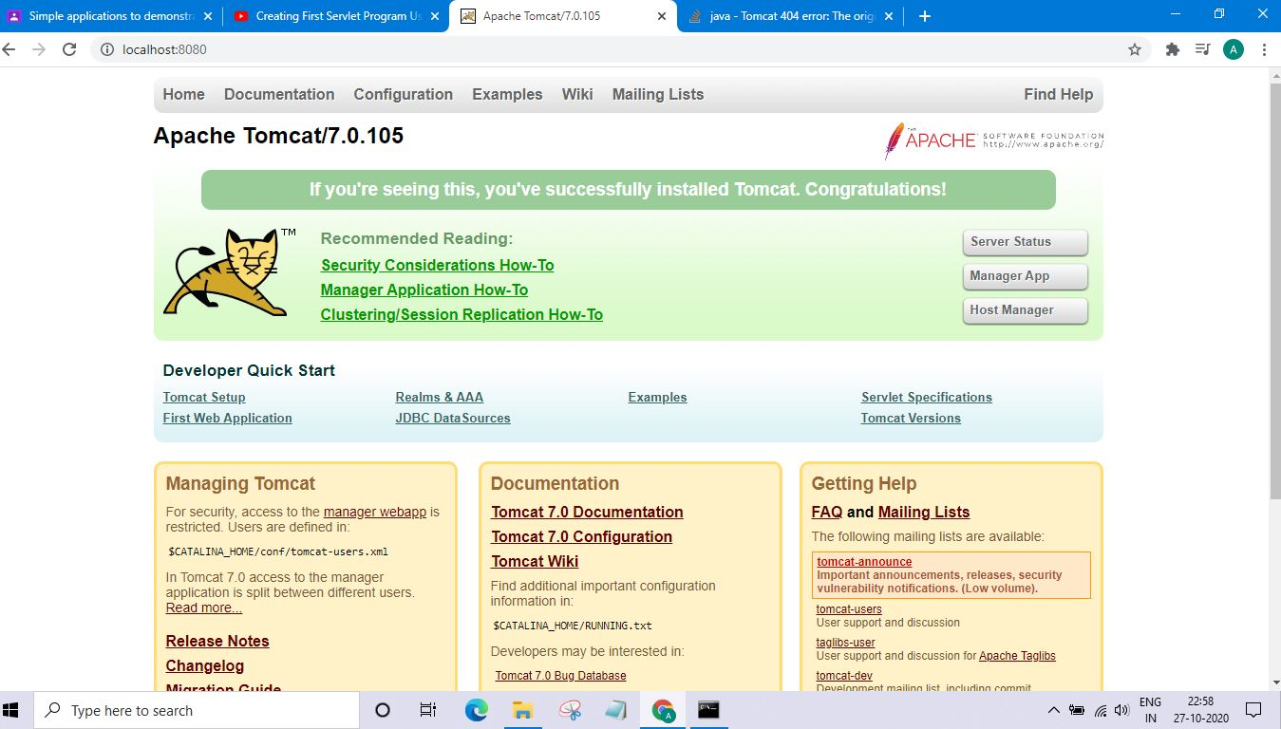

Apache Tomcat/7.0.105 Admin Page

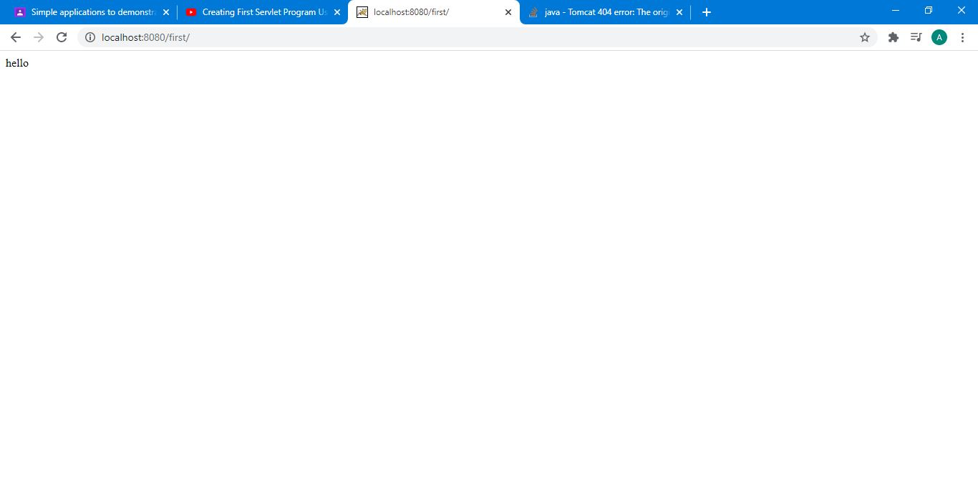

Index Page (Before compiling java program)

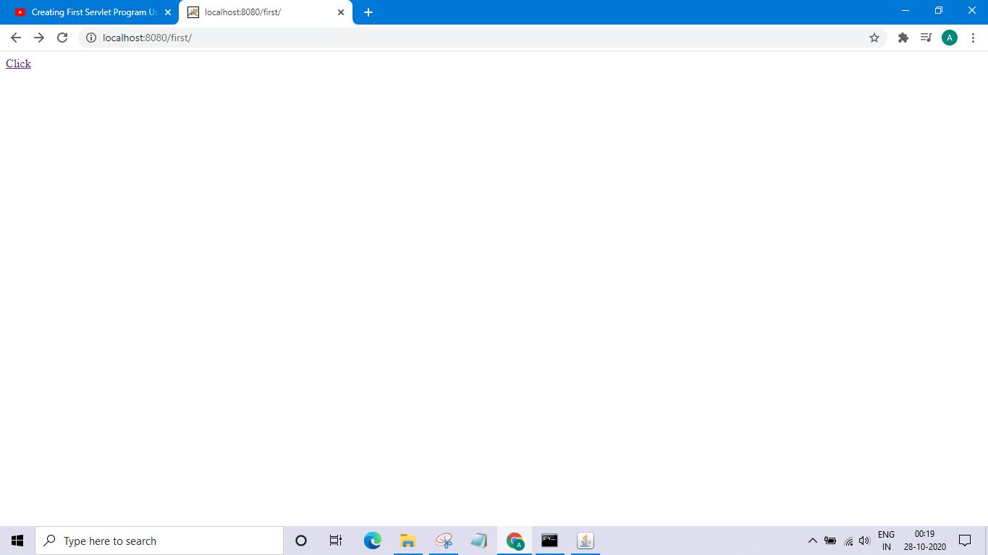

Index Page (After compiling java program)

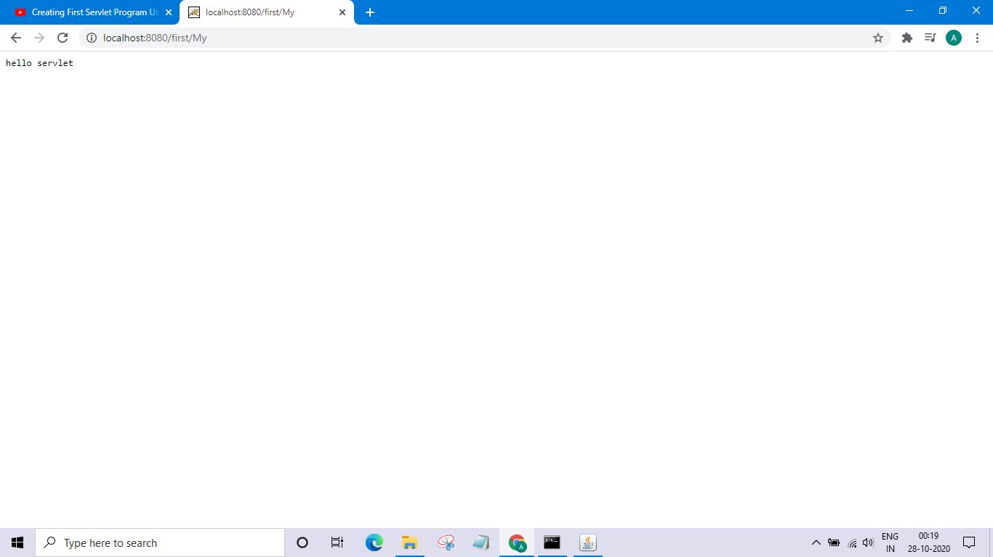

Servlet Page (after clicking on hyperlink)