ShockLens
  - Detailed Project Report
Portfolio resilience and macroeconomic shock transmission
Submission field | Details
Team | Bro Code
Problem statement | F-06
Theme | Financial technology and portfolio resilience
Members | Aman Raj, Darshan K Reddy, Ashitha R, B S Chethana
Report date | 26 October 2026
Live application | https://shocklens.vercel.app
Repository | github.com/darshankreddy7507/Srujana_hackathon2026_ShockLens

Executive summary
ShockLens is a working web prototype that connects portfolio holdings with market indicators and hypothetical economic shocks. Users can manage investments, assess exposure, compare stocks, track goals, and inspect an explainable chain from a macro trigger to an estimated monetary impact.
The achievement is an integrated React and Express application with PostgreSQL persistence, a deployed Vercel frontend and API, shared financial calculations, scenario services, and a structured PortfolioIQ assistant. The verified test run passed 46 shared tests and 15 backend tests. A later merge of existing GitHub guest-access changes also passed the production build.
The prototype demonstrates software integration and explainability, not proven predictive investment accuracy. Several sensitivity, confidence, and evidence values are configured in code rather than independently validated through a reproducible econometric study.

Official problem statement
Official problem statement ID: F-06
Exact official title and wording: _________________________________________________
____________________________________________________________________________
Project interpretation: Help investors understand how macroeconomic shocks may affect holdings and financial goals through transparent scenario analysis.

Problem understanding and proposed solution

Target users and pain points
Intended users include individual investors, students learning portfolio risk, and small advisory teams reviewing equity exposure. A portfolio screen can show current value while leaving the user unsure how an oil-price jump, currency movement, or rate shock could affect different holdings.
- Fragmented context: market indicators, stock histories, portfolio values, and goals are reviewed separately.
- Hidden concentration: different stocks may share an input-cost, currency, sector, or liquidity exposure.
- Unclear decisions: users need to see why one holding may cushion a shock while another amplifies it.
- Goal relevance: the same market loss can affect a near-term obligation differently from a long-term target.

Assumptions and needs addressed
Users supply accurate holdings and goal inputs. External market data can be delayed or unavailable. Scenario coefficients approximate relationships; they do not establish causal proof. The product supports analysis and education rather than trade execution.

Solution and user journey
A user registers or signs in, creates a portfolio, and enters holdings or imports a CSV. Market Nexus displays macro indicators and modeled effects. The user can inspect holding and sector impacts, follow the causal chain, run a scenario, compare a potential stock switch, and relate the outcome to a goal or report.
Guest access exists in the latest local source merged from GitHub. It provides sample portfolio and goal fixtures without registration. Some actions still require backend services; it is not a complete offline implementation.

Innovation and differentiation
The design contribution is the combination of personal holdings, visible macro-to-sector transmission, estimated rupee impacts, and goal-oriented workflows in one interface. Shared TypeScript types and Zod schemas align the mathematical and API contracts.
Compared with a basic price dashboard, the prototype emphasizes explanation and scenario exploration. It exposes modeled pathways and assumptions alongside a risk estimate. These are design differentiators, not claims of commercial uniqueness or measured superiority over competing financial products.

Example workflow
An investor tests a 10 percent crude-price shock, inspects sectors with positive and negative sensitivities, identifies the largest modeled contributors, and reviews a replacement stock. The output helps structure further research; it does not guarantee that a trade will improve returns.

System architecture and data flow
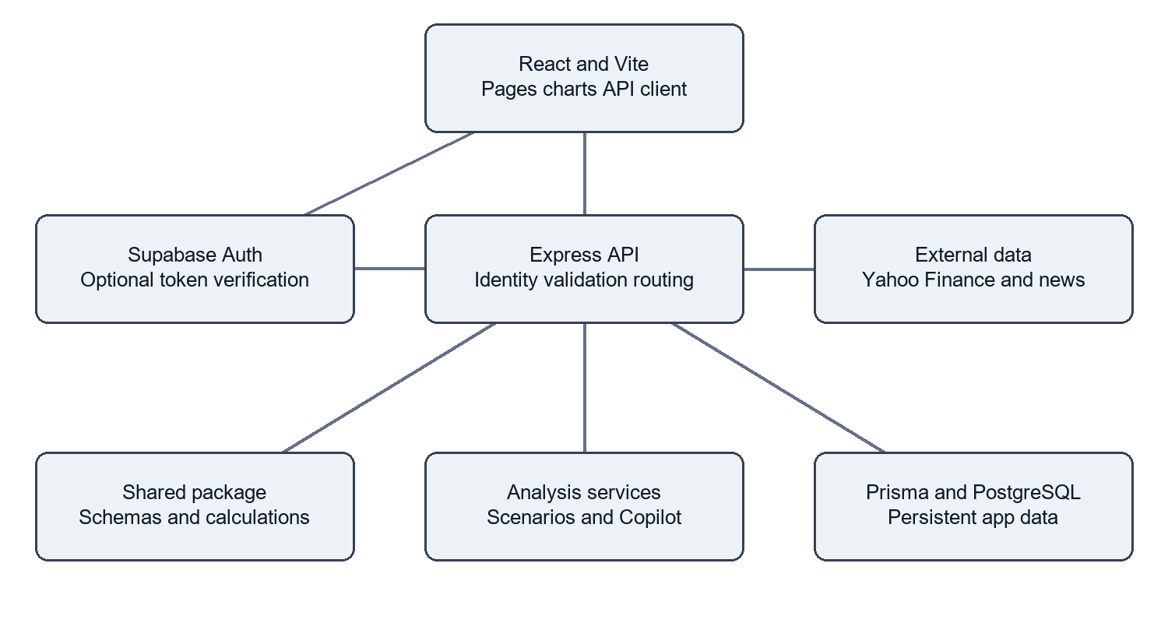
Figure 1 Major components and principal data connections
The frontend sends relative /api requests. Locally, Vite proxies them to Express on port 4000. In production, Vercel routes API paths to api/index.ts, which exports the Express app, and serves the React build for frontend routes.

Request and analysis flow
- React obtains the user profile and selected portfolio. Express middleware validates the request and resolves the identity.
- Prisma reads portfolio and goal records from PostgreSQL; shared utilities define input schemas and calculations.
- Market services fetch Yahoo Finance data and news snippets. The inspected macro service caches successful indicator results for 60 seconds.
- Scenario and Copilot services apply configured models and return structured JSON for charts, tables, explanations, and reports.

Authentication and deployment
The working deployment uses Express email/password accounts with bcrypt hashes and PostgreSQL-backed sessions. Optional Supabase Auth sends a frontend access token to the API and links the verified identity to an application User record.
The correct public key for the configured Supabase project has not been supplied, so the optional Auth path remains incomplete. Supabase PostgreSQL connectivity was verified independently of Auth.
Deployment changes added Vercel routing, a function entry point, platform-specific Prisma generation, build-tool installation with --include=dev, and production proxy handling. Approved credentials were stored as server-only Vercel variables. No secret values appear in this report.

Database design and technology stack
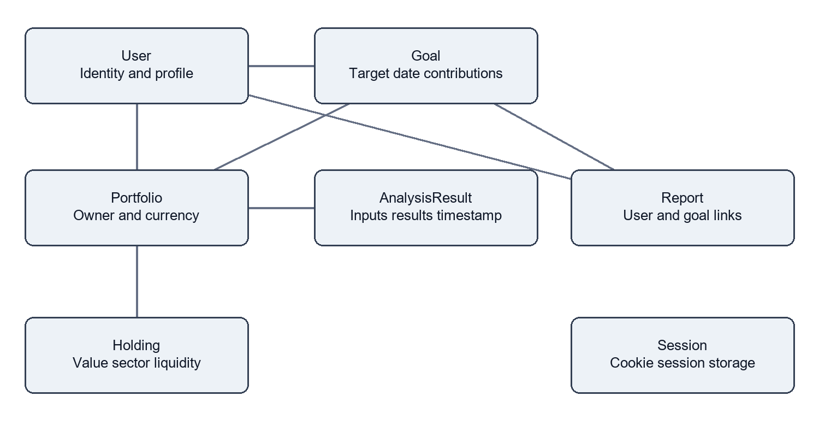
Figure 2 Persisted entities and selected relationships
A User owns portfolios and goals. A Portfolio owns holdings and cached analyses. Reports link to a user and optionally a goal. Express Session maintains a separate session table. SavedScenario is present in the schema, but a complete management workflow was not demonstrated.
Layer | Implementation
Presentation | React 18, TypeScript, Vite, React Router, Tailwind CSS, Radix UI
Charts and forms | Recharts, Framer Motion, Lucide, React Hook Form, Zod
Client data | TanStack React Query
API and persistence | Node.js, Express 4, Prisma 5, Supabase PostgreSQL
Identity and middleware | Express Session, connect-pg-simple, bcrypt, Helmet, CORS, rate limiting
Reports and tooling | jsPDF, html2canvas, Pino, npm workspaces, Vitest, Vercel

Financial amounts use decimal database columns. Account-specific ownership checks are performed by application services. A comprehensive database row-level security audit was not completed. Connection limits and pooling require measurement before scaling the prototype.

Implementation and completed features
Capability | Implementation | Evidence level
Accounts | Register, login, profile, logout and protected routes | Code inspected; signed-in app observed
Portfolios | CRUD, holdings, CSV import and template | Implemented; exhaustive UI tests pending
Macro analysis | Indicators, impact, causal chain, sector and holding views | Observed in deployed UI
Scenarios | Exposure, shock simulation, allocation comparison | Shared calculation tests passed
Stocks | Search, quotes, switch comparison form and service | UI observed; research services tested
Goals | CRUD, target and contribution inputs, recommendations | Implemented; full workflow not exhausted
PortfolioIQ | Intent routing, ranking, comparisons and education | 15 backend tests passed
Reports | Persistence routes and frontend export tools | Implemented; export fidelity unverified
Guest access | Sample data path merged from newer GitHub commits | Locally built; dedicated tests pending
Supabase Auth | SDK client and API token bridge | Missing correct project key

Business logic and algorithms
Scenario magnitude and sector sensitivities drive modeled holding returns. Estimated monetary impact equals holding value multiplied by estimated return divided by 100. Causal nodes and edges describe the transmission path. Realtime analysis combines provider baselines with configured neutral values and coefficients.
Stock switching uses historical returns, momentum, annualized volatility, price ranges, and scoring rules to explain a comparison. A six-month range type was added to match the research service. Goal analysis relates capital, target amount, deadline, and contributions to required returns.
CSV import parses and validates rows before creating holdings. Report creation persists structured analysis. These are analytical workflows; the application does not place brokerage orders.

Illustrative arithmetic
A hypothetical holding worth Rs 100000 with a modeled return of -4 percent has an estimated impact of -Rs 4000 and post-shock value of Rs 96000. This is a transparent arithmetic example, not a forecast for a specific stock.

Testing results and engineering achievements
Check | Observed result | Meaning
Shared Vitest suite | 46 passed | Existing calculation and schema checks
Backend Vitest suite | 15 passed with network | Intent routing, research and Copilot cases
Sandbox test run | 4 provider-related failures | Rerun with network access passed
Production build | Passed before deploy and after merge | TypeScript and Vite compilation
Database read check | SELECT 1 passed; User count was 7 | Read connectivity; no records changed
Homepage and app route | HTTP 200 | Static and SPA routing reachable
API health | HTTP 200 with status ok | Express function responding
Anonymous profile request | HTTP 401 Authentication required | Profile boundary rejected anonymous access

Representative test cases
- "Hi" routes to a greeting without requesting stock data.
- "Which NIFTY 50 stocks performed best over the past six months?" routes to a six-month ranking intent.
- "Compare Suzlon, IRFC and Tata Power" exercises structured multi-stock comparison with reachable provider data.
- "What happens to my portfolio if NIFTY falls 10 percent?" exercises quantified stress-test behavior.

Milestones achieved
Dependencies were restored; a macOS-generated Prisma client was regenerated for Windows. Backend TypeScript errors were corrected, the production build passed, and frontend/API routing was added. The first Vercel build lacked TypeScript under NODE_ENV=production; --include=dev corrected the remote install. Vercel reported READY and endpoint smoke checks passed.
The 61-test run preceded the later guest-access merge; the merged source passed its build. No comprehensive browser suite, independent backtest, load benchmark, penetration test, or accessibility audit was completed.

Reproducibility state
The latest local merge commit is 5e4938f. GitHub pushes returned 403 because the signed-in account lacked write access. The remote repository, latest local source, and deployed bundle should not be assumed to contain identical changes.

User interface and portfolio impact
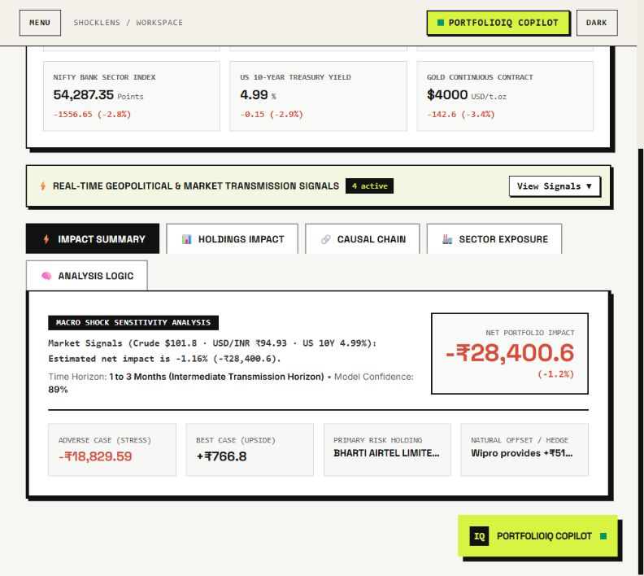
Figure 3 Deployed Market Nexus impact summary captured on 26 October 2026
The screen combines market indicators, a selected portfolio, central estimated impact, stress/upside outputs, a primary contributor, and an offsetting holding. Account details were omitted by collapsing the sidebar.
The image documents the application interface. It does not independently verify quote freshness, economic evidence, or displayed confidence. Stress/upside range ordering and calibration require additional validation before real financial use.

User interface and explainable transmission
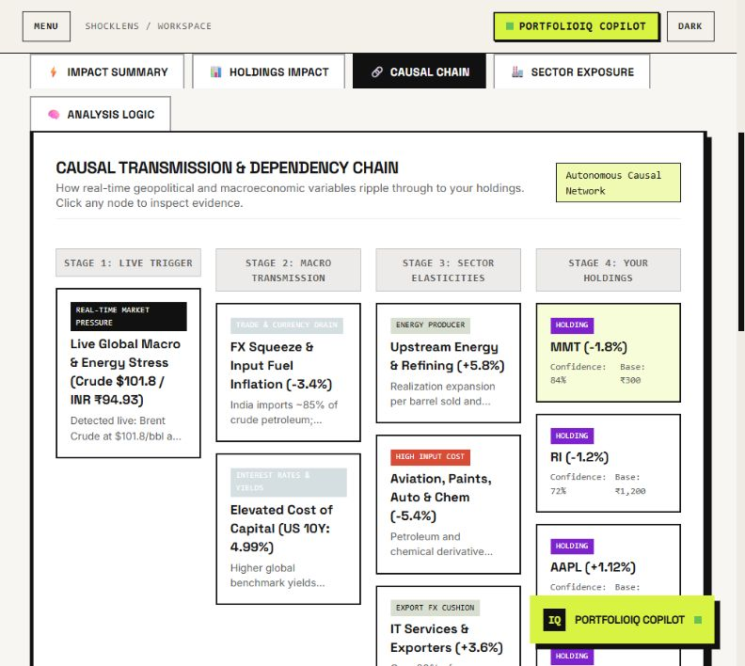
Figure 4 Deployed causal transmission view captured on 26 October 2026
The interface organizes an explanation into a live trigger, macro transmission, sector elasticities, and holdings. Users can inspect the modeled path instead of interpreting only a single score.
The screenshot shows the visible viewport, not all holdings or nodes. Confidence percentages and evidence labels are configured model output, not independently established statistical estimates. Provider values can change after capture.

User interface and stock comparison
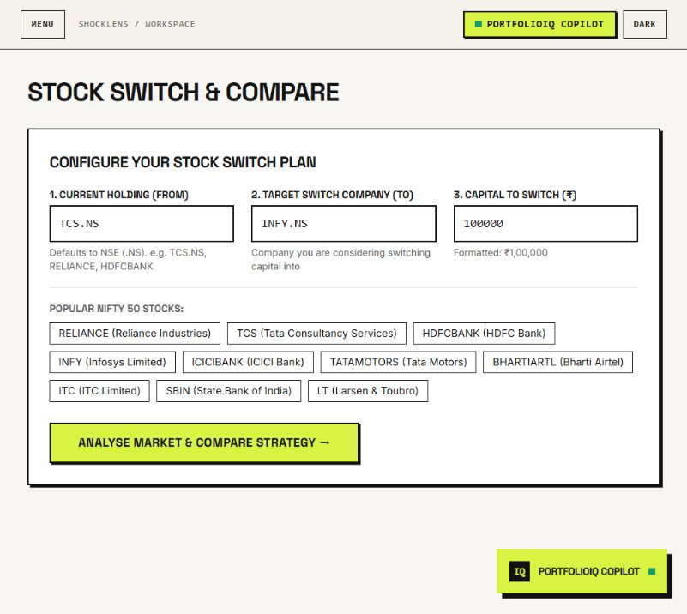
Figure 5 Deployed Stock Switch configuration captured on 26 October 2026
The form accepts a current stock, target company, and capital amount. The captured input is TCS.NS versus INFY.NS with Rs 100000. Common Indian equity shortcuts help select companies.
This image demonstrates the input interface, not a completed result for that exact request. Research services passed backend tests; a full browser comparison and resulting portfolio change were not independently verified for this screen.

Jury demonstration
Open the live app, sign in with an authorized account, choose a portfolio, and inspect Market Nexus. Show the causal view, then configure a stock comparison. Demonstrate goals, Scenario Lab, and reports with a clear distinction between completed workflows, static fixtures, and provider-dependent results.

AI data dependencies and limitations

AI used during development
OpenAI Codex assisted with repository inspection, debugging, documentation, build/test execution, deployment preparation, and this report. Work used repository context and targeted documentation queries, followed by verification of builds, test outputs, and public endpoints. No exact development model identifier or complete prompt history is asserted.
Representative tasks included checking Supabase connectivity, diagnosing the Prisma platform mismatch, preparing Vercel routing, and rewriting documentation. Team members remain responsible for reviewing generated changes and the financial assumptions.

AI inside the product
The inspected PortfolioIQ path uses keyword and regular-expression intent routing, entity extraction, quantitative tools, and response templates. No OpenAI, Claude, Gemini, or Ollama inference call was found in that path. It is a rule-based financial assistant prototype, not a demonstrated trained or fine-tuned language model.

Data and external resources
Yahoo Finance chart/search endpoints supply quotes and histories; news retrieval includes DuckDuckGo HTML snippets. Supabase supplies PostgreSQL and optional Auth; Vercel hosts the application. Context7 documentation informed Supabase health checks, Prisma regeneration, and deployment configuration.
No proprietary training dataset or independently collected labeled dataset is documented. Demo data and scenario coefficients are included in source. Graphify was attempted but repository access was unavailable, so it provided no usable verification evidence.

Known limitations and incomplete work
- Model sensitivities, confidence scores, evidence descriptions and sample counts require reproducible sourcing and independent calibration.
- Guest mode serves static fixtures for selected routes, including macro values with live-style labels; these are not verified realtime feeds.
- External providers can fail, rate-limit, change formats, or impose usage restrictions. Macro services can return marked fallback values.
- Supabase Auth requires the correct project key. Express accounts remain the working fallback.
- Export fidelity, account-isolation coverage, recovery paths, form edge cases, performance and security need broader testing.

Viability future scope and setup

Real world viability and impact
The strongest immediate use is education and guided scenario exploration: relating a market narrative to personal holdings and making assumptions visible. Commercial investment use would require licensed data, independently calibrated models, out-of-sample evaluation, monitoring, and appropriate compliance review.
Serverless hosting is feasible for a small prototype. Growth requires connection pooling, bounded provider calls, shared caches, timeouts, background jobs, and latency/concurrency measurement. Current in-memory caches and rate limits do not coordinate globally across function instances.
Privacy and security work should include least-privilege access, ownership tests, retention and deletion policies, backups, audit logs, and strict separation of public settings from secrets. The prototype executes no trades and does not establish suitability for any investor.

Prioritized future scope
Priority | Improvement | Acceptance evidence
1 | Fix fixture/live labeling and output range consistency | Automated fixtures and output invariants
2 | Complete Auth and recovery flows | Confirmation reset and isolation tests
3 | Calibrate model coefficients | Versioned data and independent backtests
4 | Harden providers and deployment | Timeout tests monitoring and load results
5 | Improve exports and accessibility | Browser journeys export checks and audit

Setup and reproducibility
Use Node.js 24 and npm. In the inner project root, run these commands in order: npm install --include=dev; npm run db:generate; npm run db:push --workspace=apps/backend for a new development database; npm run build --workspace=packages/shared; npm run dev.
Copy apps/backend/.env.example to apps/backend/.env. Configure DATABASE_URL, SESSION_SECRET, PORT=4000, NODE_ENV=development and CORS_ORIGINS=http://localhost:5173. Optional Auth needs matching SUPABASE_URL and SUPABASE_ANON_KEY on the API, and VITE_SUPABASE_URL and VITE_SUPABASE_ANON_KEY on the frontend. Never publish secrets or put a service-role key in frontend variables.
Open http://localhost:5173. Run npm test and npm run build. Backend tests need internet access. No real test credentials are included. Use an authorized account or disposable demo database. The seed command deletes existing demo records and clears cached analyses; do not use it on a populated production database.

Team contributions and references

Team Bro Code
Complete each member's contribution and supporting evidence before submission.
Member | Contribution and evidence
Aman Raj | ________________________________________________  ________________________________________________  ________________________________________________
Darshan K Reddy | ________________________________________________  ________________________________________________  ________________________________________________
Ashitha R | ________________________________________________  ________________________________________________  ________________________________________________
B S Chethana | ________________________________________________  ________________________________________________  ________________________________________________

References and evidence
1. Live application: https://shocklens.vercel.app
2. Repository: https://github.com/darshankreddy7507/Srujana_hackathon2026_ShockLens
3. README.md, SUPABASE_SETUP.md, package.json and vercel.json.
4. Architecture: apps/backend/src/app.ts, api/index.ts and frontend/vite.config.ts.
5. Data model: apps/backend/prisma/schema.prisma.
6. Algorithms: packages/shared/src/calculations.ts and backend/src/services/butterfly/.
7. Assistant: portfolioIQCopilotService.ts, copilotIntentRouter.ts and marketResearchToolService.ts.
8. Tests: calculations.test.ts and portfolioIQCopilot.test.ts in the workspace test folders.
9. Official documentation: https://supabase.com/docs and https://vercel.com/docs
10. Framework references: https://www.prisma.io/docs, https://react.dev, https://expressjs.com

Submission completion
Insert the exact official F-06 statement wording on the first page and fill the contribution fields. Keep any prediction, AI-model, or production-readiness claims aligned with the demonstrated evidence and limitations.

