Indian Institute of Information Technology, Allahabad

Software Engineering

Course Instructors: Dr. Sonali Agarwal, Dr. Abhishek Vaish.,Mr. Amit Kumar

Use Case Diagram

Elemento© - A Website for SERL Lab

**GROUP MEMBERS-**

1. Satyam Thakur (IIT2021217)
2. Ashwani Jha (IIB2021018)
3. Saurav Kumar (IIB2021034)
4. Pamula Sidhu (IIT2021234)
5. Aman Nanda (IIT2021272)
6. **Introduction:**

"Elemento©" is a Web Development which aims to develop a comprehensive platform for sharing the research work and projects of the software engineering research laboratory. The SERL Lab is a leading research lab that conducts cutting-edge research in software engineering, and the website will enable the lab's members to showcase their work and expertise to a global audience.

* 1. **Purpose:**

From Student’s point of view,

* The SERL Lab Website project will provide with a valuable resource for accessing the latest research and projects in software engineering. The website will enable to learn about the work of leading researchers and explore new topics and ideas.
* We will be able to use the website to stay up-to-date with the latest trends and developments in software engineering, which will be invaluable in my studies and future career.

From Admin’s point of view,

* The SERL Lab Website project, Admin’s role will be to ensure that the website is designed, developed, and deployed in a timely and efficient manner. Admin will work closely with the project team to gather requirements, design the website, and oversee its development and testing.
* Admin will be responsible for ensuring that the website meets the needs of the SERL Lab's members and provides a valuable resource for the broader software engineering community.

**1.2 Scope:**

Page 3 of 19

We describe what features are in the scope of the software and what are not in the scope of the software to be developed.

In Scope:

* This can be used to search and research about Software Engineering, And Get to know about the Instructors.
* This can be use only in internet.

Out of Scope:

* Student doesn’t have more flexiblites.
* This can’t be used without Internet.
  1. **Definitions, Acronyms, and Abbreviations:**

Acronyms and Abbreviations:

a. " Elemento©" : Copyrighted Website name.

Definitions:

a. " Elemento©": The SERL Lab Website project will provide with a valuable resource for accessing the latest research and projects in software engineering.

**1.4 Overview:**

Section 2 gives an overall description of the software. It gives what level of proficiency is expected of the user, some general constraints while making the software and some assumptions and dependencies that are assumed. Section 3 gives specific requirements which the software is expected to deliver. Functional requirements are given by various use cases. Some performance requirements and design constraints are also given.

**2. Overall Description:**

**2.1 Product Perspective:**

This is a Website

**2.2 Product Functions**:

|  |  |  |
| --- | --- | --- |
| **Use Cases** | **Description of use cases** | |
| **Student:** | | |
| Home | | Main Page of a website |
| Publications | | Can be used to check Publications |
| Projects | | Can be used to check Projects |
| Contact Us | | Can be used to check The people made the website |
| Resources | | Can be used to check Resources |
| Members | | Can be used to see people in the SERL |
| Student Login | | Used to login to projects and edit it |

|  |  |  |
| --- | --- | --- |
| **Use Cases** | **Description of use cases** | |
| **Admin:** | | |
| Edit | | Allows Admin to edit |
| Admin Login | | Admin maintains list of database Tables |
| Home | | Main Page of a website |
| Publications | | Can be used to check Publications |
| Projects | | Can be used to check Projects |
| Contact Us | | Can be used to check The people made the website |
| Resources | | Can be used to check Resources |
| Members | | Can be used to see people in the SERL |

**2.3 User Characteristics:**

a. The user should be familiar with the operation of Website.

**2.4 Principal Actors:**

The principal actor in "Elemento©" is “Admin”.

**2.5 General Constraints:**

b. Working of "SERL Lab" requires Internet connection.

c. " SERL Lab" is a multi-user Application. Admin can access website on their android device.

**2.4 Assumptions and Dependencies:**

a. Working of " SERL Lab" is dependent on the availability of Internet connection.

b. Admin must be active to insert all the required information’s on the app.

**APPENDIX A: USE CASE DIAGRAM**

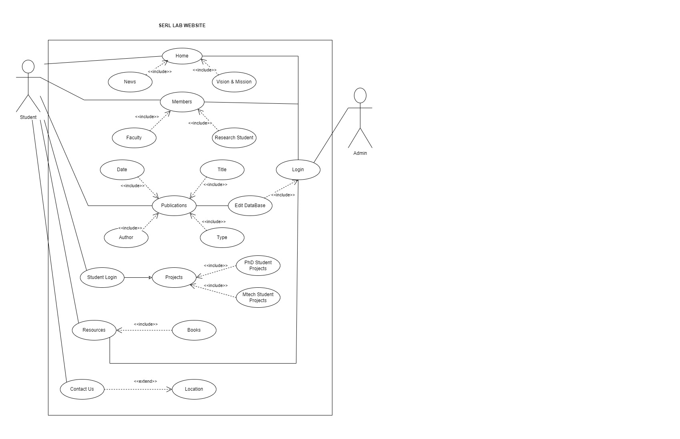

**3. Specific Requirements:**

**3.1 Functional Requirements:**

**Use Case 1:**

**Name**: Home

**Summary**: Allows students or users to view about IIITA and information on researches & projects till date and number of students worked on project.

**Actors**: IIITA students

**Pre-conditions:**

• Internet Connectivity.

• Admin must upload some data on Home page.

**Main success scenario:**

• Student clicks on home page tab.

• Student can view all data shown there.

**Extension:**

NULL

**Post-condition:**

NULL.

**Use Case 2:**

**Name**: News

**Summary**: Allows students or users to view news about IIITA and information on researches & projects.

**Actors**: IIITA students

**Pre-conditions:**

• Internet Connectivity.

• Admin must upload some data on News page.

**Main success scenario:**

• Student clicks on news page tab.

• Student can view all data shown there.

**Extension:**

NULL

**Post-condition:**

NULL

**Use Case 3:**

**Name**: Vision & Mission

**Summary**: Allows students or users to know about IIITA and to know the vision and mission on researches & the aim of projects.

**Actors**: IIITA students

**Pre-conditions:**

• Internet Connectivity.

• Admin must upload some data on Vision & Mission page.

**Main success scenario:**

* Student/user clicks on home page tab.
* Student/user dimension can view all data shown there about the vision.

**Extension:** NIL

**Post-condition: NULL**

**Use Case 4:**

**Name**: Members

**Summary**: Users can view the profile of any member who are part of this vision of IIITA and can contact them for further doubts.

**Actors**: Admin

**Pre-conditions:**

• Internet Connectivity

**Main success scenario:**

* User clicks on members tab to see the faculty & researches.
* User chooses for the member he wishes to view profile of and clicks on required Profile.
* Users views the faculty & researchers profile.

**Extension:** Admin should pre-upload all data about faculty & researchers.

**Post-condition:** Users has now successfully viewed the Faculty’s profile.

**Use Case 4:**

**Name**: Faculty

**Summary**: Users can view the profile of any Faculty he/she wishes to and check if he has uploaded any projects or research documents.

**Actors**: Admin

**Pre-conditions:**

Admin must be successfully logged in to change or edit any information about faculty. Whereas users can just view the profile in the webpage.

**Main success scenario:**

* Admin can edit the faculty profile
* User chooses for the faculty he wishes to view profile of and clicks on Profile Tab to view it.

**Extension:**

If admin has not uploaded any information about desired faculty member, it cannot found.

**Post-condition:**

* Admin has now successfully edited the faculty profile.
* User has now successfully view the faculty information.

**Use Case 5:**

**Name**: Researchers

**Summary**: Users can view the project of any researcher he/she wishes to and check if he has uploaded any projects or research documents.

**Actors**: Admin

**Pre-conditions:**

* Admin must be successfully logged in to change or edit any information about faculty. Whereas users can just view the profile in the webpage.

**Main success scenario:**

* User chooses for the researches he wishes to view projects of and clicks on Tab to view it.

**Extension:**

If admin has not uploaded any information about desired research member, it cannot found.

**Post-condition:**

* User has now successfully view the researchers information.
* Only student of IIITA can access the projects done by researchers.

**Use Case 6:**

**Name**: Publications

**Summary**: Allows users to see all the publications

**Actors**: Users/Admin

**Pre-conditions:**

* Internet Connectivity
* Admin must upload some Publications.

**Main success scenario:**

* Users/Admin clicks on Publications.
* Users/admin can view all the publications with their author name,date,type,title of publications.

**Extension:**  NULL

**Post-condition:**  NULL

**Use Case 7:**

**Name**: Date

**Summary**: Allow Users, Admin to know the date of publication

**Actors**: Users/Admins

**Pre-conditions:**

* Internet Connectivity.

• Admin must upload some publications

**Main success scenario:**

* Users click on publications.
* Users/admin can view all the publications with their author name,date,type,title of publications

**Extension:**  NULL

**Post-condition:**  NULL

**Use Case 8:**

**Name**: Author

**Summary**: Allow users/admin to know the publication author name.

**Actors**: Users/Admins

**Pre-conditions:**

• Only Internet connectivity.

* Admin must upload some publications

**Main success scenario:**

* Users click on publications.
* Users/admin can view all the publications with their author name,date,type,title of publications.

**Extension:**  NULL

**Post-condition:**  NULL

**Use Case 9:**

**Name**: Title

**Summary**: Allow users/admin to know the publication Title name.

**Actors**: Users/Admins

**Pre-conditions:**

• Only Internet connectivity.

* Admin must upload some publications,

**Main success scenario:**

* Users click on publications.
* Users/admin can view all the publications with their author name,date,type,title of publications.

**Extension:**  NULL

**Post-condition:**

* When title is pressed users/admin can view all the description of the publication

**Use Case 10:**

**Name**: Type

**Summary**: Allow users/admin to know the publication Type name.

**Actors**: Users/Admins

**Pre-conditions:**

• Only Internet connectivity.

* Admin must upload some publications,

**Main success scenario:**

* Users click on publications.
* Users/admin can view all the publications with their author name,date,type,title of publications.

**Extension:**  NULL

**Post-condition:**  NULL

**Use Case 11:**

**Name**: Projects

**Summary**: Allow users/admin to know the publication Type name.

**Actors**: Allows user to view the past projects.

**Pre-conditions:**

• Only Internet connectivity.

* Only for allowed mail ids.

**Main success scenario:**

* Admin clicks on projects.
* Website open the projects portal.

**Extension:**  Id or password incorrect. Shows error dialog box.

**Post-condition:**  Admin/students can now view projects of Mtech/PhD students.

**Use Case 12:**

**Name**: Authorized login

**Summary**: Allows Admin to login.

**Actors**: Admin.

**Pre-conditions:**

• Only Internet connectivity.

* Only for allowed mail ids.

**Main success scenario:**

* Admin clicks on Login Button.
* Website checks for the authorization of login.

**Extension:**  Id or password incorrect. Shows error dialog box.

**Post-condition:**  Admin can now access all features of the website.

**Use Case 13:**

**Name**: Student Login

**Summary**: Allows student to login.

**Actors**: Students/Admin.

**Pre-conditions:**

• Only Internet connectivity.

* Only for allowed mail ids.

**Main success scenario:**

* Student clicks on login button.
* Website checks for the authorization of login.

**Extension:**  Id or password incorrect. Shows error dialog box.

**Post-condition:**  Student can now access all features of the website

**Use Case 14:**

**Name**: Mtech

**Summary**: Allows student to login.

**Actors**: Students/Admin.

**Pre-conditions:**

• Only Internet connectivity.

* Only for allowed mail ids.

**Main success scenario:**

* User clicks on Mtech to view projects of Mtech students.

**Extension:**  NULL

**Post-condition:**  Admin/Students can now view all the projects of mtech students.

**Use Case 15:**

**Name**: PhD

**Summary**: View the projects of PhD students..

**Actors**: Students/Admin.

**Pre-conditions:**

• Only Internet connectivity.

* Only for allowed mail ids.

**Main success scenario:**

* User clicks on PhD to view projects of PhD students.

**Extension:**  Id or password incorrect. Shows error dialog box.

**Post-condition:**  Admin/Students can view all projects of PhD Students.

**Use Case 16:**

**Name**: Edit

**Summary**: Allows Admin to login.

**Actors**: Admin.

**Pre-conditions:**

• Only Internet connectivity.

* Only for allowed mail ids.

**Main success scenario:**

* Admin clicks on add/delete/change and implement them.
* Website then make the changes subsequently.

**Extension:**  NILL.

**Post-condition:**  Now the new changes are updated.

**Use Case 17:**

**Name**: Resources

**Summary**: Websites often have a dedicated ‘Resources’ page that includes links to external websites, helpful articles, tutorials, and other information that can be useful to visitors.

**Actors**: Students/Admin.

**Pre-conditions:**

• Firstly, the resources should be relevant to the topics and information on the website.

• Secondly, the resources should be organised in a logical manner, making it easy for visitors to find the information they need.

**Main success scenario:**

* The main scenario for a website that provides resources is to ensure that the information is accurate and up-to-date.

**Extension:**  When extending a resources website, some important considerations include the type of content to include, the design of the website, and the marketing strategy. When developing content, it's important to ensure that the resources are relevant and up-to-date, and that they are organised.

**Post-condition:**  Firstly, it's important to periodically review the resources to ensure that they are still relevant and accurate. Additionally, it's important to ensure that the links are functioning correctly and that the resources are linked to the appropriate pages on the website.

**Use Case 18:**

**Name**: Books

**Summary**: It is important to ensure that the books are organised in a logical manner and are easy to find. The books should be relevant to the topics and information on the website, and it is important to include reviews, ratings.

**Actors**: Students/Admin.

**Pre-conditions:**

• Firstly, it is important to compile a list of relevant books that are related to the topics and information on the website. Additionally, it is important to include reviews, ratings, and other information about the books, such as the author, publisher, and ISBN number.

**Main success scenario:**

* When creating a books page on a website, it is important to consider the pre-conditions that will help ensure a successful page. Firstly, it is important to compile a list of relevant books that are related to the topics and information on the website.

**Extension:**  When extending the books page on a website, it is important to consider the additional content that should be included. Firstly, it is important to ensure that the books are organized in a logical manner and are easy to find.

**Post-condition:**  It is important to ensure that the books are organized in a logical manner and are easy to find. Additionally, it is important to include reviews, ratings, and other information about the books, as well as external links to the books to allow visitors to purchase them if they choose. Finally, it is important to ensure that the page is regularly updated to ensure that the books are still relevant and accurate.

**Use Case 19:**

**Name**: Contact Us

**Summary**: Contact us pages on websites are typically designed to provide users with information about how to get in touch with the company or organization. This usually includes an email address, phone number, and a form for submitting queries or feedback.

**Actors**: Students/Admin.

**Pre-conditions:**

• The pre-conditions of a contact us page on a website typically involve having the right information readily available, such as an email address, phone number, and a form for submitting queries or feedback. The page should also include any relevant contact information, such as an office address, and have up-to-date information about the company or organization.

**Main success scenario:**

* The main success scenario of a contact us page on a website is for users to easily find and access the relevant contact information, such as an email address, phone number, and a form for submitting queries or feedback. The page should also provide users with a clear understanding of what type of feedback or queries the company or organization is able to respond to, as well as any other relevant terms or conditions.

**Extension:**  Extensions of a contact us page on a website can include providing additional information about the company or organization, such as a description of the company's mission and values, links to social media accounts, or links to other relevant websites.

**Post-condition:**  The post-conditions of a contact us page on a website include providing users with an easy and efficient way to get in touch with the company or organization. This should include an up-to-date email address, phone number, and a form for submitting queries or feedback.

**Use Case 20:**

**Name**: Location

**Summary**: The location of a website is the physical address of the server that hosts the website. This information can be used to identify the country and city where the website is hosted, as well as the hosting provider.

**Actors**: Students/Admin.

**Pre-conditions:**

• Preconditions for location on a website refer to rules and requirements that need to be met before certain content or features can be accessed. This usually involves authentication, such as checking if a user is logged in or has the correct permissions. It can also refer to other conditions, such as ensuring that certain parameters are set or that the user's device is compatible with the content.

**Main success scenario:**

* The main success scenario of location on a website involves the user being able to access the desired content or feature based on their location. This involves checking if the user is logged in or has the correct permissions, as well as checking the user's device to ensure that the content is compatible.

**Extension:**  Location on a website can be extended in a number of ways, such as by providing additional content or features based on the user's location. This could involve providing localized content, such as different language versions of a page, or providing specific content based on the user's country or city.

**Post-condition:**  The postcondition of location on a website is that the desired content or feature has been accessed successfully, and the user has been able to gain the information or experience they were looking for. This postcondition should also include any relevant parameters or user preferences that were set prior to accessing the content, such as language or location, being retained and/or updated.