**BFS (Breadth First Search):**

It kind of signifies level wise traversal, here we would be provided and that would be considered as level 0.

After traversing the node at level 0 we would move ahead to the next level and continue till we reach the last node.

The image given below shoes the result for BFS where starting node was 1

* After visiting 1
* We went to next level which is 2 and 6
* After 2 and 6 we would move on to 3 4 7 and 8

**What if we change the starting point**

If 6 becomes our starting point, we would need to follow the steps given below.

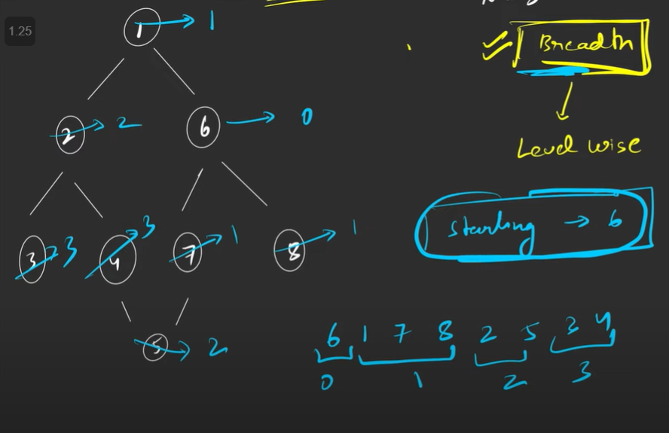

6 would be considered as level 0.

1, 7 and 8 would be considered as level 1.

2 and 5 would be considered as level 2.

3 and 4 would be considered as level 3.

**Algorithm**

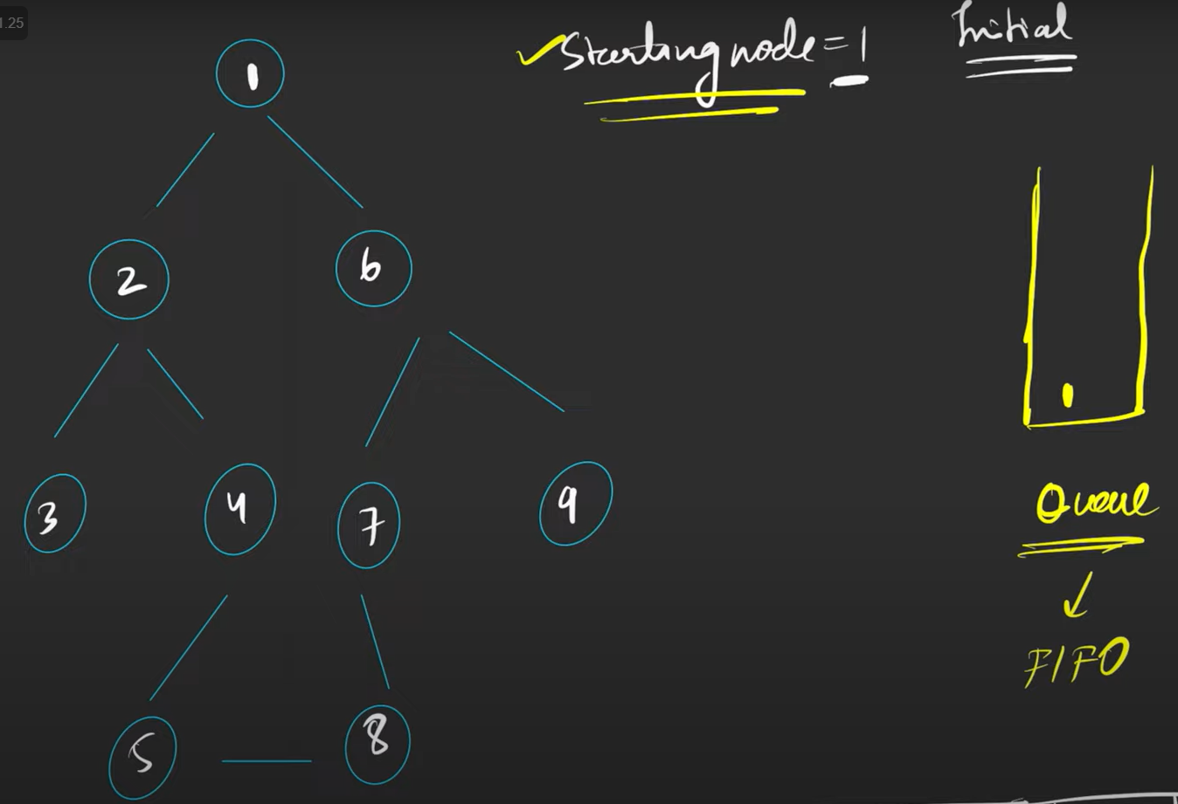

Initially we would be provided with the starting node.

We will have a Queue data structures which follows FIFO (First In First Out).

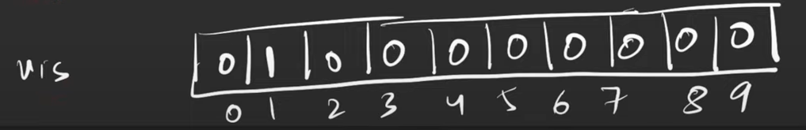

A visited array as shown above will mark the node which has been touched or we can say visited as 1.

So if a node’s index in visited array is marked as 1 it means that the element has already been into Queue.

**Note: What will do is that whatever has been into Queue, will start taking it out and we will take out elements till our queue is not empty.**

We take out 1 from the queue and we print it as shown in the picture given below.

We have stored our graph data structure in form of some adjacency list and that list looks like:

Now since we took out 1 from the queue which was the starting point.

We will take the neighbours of 1 and put it into the queue and mark it as 1 which means visited for the visited array.

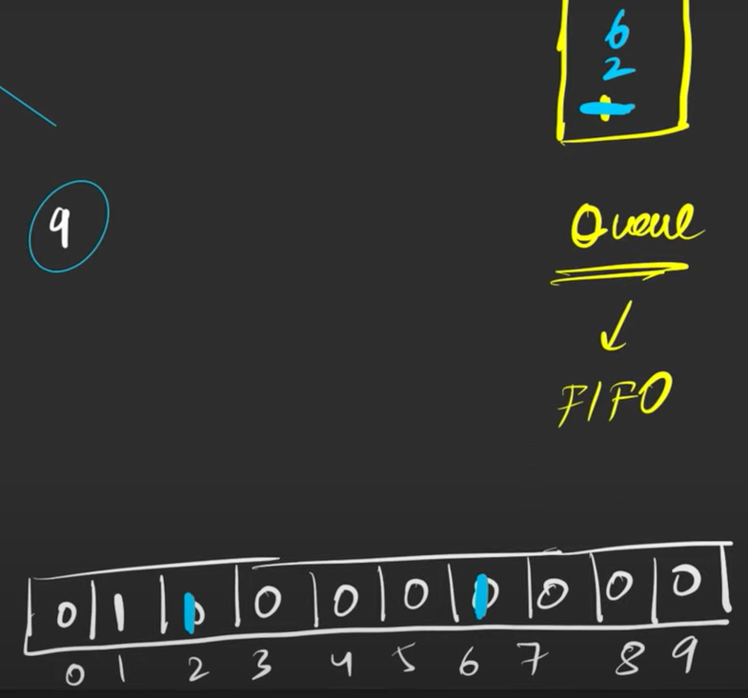

Now take out the next node which is 2 and store its unvisited neighbours into the queue, now two has 3 neighbours which are 1,3 and 4. Since 1 is already visited, we would not put it into the queue.

We will put 3 and 4 into the queue.

At the end we would get our BFS traversal as shown in below picture.

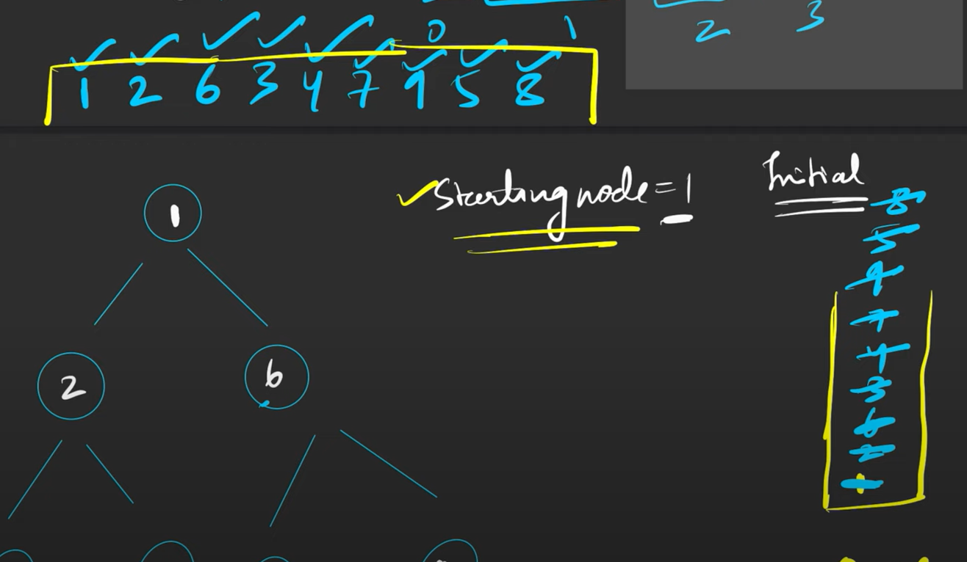

**Time complexity**: Now for every node, we would push it into the queue and run BFS for all its degrees that if a node is pushed into the Queue, we are going to run BFS for all its neighbours.

Therefore, our time complexity comes out to be O(N) + O(2E) where 2E is total number of degrees in the graph as Each edge connects two nodes therefore total number of degrees in a graph would be 2E.