**DFS (Depth First Search)**

Given the above graph, we would be provided with the starting point which here suppose is 1.

We will start from 1, and start exploring the left graph and we will go into more and more depth till we reach the last node which is 5.

Then we cannot move further so we will come back to 2 and then from 2 we can go further to 6.

After 6 we cannot move ahead to after we will go back to 2 from 2 we will go back to 1.

Now from 1 we will move to 3 and explore it in the same way.

This way our output would be:

**1 2 5 6 3 7 8 4**

**Algorithm:**

We will start with the same visited array.

Whatever our starting node is we will call recursive DFS function for that node.

Our function would look something like:

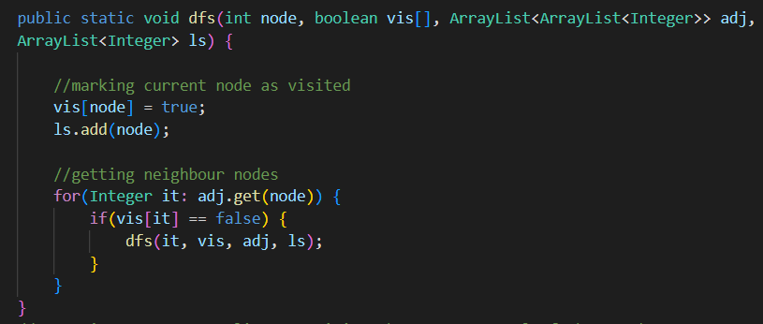

We will store 1 into the list and move ahead with one of its neighbors and the list would go on to save all the nodes in DFS order.

**Time Complexity:**For an undirected graph, O(N) + O(2E), For a directed graph, O(N) + O(E), Because for every node we are calling the recursive function once, the time taken is O(N) and 2E is for total degrees as we traverse for all adjacent nodes.

**Space Complexity:**O(3N) ~ O(N), Space for dfs stack space, visited array and an adjacency list.