A Project Report On

**Cricket Scorecard Maintenance**

Bachelor of Technology

In

Computer Science Engineering



AT

DEPARTMENT OF COMPUTER SCIENCE ENGINEERING

**CGC-College of Engineering**

**LANDRAN, MOHALI**

**Submitted by: Submitted to:**

Aman

1726078 Mrs. Dapinder Kaur

Btech-CSE(A)

**Table of contents:**

|  |  |  |
| --- | --- | --- |
| **Chapter No.** | **Titles** | **Page no.** |
| 1. | Abstract | 3 |
| 2. | Introduction | 4 |
| 3. | Application of Project | 5 |
| 4. | Screenshots | 6 |

**Abstract**

* The project is based on Cricket Scorecard Maintenance . This project is able to record runs of a batting team , individual scores of each player, how many players got out, how many extras were given including wides, no balls, leg byes, byes. The project is helpful in maintaining a batting team’s scorecard.
* The code is quite simple as anyone can easily understand it. I have used

Classes and objects in my code, that are basic concepts of Object Oriented Programming.

* The software can provide following options:-
* It will show how many runs were scored by each player of the team.
* It will tell us about the fallen wickets of the batting team.
* It will give the total runs scored by the batting team in their respective overs.
* It will tell us about how many extras were bowled. (wides, no ball, leg byes, byes)
* The software will also tell the user when the strike is rotated.

**Introduction**

What is Cricket Scorecard Maintenance ?

Cricket is one of the most loved sport in our country. Cricket scorecard maintenance is a software that can be used to record scorecard of a batting team in a cricket match. This software can be used to show how many runs each player had scored, how many wickets had fallen, how many extras were given, however this scorecard is limited to the recording the runs for batting team, it will not record the scorecard of bowling team.

The scorecard will be displayed at the end of the software execution, when all the balls were played. The extras runs will be showed at the bottom of the scorecard ,where it will be shown individually how many extras includes wides, no balls, byes, leg byes and all.

The software can also be used during a live match as well.

**Application of Project**

The software can be used for following types of match:

* For a one day match that constitutes a total of 50 overs.
* For a T20 match that constitutes a total of 20 overs.
* For a 5 day test match where 90 overs/ day is bowled.

You can also play for n number of the overs, where n is a positive integer.

**Screenshots**

**Recording ball by ball:**

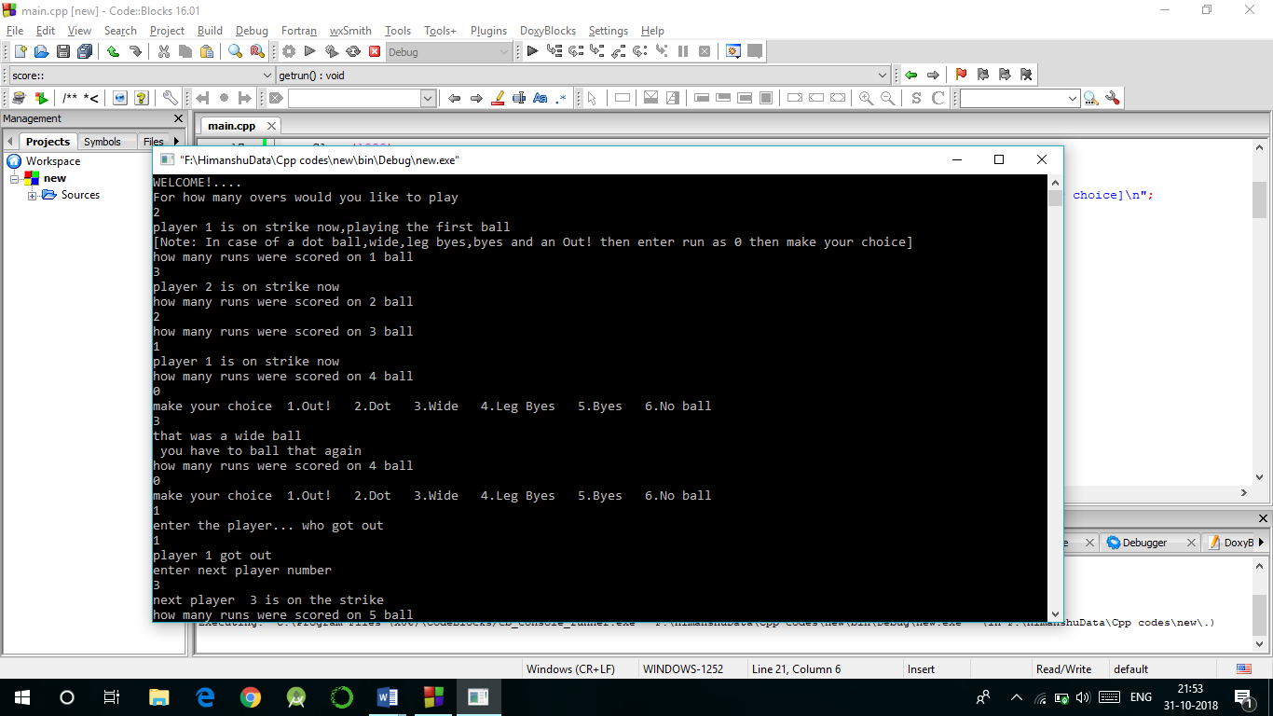

**Scorecard:**

