**Course = MKT905(Digital Marketing)**

CA1 Report on

WEBSITE NAME= **Beyond the Haze**

Submitted in partial fulfillment of the requirements for the award of degree of

**B.Tech(Computer Science and engineering)**

**LOVELY PROFESSIONAL UNIVERSITY**

**PHAGWARA, PUNJAB**



### 

### **SUBMITTED TO: Dr. Richa Bhatia: 17438**

|  |  |  |  |
| --- | --- | --- | --- |
| Serial No. | Name | Registration No. | Peer Rating |
| **1** | Amandeep singh | 12101332 | 10 |
| **2** | Owais Nabi Bhat | 12100673 | 10 |
| **3** | Abhishek Ubale | 12101294 | 10 |

**Part A: Understanding SEO Fundamentals:**

Understanding SEO (Search Engine Optimization) fundamentals is crucial for improving a website's visibility and ranking on search engine results pages (SERPs).

**Knowing Target Audience:**

By conducting various researches and findings, we finally came across a survey Report regarding drug usage statistics in India in various states.

*Here is the attached link :* https://drive.google.com/file/d/1JAkJaeEInPpU5SMHp65-4HlbYfjxrdZm/view?usp=drive_link

**Key findings:**

* In the household survey, a total of 200,111 households across 36 states and UTs were visited (spread across 5808 Primary Sampling Units and 186 districts) and a total of 473,569 individuals were interviewed. Notably, at the national level, the sample selected for HHS closely matched that of census 2011 (in terms of male:female, and urban:rural ratios and age-group distribution).
* Alcohol use does not appear to be an exclusively male phenomena. Though the prevalence of alcohol use among women is substantially lower than the men, it is notable that alcohol use exists among women in almost all the states of country. alcohol use has been reported in all the age groups, including among children aged 10-17 years. However, the demographic group with the largest prevalence of alcohol use is men more than 18 years of age.
* About one in five alcohol using men suffer from alcohol dependence, while only one in sixteen alcohol using women is dependent on it.

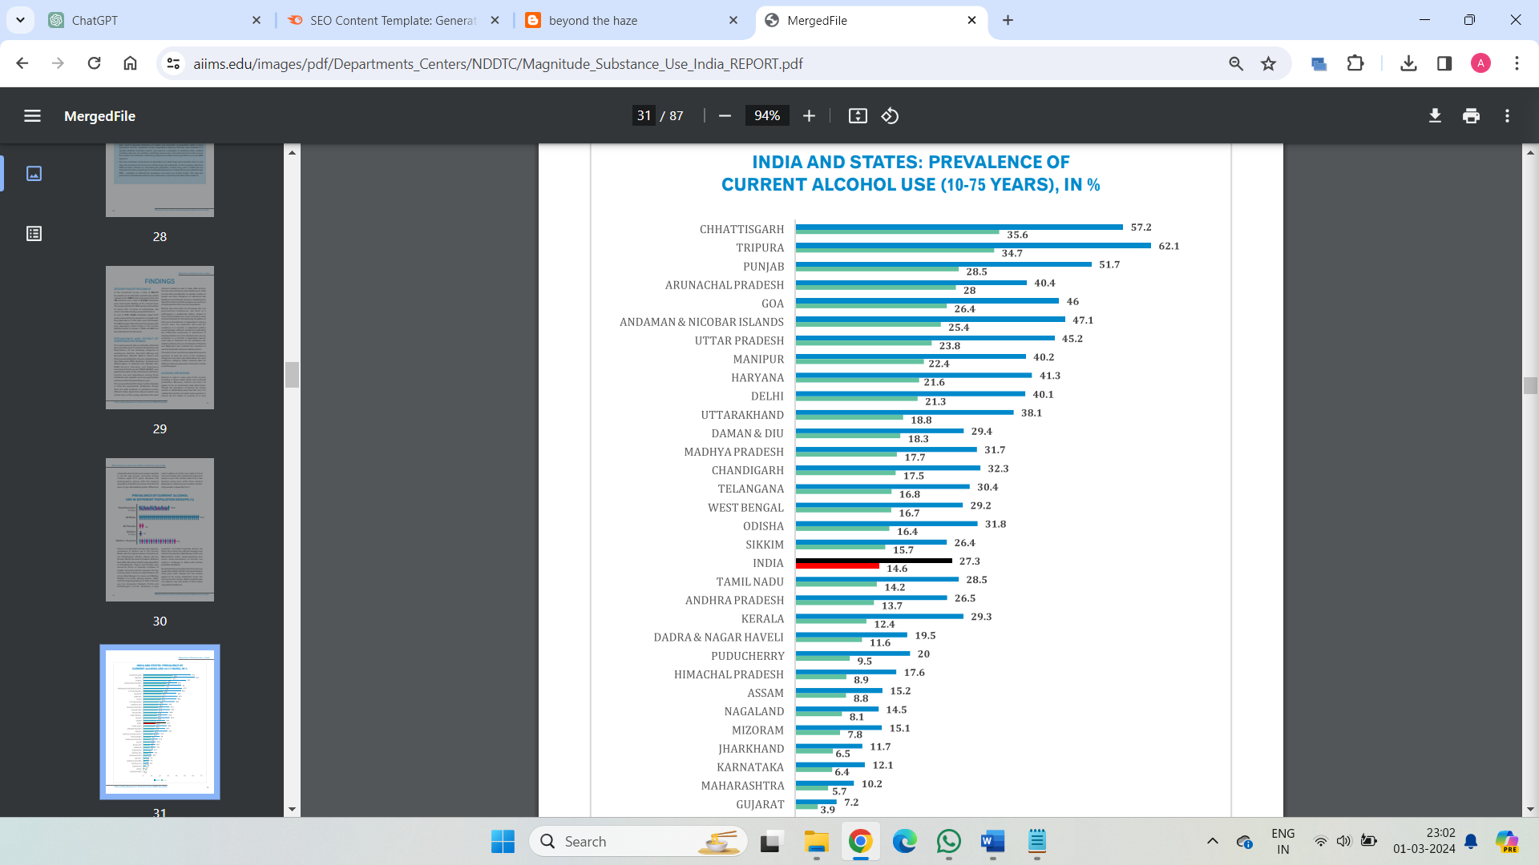

* In India, Cannabis is used as, (a) Bhang, which is legally available in many states and (b) Ganja and Charas which are illegal as per the international drug conventions as well as the Indian law (the NDPS Act, 1985). About 2.8% of Indians aged 10-75 years (3.1 crore individuals) are current users of any cannabis product. More number of people use bhang (2%) as compared to charas/ganja (1.2%). There is a preponderan.

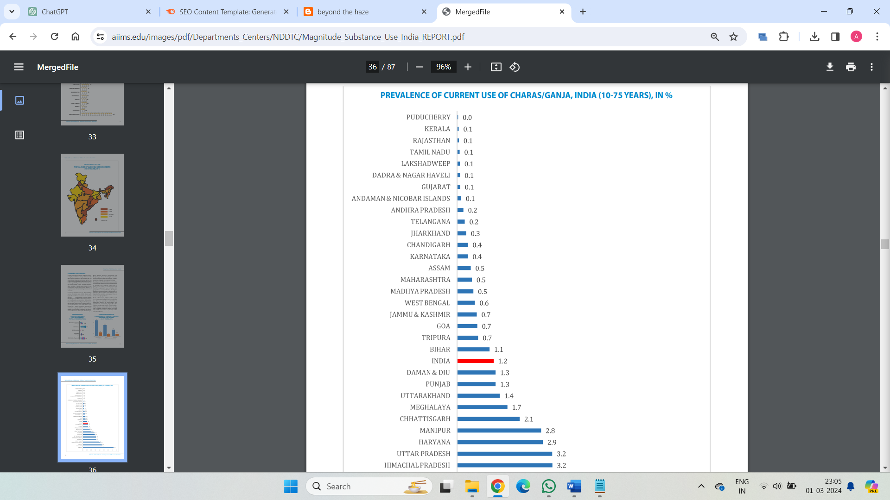

**Website Analytics:**

It includes : - It includes keywords, traffic, traffic cost, branded traffic and non-branded traffic.

1. Keywords: Words or phrases users type into search engines to find information.They're essential for SEO and advertising strategies.

2. Traffic: The number of visitors a website receives. It's a key metric for assessing website performance.

3. Traffic Cost: The estimated value of the traffic a website receives, often used in advertising and marketing calculations.

4. Branded Traffic: Visitors who reach a website by searching for the brand name specifically. It reflects brand awareness and loyalty.

5. Non-branded Traffic: Visitors who reach a website by searching for terms not directly related to the brand. It indicates the effectiveness of SEO efforts and overall visibility.

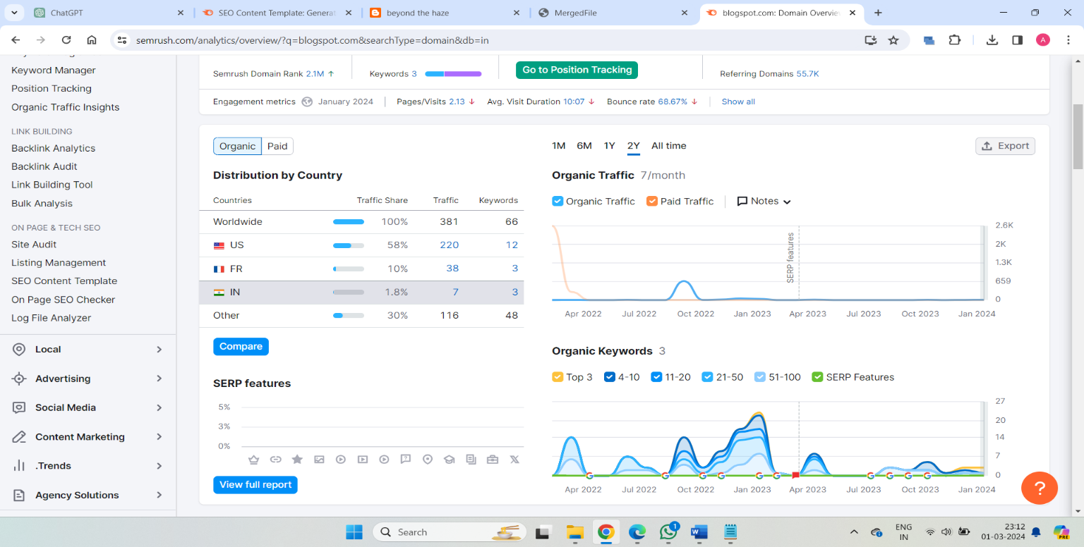

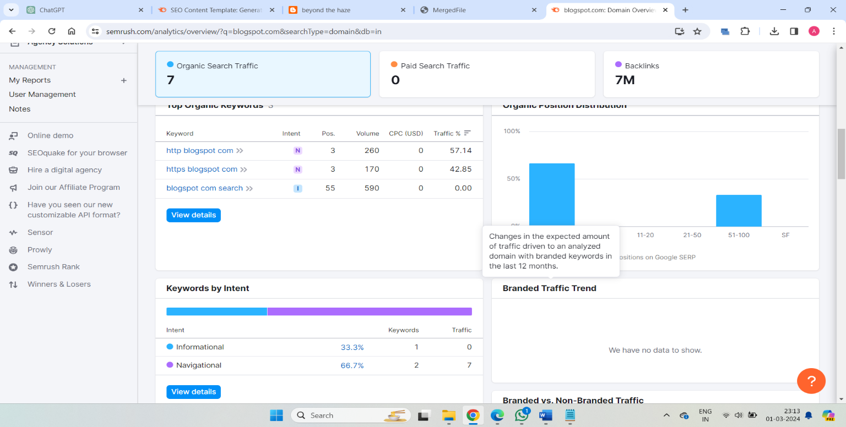

KEYWORD ANALYSIS

Keyword research is the process of finding and analyzing what relevant audiences search for in search engines like Google. So you can create content that’s more likely to rank highly in search results. It’s a crucial part of any search engine optimization (SEO) strategy. And a helpful step to take whenever you’re planning new content.

Using Semrush keyword research tool, we have tried to create Analytic reports for various keywords relevant to the website.

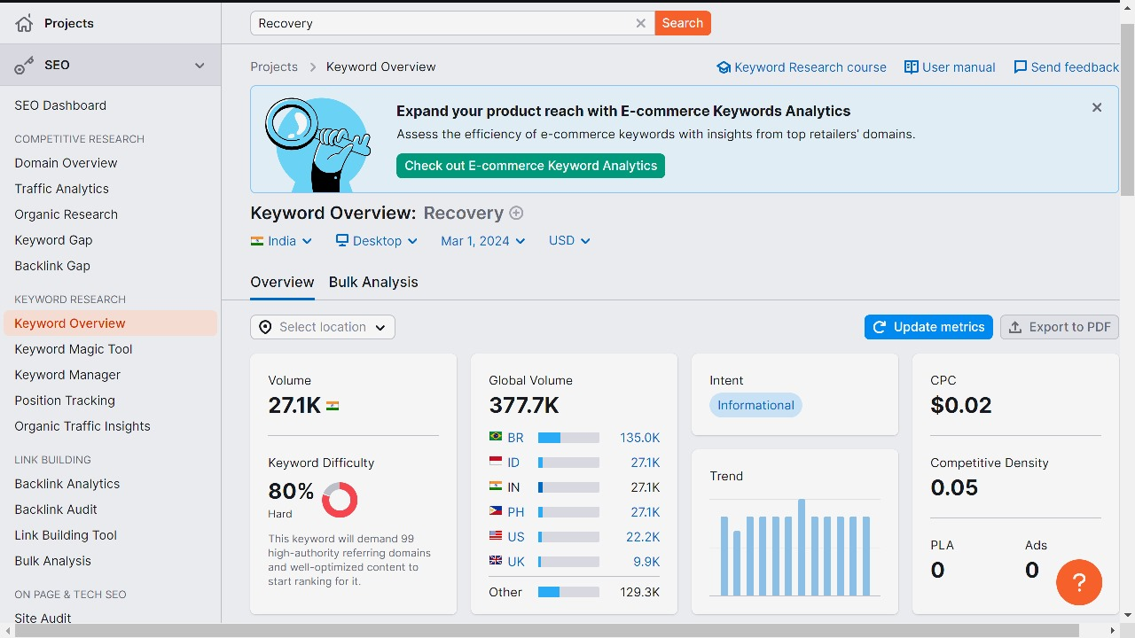

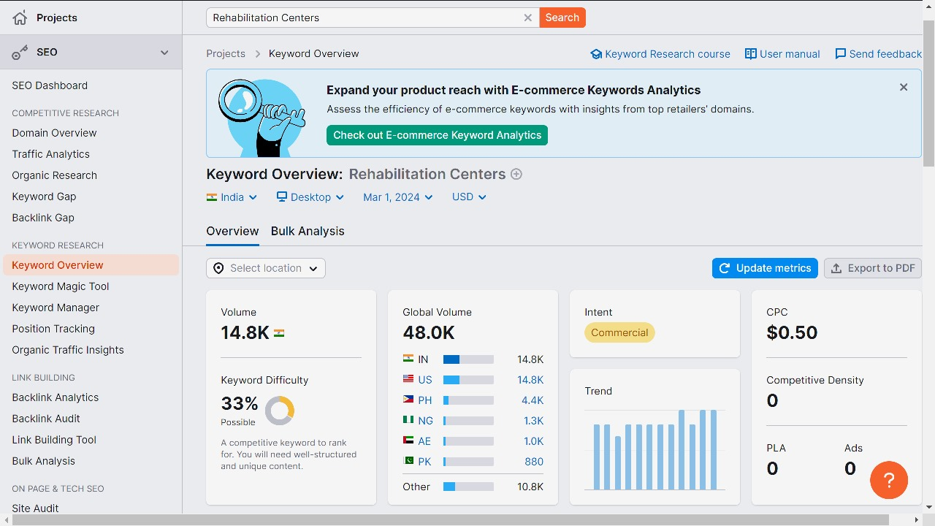

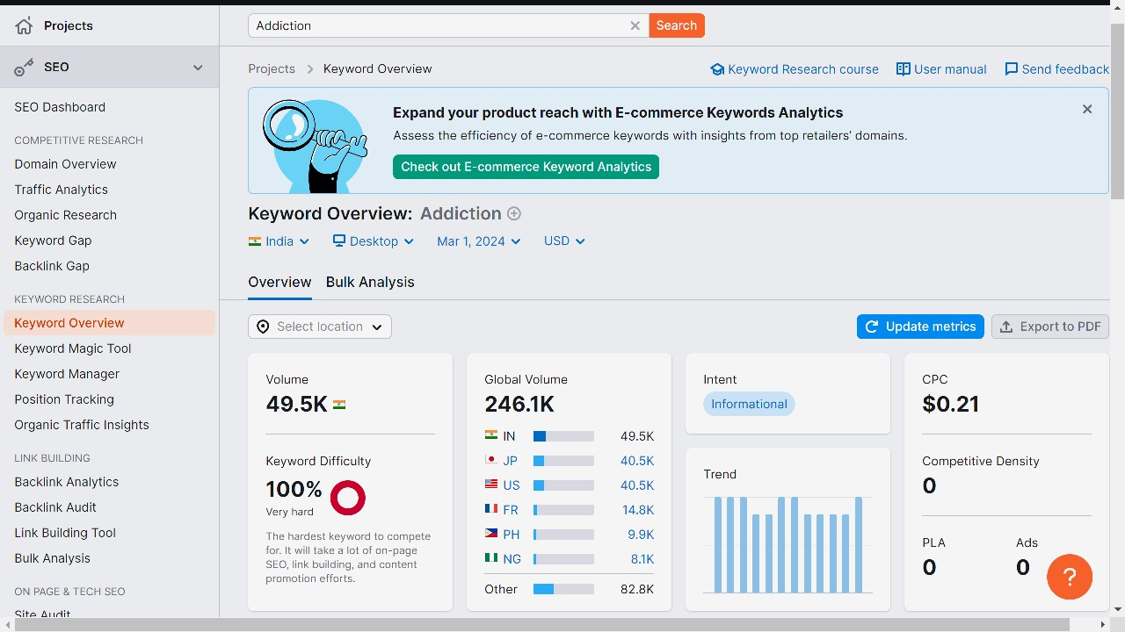

*The detailed analysis of keyword research can be accessed at*: https://drive.google.com/file/d/1E33_PDi1KsXcpFzQFzjAcrGcC6wH5J9y/view?usp=drive_link

KEY FINDINGS:

1. **Keyword Trends**: The data showcases a variety of keywords related to website creation, management, and optimization. These keywords range from generic terms like "website" and "site" to more specific phrases like "create your website" and "website builder." This suggests a diverse range of user intents, from individuals looking to build their own websites to businesses seeking website development services.
2. **Search Volume Distribution**: The average monthly searches for the listed keywords vary significantly, ranging from as low as 50 to as high as 500,000. This distribution suggests varying levels of user interest and demand for different aspects of website creation and management.
3. **Competition Analysis**: The competition level for the keywords is predominantly Low or Medium, indicating that while there is competition, it may still be feasible for businesses to rank or advertise for these keywords with effective strategies. However, some keywords show higher competition levels, suggesting more intense competition in those niches.
4. **Bid Range Insights**: The bid ranges provide insights into the cost of advertising for each keyword. Lower bid ranges indicate less competitive keywords, while higher bid ranges suggest more competition among advertisers. Businesses can use this information to optimize their advertising budgets and choose keywords that offer a balance between visibility and cost-effectiveness.
5. **Year-Over-Year Changes**: Some keywords show significant year-over-year changes in search volume, with increases of up to 900%. This indicates evolving user interests and trends in the website creation and management space. Monitoring such changes can help businesses adapt their strategies to capitalize on emerging opportunities.
6. **Data Gaps and Unknowns**: The presence of unknown or missing data points, such as three-month changes and competition levels for some keywords, highlights potential limitations in data collection or reporting. Businesses should consider the completeness and reliability of available data when making decisions based on these insights.

Overall, these insights provide valuable information for businesses involved in website development, SEO, and SEM, helping them understand market dynamics, prioritize keywords, and optimize their strategies for better visibility and competitiveness.

Keyword mapping involves assigning target landing pages to specific keywords based on relevance and search intent. Here's a simplified keyword mapping for the provided list of keywords:

1. **Primary Keywords**:
   * "website builder"
   * "create your website"
   * "web builder"
   * "start your website"
   * "create a website now"
   * "develop your website"
   * "website platform"

**Target Landing Page**: Homepage or main landing page promoting website building services or tools.

**Secondary Keywords**:

* "site builder"
* "create site"
* "create your site"
* "start a website"
* "web site is"
* "website create"
* "create your on website"
* "create your web"
* "create web sites"
* "create your page"
* "site for website"
* "more about website"
* "about our website"
* "about home page"
* "homepage page"
* "main page"

**Target Landing Page**: Subpages or specific service pages within the website that provide detailed information about website creation, different features, pricing, testimonials, etc.

**Part C: Implementing Content Marketing and Internal Linking:**

Crafting compelling and invaluable content tailored precisely to our audience's needs is paramount in addressing drug addiction and providing meaningful support.

**Our Approach to Content Strategy:** At Beyond the Haze, we meticulously shape our content strategy rooted in comprehensive research on addiction, profound understanding of our audience, and awareness of current treatment methodologies. This involves carefully constructing a content calendar, pinpointing pertinent topics and formats, and setting clear content goals and objectives aimed at providing education, guidance, and support.

**Diverse Range of Content:** Beyond the Haze is dedicated to providing a diverse range of content types, each carefully curated to address various aspects of drug addiction and recovery. From insightful articles and personal stories to expert interviews, practical tips, and resources for seeking help, our content aims to inform, inspire, and empower individuals on their journey towards overcoming addiction.

**Optimizing Content for Maximum Impact**: At Beyond the Haze, we are committed to optimizing every piece of content to ensure it reaches and resonates with those who need it most. This involves strategically incorporating relevant keywords, crafting compelling headlines and meta descriptions, and providing clear calls-to-action for seeking help or further information. Through ongoing analysis and refinement, we strive to continuously improve our content's visibility, relevance, and effectiveness in supporting individuals affected by drug addiction.

**Keyword Specific Content:**

Are you looking to establish your online presence but feeling overwhelmed by the technicalities of **website builder**? Look no further than our intuitive **website builder** tool, designed to empower you to bring your vision to life effortlessly. With our platform, you can easily **create your website** from scratch or customize professionally designed templates to suit your brand identity. Whether you're a novice entrepreneur or a seasoned professional, our **web builder** offers the flexibility and functionality you need to **start your website** journey with confidence. Take the first step towards realizing your online dreams by **developing your website** today!

For those seeking more guidance and insights into the **website building** process, our comprehensive guides and tutorials offer invaluable resources. From step-by-step instructions on **creating your site** to in-depth comparisons of different **web builder** platforms, we equip you with the knowledge and tools needed to make informed decisions. Additionally, our dedicated FAQ pages address common queries about **website creation** and management, ensuring you have all the information you need at your fingertips.

At Beyond the haze, we understand the importance of optimizing every aspect of your **website** to maximize its effectiveness. That's why our landing pages are strategically designed to highlight key features and benefits, driving conversions and enhancing user experience. Whether you're showcasing your products or services or sharing your story with the world, our optimized **website sections**, including the **About Us page** and **homepage**, provide compelling insights into your brand and offerings.

Experience the power of personalized **website creation** with Beyond the haze where every aspect of your online presence is tailored to your unique needs and aspirations. From designing your **homepage** to crafting engaging content and optimizing for search engines, we go beyond the basics to ensure your **website** stands out from the crowd. Join our community of **website creators** today and discover the endless possibilities of building your online empire with Beyond the Haze.

**Content Marketing Plan:**

1. **Local SEO Optimization**:
   * "Beyond the Haze" optimizes its website content with local keywords related to drug addiction and recovery services in the specific geographical areas it serves.
   * The business claim and optimize its Google My Business listing with accurate information and encourage positive reviews from local clients.
2. **Localized Content Creation**:
   * Develop blog posts, articles, and resources addressing local addiction statistics, treatment options, and recovery success stories relevant to the community.
   * Highlight local rehabilitation centers, support groups, and resources available for individuals seeking help with addiction in the area.

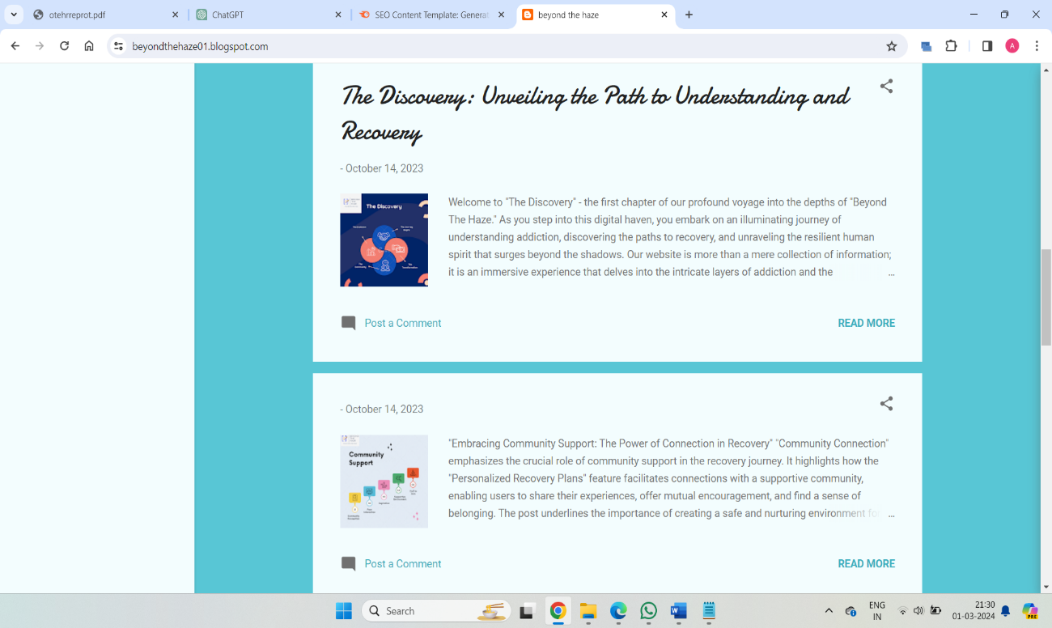

Blog Posts

1. **Community Engagement and Partnerships**:
   * Engage with local addiction support groups, healthcare providers, and community organizations to foster partnerships and collaborations.
   * Participate in local events, workshops, and awareness campaigns related to addiction prevention and recovery.
2. **Social Media Localization**:
   * Create social media content tailored to address local addiction-related issues, share local success stories, and promote community events and resources.
   * Utilize geotargeting features on social media platforms to reach local audiences effectively.

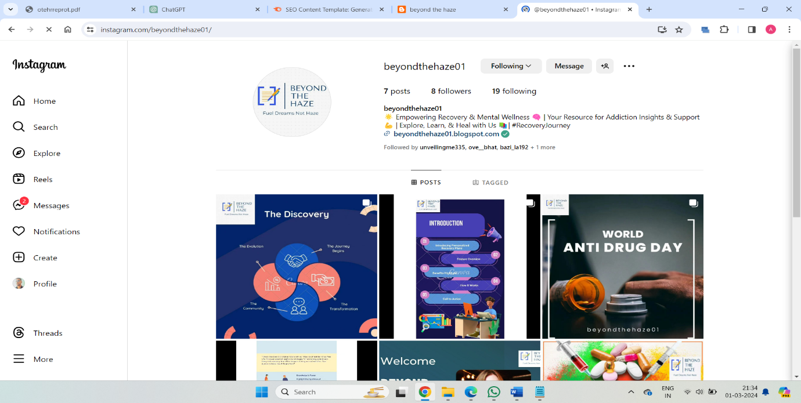

Instagram posts

1. **Local Online Advertising**:
   * Invest in online advertising channels such as Google Ads or Facebook Ads targeting local audiences searching for addiction recovery resources.
   * Create ad campaigns with localized messaging highlighting "Beyond the Haze's" services, testimonials, and success stories in the area.

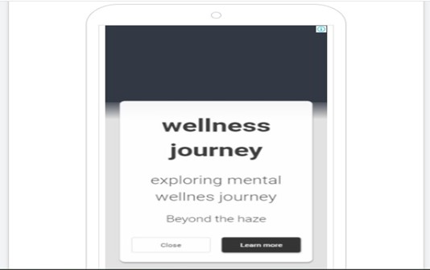

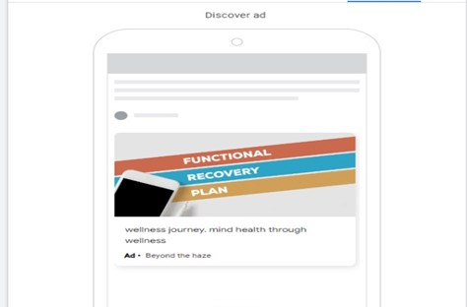

1. **Monitor and Measure Results**:
   * Use analytics tools to track website traffic, engagement metrics, and local search performance to assess the effectiveness of the content marketing efforts.
   * Monitor online reviews, social media mentions, and brand sentiment to gauge the impact of local content and engagement strategies.

**Internal Linking Structure:**

An internal link is any link from one page on your website to another page on your website. Your users and search engines use links to find content on your website. Your users use links to navigate through your site and to find the content they want to find. Search engines also use links to navigate your site.

Here, we have shown the report about Internal Links in our website which shows the need for strengthening the internal structure to make the website more interactive.

**Social Networks to boost the website's SEO.**

**Increased Website Visibility*:*** Sharing content on social networks exposes it to a wider audience beyond your website visitors. When users engage with your content on social media platforms like Facebook, Twitter, LinkedIn, or Instagram, it can lead to increased visibility and traffic to your website.

**Backlinks and Referral Traffic**: Social media shares can generate backlinks when other users or websites reference and link back to your content. These backlinks signal to search engines that your content is valuable and relevant, potentially improving your website's search engine rankings. Additionally, referral traffic from social media can contribute to your website's overall traffic and SEO performance.

**Social Signals**: While the direct impact of social signals on search engine rankings is debated among SEO professionals, there is evidence to suggest that social engagement metrics (likes, shares, comments) can indirectly influence rankings. Search engines may consider social signals as indicators of content quality, relevance, and user engagement, which can contribute to improved SEO performance.

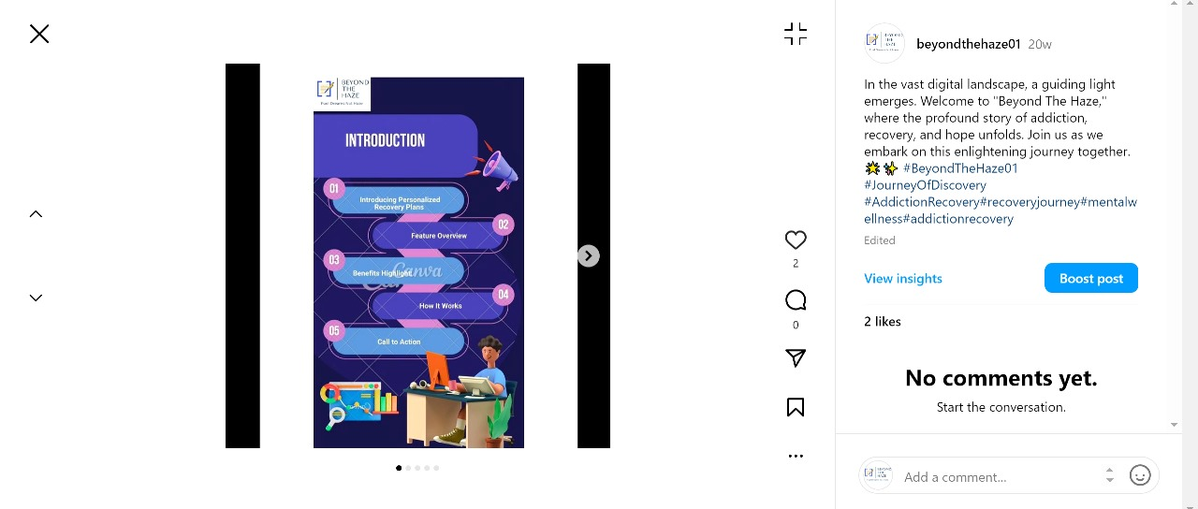

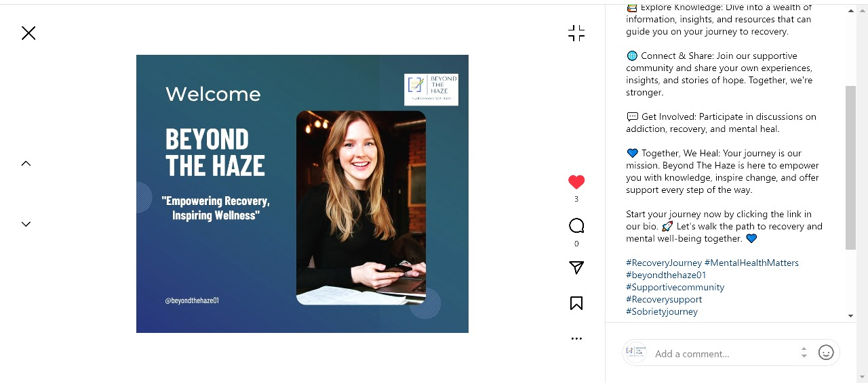

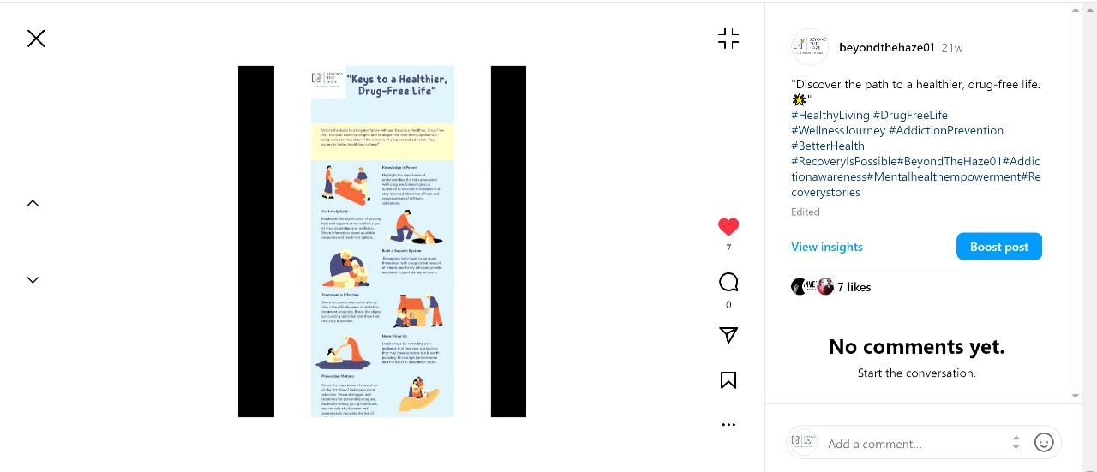

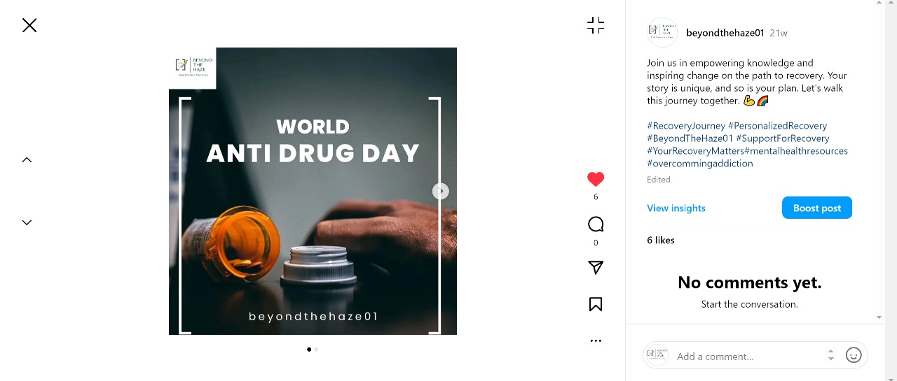

Overall, integrating social media into your SEO strategy can amplify your website's reach, engagement, and authority, ultimately leading to improved search engine rankings and visibility.

**Social Media Links:** [**https://www.instagram.com/beyondthehaze01/**](https://www.instagram.com/beyondthehaze01/)