**QUESTION 1**

1. Database access frequencies are estimated from:

|  |  |  |
| --- | --- | --- |
|  |  | transaction volumes |
|  |  | user logins |
|  |  | security violations |
|  |  | random number generation |

**1 points**

**QUESTION 2**

1. Which of the following criteria should be considered when selecting an identifier

|  |  |  |
| --- | --- | --- |
|  |  | Choose an identifier that is not stable |
|  |  | Choose a null identifier. |
|  |  | Choose an identifier that doesn't have large composite attributes. |
|  |  | Choose the most complex identifier possible . |

**1 points**

**QUESTION 3**

1. A simultaneous relationship among the instances of three entity types is called a ________

|  |  |  |
| --- | --- | --- |
|  |  | number |
|  |  | identifying characteristic. |
|  |  | degree |
|  |  | counter |

**1 points**

**QUESTION 4**

1. In an E-R diagram, there are/is ________ business rule(s) for every relationship.

|  |  |  |
| --- | --- | --- |
|  |  | two |
|  |  | three |
|  |  | one |
|  |  | zero |

**1 points**

**QUESTION 5**

1. Which of the following is an entity that exists independently of other entity types?

|  |  |  |
| --- | --- | --- |
|  |  | Codependent |
|  |  | Weak |
|  |  | Strong |
|  |  | Variant |

**1 points**

**QUESTION 6**

1. A(n) ________ is the relationship between a weak entity type and its owner.

|  |  |  |
| --- | --- | --- |
|  |  | member chain |
|  |  | identifying relationship |
|  |  | jump path |
|  |  | chain link |

**1 points**

**QUESTION 7**

1. A ________ specifies the number of instances of one entity that can be associated with each instance of another entity.

|  |  |  |
| --- | --- | --- |
|  |  | degree |
|  |  | cardinality constraint |
|  |  | counter constraint |
|  |  | limit |

**1 points**

**QUESTION 8**

1. 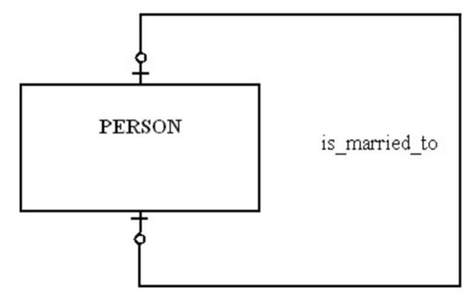

|  |  |  |
| --- | --- | --- |
|  |  | A person can marry at most one person |
|  |  | A person has to be married. |
|  |  | A person can marry more than one person, but that person can only be married to one person. |
|  |  | A person can marry more than one person. |

**1 points**

**QUESTION 9**

1. A person's name, birthday, and social security number are all examples of

|  |  |  |
| --- | --- | --- |
|  |  | attributes |
|  |  | entities |
|  |  | relationships |
|  |  | descriptors |

**1 points**

**QUESTION 10**

1. An entity type whose existence depends on another entity type is called a ________ entity.

|  |  |  |
| --- | --- | --- |
|  |  | strong |
|  |  | weak |
|  |  | codependent |
|  |  | variant |

**1 points**

**QUESTION 11**

1. The relationship between a weak entity type and its owner is an identifying relationship.

 True

 False

**1 points**

**QUESTION 12**

1. Which of the following is NOT a good characteristic of a data name?

|  |  |  |
| --- | --- | --- |
|  |  | Relates to business characteristics |
|  |  | Relates to a technical characteristic of the system |
|  |  | Repeatable |
|  |  | Readable |

**1 points**

**QUESTION 13**

1. When choosing an identifier, choose one that will not change its value often.

 True

 False

**1 points**

**QUESTION 14**

1. An attribute of an entity that must have a value for each entity instance is a(n):

|  |  |  |
| --- | --- | --- |
|  |  | required attribute. |
|  |  | composite attribute. |
|  |  | fuzzy attribute. |
|  |  | optional attribute. |

**1 points**

**QUESTION 15**

1. In the figure below, which attribute is derived?   
     
   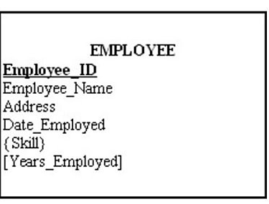

|  |  |  |
| --- | --- | --- |
|  |  | Skill |
|  |  | Employee_ID |
|  |  | Years_Employed |
|  |  | Address |

**1 points**

**QUESTION 16**

1. In the figure shown below, which of the following business rules would apply?   
   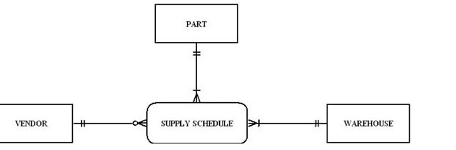

|  |  |  |
| --- | --- | --- |
|  |  | Each warehouse can be supplied with any number of parts from more than one vendor, and each warehouse could be supplied with no parts. |
|  |  | VENDOR is not allowed. |
|  |  | Each vendor can supply many parts to any number of warehouses, but need not supply any parts. |
|  |  | Each part must be supplied by exactly one vendor to any number of warehouses. |

**1 points**

**QUESTION 17**

1. A business rule should be internally consistent.

 True

 False

**1 points**

**QUESTION 18**

1. A good data definition is always accompanied by diagrams, such as the entity-relationship diagram.

 True

 False

**1 points**

**QUESTION 19**

1. A multivalued attribute may take on more than one value for a particular entity instance.

 True

 False

**1 points**

**QUESTION 20**

1. Data modeling is about documenting rules and policies of an organization that govern data.

 True

 False

**1 points**

**QUESTION 21**

1. In the following diagram, which of the answers below is true?  
     
   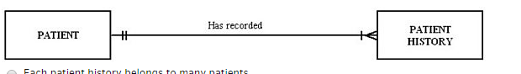

|  |  |  |
| --- | --- | --- |
|  |  | Each patient history belongs to many patients. |
|  |  | Each patient history belongs to zero and one patient. |
|  |  | Each patient has one and only one visit. |
|  |  | Each patient has one or more patient histories. |

**1 points**

**QUESTION 22**

1. A relationship between the instances of a single entity type is called a ________ relationship.

|  |  |  |
| --- | --- | --- |
|  |  | binary |
|  |  | unary |
|  |  | primary |
|  |  | ternary |

**1 points**

**QUESTION 23**

1. A property or characteristic of an entity type that is of interest to the organization is called a(n):

|  |  |  |
| --- | --- | --- |
|  |  | cross-function. |
|  |  | relationship. |
|  |  | coexisting entity. |
|  |  | attribute. |

**1 points**

**QUESTION 24**

1. While business rules are not redundant, a business rule can refer to another business rule.

 True

 False

**1 points**

**QUESTION 25**

1. A student can attend five classes, each with a different professor. Each professor has 30 students. The relationship of students to professors is a ________ relationship.

|  |  |  |
| --- | --- | --- |
|  |  | one-to-many |
|  |  | one-to-one |
|  |  | many-to-many |
|  |  | strong |

**1 points**

**QUESTION 26**

1. In the figure below, which attribute is multivalued?   
     
   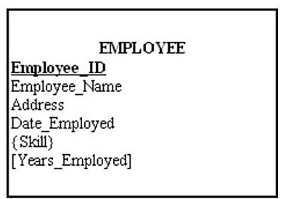

|  |  |  |
| --- | --- | --- |
|  |  | Skill |
|  |  | Employee_ID |
|  |  | Years_Employed |
|  |  | Address |

**1 points**

**QUESTION 27**

1. The total quiz points for a student for an entire semester is a(n) ________ attribute.

|  |  |  |
| --- | --- | --- |
|  |  | mixed |
|  |  | addressed |
|  |  | stored |
|  |  | derived |

**1 points**

**QUESTION 28**

1. A customer can order many items, and an item can be ordered by many customers is an example of a recursive relationship.

 True

 False

**1 points**

**QUESTION 29**

1. Data modeling may be the most important part of the systems development process because:

|  |  |  |
| --- | --- | --- |
|  |  | it is the easiest. |
|  |  | the data in a system are generally less complex than processes and play a central role in development. |
|  |  | data characteristics are important in the design of programs and other systems components. |
|  |  | data are less stable than processes. |

**1 points**

**QUESTION 30**

1. A value that indicates the date or time of a data value is called a:

|  |  |  |
| --- | --- | --- |
|  |  | checkpoint. |
|  |  | time stamp. |
|  |  | check counter. |
|  |  | value stamp. |

**1 points**

**QUESTION 31**

1. A simple attribute can be broken down into smaller pieces.

 True

 False

**1 points**

**QUESTION 32**

1. A ternary relationship is equivalent to three binary relationships.

 True

 False

**1 points**

**QUESTION 33**

1. A ________ defines or constrains some aspect of the business.

|  |  |  |
| --- | --- | --- |
|  |  | business control |
|  |  | business structure |
|  |  | business rule |
|  |  | business constraint |

**1 points**

**QUESTION 34**

1. A good data definition will describe all of the characteristics of a data object EXCEPT:

|  |  |  |
| --- | --- | --- |
|  |  | who can delete the data. |
|  |  | subtleties. |
|  |  | who determines the value of the data. |
|  |  | examples. |

**1 points**

**QUESTION 35**

1. In the figure below, what is depicted?   
   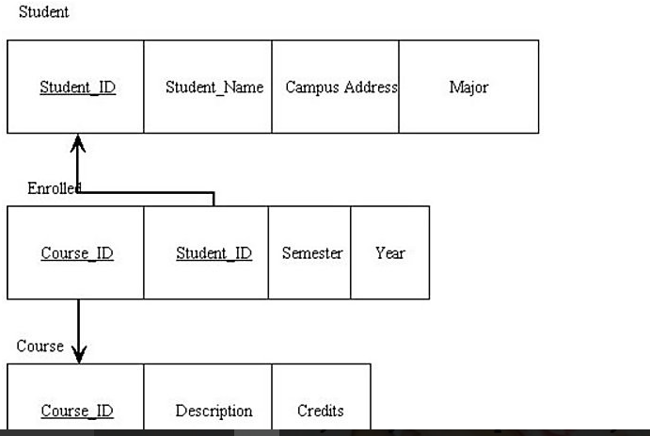

|  |  |  |
| --- | --- | --- |
|  |  | A unary relationship |
|  |  | A one-to-one relationship |
|  |  | A one-to-many relationship |
|  |  | An associative entity |

**1 points**

**QUESTION 36**

1. A nonkey attribute is also called a(n):

|  |  |  |
| --- | --- | --- |
|  |  | descriptor. |
|  |  | column. |
|  |  | address. |
|  |  | unimportant datum. |

**1 points**

**QUESTION 37**

1. ________ problems are encountered when removing data with transitive dependencies.

|  |  |  |
| --- | --- | --- |
|  |  | Modification |
|  |  | Insertion |
|  |  | Merging |
|  |  | Deletion |

**1 points**

**QUESTION 38**

1. Anomalies do not generally arise out of transitive dependencies.

 True

 False

**1 points**

**QUESTION 39**

1. Which of the following violates the atomic property of relations?

|  |  |  |
| --- | --- | --- |
|  |  | Sam Hinz |
|  |  | Hinz |
|  |  | Atomic |
|  |  | Sam |

**1 points**

**QUESTION 40**

1. An anomaly is a type of flaw in the database server.

 True

 False

**1 points**

**QUESTION 41**

1. An attribute that may have more than one meaning is called a(n):

|  |  |  |
| --- | --- | --- |
|  |  | homonym. |
|  |  | double defined attribute. |
|  |  | alias. |
|  |  | synonym. |

**1 points**

**QUESTION 42**

1. A primary key whose value is unique across all relations is called a(n):

|  |  |  |
| --- | --- | --- |
|  |  | global primary key. |
|  |  | enterprise key. |
|  |  | inter-table primary key. |
|  |  | foreign global key. |

**1 points**

**QUESTION 43**

1. A two-dimensional table of data sometimes is called a:

|  |  |  |
| --- | --- | --- |
|  |  | group. |
|  |  | set. |
|  |  | declaration. |
|  |  | relation. |

**1 points**

**QUESTION 44**

1. A functional dependency between two or more nonkey attributes is called a:

|  |  |  |
| --- | --- | --- |
|  |  | partial nonkey dependency. |
|  |  | transitive dependency. |
|  |  | partial functional dependency. |
|  |  | partial transitive dependency. |

**1 points**

**QUESTION 45**

1. Which of the following are properties of relations?

|  |  |  |
| --- | --- | --- |
|  |  | All columns are numeric. |
|  |  | There are multivalued attributes in a relation. |
|  |  | No two rows in a relation are identical. |
|  |  | Each attribute has the same name. |

**1 points**

**QUESTION 46**

1. An alternative name for an attribute is called a(n):

|  |  |  |
| --- | --- | --- |
|  |  | alternate attribute. |
|  |  | synonym. |
|  |  | alias. |
|  |  | related characteristic. |

**1 points**

**QUESTION 47**

1. A constraint between two attributes is called a(n):

|  |  |  |
| --- | --- | --- |
|  |  | functional dependency. |
|  |  | functional relation. |
|  |  | attribute dependency. |
|  |  | functional relation constraint. |

**1 points**

**QUESTION 48**

1. When normalizing, the goal is to decompose relations with anomalies to produce smaller, well-structured relations.

 True

 False

**1 points**

**QUESTION 49**

1. A relation that contains no multivalued attributes and has nonkey attributes solely dependent on the primary key but contains transitive dependencies is in which normal form?

|  |  |  |
| --- | --- | --- |
|  |  | First |
|  |  | Second |
|  |  | Third |
|  |  | Fourth |

**1 points**

**QUESTION 50**

1. A domain definition consists of all of the following components EXCEPT:

|  |  |  |
| --- | --- | --- |
|  |  | domain name. |
|  |  | integrity constraints. |
|  |  | data type. |
|  |  | size. |

**1 points**

**QUESTION 51**

1. A well-structured relation contains minimal redundancy and allows users to manipulate the relation without errors or inconsistencies.

 True

 False

**1 points**

**QUESTION 52**

1. A relation that contains minimal redundancy and allows easy use is considered to be:

|  |  |  |
| --- | --- | --- |
|  |  | clean. |
|  |  | simple. |
|  |  | well-structured. |
|  |  | complex. |

**1 points**

**QUESTION 53**

1. The normal form which removes any remaining functional dependencies because there was more than one primary key for the same nonkeys is called:

|  |  |  |
| --- | --- | --- |
|  |  | sixth normal form. |
|  |  | fifth normal form. |
|  |  | fourth normal form. |
|  |  | Boyce-Codd normal form. |

**1 points**

**QUESTION 54**

1. A referential integrity constraint is a rule that maintains consistency among the rows of two relations.

 True

 False

**1 points**

**QUESTION 55**

1. A relation is in first normal form if it has no more than one multivalued attribute.

 True

 False

**1 points**

**QUESTION 56**

1. A partial functional dependency is a functional dependency in which one or more nonkey attributes are functionally dependent on part (but not all) of the primary key.

 True

 False

**1 points**

**QUESTION 57**

1. ________ is a component of the relational data model included to specify business rules to maintain the integrity of data when they are manipulated.

|  |  |  |
| --- | --- | --- |
|  |  | Data structure |
|  |  | Data integrity |
|  |  | Business integrity |
|  |  | Business rule constraint |

**1 points**

**QUESTION 58**

1. Data is represented in the form of:

|  |  |  |
| --- | --- | --- |
|  |  | data trees. |
|  |  | tables. |
|  |  | chairs. |
|  |  | data notes. |

**1 points**

**QUESTION 59**

1. An enterprise key is a foreign key whose value is unique across all relations.

 True

 False

**1 points**

**QUESTION 60**

1. A cascading delete removes all records in other tables associated with the record to be deleted.

 True

 False

**1 points**

**QUESTION 61**

1. A functional dependency in which one or more nonkey attributes are functionally dependent on part, but not all, of the primary key is called a ________ dependency.

|  |  |  |
| --- | --- | --- |
|  |  | partial key-based |
|  |  | merged relation |
|  |  | cross key |
|  |  | partial functional |

**1 points**

**QUESTION 62**In the figure below, what type of relationship do the relations depict?   
  
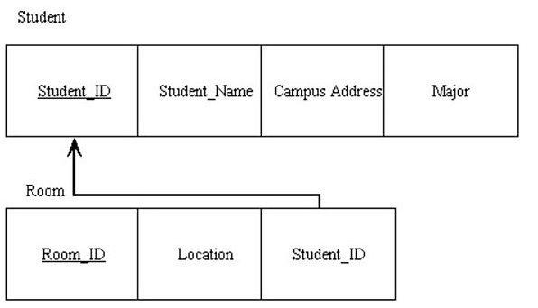

|  |  |  |
| --- | --- | --- |
|  |  | Many-to-many |
|  |  | Ternary |
|  |  | One-to-many |
|  |  | Strong entity/weak entity |

**1 points**

**QUESTION 63**

1. A primary key that consists of more than one attribute is called a:

|  |  |  |
| --- | --- | --- |
|  |  | multivalued key. |
|  |  | composite key. |
|  |  | foreign key. |
|  |  | cardinal key. |

**1 points**

**QUESTION 64**

1. A candidate key is an attribute, or combination of attributes, that uniquely identifies a row in a relation.

 True

 False

**1 points**

**QUESTION 65**

1. The ________ states that no primary key attribute may be null.

|  |  |  |
| --- | --- | --- |
|  |  | partial specialization rule |
|  |  | referential integrity constraint |
|  |  | range domain rule |
|  |  | entity integrity rule |

**1 points**

**QUESTION 66**

1. A candidate key must satisfy all of the following conditions EXCEPT:

|  |  |  |
| --- | --- | --- |
|  |  | the key must indicate the row's position in the table. |
|  |  | the key must uniquely identify the row. |
|  |  | each nonkey attribute is functionally dependent upon it. |
|  |  | the key must be nonredundant. |

**1 points**

**QUESTION 67**

1. A rule that states that each foreign key value must match a primary key value in the other relation is called the:

|  |  |  |
| --- | --- | --- |
|  |  | key match rule. |
|  |  | entity key group rule. |
|  |  | referential integrity constraint. |
|  |  | foreign/primary match rule. |

**1 points**

**QUESTION 68**

1. Horizontal partitioning makes sense:

|  |  |  |
| --- | --- | --- |
|  |  | when partitions must be organized the same. |
|  |  | when less security is needed. |
|  |  | when only one category is allowed. |
|  |  | when different categories of a table's rows are processed separately. |

**1 points**

**QUESTION 69**

1. A disadvantage of partitioning is:

|  |  |  |
| --- | --- | --- |
|  |  | simplicity. |
|  |  | shorter technology spans. |
|  |  | remote optimization. |
|  |  | extra space and update time. |

**1 points**

**QUESTION 70**

1. Parallel query processing speed is not significantly different from running queries in a non-parallel mode.

 True

 False

**1 points**

**QUESTION 71**

1. A method to allow adjacent secondary memory space to contain rows from several tables is called:

|  |  |  |
| --- | --- | --- |
|  |  | clustering. |
|  |  | concatenating. |
|  |  | compiling. |
|  |  | cluttering. |

**1 points**

**QUESTION 72**

1. One objective of selecting a data type is to minimize storage space.

 True

 False

**1 points**

**QUESTION 73**

1. Which type of file is most efficient with storage space?

|  |  |  |
| --- | --- | --- |
|  |  | Sequential |
|  |  | Indexed |
|  |  | Hashed |
|  |  | Clustered |

**1 points**

**QUESTION 74**

1. Using an index for attributes referenced in ORDER BY and GROUP BY clauses has no significant impact upon database performance.

 True

 False

**1 points**

**QUESTION 75**

1. Keeping the zip code with the city and state in a table is a typical form of denormalization.

 True

 False

**1 points**

**QUESTION 76**

1. The smallest unit of named application data is a record.

 True

 False

**1 points**

**QUESTION 77**

1. In a Heap file organization, files are not stored in any particular order:

 True

 False

**1 points**

**QUESTION 78**

1. Security is one advantage of partitioning.

 True

 False

**1 points**

**QUESTION 79**

1. A(n) ________ is a routine that converts a primary key value into a relative record number.

|  |  |  |
| --- | --- | --- |
|  |  | record index calculator |
|  |  | pointing algorithm |
|  |  | index pointer program |
|  |  | hashing algorithm |

**1 points**

**QUESTION 80**

1. An index on columns from two or more tables that come from the same domain of values is called a:

|  |  |  |
| --- | --- | --- |
|  |  | bitmap index. |
|  |  | transaction index. |
|  |  | join index. |
|  |  | multivalued index. |

**1 points**

**QUESTION 81**

1. In a sequential file, the records are stored in sequence according to a primary key value.

 True

 False

**1 points**

**QUESTION 82**

1. A method that speeds query processing by running a query at the same time against several partitions of a table using multiprocessors is called:

|  |  |  |
| --- | --- | --- |
|  |  | perpendicular query processing. |
|  |  | multiple partition queries. |
|  |  | query optimization. |
|  |  | parallel query processing. |

**1 points**

**QUESTION 83**

1. Which type of file is easiest to update?

|  |  |  |
| --- | --- | --- |
|  |  | Indexed |
|  |  | Hashed |
|  |  | Sequential |
|  |  | Clustered |

**1 points**

**QUESTION 84**

1. Requirements for response time, data security, backup and recovery are all requirements for physical design.

 True

 False

**1 points**

**QUESTION 85**

1. Indexes are most useful for columns that frequently appear in WHERE clauses of SQL commands, either to qualify the rows to select or for linking.

 True

 False

**1 points**

**QUESTION 86**

1. A(n) ________ is a technique for physically arranging the records of a file on secondary storage devices.

|  |  |  |
| --- | --- | --- |
|  |  | update program |
|  |  | retrieval program |
|  |  | physical pointer |
|  |  | file organization |

**1 points**

**QUESTION 87**

1. ________ partitioning distributes the columns of a table into several separate physical records.

|  |  |  |
| --- | --- | --- |
|  |  | Crossways |
|  |  | Vertical |
|  |  | Final |
|  |  | Horizontal |

**1 points**

**QUESTION 88**

1. A file organization that uses hashing to map a key into a location in an index where there is a pointer to the actual data record matching the hash key is called a:

|  |  |  |
| --- | --- | --- |
|  |  | multi-indexed file organization. |
|  |  | hashed file organization. |
|  |  | hash index table. |
|  |  | hash key. |

**1 points**

**QUESTION 89**

1. Denormalization almost always leads to more storage space for raw data.

 True

 False

**1 points**

**QUESTION 90**

1. A file organization where files are not stored in any particular order is considered a:

|  |  |  |
| --- | --- | --- |
|  |  | multi-indexed file organization. |
|  |  | hashed file organization. |
|  |  | hash key. |
|  |  | heap file organization. |

**1 points**

**QUESTION 91**

1. The logical database design always forms the best foundation for grouping attributes in the physical design.

 True

 False

**1 points**

**QUESTION 92**

1. A(n) ________ is a field of data used to locate a related field or record.

|  |  |  |
| --- | --- | --- |
|  |  | key |
|  |  | index |
|  |  | lock |
|  |  | pointer |

**1 points**

**QUESTION 93**

1. An advantage of partitioning is:

|  |  |  |
| --- | --- | --- |
|  |  | extra space and update time. |
|  |  | efficiency. |
|  |  | remote optimization. |
|  |  | increase redundancy. |

**1 points**

**QUESTION 94**

1. A factor to consider when choosing a file organization is:

|  |  |  |
| --- | --- | --- |
|  |  | efficient storage. |
|  |  | DDL. |
|  |  | DML. |
|  |  | inefficient data retrieval. |

**1 points**

**QUESTION 95**

1. A hashing algorithm is a routine that converts a primary key value into a relative record number.

 True

 False

**1 points**

**QUESTION 96**

1. Fast data retrieval is one factor to consider when choosing a file organization for a particular database file.

 True

 False

**1 points**

**QUESTION 97**

1. An appropriate datatype for one wanting a fixed-length type for last name would include

|  |  |  |
| --- | --- | --- |
|  |  | VarChar |
|  |  | Char |
|  |  | Blob |
|  |  | Date |

**1 points**

**QUESTION 98**

1. An appropriate datatype for adding a sound clip would be:

|  |  |  |
| --- | --- | --- |
|  |  | VarChar |
|  |  | Char |
|  |  | Blob |
|  |  | Date |

**1 points**

**QUESTION 99**

1. In a Heap file organization, files are not stored in any particular order:

 True

 False

**1 points**

**QUESTION 100**

1. In horizontal and vertical partitioning there is no change in access time nor any change in complexity

 True

 False