**CST8101 Computer Essentials**

**Lab 3**

**Backup and restore files and folders**

**Due Date:**

Wednesday, September 21-2016

**Marking: 10**

Objective:

In this exercise, you will be learning how to backup data. All of the labs are targeted to a laptop running **Windows 10**. For this lab make sure you have a **Skydrive** account to upload your folders online; you will also bring an **external hard drive** or **memory stick**, to back up and **restore** your folders.

Important note before you do the backup:

Make sure you backup ONLY the **Algonquin** folder and sub folders (files for all courses you are taking **Backup the first two weeks files only).**

**DO NOT BACK UP THE ENTIRE LABTOP.**

1. **Create a copy of your Blackboard courses.**
2. Log in to Blackboard ([http://online.algonquincollege.com](http://online.algonquincollege.com/)) using your network ID/password. You should see all the courses in which you are enrolled: In this example, you see courses **16F**_**CST8101-340** and **16F_CST8177_013 GNU/Linux operating system II** and **16F_CST8177_014 GNU.Linux operating system II** for this semesters. (F2016)

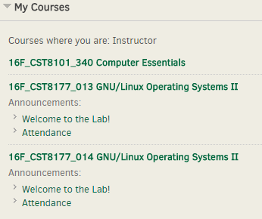

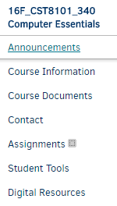

Click here

You will see this

You have to go to each individual course that your taking, check the **course information** and **course documents** and download them to your computer and back them up.

**Important Note**: each professor has a different naming for his/her Course Documents. Remember only back up the files not the links.

Procdure to create folder

1. First, create a folder called **“Algonquin”** under **“ Documents”** in your computer.

You create the folder by pointing the mouse in the area you want the folder created and right-clicking the mouse. Select “**New**” and then “**Folder**”. You can then name the folder.

1. On your laptop, under **“Algonquin”,** you need to create one folder for this semester **2016F.**
2. Under **2016F**, you would now create a folder for each course. Again, using this example, you would create **“16F_CST8101_340 Computer Eessentials”**; another folder for **“16F_CST8177_014 GNU/Linux Operating system II”** and so on. (depending on how many courses you have)

**Note: if you have 4 or 5 courses this term, you will create 4 or 5 folders, one folder for each course you are taking.**

1. You will now create other folders underneath each course representing the organization of that course. As shown below, not all the Blackboard entries will contain content, so you must open each course to see what is inside. In this example, for **16F_CST8101_340** there are two important entries: the  **“Course Information**” and the **“Course Documents”**.

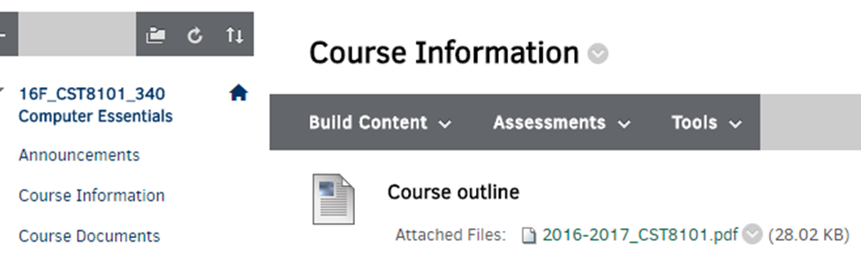

Under the **Course Information** there is one file called **Course Outline** (2016-2017_CST8101.PDF) and under the **Course Documents** there are two folders **Week01** and **Week02**, Under **Week01** there are fours files: **welcome to computer Essentials, Course information, email, password,Virus-mike** and **CST8101-Lab01_2016F-(1).docx.** You should save these files into your laptop.



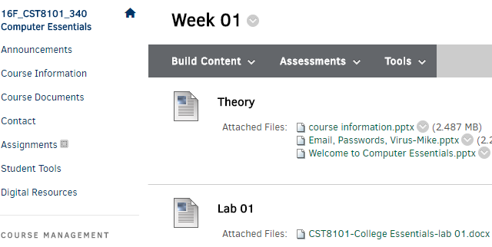

Folder hierarchy

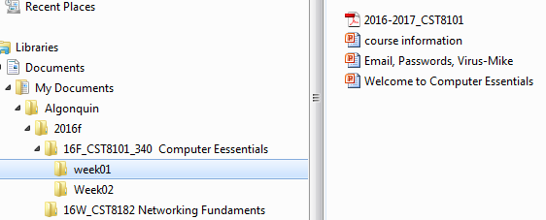

**Ways to backup your documents (your Algonquin folder in this case) to an external device (memory stick or an external hard drive)**

1. Using Microsoft ***Windows 10 Backup and Restore*** procedure.
2. ***Copying and pasting*** your Algonquin folder to either FD, HD, or CD/DVD
3. Using ***Skydrive***

**How to schedule Back up in Windows 10 automatically:**

1. Go to Start 🡪 Control Panel 🡪 Backup and Restore





Click *Backup and Restore (Windows 7)*.

Click ***Set up backup***

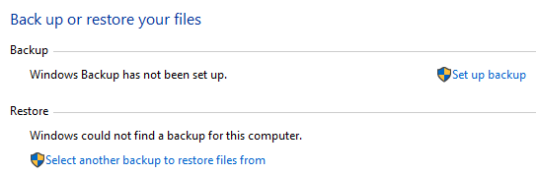



Select a destination

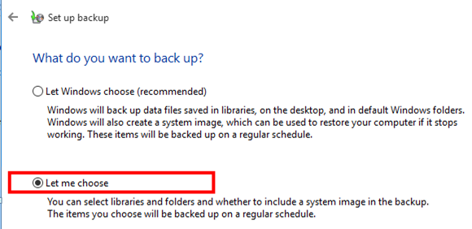

select the ***Let Me Choose***radio button

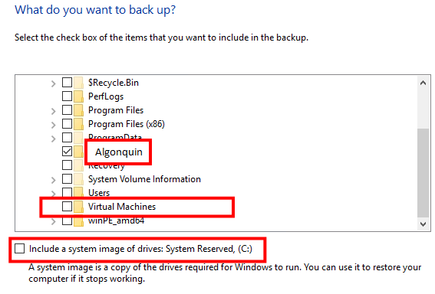

Check any folder that you would like to backup

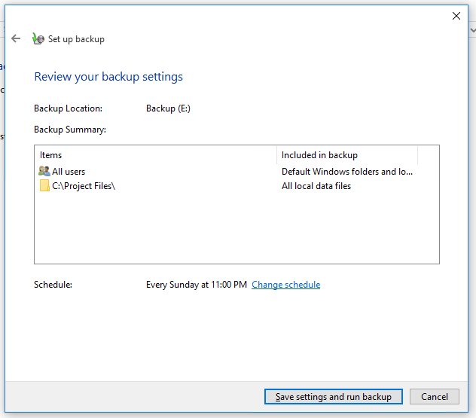

Now click on the **local Disk (C:)** and look for the **Algonquin** folder

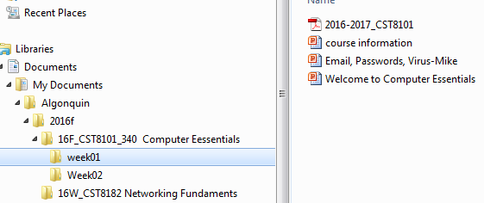

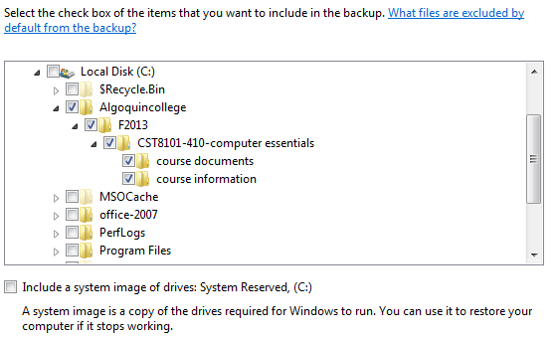

Review your backup and make sure the backup location is an **external device**, **memory stick** or **CD ROM**

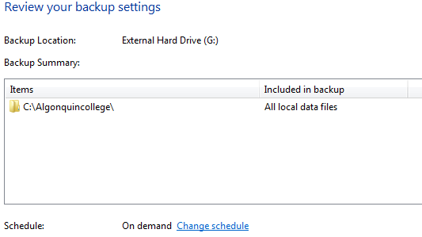

Click on **Change schedule**.

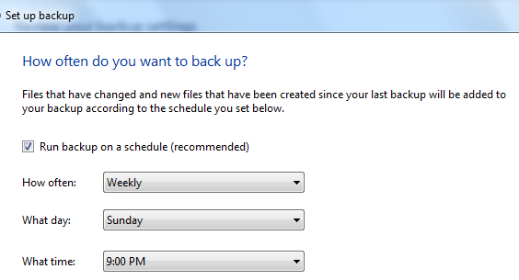

Change the schedule to **Weekly**, **Sunday at 9:00 PM** and click **OK.**

Microsoft backup begins to back up your folders.

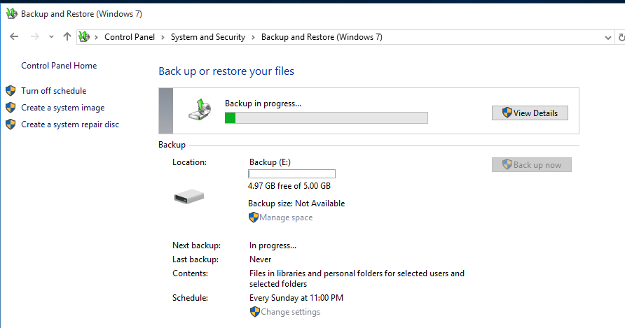

Full backup will occur when you have completed all of the steps

Back up shows the progress.



Restore a copy of your backup

**Manual or unstructured backup**

1. **Copy** and **paste** your **Algonquin** folder to either a flash drive, or to your External HD, or CD/DVD (manual or unstructured backup**)**

* Open the file browser for your “**Document**”folder.
* Find **Algonquin** folder and then the **F13** folder
* **Copy and Paste** these folders to an external device of choice.

1. **Skydrive or online (your email account)**

Log in to your Skydrive account.

Click on **upload** and choose the **Algonquin** folder that you have created in your computer.

***This step may require to compress (zip file) your folder first.***

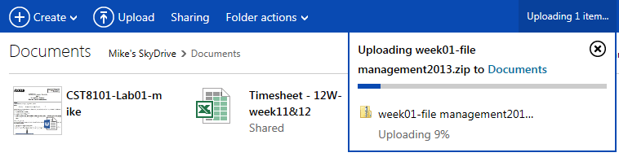

1. **Restore**

All of the backup methods presented here are fairly simple. However, you should always **test** your backup by restoring a file.

Using one of the backup methods shown, choose a file for a“test” restore.

You should be able to easily retrieve the backup file to a location of your choice. Again, if you have trouble or cannot complete the restore, you should reconsider changing the backup method or practice more until you are proficient. The time to learn how to restorea file is NOT when you need it!

**Questions**

1-What type of Backup Solution does Windows 10 implement? (Full, Differential, Incremental)

2-Where did you find this information?

3-What is a system image?  Is a system image the same as a backup?

4-What is the output file type for your backup?

5-How do you restore files using the windows 10 backup system?

6-Can you view the backup files on Disk? Do you receive a warning message

***Show each completed task to your lab instructor for sign-off.***

***Be prepared to discuss YOUR backup plans and schedule with the lab instructor for full mark***.

|  |  |  |
| --- | --- | --- |
| **Item** | **Marking Scheme** | |
| Windows 10 Backup Plan and Schedule (Backup setup) |  | 3 |
| Back up Algonquin folder to another device (FD, CD/DVD, EX-HD) |  | 3 |
| SkyDrive or email account creation |  | 1 |
| Algonquin folder (ZIP) upload to SkyDrive |  | 2 |
| Restore Tested |  | 1 |
| **Total mark** |  | 10 |