Linux installation

Due date

- End of Week 2 lab class

Submission

- Submit a screen grab of your terminal window to Blackboard under the Lab 1 submission link.

Evaluation

- 3% of final mark

Materials

- Student laptop computer with VMware Workstation 12 installed

- Ubuntu 14.04.5 Desktop ISO image

Procedure

In this lab you will be installing a copy of Linux within a VMware Virtual Machine. This virtual machine will give you a Linux environment that you can use for future lab work.

1. Create a new virtual machine

- Start VMware Workstation.

- Select File → New Virtual Machine → Next.

- Type of Configuration: Select Typical (Recommended) → Next

- Guest Operating System Installation: choose “I will install the operating
system later” → Next

- Use all the default options for the next a few steps and click Finish when you
reach the following screen.

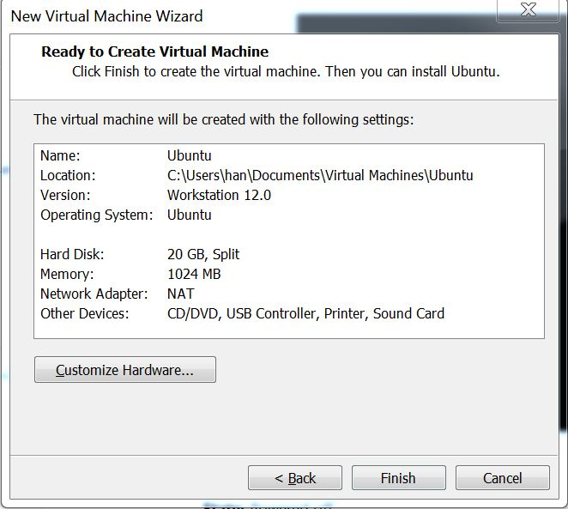

2. Mount Ubuntu ISO image file

a) Get Ubuntu Desktop 14.04.5 ISO image :

Download the image (ubuntu-14.04.5-desktop-amd64.iso) from
http://releases.ubuntu.com/14.04/

Note: If your laptop is not working with the 64-bit image, download the 32-bit
image instead

b) Mount the ISO image to the Ubuntu virtual machine:

Click CD/DVD (SATA) → Connection → Use ISO Image File →
Browse to find the ISO image

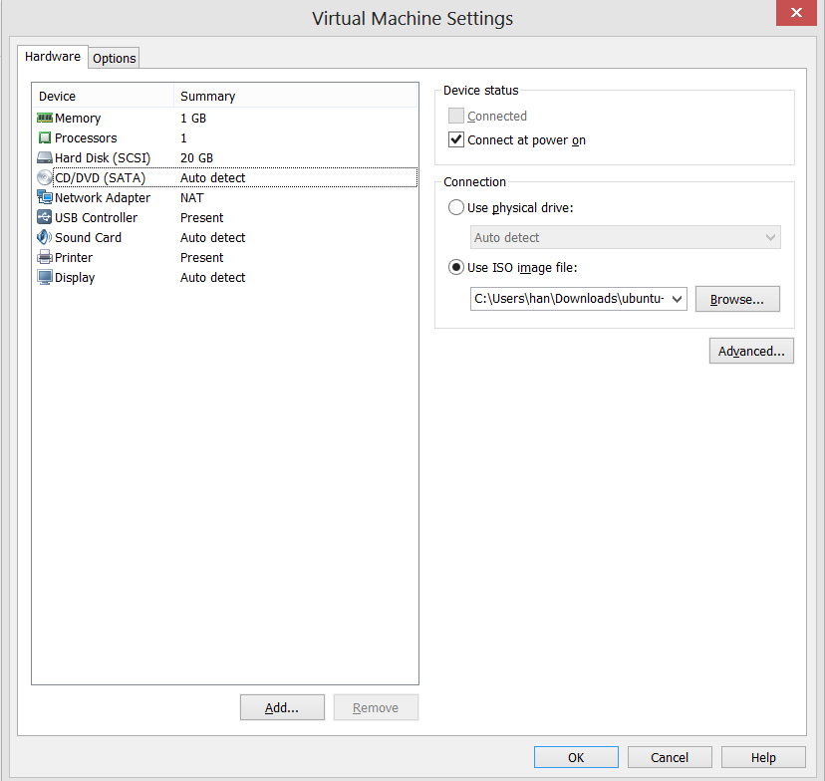

3. Start the Ubuntu Virtual Machine

- Click Power on this virtual machine

- Linux installation will start automatically.

- Click “Install Ubuntu” in the Welcome screen

- Click “Continue” for “Preparing to install Ubuntu”

- Click “Install now” for “Installation type”
Click “Continue” in the popup window of “Write changes to disks?”

- Type and select “Ottawa (Ontario, Canada)” in “Where are you?” screen

- Keep the default setting on “Keyboard layout” screen, and click “Continue”.

Input your information on the “Who are you?” screen. Use your college username for this in the format ABCD0001. Now change your computer's name from abcd0001-virtual-machine to abcd0001-VM.

***Make sure that you write your college username instead of "ABCD0001"***

- make sure “Require
password to login” is selected”, and then click “Continue”

- Wait for installation to finish, and click “Restart Now”

- Login with the user and password you input in “3 h)”
DO NOT upgrade to Ubuntu 16.04.1 LTS when prompted

- Open a terminal window by typing “terminal” :

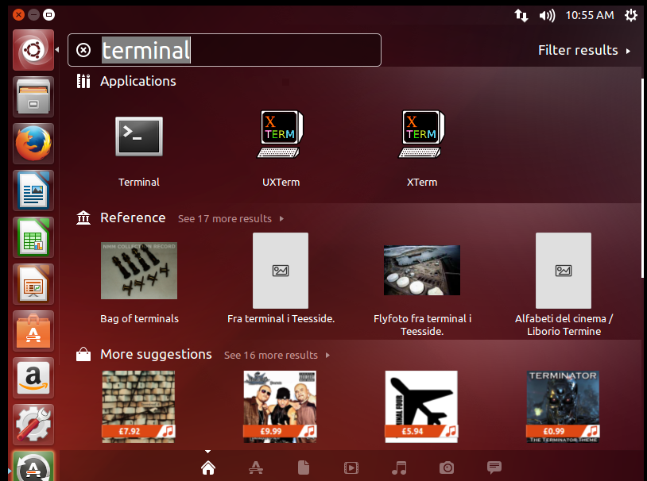

- Set root user password with the command in terminal windows:

sudo passwd root

- Install vim (the Linux editor to be used in future labs) with the following command:

sudo apt-get install vim

- Install VMware Tools with the following command:

sudo apt-get install open-vm-tools-Desktop

- Create a full clone of your virtual machine in case you really mess things up:

  - Shutdown the virtual machine with the command in terminal:

sudo shutdown –h now

  - Select VM →Manage →Clone from the menu (make sure your client OS is powered off). After going through the wizard, the Clone Type dialog window comes up, select Create a Full Clone.

Double-check you work! When you are satisfied with your work you may take a screen grab of you terminal window and submit that file to Blackboard.

