This for the super abstract class

**public** **abstract** **class** **BankAccount**{

**double** balance;

**public** **void** **getBalance**(){

balance=**Math**.*random*()*1000;

}

**public** **abstract** **void** **calculateandUpdateBalance**();

}

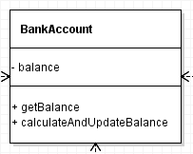

**public** **class** **SavingAccount** **extends** **BankAccount**{

**private** **double** interestRate=0.03;

**public** **SavingAccount**(**int** balance ){

**super**.balance=balance;

}

***@Override***

**public** **void** **calculateandUpdateBalance**(){

balance =balance+ (balance+(interestRate/12));

//double interest = getBalance()* (interestRate / 100.0);

}

}

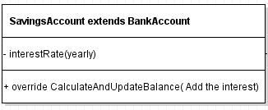

**public** **class** **ChequingAccount** **extends** **BankAccount**{

**private** **double** fee = 2.0;

**public** **ChequingAccount**(**double** Abalance) {

**super**.balance=Abalance;

}

***@Override***

**public** **void** **calculateandUpdateBalance**(){

balance =balance - fee;

//double interest = getBalance()* (interestRate / 100.0);

}

}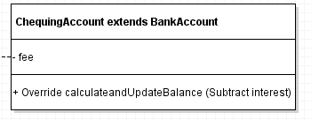

**import** java.util.Random;

//import javax.print.attribute.standard.MediaSize.NA;

**public** **class** **BankAccountTest** {

**Random** rnd = **new** Random();

**BankAccount**[] bank = **new** **BankAccount**[30];

**public** **BankAccountTest**() {

**System**.***out***.println("======== The Savings Accounts Information =======");

**for** (**int** **i** = 0; i <15; i++) {

bank[i]= **new** SavingAccount(rnd.nextInt(25000)+1000);

}

**System**.***out***.println("======== The Chequing Accounts Information =======");

**for** (**int** **j** = 16; j <30; j++) {

bank[j]= **new** ChequingAccount(rnd.nextInt(40000)+1000);

}

}

**public** **void** **monthlyProcess**(**BankAccount**[] c){

**for** (**int** **i** = 0; i < 15; i++) {

c[i].getBalance();

}

**for** (**int** **i** = 16; i < 30; i++) {

c[i].getBalance();

}

}

**public** **void** **display**(){

**for** (**int** **i** = 0; i < 15; i++) {

**System**.***out***.println("balance of saving account " + (i + 1) + " = " + bank[i].balance+ " $");

}

**System**.***out***.println();

**for** (**int** **i** = 16; i < 30; i++) {

**System**.***out***.println("balance of chequing account " + (i + 1) + " = " + bank[i].balance+" $");

}

**System**.***out***.println();

}

**public** **static** **void** **main**(**String** []args) {

**BankAccountTest** **Bank**= **new** BankAccountTest();

**String** [] **months**={"Jan", "Feb", "Mar", "April","May", "Jun" ,"Jul" ,"Aug" ,"Sep" ,"Oct" ,"Nov" ,"Dec"};

**for**(**int** **i**=0;i<12;i++){

**System**.***out***.println();

**System**.***out***.println(months[i]+" :-");

**System**.***out***.println();

Bank.monthlyProcess(Bank.bank);

Bank.display();

 