Java EE Lab Activity 1

We will work on this Activity in the first Lab period. Demonstrate your final results to your Lab Professor for 10 marks (1% of course grade)

See Brightspace for due date.

Follow the instructions below to

1. Download Netbeans with JEE support
2. Download and install JEE 7 SDK update 1
3. Run the Address Book example Application

**Installing NetBeans IDE and GlassFish 5 installation**

The NetBeans integrated development environment (IDE) is a free, open-source IDE for developing Java applications, including enterprise applications. NetBeans IDE supports the Java EE platform. You can build, package, deploy, and run your Java EE applications from within NetBeans IDE.

Step 1: Download and install Netbeans with JavaEE support (Glassfish is bundled -- but you **won't** use that copy of glassfish that the Netbeans bundle will place in C:\Program Files\glassfish4). You can download NetBeans from <http://www.netbeans.org/downloads/>

Step 2: Download Java EE from http://www.oracle.com/technetwork/java/javaee/downloads/index.html (you should already have the latest SE JDK installed). When you install/extract this zip file, place it the root of your C: drive, so you will end up with C:\glassfish5\.

NOTE: We are installing GlassFish Open Source Edition 5

Step 3: Run Netbeans, select the Services tab, and under Servers, remove the default Glassfish server (stored at C:\Program Files\glassfish4) by right clicking on it and selecting "Remove" (see below). Then, right click on Servers and select Add Server, then follow the wizard for "Glassfish Server" and select your C:\glassfish5 directory as the installation directory. Accept the defaults throughout the rest of the wizard.

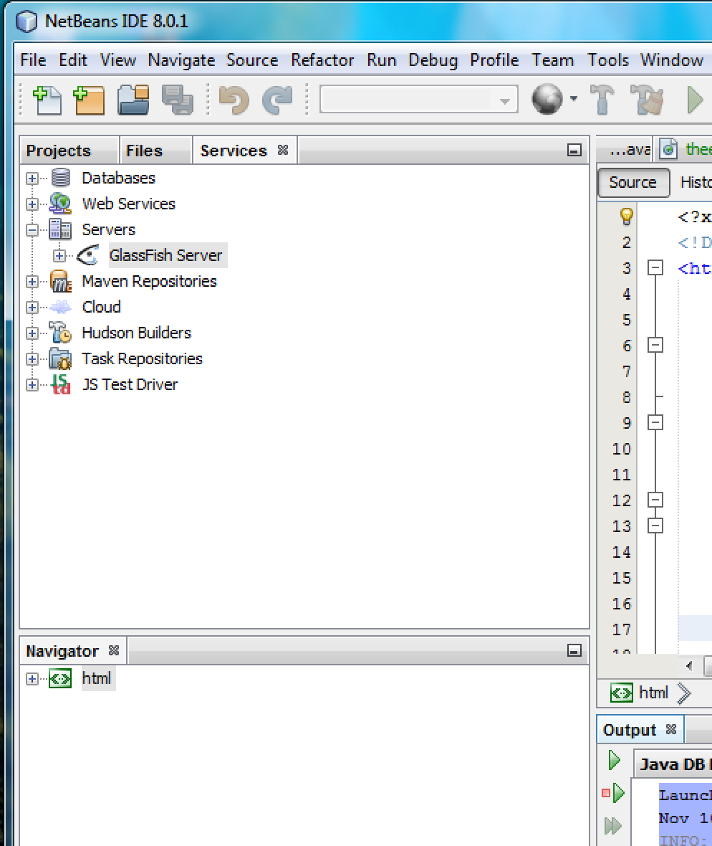

**Starting and Stopping the GlassFish Server using NetBeans**

To *start* the GlassFish Server:

1. Launch NetBeans.
   * Applications -> Programming -> NetBeans IDE
2. Click the **Services** tab.
   * Don't see the Services tab? Window -> Services
3. Be sure you've added the JEE Server you downloaded separately from Netbeans, and that you placed in C:\glassfish5.
4. Expand the **Servers** node.
5. Right-click the GlassFish Server instance and select **Start.**
6. Right-click the GlassFish Server instance and select **View Server Log.**
   * notice the output from the GlassFish Server

Note: NetBeans is configured by default to also start the Java DB server when starting GlassFish.

**In NETBEANS:**

To *stop* the GlassFish Server:

1. Right-click the GlassFish Server instance and select **Stop.**

To *restart* the GlassFish Server:

1. Right-click the GlassFish Server instance and select **Restart.**

To *refresh* the GlassFish Server:

1. Right-click the GlassFish Server instance and select **Refresh.**

**Starting the Administration Console**

The Glassfish Administration Console is a web application (accessed through browser) built-in to the Glassfish Server. To administer the GlassFish Server and manage users, resources, and Java EE applications, use the Administration Console tool. The GlassFish Server must be running before you invoke the Administration Console. To start the Administration Console, open a browser at <http://localhost:4848/>

Select the “Applications” button on the left, to see what applications are deployed to your server at this point.

**Viewing the GlassFish Server Admin Console using NetBeans**

1. Click the **Services** tab.
2. Expand the **Servers** node.
3. Right-click the GlassFish Server instance and select **View Admin Console**.

Note: NetBeans IDE uses your default web browser to open the Administration Console at the proper URL.

**Java EE Tutorial Example Applications**

The tutorial example source is contained in the tutorial component which should already be installed (unzipped) in **C:\glassfish5\docs\javaee-tutorial** and the example projects will be under **C:\glassfish4\docs\javaee-tutorial\examples**

**Run the Address Book Example Application**

To run the same 3-tier application we discussed in the classroom lecture, select File->Open Project and browse to C:\glassfish5\docs\javaee-tutorial\examples\persistence\address-book , and open the project. Then select the project and click the green “Play” button to run the application (it will run as a web application in your default browser). When asked, specify that you will run it on your Glassfish server. If all is well, Netbeans will launch your web browser with the URL of your Address Book JSF application. Check the Glassfish Admin console to see what applications are deployed now.

**Writing a JSF Application**

You can quickly write an application like the Address Book application, from scratch, using Netbeans:

1. Use Netbeans to create a new Web Application (File->New Project…)
2. Create a **Contact** entity class (right click on Project, New->Entity Classes from Database, and select the Contact table). There should now be a **Contact.java** class in your project, in the package you specified for it.
3. Create the JSF Application (right click on Project, New->JSF Pages from Entity Class, and select the **Contact** entity)
4. Run the new JSF Application, and compare it to the Address Book example
5. View the Admin Console to see what applications are deployed at this point.