- MOODBUDS
- Master Product & System Architecture
- Building the Intelligence Layer for the Next Generation of Wearables

- Document Version | - v0.2 — Architecture Revival
- Product Model | - B2B physiological intelligence SDK + APIs
- Initial Application | - Adaptive audio and mental-wellness experiences

- Status: Foundational architecture for team alignment and MVP implementation

Document Map
- 1. Executive Vision
- 2 .Market Research
- 3. Exactly why Moodbuds?

1. Executive Vision

Introduction
- Wearables have become strong at measuring the body but remain weak at interpreting what multiple signals collectively suggest about a user's cognitive and emotional condition. MoodBuds is built on the belief that the next generation of wearable products should move from passive measurement toward context-aware support.
- MoodBuds combines physiological streams such as brain activity (EEG), heart rate, pulse-derived features, heart-rate variability (HRV), motion, and future biosensor inputs. Multimodal models convert these raw streams into a unified physiological representation, confidence-scored wellness-state estimates, and safe personalization signals.
- The first application is adaptive audio: music, soundscapes, focus sessions, recovery routines, and calming experiences that adjust according to estimated user state and explicit user preference.

Vision
- MoodBuds seeks to become the foundational physiological intelligence platform for wearable manufacturers. Instead of manufacturing consumer hardware, MoodBuds will expose device-side SDKs, cloud APIs, inference services, partner tooling, and analytics that wearable companies can integrate into their own products.

Mission
- Build a scalable, privacy-conscious, hardware-agnostic physiological intelligence platform that enables wearable companies to create personalized wellness experiences through real-time multimodal biosignal analysis.

Business Model
- B2B SDK and API licensing.
- Usage-based inference and analytics tiers.
- Enterprise integration and model-customization services.
- Hardware-agnostic partner architecture.
- Initial market: smart earbuds, audio wearables, and wellness-device companies.

- 2 .Market Research

- Industry->Current Market ->Problems --->Existing Solutions(Feasibility and Market Share)->Cap(Based on Technical and Financial Scope)->Our Oppurtunity->Product->Architecture->Execution(Time Scoped)-->Business

- -Current Market Size ->1.25 Billion USD
- The global music distribution services market size is anticipated to be valued at USD 1.25 Billion in 2026, with a projected growth to USD 1.8 Billion by 2035 at a Compounded Annual Growth Rate of 4.2% during the forecast from 2026 to 2035.

- Main Contenders/Market Players-
- Spotify, Apple Music, and Amazon Music

- Source: https://www.businessresearchinsights.com/market-reports/music-distribution-services-market-112293

- 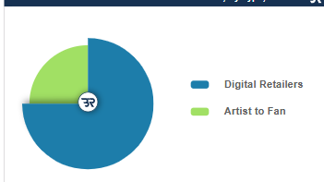
- Expected Market Share by 2035 >=75%

- Digital Retailers
- 1.Streaming Services

- Artist to Fan
- Websites or Streaming Services
- Live Music

- The market is primarily segregated into Europe, Latin America, Asia Pacific, North America, and Middle East & Africa.

- Source: https://www.businessresearchinsights.com/market-reports/music-distribution-services-market-112293

- An industrial development in the music distribution services market is the increasing adoption of blockchain technology. Blockchain offers solutions to various challenges faced by the industry, including royalty tracking, rights management, and transparent transactions. By leveraging blockchain, music distribution services can provide artists with greater control over their content, ensure fair compensation, and reduce inefficiencies in the distribution process. This development is revolutionizing the way music is distributed, empowering artists, and fostering trust and transparency within the ecosystem.

- Source: https://www.businessresearchinsights.com/market-reports/music-distribution-services-market-112293

- 3.
- Every day billions of listening sessions occur across phones, cars, TVs, smart speakers and earbuds.
- The result is one of the largest behavioral datasets ever created.
- Yet despite this explosion in data, one important question remains unanswered:
- Does the music actually match how the listener feels right now?
- That is the gap MoodBuds exists to explore.

- Core:We PLAY ON THE ASPECT OF “BEHAVIOUR” Through Real Data

- Current/Existing Behavioural Scope
- Listening History
- Likes
- Dislikes
- Skips

Context
- Time
- Location
- Device
- Activity

Content Similarity
- Genre
- Artist
- Tempo
- Mood tags
- Audio embeddings
- These systems answer the question:
- "What songs are you likely to play?"
- They do not answer:
- "What kind of music would best support you right now?"
- That distinction is central to the core Idea Behind MoodBuds

- User

- ↓

- Clicks
- Searches
- Likes
- Playlists
- History

- ↓

- Recommendation Model

- ↓

- Music
What Exaclty are the recommendation systems missing today?
Brain Activity

Heart Rate-Partially but not Exaclty

HRV

Stress

Fatigue

Attention

Emotional Arousal

↓

Ignored

1.5 The Opportunity
Imagine two people playing the exact same playlist.
Both listened to identical songs yesterday.
Both have identical listening history.
Spotify will likely recommend nearly identical music.
Yet internally:
Person A
- Calm
- Focused
- Well-rested
Person B
- Mentally exhausted
- High stress
- Elevated heart rate
Behaviorally, they look similar.
Physiologically, they may need very different experiences.
This is the opportunity MoodBuds aims to address.

Inside a Modern Music Recommendation System

2.1 The Goal
At its core, every recommendation system tries to answer a single question:
Given everything we know about this user, what is the next piece of content they are most likely to enjoy or engage with?
For Netflix, it's the next movie.
For Amazon, the next product.
For Instagram, the next reel.
For Spotify, the next song.
Everything else is built around answering this one question.
What do they essentially track?
• Search queries
• Songs played
• Songs skipped
• Listening duration
• Volume changes
• Playlist creation
• Likes
• Dislikes
• Shares
• Downloads
• Repeat plays

- Search queries
Turning Action to Events
{
"user_id":1452,
"song_id":9132,
"event":"play",
"time":"21:03",
"device":"Android",
"duration":182,
"completed":true
}
Event Stream

Play

Pause

Skip

Like

Search

Playlist

Download

Repeat

Follow Artist

Share Song

───────────────►
Event Pipeline loaded into Distributed Systems such as Apache Kafka before being loaded into Machine Learning Pipelines
This is mere Observation Collection

How does System actually remembers you?
User #1542

Preferred Genres
-----------------
Lo-fi
Classical
EDM

Average Session
----------------
58 min

Night Listening
----------------
92%

Favorite Tempo
----------------
70-90 BPM

Frequently Skips
----------------
Heavy Metal

Preferred Language
----------------
English
Hindi

Weekend Usage
----------------
High

Song

↓

Tempo

↓

Energy

↓

Danceability

↓

Acousticness

↓

Loudness

↓

Instrumentalness

↓

Speech Ratio

↓

Valence

↓

Popularity

↓

Release Year

↓

Artist Similarity

↓

Embedding Vector

Song

↓

Tempo

↓

Energy

↓

Danceability

↓

Acousticness

↓

Loudness

↓

Instrumentalness

↓

Speech Ratio

↓

Valence

↓

Popularity

↓

Release Year

↓

Artist Similarity

↓

Embedding Vector

What are Vector Reprsentations in General and in terms of Music?
Dense vector representations (embeddings) are a way of turning something complex — a word, an image, a song — into a list of numbers (a vector) that captures its meaning or characteristics, so that similar things end up with similar number patterns.

how these music embeddings actually get trained, since that's the interesting part.
The main technique: contrastive learning
The core idea is simple: instead of teaching the model "this song is jazz" (which requires expensive human labels), you teach it "these two things belong together, these two don't" — using signals that already exist for free.

how these music embeddings actually get trained, since that's the interesting part.
The main technique: contrastive learning
The core idea is simple: instead of teaching the model "this song is jazz" (which requires expensive human labels), you teach it "these two things belong together, these two don't" — using signals that already exist for free.

The model takes each song's raw audio (or metadata) and passes it through a neural network that spits out a vector. Then a loss function does one job: pull the vectors of "positive pairs" close together in the vector space, and push "negative pairs" apart. Repeat over millions of pairs, and the geometry of the space self-organizes — songs that share qualities humans associate together end up nearby, even though no human ever typed the word "chill" or "aggressive" into a label field.
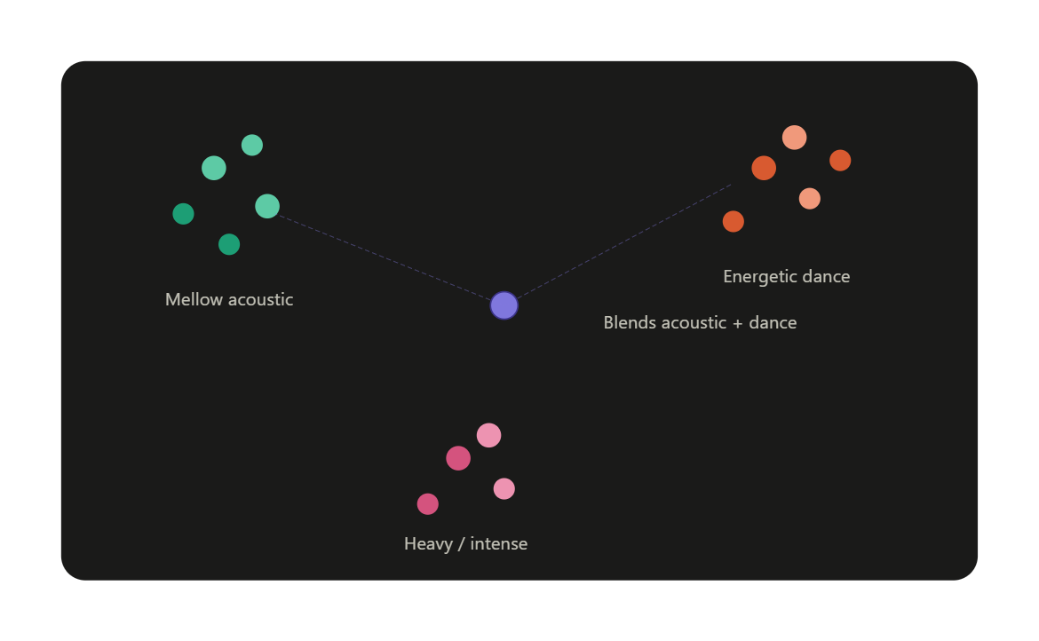
• Collect signal: massive dataset of songs + co-occurrence data (playlists, listening sessions, artist/album groupings).
• Encode: a neural network (often a CNN or transformer operating on the audio spectrogram, or sometimes on raw waveforms) turns each song into a vector.
• Contrastive loss: train the network so that positive pairs end up close, negative pairs end up far, across millions of examples.
• Resulting space: every song, everywhere in the catalog, now has a fixed-length vector. Adding a brand-new song is cheap — just run it through the trained encoder once.
• Use it downstream: nearest-neighbor search for recommendations, clustering for auto-generated playlists, even blending vectors (e.g., "more energetic version of this song") for controllable discovery.

real systems (like Spotify's) usually combine audio-based embeddings (learned from the sound itself) with collaborative-filtering embeddings (learned purely from user behavior — who listened to what) and sometimes text embeddings (from lyrics, reviews, or playlist titles), because "who listens to this" and "what does this sound like" capture different, complementary kinds of similarity.
Now comes the most important observation for MoodBuds.
Everything the recommendation system knows comes after the user's actions.
It learns from:
- clicks
- searches
- skips
- listening history
- playlists
- favorites
It has almost no direct information about the listener's current physiological condition.
A recommendation engine can infer that you often listen to calm music late at night, but it cannot directly observe whether, right now, you're mentally fatigued, highly stressed, deeply focused, or relaxed. That missing layer is exactly where MoodBuds can add value: by complementing behavioral signals with real-time physiological context, rather than replacing existing recommendation systems.

