MOODBUDS
Technical Architecture & MVP Execution Plan
From sensing to inference to adaptive output — the engineering path to a fundable MVP
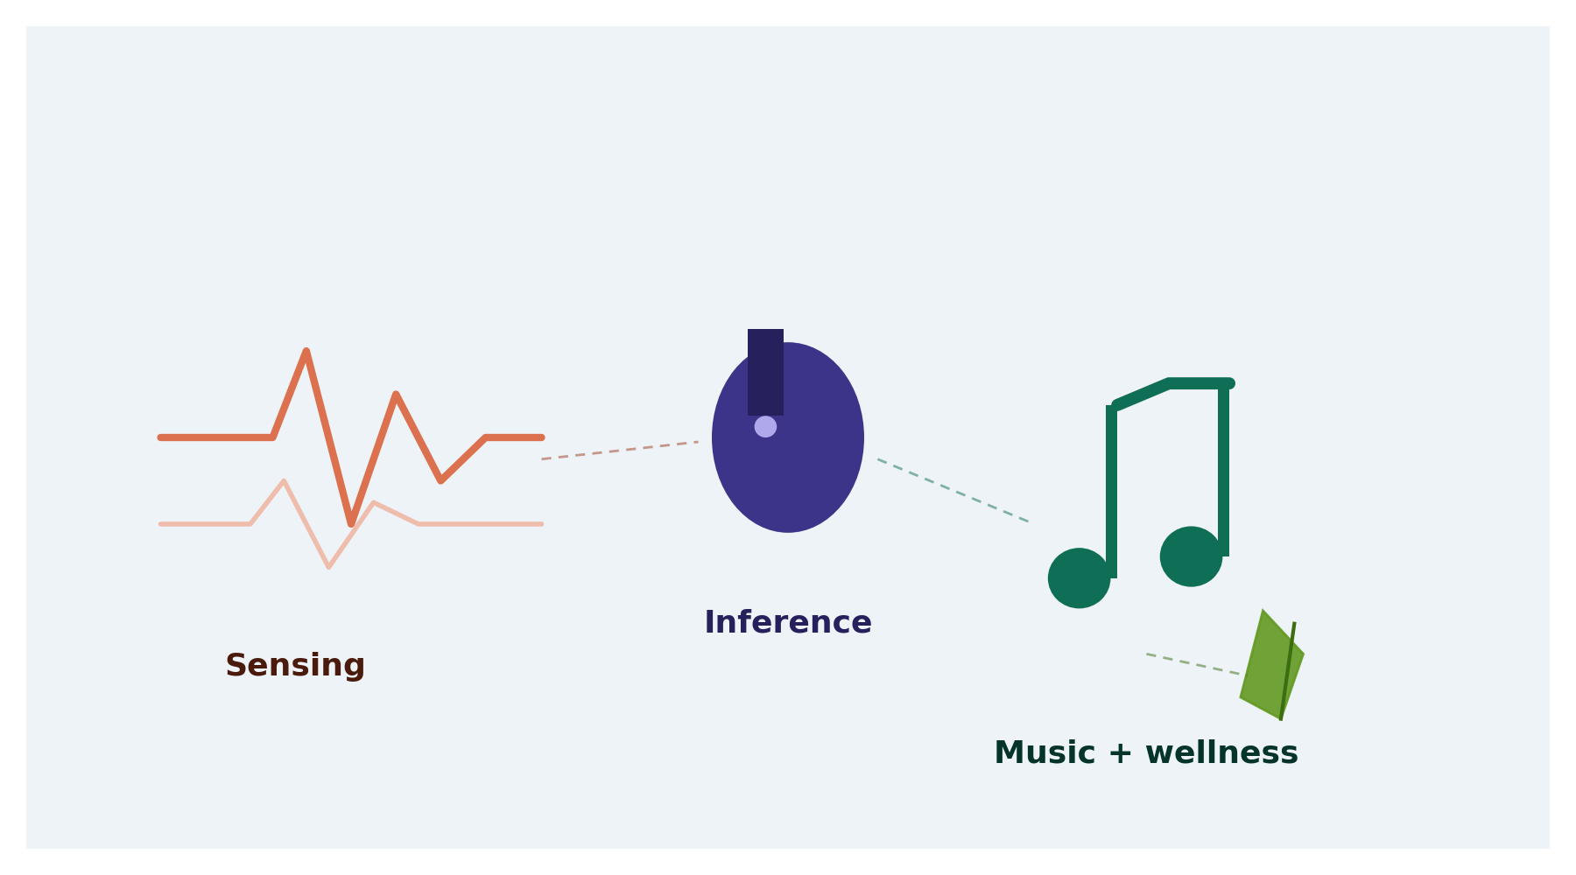
Field | Detail
Document Version | v0.1 — Draft for team alignment
Companion Document | MoodBuds Master Product & System Architecture v0.2
Team Size | 4 — 1 Backend/Systems, 3 AI/ML
Target | Working MVP in 6 months, then fundraising

1. Purpose & Scope
This document defines the technical system behind MoodBuds and the execution plan to reach a fundable MVP within six months. Where the Master Design Document covers market positioning and product vision, this document covers how the system is actually built: the full loop from a user putting on a wearable, through continuous physiological and behavioral monitoring, to real-time inference, to adaptive music playback and mental-wellness guidance.
It also defines team roles, the training-data strategy, the web app/dashboard approach, and a month-by-month roadmap with KPIs.

2. System Architecture Overview
At a high level, data flows through five stages — device sensing, browser-side transport, backend ingestion, ML inference, and adaptive output:
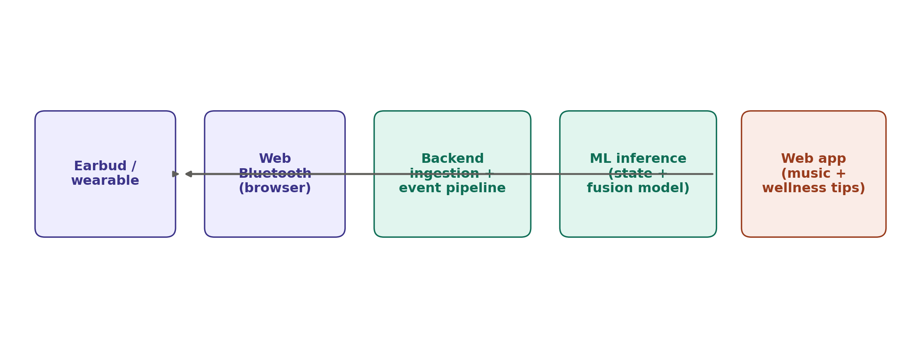
Figure 1. End-to-end MoodBuds data flow, from wearable to adaptive output

2.1 Device Layer
Covers earbud/wearable hardware wake-up, sensor calibration, and in-ear/worn confirmation, as detailed in the companion business document (Section 3). Raw physiological streams — EEG (where available), heart rate, HRV, motion — originate here.

2.2 Transport Layer — Web Bluetooth
Rather than building a native mobile app, MoodBuds' MVP uses the Web Bluetooth API to connect directly from a browser tab to the wearable over BLE. This removes the need for iOS/Android app development entirely for the MVP stage, letting the existing backend/full-stack skill set cover the client as well as the server. The one limitation is lack of Safari support, which is acceptable for an investor-facing and pilot-stage demo running on laptops and Android devices.

2.3 Backend Ingestion & Event Pipeline
Sensor readings are converted into structured events (sensor ID, timestamp, calibrated values) and pushed into an event pipeline — the same pattern outlined in the companion document's discussion of modern recommendation systems (Section 5.2), adapted here for physiological events instead of listening events. This stage is owned entirely by the Backend & Systems role.

2.4 ML Inference Layer
Two model families operate in parallel and are combined by a fusion layer:
- State-estimation model — converts raw physiological streams into a confidence-scored wellness-state estimate (e.g., stress, fatigue, focus, calm)
- Music intelligence model — the audio embedding space described in the companion document, built via contrastive learning, representing songs by sonic and behavioral similarity
- Fusion layer — maps the current state estimate onto the music embedding space (and/or a wellness-tip decision) to select the next action

2.5 Output Layer — Web App
The same web app that hosts the Web Bluetooth connection also renders the output: adaptive audio playback and, where appropriate, a short mental-wellness suggestion. A lightweight explanation ("why this song") is shown alongside the state readout to make the system's behavior legible during demos.

3. Team & Roles
With three AI/ML backgrounds and one backend/systems background, the split below covers the full loop without overlap, and avoids assigning mobile development to anyone — the web app covers that need instead.
Role | Owns | Primary stack
Backend & Systems Lead (you) | Web Bluetooth client, event ingestion, APIs, cloud infra, auth/security, deployment, web app + dashboard | AWS (EC2), Kafka/event streaming, REST/gRPC, React/Node
ML Engineer 1 — Signal & State Modeling | Physiological signal processing; EEG/HRV/PPG/motion to state estimate | Time-series models, PyTorch
ML Engineer 2 — Music Intelligence | Audio/song embeddings, contrastive-learning pipeline, state-to-music mapping | Audio ML, embedding models, recommendation logic
ML Engineer 3 — Fusion & Evaluation | Combining state + music models into one decision layer; eval harness; data-labeling tooling | Multimodal fusion, experiment design, EMA/self-report tooling

4. Training Data Strategy
Since proprietary earbud hardware and data don't exist yet, data acquisition happens in three layers, moving from free public data to real user feedback:

4.1 Layer 1 — Public Datasets (Month 1)
- WESAD — wearable stress detection (ECG/EDA/respiration)
- DEAP — EEG and physiological signals with emotion/valence-arousal labels
- PhysioNet — HRV/ECG collections
- Music side: Free Music Archive, Million Song Dataset, or the Spotify Web API audio-features endpoint, to bootstrap the music embedding space without training an audio model from scratch

4.2 Layer 2 — In-House Data Collection (Months 2–3)
Using off-the-shelf wearables with exposed raw-signal APIs (e.g., a Muse EEG headband, Polar H10 HRV strap, or Empatica E4), a small cohort (15–20 people, including the team) wears the devices while listening to music and periodically self-reports mood/stress via ecological momentary assessment (EMA). This produces the (signal, self-report, song) triples the public datasets cannot provide, since none of them were paired with music.

4.3 Layer 3 — Pilot Usage Data (Month 5+)
Once the MVP is in front of real pilot users, implicit feedback — skips, session length, completion — becomes an ongoing fine-tuning signal for the recommendation layer, the same way collaborative-filtering signal works in mainstream music platforms.

5. Web App & Dashboard
Two thin surfaces, one shared stack:

5.1 Demo / Pilot Web App
Connects to the wearable via Web Bluetooth, shows a live state readout, plays adaptive audio, and displays a short explanation of the current recommendation. This is the fundraising demo surface, so it needs to feel real even while the underlying models are still early — but it does not need visual polish beyond clarity.

5.2 Partner Dashboard
A plainer, more functional surface aimed at prospective wearable-company partners: API usage, integration documentation, sandbox testing, and analytics on inference outputs. This is what actually demonstrates the B2B SDK/API model.
Both surfaces should be built as thin as possible early on, with the bulk of the six months spent improving model quality rather than UI — for this stage, investors and partners are evaluating whether the sensing-to-output loop is real, not the interface polish.

6. Six-Month Roadmap & KPIs
Month | Focus | Key deliverable / KPI
1 | Foundations | Architecture finalized; event pipeline skeleton live; public datasets ingested; baseline state model v0 trained
2 | Core models | State-estimation model hits target accuracy/correlation on held-out public data; music embedding space built; web app connects to a real wearable over Web Bluetooth
3 | Real data + fusion | In-house data collection cohort running (15–20 people); fusion logic v1 implemented; first rough end-to-end demo working
4 | Integration | Full loop working reliably in the web app; partner dashboard v1; daily internal dogfooding
5 | Pilot | External pilot cohort using the app; real usage data flowing back; models refined on real feedback
6 | Fundraising readiness | Polished demo, pilot metrics/case study, pitch deck, partner dashboard presentable to prospective partners

7. Open Risks & Decisions Needed
- Safari's lack of Web Bluetooth support — acceptable for MVP/demo stage, but a constraint to revisit before any public consumer release
- Hardware dependency — MVP relies on off-the-shelf wearables (Muse, Polar, Empatica) rather than custom earbuds; timeline for custom hardware, if needed, is not yet scoped
- EMA data quality — self-reported mood/stress labels from a 15–20 person cohort are a small, potentially noisy training signal; may need to expand cohort size or sampling frequency
- Model evaluation criteria — the specific accuracy/correlation thresholds for the state-estimation model (Month 2 KPI) still need to be defined by ML Engineer 1 and ML Engineer 3

The Webapp Interface

