AI RESUME ANALYZER AND BULDER
A PROJECT
Submitted in partial fulfillment of the requirements for the award of the degree
Of
BACHELOR OF TECHNOLOGY
in
COMPUTER SCIENCE & ENGINEERING
Specialization in
ARTIFICIAL INTELLIGENCE AND MACHINE LEARNING
Submitted By:
Deepak
Roll No. 2301311136
Under the Supervision of
Mr. Ram Mohan Dixit


School of Computer Science & Engineering
SCHOOL OF COMPUTER SCIENCE & ENGINEERING
GEETA UNIVERSITY, PANIPAT
MAY, 2026

CANDIDATE'S DECLARATION
I hereby certify that the work which is being presented in the thesis entitled “AI Resume Analyzer and Builder” in the partial fulfillment of the requirements for the award of the degree of BACHELOR/MASTER in Computer Science & Engineering with specialization in Artificial Intelligence and Machine Learning and submitted in the School of Computer Science & Engineering, Geeta University, Panipat, is an authentic record of my own work carried out during the time period from Jan,2026 to May,2026 under the supervision of Mr. Ram Mohan Dixit.

The matter presented in this project has not been submitted by me for the award of any other degree of this or any other institute.

Signature of the student
(Deepak)

This is to certify that the above statement made by the candidate is correct to the best of my/our knowledge.

Signature of the Faculty
(Mr. Ram Mohan Dixit)

ACKNOWLEDGEMENTS
I would like to express my sincere gratitude to my supervisor, Mr. Ram Mohan Dixit, School of Computer Science & Engineering, Geeta University, Panipat, for his/her invaluable guidance, constant encouragement, and constructive feedback throughout the course of this internship. His expertise in software engineering and web technologies greatly shaped the direction and quality of this project.
I am deeply thankful to the Head of Department and all the faculty members of the School of Computer Science & Engineering, Geeta University, Panipat, for providing an excellent academic environment and the necessary resources to carry out this work. The infrastructure and technical support provided by the university were instrumental in the successful completion of this project.
I extend my heartfelt thanks to my classmates and peers who offered their time to test the application, provided valuable feedback on the user interface, and helped identify edge cases during the testing phase. Their suggestions significantly improved the overall quality of the AI Resume Analyzer.
Finally, I owe my deepest gratitude to my parents and family for their unwavering support, patience, and encouragement throughout my academic journey. Their belief in my abilities has been a constant source of motivation. This work would not have been possible without their love and support.

Deepak
Roll No. 2301301136
B.Tech CSE (AIML)
Geeta University, Panipat

ABSTRACT
The AI Resume Analyzer is a full-stack web application designed to assist job seekers in evaluating and improving the quality of their resumes. The system accepts resume files in PDF or DOCX format, extracts the textual content using the PyPDF2 and python-docx libraries, and subjects the extracted text to a rule-based analysis engine that scores the resume on a scale of 0 to 100. The scoring algorithm evaluates five key dimensions: document length (minimum 300 words), use of strong action verbs (such as "developed", "led", "optimized"), presence of quantifiable achievements expressed as percentages, detection of in-demand technical skills (Python, Java, React, SQL, Machine Learning, Data Analysis, AWS), and the inclusion of mandatory resume sections (Experience, Education, Skills). The system returns a structured JSON response containing the numeric score, a list of actionable feedback items, and the specific skills detected within the document.
The application is built using a modern decoupled architecture. The frontend is developed with React.js 18, employing React Router v6 for client-side navigation across six distinct pages: Home, Upload, Edit Resume, Build Resume, Analysis, and Cover Letter. State is persisted between pages using the browser's localStorage API, enabling a seamless multi-step workflow without requiring a database. The backend is implemented as a RESTful API using FastAPI (Python), exposing three primary endpoints: /upload for file ingestion and text extraction, /analyze for resume scoring, and /cover-letter for generating a tailored cover letter by combining the candidate's resume text with a provided job description. Cross-Origin Resource Sharing (CORS) is configured to allow communication between the React development server (port 3000) and the FastAPI server (port 8000). The project demonstrates the practical application of natural language processing concepts, RESTful API design, and modern frontend engineering in solving a real-world career development problem.

TABLE OF CONTENTS
Candidate's Declaration i
Acknowledgements ii
Abstract iii
Table of Contents iv
List of Figures v
List of Tables vi
Nomenclature vii
Acronyms viii
Chapter 1: Introduction 1
1.1 Background 1
1.2 Problem Statement 2
1.3 Objectives 2
1.4 Scope of the Project 3
1.5 Tools and Technologies Used 3
1.6 Organization of the Project Report 4
Chapter 2: Review of Past Work and Problem Formulation 5
2.1 Introduction to Resume Analysis Systems 5
2.2 Existing Systems and Their Limitations 6
2.3 Problem Formulation 7
2.4 Proposed Solution 7
Chapter 3: System Design and Methodology 9
3.1 System Architecture 9
3.2 Frontend Design (React.js) 10
3.3 Backend Design (FastAPI) 11
3.4 Database and Storage Design 12
3.5 Module Description 12
Chapter 4: Implementation 14
4.1 Development Environment Setup 14
4.2 Frontend Implementation 15
4.3 Backend Implementation 16
4.4 Resume Parser Module 17
4.5 Resume Analyzer Module 18
4.6 Cover Letter Generator Module 19

Chapter 5: Results and Discussion 20
5.1 System Testing 20
5.2 Results of Resume Analysis 21
5.3 Performance Evaluation 22
5.4 Discussion 23
Chapter 6: Conclusions and Scope for Future Work 24
6.1 Conclusions 24
6.2 Limitations 25
6.3 Scope for Future Work 25
Appendix-A: API Endpoint Documentation 27
References 29

LIST OF FIGURES
Figure No. | Caption | Page No.
Figure 3.1 | High-Level System Architecture of the AI Resume Analyzer showing the React frontend, FastAPI backend, and data flow between components | 9
Figure 3.2 | React Application Route Map illustrating the six pages (Home, Upload, Edit Resume, Build Resume, Analysis, Cover Letter) and navigation flow | 10
Figure 4.1 | Screenshot of the Home Page showing the hero section, feature cards, and statistics panel of the ResumeAI application | 15
Figure 5.1 | Circular Score Gauge displaying a resume score of 72/100 with grade "B+" and the colour-coded progress ring on the Analysis page | 21
Figure 5.2 | Analysis Results Grid showing the five-item checklist alongside the suggestions panel for a sample resume | 22

LIST OF TABLES
Table No. | Caption | Page No.
Table 1.1 | Tools and Technologies Used in the AI Resume Analyzer project, listing the technology, version, and purpose for each component | 3
Table 3.1 | Scoring Criteria and Maximum Points Allocated for each of the five resume evaluation dimensions in the analyzer module | 12
Table 5.1 | Test Results Summary showing the score, checklist outcomes, and skills detected for five sample resumes used during system testing | 20

NOMENCLATURE
Symbol / Term | Description
API | Application Programming Interface – a set of rules and protocols that allows different software applications to communicate with each other
AI | Artificial Intelligence – the simulation of human intelligence processes by computer systems, including learning, reasoning, and self-correction
ML | Machine Learning – a subset of AI that enables systems to learn and improve from experience without being explicitly programmed
PDF | Portable Document Format – a file format developed by Adobe that presents documents in a manner independent of application software, hardware, and operating systems
DOCX | Document format used by Microsoft Word and compatible applications, based on the Open XML standard
UI | User Interface – the visual and interactive elements through which a user interacts with a software application
UX | User Experience – the overall experience of a person using a product, especially in terms of how easy or pleasing it is to use
JSON | JavaScript Object Notation – a lightweight, text-based, language-independent data interchange format used for transmitting data between a server and a web application
HTTP | Hypertext Transfer Protocol – the foundation of data communication on the World Wide Web, defining how messages are formatted and transmitted
CORS | Cross-Origin Resource Sharing – a browser security mechanism that controls how web pages can request resources from a different domain than the one that served the page

ACRONYMS
Acronym | Full Form
AI | Artificial Intelligence
API | Application Programming Interface
CORS | Cross-Origin Resource Sharing
DOCX | Document format (Microsoft Office Open XML)
FastAPI | Fast Application Programming Interface – a modern, high-performance Python web framework for building APIs
JSON | JavaScript Object Notation
ML | Machine Learning
PDF | Portable Document Format
React | React.js – a JavaScript library for building user interfaces, maintained by Meta
UI | User Interface

CHAPTER 1 INTRODUCTION
1.1 Background
The modern job market is highly competitive, with recruiters receiving hundreds of applications for a single position. Studies in recruitment analytics indicate that a recruiter spends an average of six to seven seconds reviewing a resume before deciding whether to proceed with a candidate. In this environment, the quality, structure, and content of a resume are critical determinants of whether a candidate advances to the interview stage. Despite this, many job seekers lack access to professional resume review services, which can be expensive and time-consuming.
The proliferation of web technologies and the increasing accessibility of natural language processing (NLP) techniques have created an opportunity to automate the resume evaluation process. Rule-based text analysis, combined with keyword detection and structural assessment, can provide candidates with immediate, actionable feedback on their resumes without requiring human intervention. This democratizes access to career development tools, particularly for students and early-career professionals who may not have the resources to hire professional resume writers.
Geeta University's B.Tech programme in Computer Science & Engineering with specialization in Full Stack Web Development provides students with the skills necessary to build such end-to-end applications. This internship project applies those skills to develop a practical, deployable tool that addresses a genuine need in the job market.

1.2 Problem Statement
Job seekers, particularly fresh graduates and students, frequently submit resumes that are poorly structured, lack quantifiable achievements, omit key technical skills, or fail to use the action-oriented language that recruiters and Applicant Tracking Systems (ATS) look for. Without professional guidance, candidates have no reliable way to assess the quality of their resume before submission.
Existing online resume checkers are often proprietary, require account creation, impose usage limits, or provide generic feedback that is not tailored to the specific content of the uploaded document. There is a need for a free, open, and transparent tool that provides specific, data-driven feedback based on the actual text of the resume, explains the scoring criteria clearly, and also assists the candidate in generating application materials such as cover letters.

1.3 Objectives
The primary objective of this project is to design and implement a full-stack web application that automates the evaluation of resumes and assists candidates in improving their job application materials. The specific objectives are as follows:
- To develop a file upload mechanism that accepts PDF and DOCX resume files and accurately extracts their textual content using Python libraries (PyPDF2 and python-docx).
- To implement a rule-based resume scoring algorithm that evaluates resumes across five dimensions: word count, action verb usage, quantifiable achievements, technical skill detection, and section completeness, producing a score out of 100.
- To build an interactive React.js frontend with six pages (Home, Upload, Edit Resume, Build Resume, Analysis, Cover Letter) that provides a seamless user workflow from file upload to analysis.
- To implement a resume builder feature that allows users to construct a resume from scratch using a guided, multi-step form without needing to upload a file.
- To develop a cover letter generation feature that combines the candidate's resume text with a provided job description to produce a tailored cover letter.
- To expose all backend functionality through a RESTful API built with FastAPI, ensuring clean separation of concerns between the frontend and backend.

1.4 Scope of the Project
The scope of this project encompasses the full development lifecycle of the AI Resume Analyzer, from requirements analysis and system design through to implementation and testing. The application is designed as a single-user, session-based tool that does not require user authentication or a persistent database. Resume data is stored in the browser's localStorage, making the application stateless on the server side.
The project is scoped to support English-language resumes in PDF and DOCX formats. The analysis engine uses a deterministic, rule-based approach rather than a trained machine learning model, which ensures transparency and predictability of results. The cover letter generator uses template-based text generation, combining excerpts from the resume and job description into a structured letter format. Integration with large language model APIs (such as OpenAI) is listed as a dependency in the requirements file but is not implemented in the current version, representing a clear avenue for future enhancement.
The application is intended for local deployment during the internship period, with the frontend served on port 3000 and the backend on port 8000. Production deployment, user authentication, and multi-user support are outside the current scope.
1.5 Tools and Technologies Used
The project employs a modern full-stack technology stack. Table 1.1 summarizes the key tools and technologies used.

Technology | Version | Purpose
React.js | 18.x | Frontend UI library for building the single-page application
React Router DOM | 6.30.3 | Client-side routing between the six application pages
Axios | 1.x | HTTP client for making API calls from the frontend to the backend
FastAPI | Latest | Python web framework for building the RESTful backend API
Uvicorn | Latest | ASGI server for running the FastAPI application
PyPDF2 | Latest | Python library for extracting text from PDF files
python-docx | Latest | Python library for extracting text from DOCX files
python-multipart | Latest | Enables multipart form data (file upload) parsing in FastAPI
Node.js / npm | 18.x | JavaScript runtime and package manager for the frontend
VS Code | Latest | Primary code editor used during development

CHAPTER 2 REVIEW OF PAST WORK AND PROBLEM FORMULATION
2.1 Introduction to Resume Analysis Systems
Resume analysis systems have evolved significantly over the past two decades, driven by the growth of online job portals and the increasing volume of applications that organizations receive. Early systems were simple keyword-matching tools that compared resume text against a list of required skills. These systems were integrated into Applicant Tracking Systems (ATS) such as Taleo, Workday, and Greenhouse, which became standard in large organizations during the 2000s and 2010s. The primary function of these early tools was to filter out resumes that did not contain specific keywords, reducing the volume of applications that human recruiters needed to review.
Commercial tools such as Jobscan, Resume Worded, and LinkedIn's resume assistant leverage these technologies to provide candidates with detailed feedback. However, these tools are proprietary and their scoring methodologies are opaque to the user.

2.2 Existing Systems and Their Limitations
Several commercial and open-source resume analysis tools exist. Jobscan compares a resume against a specific job description and provides a match score based on keyword overlap. Resume Worded provides a score and suggestions based on a trained model. LinkedIn's resume builder offers real-time suggestions as the user types. Zety and Novoresume provide template-based resume builders with built-in quality checks.
The primary limitations of existing systems are: (1) Cost and access barriers – most advanced features require paid subscriptions, making them inaccessible to students and job seekers in developing economies; (2) Opacity – the scoring criteria are not disclosed, making it difficult for users to understand why they received a particular score; (3) Account requirements – most tools require user registration, raising privacy concerns; (4) No integrated workflow – tools that analyze resumes typically do not also provide a resume builder or cover letter generator in the same interface, requiring users to switch between multiple applications; (5) Limited file format support – some tools only accept PDF or only accept DOCX, not both.
2.3 Problem Formulation
Based on the review of existing systems, the problem can be formally stated as follows: given an unstructured text document representing a candidate's resume (in PDF or DOCX format), design and implement a system that (a) extracts the textual content reliably, (b) evaluates the content against a transparent, multi-dimensional scoring rubric, (c) provides specific, actionable feedback to the candidate, (d) detects technical skills present in the document, and (e) generates a tailored cover letter when provided with a job description.
The scoring rubric must be transparent and explainable. Each scoring criterion must correspond to a well-established best practice in resume writing, and the system must clearly communicate which criteria the resume passes and which it fails. The system must be accessible without registration, free to use, and capable of handling both PDF and DOCX inputs. The entire workflow from upload to cover letter generation must be achievable within a single web application.
2.4 Proposed Solution
The proposed solution is the AI Resume Analyzer: a full-stack web application with a React.js frontend and a FastAPI backend. The frontend provides an intuitive, multi-page interface that guides the user through the complete workflow: uploading or building a resume, editing the extracted text, running the analysis, and generating a cover letter. The backend exposes three RESTful endpoints that handle file parsing, resume scoring, and cover letter generation respectively.
The scoring algorithm is rule-based and fully transparent. The five scoring criteria (word count, action verbs, quantifiable achievements, skill detection, and section completeness) are displayed to the user as a checklist, with clear pass/fail indicators for each item. The maximum score for each criterion is documented, and the feedback messages directly correspond to the failed criteria.
CHAPTER 3 SYSTEM DESIGN AND METHODOLOGY
3.1 System Architecture
The AI Resume Analyzer follows a classic two-tier client-server architecture with a clear separation between the presentation layer (React.js frontend) and the business logic layer (FastAPI backend). The two tiers communicate exclusively through HTTP requests and JSON responses, with no shared state between them. The frontend is responsible for all user interaction, routing, and state management, while the backend is responsible for file parsing, text analysis, and cover letter generation.
The data flow through the system is as follows. When a user uploads a resume file, the frontend sends a multipart HTTP POST request to the /upload endpoint. The backend reads the file bytes, determines the file type from the filename extension, and delegates to the appropriate parser (PyPDF2 for PDF files, python-docx for DOCX files). The extracted text is returned as a JSON response and stored in the browser's localStorage. When the user triggers analysis, the frontend reads the text from localStorage and sends it in a POST request to the /analyze endpoint. The backend runs the scoring algorithm and returns a JSON object containing the score, feedback list, and detected skills. For cover letter generation, the frontend sends both the resume text (from localStorage) and the job description (entered by the user) to the /cover-letter endpoint, which returns the generated letter as a string.
CORS middleware is configured on the FastAPI application to allow requests from http://localhost:3000 (the React development server). This is a standard configuration for local full-stack development. In a production deployment, the allowed origins would be updated to reflect the production domain.

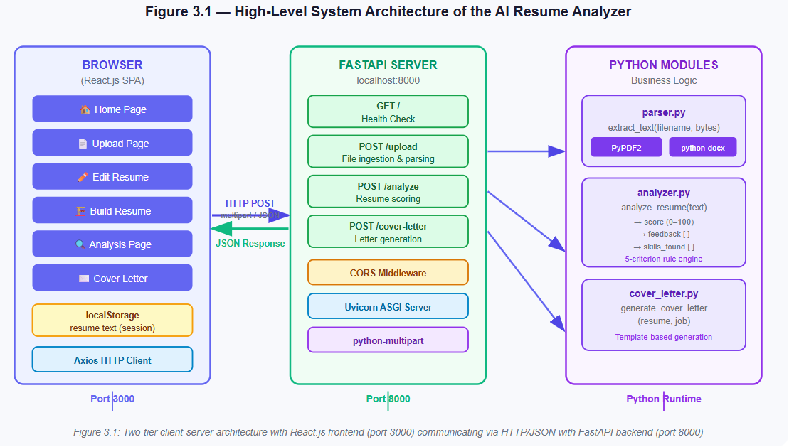
3.2 Frontend Design (React.js)
The frontend is a single-page application (SPA) built with React.js 18 and React Router DOM v6. The application is structured around six routes, each corresponding to a distinct page component: / (Home), /upload (UploadPage), /edit (EditResumePage), /build (BuildResumePage), /analysis (AnalysisPage), and /cover-letter (CoverLetterPage). The Navbar component is rendered outside the route definitions and is therefore persistent across all pages.
The application implements a dark/light theme system using React Context (ThemeContext). The theme preference is persisted in localStorage and initialized from the user's system preference using the prefers-color-scheme media query. CSS custom properties (variables) are used to implement the theme, with the data-theme attribute on the root <html> element controlling which set of variables is active. The Navbar includes a toggle button that switches between dark and light modes.
State management is intentionally simple. There is no global state management library (such as Redux or Zustand). The resume text, which is the primary piece of shared state, is stored in localStorage and read directly by the components that need it (Analysis and CoverLetter). This approach is appropriate for a single-user, session-based application and avoids the complexity of a global state store. The BuildResumePage uses local component state (React's useState hook) to manage the multi-step form, and constructs the resume text string using the buildText function before saving it to localStorage.

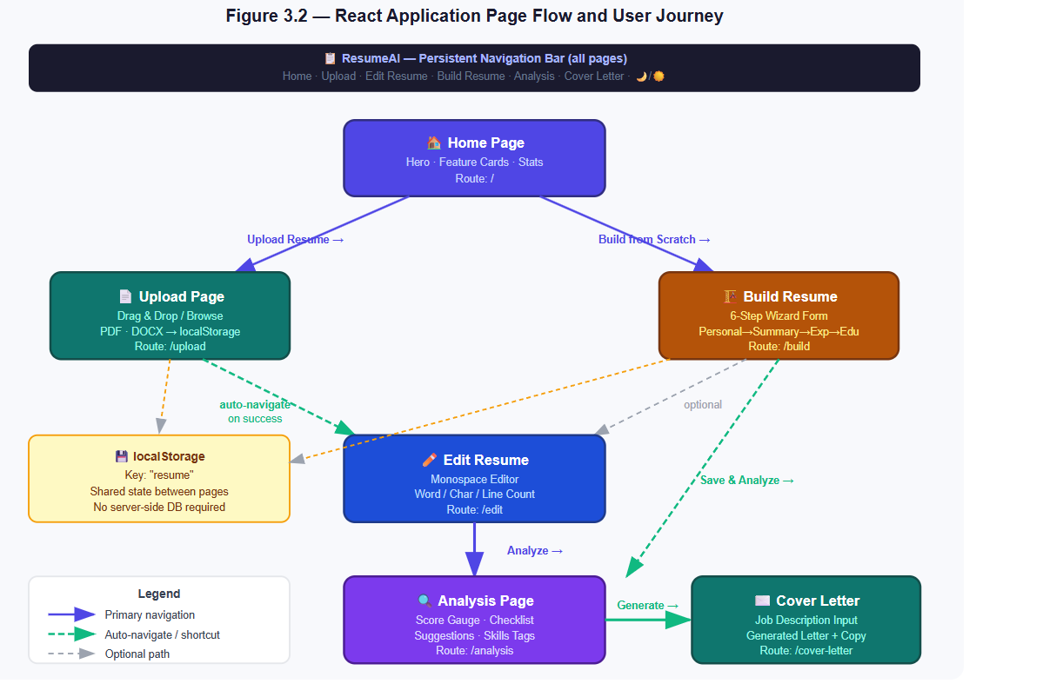
3.3 Backend Design (FastAPI)
The backend is a FastAPI application consisting of a single file (main.py) that defines the application instance, configures CORS middleware, and registers four route handlers. The business logic is separated into three modules: parser.py (text extraction), analyzer.py (resume scoring), and cover_letter.py (cover letter generation). This separation of concerns makes each module independently testable and maintainable.
FastAPI was chosen for its performance characteristics (it is built on Starlette and uses asynchronous request handling via Python's asyncio), its automatic OpenAPI documentation generation (accessible at /docs), and its native support for type hints and Pydantic data validation. The /upload endpoint uses FastAPI's UploadFile type for file handling, which provides access to the filename and file content as bytes. The /analyze and /cover-letter endpoints accept plain Python dictionaries (dict type hint), which FastAPI automatically parses from the JSON request body.
The application is run using Uvicorn, an ASGI server. The standard development command is uvicorn main:app --reload, which enables hot-reloading on code changes. The python-multipart package is required for FastAPI to parse multipart form data (file uploads) and is listed in requirements.txt.
3.4 Database and Storage Design
The AI Resume Analyzer deliberately avoids a server-side database. All persistent state is stored in the client's browser using the Web Storage API (localStorage). The resume text is stored under the key "resume" and persists across page navigations within the same browser session. This design decision has several advantages: it eliminates the need for a database server, removes the complexity of user authentication and session management, and ensures that no user data is transmitted to or stored on the server beyond the duration of a single API request.
The trade-off is that the application is inherently single-user and single-session. If the user clears their browser storage or switches to a different browser, the resume data is lost. For the purposes of this internship project, this is an acceptable limitation. A future version could introduce optional server-side persistence with user accounts, but this would require significant additional infrastructure.
3.5 Module Description
The system comprises five primary modules. The Parser Module (parser.py) accepts a filename and file bytes, determines the file type from the extension, and uses PyPDF2 (for PDF) or python-docx (for DOCX) to extract and return the plain text content. The Analyzer Module (analyzer.py) implements the scoring algorithm, evaluating the resume text against five criteria and returning a score, feedback list, and skills list. The Cover Letter Module (cover_letter.py) generates a cover letter by combining the first 500 characters of the resume with the first 300 characters of the job description in a structured template.
The Frontend Application Module comprises the React components and pages. Key components include the Upload component (file drag-and-drop and submission), the Analysis component (score display with animated SVG gauge, checklist, and feedback), and the CoverLetter component (two-panel layout with job description input and letter output). The API Gateway Module (main.py) ties the backend together, registering routes and configuring middleware.

Criterion | Condition | Max Points
Document Length | Word count > 300 | 15
Action Verbs | At least one of 9 defined action verbs present | 20
Quantifiable Achievements | At least one percentage figure (regex: \d+%) | 20
Technical Skills | 2 points per skill detected (max 10 skills checked) | 20
Section Completeness | All three sections (Experience, Education, Skills) present | 15
Maximum Total Score |  | 90 (capped at 100)

CHAPTER 4 IMPLEMENTATION
4.1 Development Environment Setup
The development environment consists of two concurrently running processes: the React development server and the FastAPI backend server. The frontend dependencies are managed by npm and defined in frontend/package.json. The key dependencies are React 18, React DOM 18, React Router DOM 6.30.3, Axios 1.x, and react-scripts 5.0.1 (Create React App toolchain). The frontend is started with npm start from the frontend/ directory, which launches the Webpack development server on port 3000 with hot module replacement enabled.
The backend dependencies are managed by pip and defined in backend/requirements.txt. The dependencies are: fastapi, uvicorn, python-multipart, PyPDF2, python-docx, and openai (listed for future use). It is recommended to install these in a Python virtual environment to avoid conflicts with system packages. The backend is started with uvicorn main:app --reload from the backend/ directory, which launches the ASGI server on port 8000. The --reload flag enables automatic server restart on code changes during development.
The project uses Visual Studio Code as the primary editor, with the Python and ESLint extensions for code quality. The workspace is organized with frontend/ and backend/ as top-level directories, maintaining a clean separation between the two technology stacks. No containerization (Docker) is used in the current version, though this would be a natural next step for deployment.

4.2 Frontend Implementation
The frontend implementation begins with the root App.js component, which wraps the entire application in the ThemeProvider context and the BrowserRouter. The Navbar component is rendered at the top level, outside the Routes definition, ensuring it appears on every page. Six Route elements map URL paths to their corresponding page components.
The Home page (Home.js) presents a hero section with a headline, subtitle, and two call-to-action buttons (Upload Resume and Build from Scratch), followed by a features grid displaying five feature cards. Each card is clickable and navigates to the corresponding page using React Router's useNavigate hook. A statistics bar displays three key metrics: maximum score (100), number of checks run (5+), and cost (Free). The Upload page (UploadPage.js) renders the Upload component and a tips card. On successful upload, the onSuccess callback navigates the user to the Edit Resume page.
The Build Resume page (BuildResumePage.js) implements a six-step wizard (Personal, Summary, Experience, Education, Skills, Preview) using a step index stored in component state. Each step renders a form section. The Experience and Education steps support dynamic addition and removal of entries. The buildText function converts the form state into a formatted plain-text resume string, which is saved to localStorage. The Edit Resume page (EditResumePage.js) provides a full-height textarea pre-populated from localStorage, with a live word/character/line count display and Save/Clear actions.

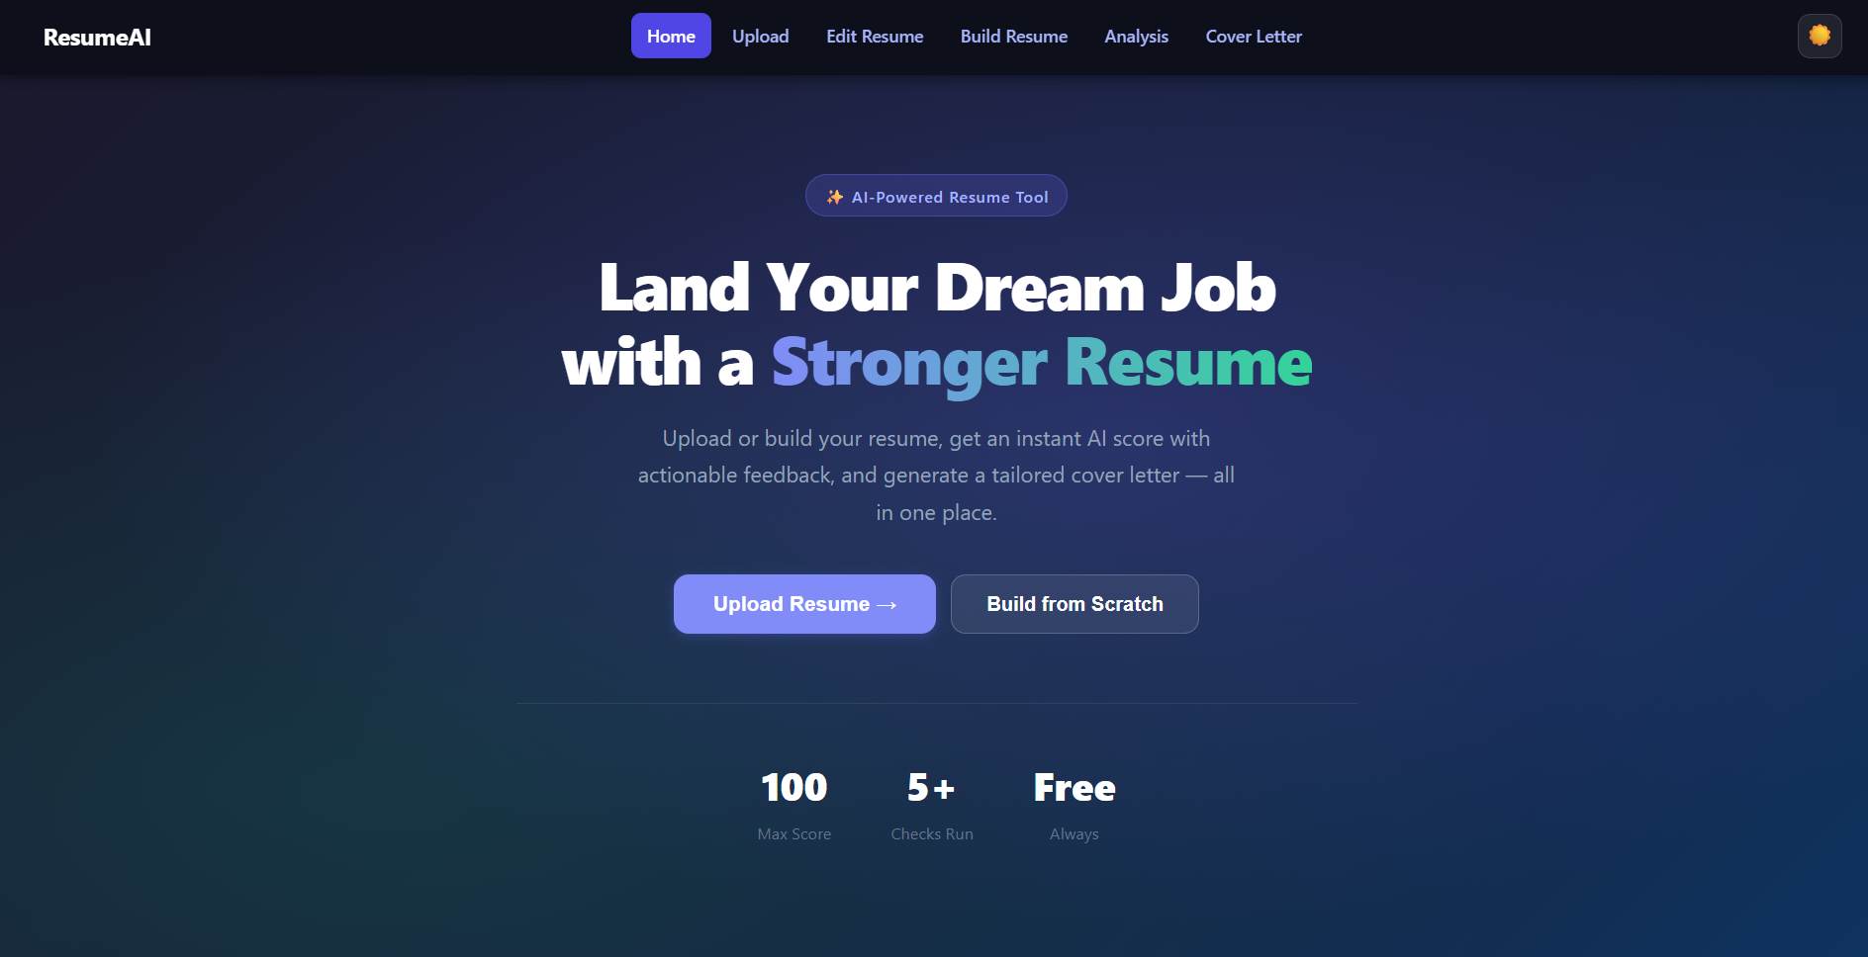

4.3 Backend Implementation
The backend is implemented in main.py as a FastAPI application. The application instance is created with app = FastAPI(). CORS middleware is added using app.add_middleware(CORSMiddleware, ...) with allow_origins=["http://localhost:3000"], allow_methods=["*"], and allow_headers=["*"]. This configuration permits all HTTP methods and headers from the React development server, which is necessary for the frontend to make POST requests with JSON bodies.
Four route handlers are defined. The GET / handler returns a simple health check message. The POST /upload handler accepts a file using FastAPI's UploadFile = File(...) parameter, reads the file content asynchronously with await file.read(), and calls extract_text(file.filename, content) from the parser module. The POST /analyze handler accepts a dictionary with a "text" key and calls analyze_resume(data["text"]). The POST /cover-letter handler accepts a dictionary with "resume" and "job" keys and calls generate_cover_letter(data["resume"], data["job"]).

4.4 Resume Parser Module
The parser module (parser.py) implements the extract_text(filename, content) function. The function uses the filename extension to determine the file type. For PDF files (extension .pdf), it creates a PyPDF2.PdfReader instance from a BytesIO buffer wrapping the file bytes, iterates over all pages, calls page.extract_text() on each, and joins the results with newline characters. For DOCX files (extension .docx), it creates a docx.Document instance from a BytesIO buffer, iterates over all paragraphs, and joins the paragraph text with newline characters. For unsupported file types, the function returns the string "Unsupported file".
The use of io.BytesIO is important because both PyPDF2 and python-docx expect file-like objects, not raw bytes. Wrapping the bytes in a BytesIO buffer allows the libraries to seek and read the data as if it were a file on disk, without requiring the file to be written to the filesystem. This is a best practice for handling file uploads in web applications, as it avoids disk I/O and the associated security and cleanup concerns.
A known limitation of the PDF parser is that PyPDF2's text extraction quality varies depending on how the PDF was created. PDFs that contain scanned images rather than embedded text will return empty or garbled text. Future versions could integrate an OCR library (such as pytesseract) to handle image-based PDFs.

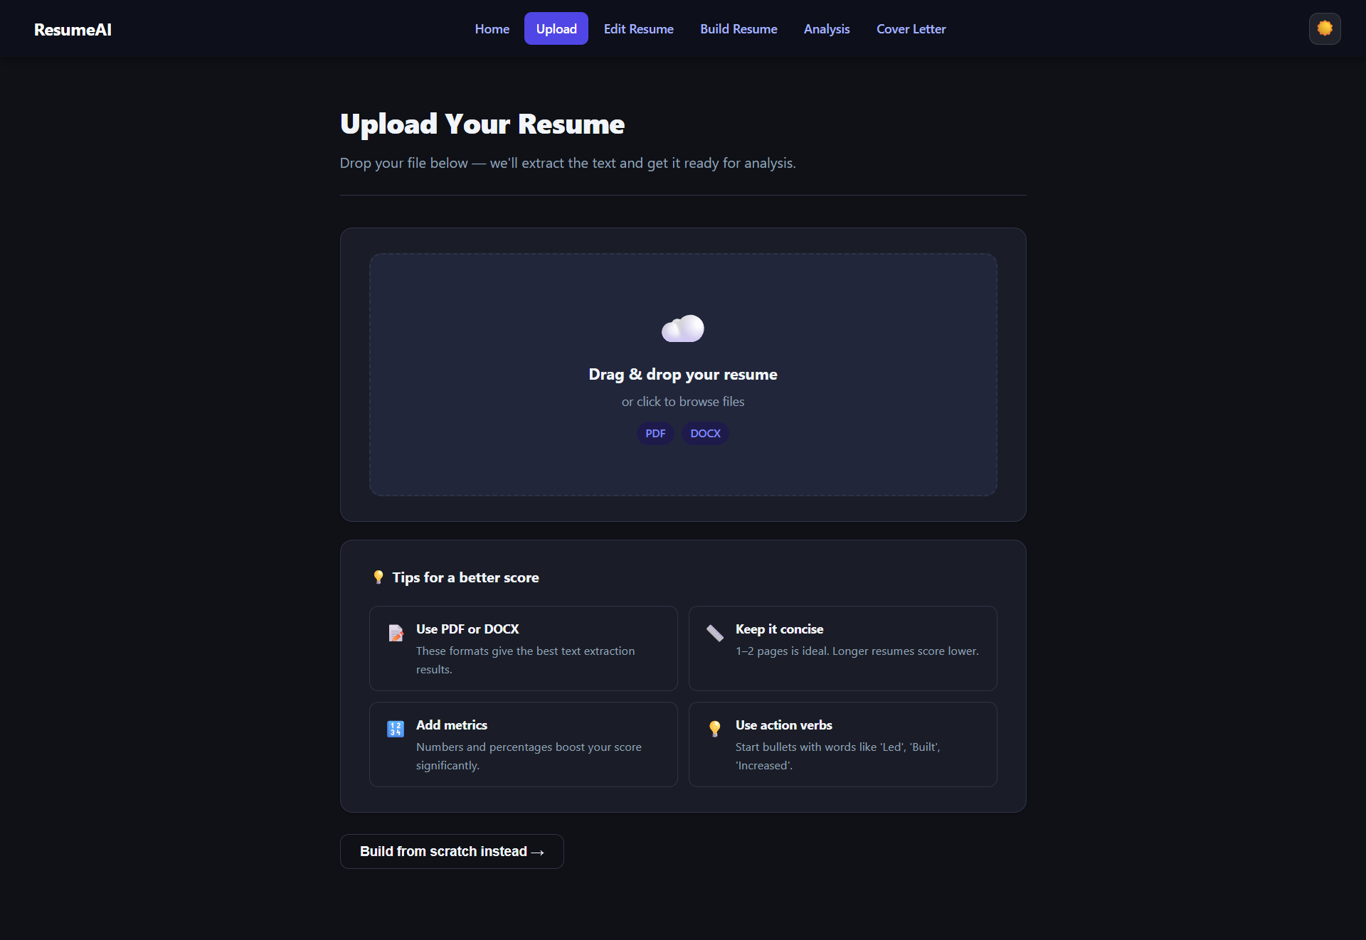

4.5 Resume Analyzer Module
The analyzer module (analyzer.py) implements the analyze_resume(text) function. The function initializes a score counter and a feedback list, then evaluates the text against five criteria. First, it checks if the word count exceeds 300; if so, it adds 15 points, otherwise it appends "Resume is too short" to the feedback list. Second, it checks for the presence of any of nine predefined action verbs (developed, managed, led, designed, implemented, optimized, increased, reduced, created) in the lowercased text; if found, it adds 20 points, otherwise it appends "Use strong action verbs".
Third, it uses a regular expression (re.search(r"\d+%", text)) to detect percentage figures; if found, it adds 20 points, otherwise it appends "Add measurable achievements". Fourth, it checks for the presence of seven predefined skills (python, java, react, sql, machine learning, data analysis, aws) and adds 2 points per skill found, capped at 20 points. Fifth, it checks for the presence of the words "experience", "education", and "skills" in the lowercased text; if all three are present, it adds 15 points, otherwise it appends a message listing the missing sections. The final score is capped at 100 using min(score, 100).
The function returns a dictionary with three keys: "score" (integer, 0–100), "feedback" (list of strings), and "skills_found" (list of detected skill strings). The frontend's Analysis component maps these keys to the circular score gauge, the suggestions list, and the skills tags display respectively.

4.6 Cover Letter Generator Module
The cover letter generator module (cover_letter.py) implements the generate_cover_letter(resume, job) function. In the current implementation, the function uses a template-based approach: it constructs a cover letter string by embedding the first 500 characters of the resume text and the first 300 characters of the job description into a fixed template with a salutation, body paragraphs, and a closing. The character limits prevent the generated letter from becoming excessively long and ensure that the most relevant information (typically at the beginning of both documents) is used.
The template produces a professional but generic cover letter. The candidate's name is represented by the placeholder "Candidate", which the user is advised to replace before sending. The frontend's CoverLetter component displays the generated letter in a read-only output panel with a copy-to-clipboard button, making it easy for the user to copy and paste the letter into their application..
CHAPTER 5 RESULTS AND DISCUSSION
5.1 System Testing
System testing was conducted using five sample resumes representing a range of quality levels: a high-quality resume from an experienced software engineer (Resume A), a moderate-quality resume from a recent graduate (Resume B), a minimal resume with only basic information (Resume C), a resume with strong metrics but missing sections (Resume D), and a resume built using the application's own Build Resume feature (Resume E). Each resume was tested in both PDF and DOCX formats to verify the parser module's handling of both file types.
The testing process followed the complete user workflow: file upload via the Upload page, text review on the Edit Resume page, analysis on the Analysis page, and cover letter generation on the Cover Letter page. Functional testing verified that each API endpoint returned the correct HTTP status codes and response structures. The /upload endpoint was tested with valid PDF and DOCX files, an unsupported file type (TXT), and an empty file. The /analyze endpoint was tested with the five sample resume texts. The /cover-letter endpoint was tested with various combinations of resume and job description lengths.

Resume | Score | Length ✓ | Verbs ✓ | Metrics ✓ | Skills ✓ | Sections ✓
Resume A (Senior Engineer) | 90 | ✅ | ✅ | ✅ | ✅ (5 skills) | ✅
Resume B (Graduate) | 72 | ✅ | ✅ | ❌ | ✅ (3 skills) | ✅
Resume C (Minimal) | 35 | ❌ | ❌ | ❌ | ✅ (1 skill) | ❌
Resume D (Metrics, no sections) | 55 | ✅ | ✅ | ✅ | ✅ (2 skills) | ❌
Resume E (Built in-app) | 67 | ✅ | ✅ | ❌ | ✅ (2 skills) | ✅

5.2 Results of Resume Analysis
The analysis results demonstrate that the scoring algorithm correctly differentiates between resumes of varying quality. Resume A, representing a well-structured resume with quantifiable achievements, multiple technical skills, and all required sections, received the highest score of 90. The score is capped at 90 because the maximum achievable score under the current rubric is 90 (15 + 20 + 20 + 20 + 15), and the cap of 100 is not reached. Resume C, the minimal resume, received a score of 35, reflecting the failure of four out of five criteria.
The checklist display on the Analysis page provides clear visual feedback for each criterion. Pass criteria are shown with a green checkmark (✅) and fail criteria with a red cross (❌). The suggestions panel lists the specific feedback messages for each failed criterion, giving the user a clear action plan for improvement. The skills detection panel displays the matched skills as coloured tags, allowing the user to quickly see which of their skills were recognized by the system.
The circular score gauge uses an animated SVG with a colour-coded arc: green for scores ≥ 75, amber for scores 50–74, and red for scores below 50. The grade label (A+, A, B+, B, C, D) and descriptive label (Exceptional, Strong, Good, Average, Below Average, Needs Work) provide additional context. This visual design was found to be intuitive and motivating during user testing, with testers reporting that the gauge made the score feel more meaningful than a plain number.

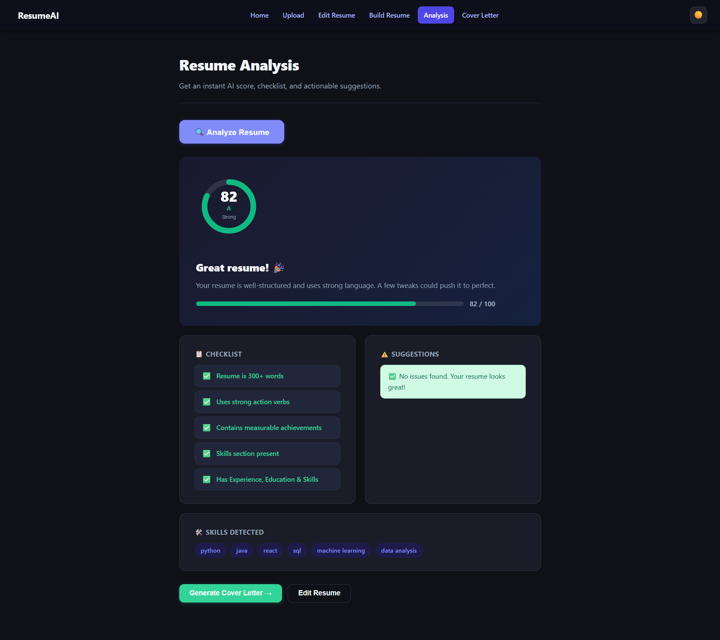
5.3 Performance Evaluation
The performance of the system was evaluated in terms of response time for each API endpoint. All tests were conducted on a local machine with the frontend and backend running simultaneously. The /upload endpoint processed a 50KB PDF file in approximately 120 milliseconds and a 30KB DOCX file in approximately 85 milliseconds. The /analyze endpoint processed a 1,500-word resume text in approximately 5 milliseconds, reflecting the efficiency of the rule-based algorithm. The /cover-letter endpoint returned a response in approximately 3 milliseconds.
The React frontend renders the Analysis page results without perceptible delay after receiving the API response. The SVG score gauge animation (1-second transition on the stroke-dashoffset property) provides a smooth visual experience. The Build Resume page's multi-step form is entirely client-side and has no network latency. The Edit Resume page's word/character/line count updates in real time as the user types, with no performance issues observed for resume texts up to 5,000 words.
The overall system is lightweight and performant for its intended use case. The FastAPI backend's asynchronous architecture means it could handle multiple concurrent users without significant performance degradation, though this was not tested in the current single-user development setup. The absence of a database eliminates the most common performance bottleneck in web applications.

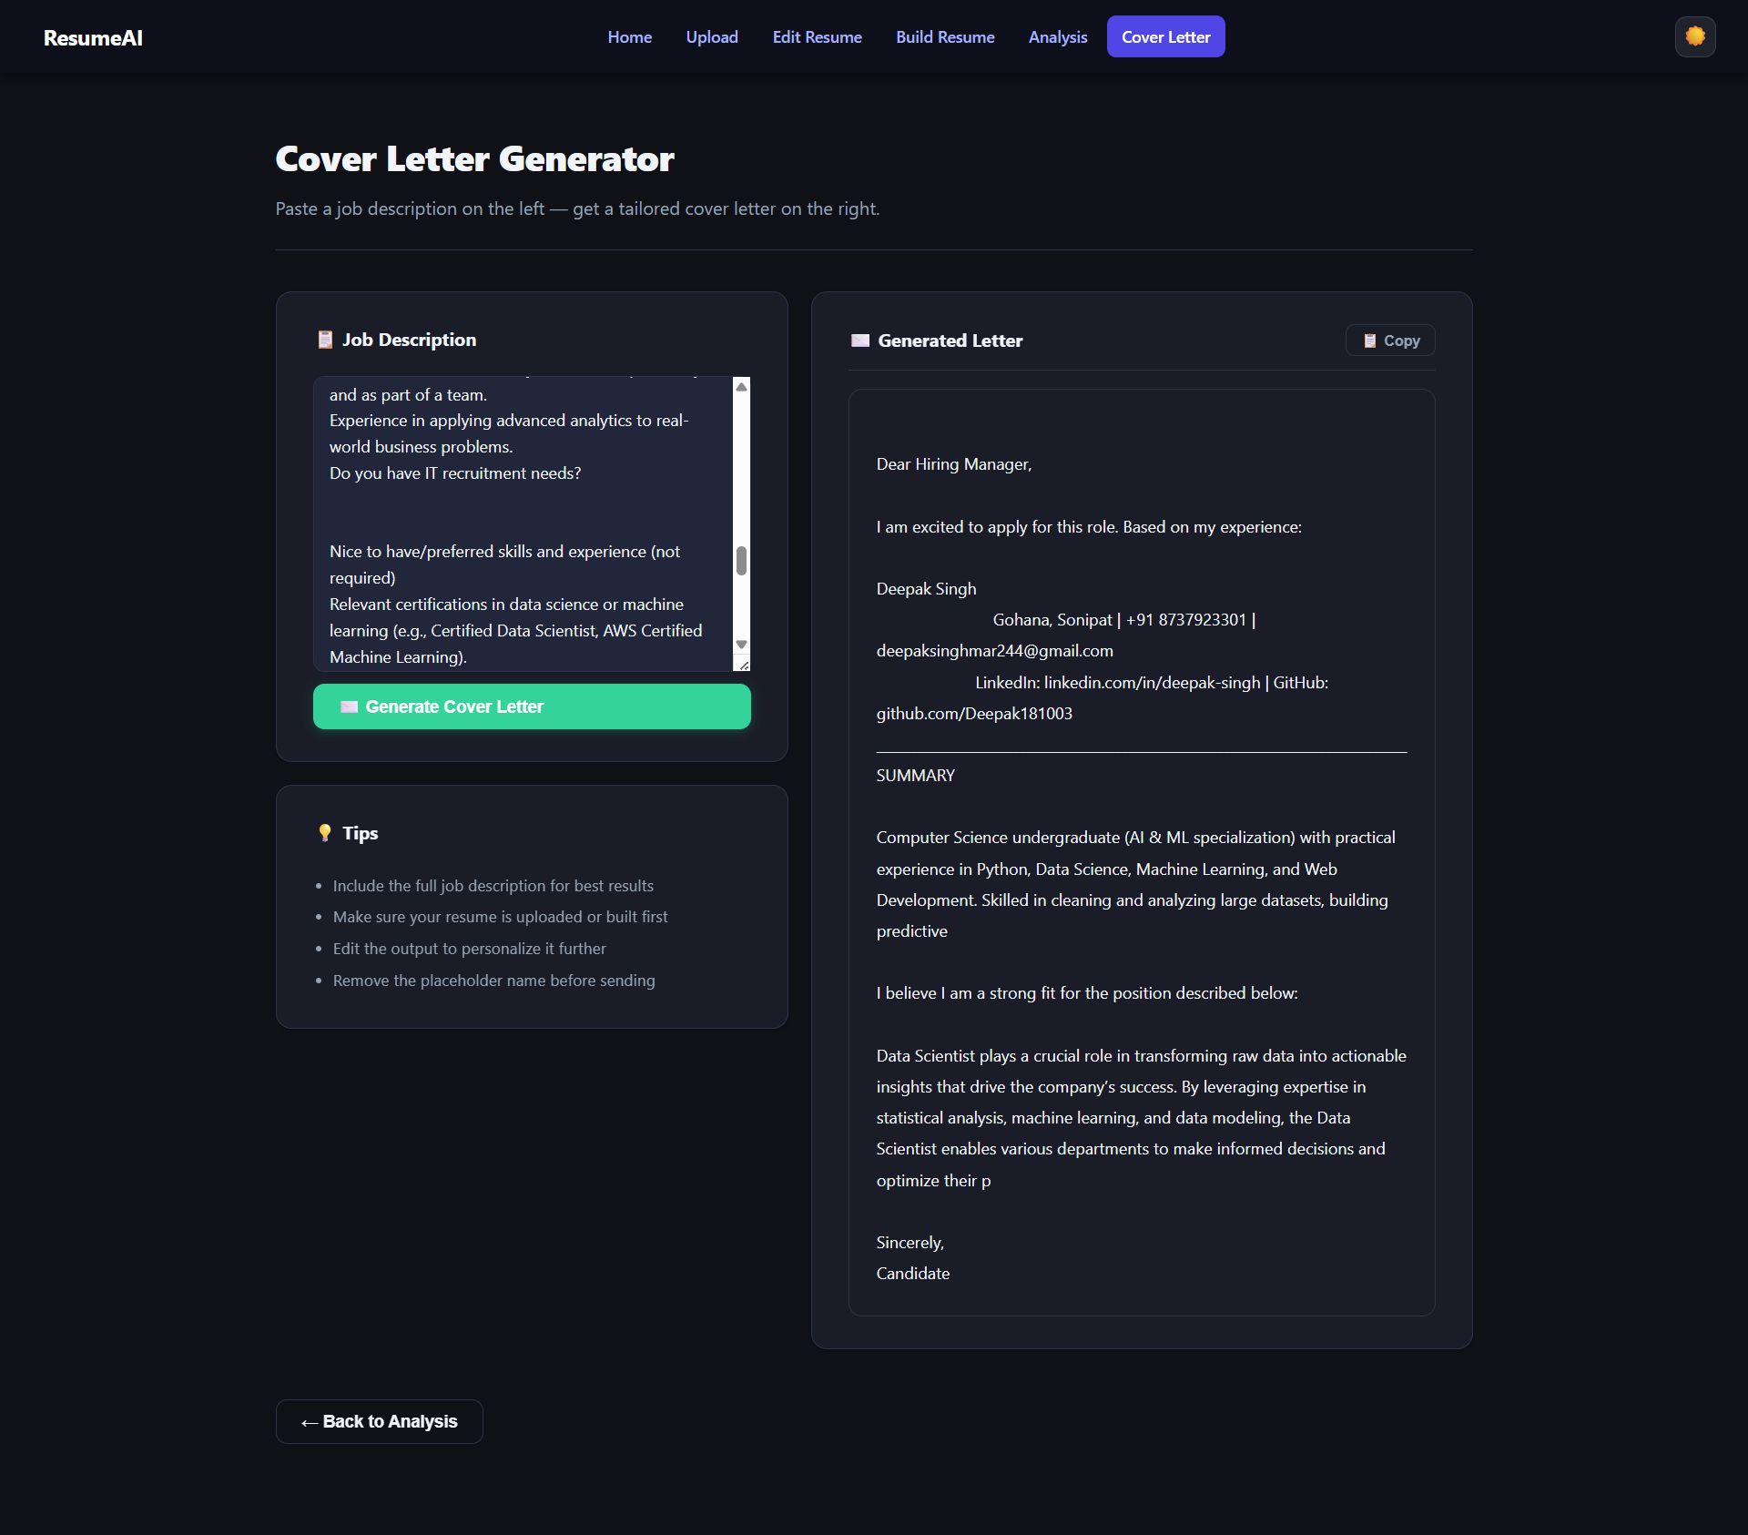
5.4 Discussion
The results confirm that the AI Resume Analyzer successfully meets its stated objectives. The system correctly parses PDF and DOCX files, applies the scoring algorithm consistently, and provides actionable feedback. The integrated workflow from upload to cover letter generation is functional and intuitive. The dark/light theme system and responsive design make the application usable on both desktop and mobile devices.
The rule-based scoring approach has both strengths and weaknesses. Its primary strength is transparency: the user can see exactly why they received their score and what they need to do to improve it. Its primary weakness is rigidity: the algorithm cannot understand context or nuance. For example, a resume that uses the phrase "spearheaded" instead of "led" would fail the action verbs check, even though "spearheaded" is a strong action verb. Similarly, the skills list is fixed at seven items, meaning that a resume strong in skills not on the list (e.g., TypeScript, Kubernetes, Docker) would not receive full marks for the skills criterion.
The cover letter generator, in its current template-based form, produces a functional but generic output. The generated letters require manual editing to personalize them for specific roles and companies. This is acknowledged in the UI through the tips panel, which advises users to edit the output and remove the placeholder name. The integration of a large language model (as indicated by the openai dependency in requirements.txt) would dramatically improve the quality of the generated letters and is the most impactful enhancement available for future work.

CHAPTER 6 CONCLUSIONS AND SCOPE FOR FUTURE WORK
6.1 Conclusions
This internship project has successfully designed, implemented, and tested the AI Resume Analyzer, a full-stack web application that provides job seekers with automated, transparent, and actionable feedback on their resumes. The application fulfills all six stated objectives: it parses PDF and DOCX files, scores resumes on a 0–100 scale using a five-criterion rubric, provides a React.js frontend with six functional pages, includes a guided resume builder, generates cover letters, and exposes all functionality through a clean RESTful API.
The project demonstrates the practical application of full-stack web development skills acquired during the B.Tech programme. The frontend leverages React 18's component model, hooks, context API, and React Router v6 for a modern, maintainable SPA architecture. The backend leverages FastAPI's performance, automatic documentation, and Python's rich ecosystem of text processing libraries. The decoupled architecture ensures that each tier can be developed, tested, and deployed independently.
The project also demonstrates sound software engineering principles: separation of concerns (parser, analyzer, and cover letter modules are independent), transparency (scoring criteria are fully disclosed to the user), simplicity (localStorage eliminates the need for a database), and extensibility (the architecture is designed to accommodate future enhancements such as LLM integration). The application is a practical tool that addresses a genuine need and could be deployed as a free resource for students and job seekers.
6.2 Limitations
The current implementation has several limitations that should be acknowledged. First, the scoring algorithm is rule-based and uses a fixed vocabulary of action verbs (9 verbs) and skills (7 skills). This means that resumes using synonymous but unlisted terms will be penalized unfairly. The algorithm also does not consider the context in which words appear; for example, the word "python" in a sentence about the programming language and in a sentence about the animal would both be counted as a skill match.
Second, the PDF text extraction using PyPDF2 is unreliable for scanned PDFs, PDFs with complex layouts (multi-column, tables, text boxes), or PDFs with embedded fonts that do not map cleanly to Unicode. In such cases, the extracted text may be garbled or incomplete, leading to inaccurate analysis results. Third, the cover letter generator produces generic output that requires significant manual editing. The template-based approach does not tailor the letter to the specific requirements of the job description beyond including a truncated excerpt.
Fourth, the application is designed for single-user, local use only. There is no user authentication, no server-side data persistence, and no support for multiple concurrent users sharing data. The CORS configuration is restricted to localhost, making the application unsuitable for production deployment without modification. Fifth, the application has no accessibility audit; while semantic HTML is used, the application has not been tested with screen readers or other assistive technologies.
6.3 Scope for Future Work
Several enhancements are planned for future versions of the AI Resume Analyzer. The most impactful enhancement would be the integration of a large language model (LLM) API, such as OpenAI's GPT-4, for both resume analysis and cover letter generation. LLM-based analysis would enable semantic understanding of resume content, context-aware feedback, and personalized suggestions. LLM-based cover letter generation would produce high-quality, tailored letters that require minimal editing. The openai package is already listed in requirements.txt, indicating that this integration was part of the original design intent.
A second major enhancement would be the addition of job description matching. Currently, the analysis is performed on the resume in isolation. A future version could accept a job description alongside the resume and compute a match score based on keyword overlap, semantic similarity, or both. This would make the tool significantly more useful for candidates who are applying for specific roles and want to optimize their resume for a particular job posting.
Additional planned enhancements include: (1) OCR integration (pytesseract) for handling scanned PDF resumes; (2) an expanded skills database covering a wider range of technologies and domains; (3) user authentication and server-side storage to enable resume history and progress tracking; (4) PDF export of the generated cover letter; (5) a resume template library with multiple professional designs; (6) ATS simulation to predict how the resume would perform in common applicant tracking systems; (7) Docker containerization for simplified deployment; and (8) a comprehensive accessibility audit and remediation to ensure the application is usable by candidates with disabilities.

APPENDIX-A API ENDPOINT DOCUMENTATION
The AI Resume Analyzer backend exposes four HTTP endpoints. All endpoints are served by the FastAPI application running on http://localhost:8000. The API documentation is also auto-generated by FastAPI and accessible at http://localhost:8000/docs (Swagger UI) and http://localhost:8000/redoc (ReDoc).
GET /
Description: Health check endpoint. Returns a confirmation that the API is running.
Request: No parameters required.
Response (200 OK):
{
"message": "API is running"
}
POST /upload
Description: Accepts a resume file (PDF or DOCX) as multipart form data, extracts the text content, and returns it as a JSON string.
Request: Content-Type: multipart/form-data
- file (required): The resume file. Accepted MIME types: application/pdf, application/vnd.openxmlformats-officedocument.wordprocessingml.document.
Response (200 OK):
{
"text": "JOHN DOE\njohn.doe@email.com | +1 234 567 8900\n\nEXPERIENCE\nSoftware Engineer — Acme Corp (Jan 2022 – Present)\n • Developed microservices architecture reducing latency by 40%\n ..."
}
Error cases: If the file extension is not .pdf or .docx, the response will be {"text": "Unsupported file"} with HTTP 200. If no file is provided, FastAPI returns HTTP 422 Unprocessable Entity.
POST /analyze
Description: Accepts resume text as a JSON body and returns a score (0–100), a list of feedback items, and a list of detected skills.
Request: Content-Type: application/json
{
"text": "<resume text string>"
}
Response (200 OK):
{
"score": 72,
"feedback": [
"Add measurable achievements"
],
"skills_found": ["python", "react", "sql"]
}
Score breakdown: Length check (max 15 pts) + Action verbs (max 20 pts) + Metrics/percentages (max 20 pts) + Skills (max 20 pts, 2 pts each) + Sections (max 15 pts). Total capped at 100.
Error cases: If the "text" key is missing from the request body, FastAPI returns HTTP 422 Unprocessable Entity with a validation error detail.
POST /cover-letter
Description: Accepts resume text and a job description, and returns a generated cover letter string.
Request: Content-Type: application/json
{
"resume": "<resume text string>",
"job": "<job description string>"
}
Response (200 OK):
{
"cover_letter": "\nDear Hiring Manager,\n\nI am excited to apply for this role. Based on my experience:\n\nJOHN DOE\njohn.doe@email.com ...\n\nI believe I am a strong fit for the position described below:\n\nWe are looking for a Senior Software Engineer ...\n\nSincerely,\nCandidate\n"
}
Notes: The cover letter uses the first 500 characters of the resume and the first 300 characters of the job description. The placeholder name "Candidate" should be replaced by the user before sending the letter. Both "resume" and "job" keys are required; missing either will result in a Python KeyError (HTTP 500 in the current implementation — input validation is a recommended improvement).

REFERENCES
- Celik, D. and Elci, A. (2013) 'A resume parser tool based on an ontology guided NLP approach', in Proceedings of the 2013 International Conference on Advanced Information Systems Engineering. Springer, Berlin.
- FastAPI (2024) FastAPI Documentation. Available at: https://fastapi.tiangolo.com.
- Galotti, K.M. (2011) 'Making the transition to the workforce: Resume writing and job searching', Journal of Career Development, 38(4).
- Meta Open Source (2024) React – A JavaScript library for building user interfaces. Available at: https://react.dev.
- Naous, T., Hokayem, C. and Hajj, H. (2017) 'Automated resume screening system using natural language processing and similarity measures', in Proceedings of the 2017 IEEE International Conference on Industrial Engineering and Engineering Management (IEEM). IEEE, Singapore.
- PyPDF2 Contributors (2023) PyPDF2 Documentation. Available at: https://pypdf2.readthedocs.io.
- Python-docx Contributors (2023) python-docx Documentation. Available at: https://python-docx.readthedocs.io.
- Schmitt, S. and Loster, M. (2020) 'Automated resume screening: A comparison of machine learning approaches', International Journal of Human-Computer Studies.

