**REPORT**

**Table of Contents**

|  |  |  |
| --- | --- | --- |
| **S. No.** | **Topic** | **Pg. No.** |
| **1** | **Introduction** |  |
| 1.1 | Purpose |  |
| 1.2 | Proxy Server and its Types |  |
| 1.3 | Project Scope |  |
| **2** | **Overall Description** |  |
| 2.1 | Project Working |  |
| 2.2 | Project Functions |  |
| 2.3 | Main Characteristics |  |

|  |  |
| --- | --- |
|  |  |

**1. Introduction**

A proxy server is a computer that offers a computer network service to allow clients to make indirect network connections to other network services. A client connects to the proxy server, and then requests a connection, file or other resource available on a different server.

A proxy acts as an intermediary agent between its clients and the servers which they want to access, performing functions directed towards a variety of purposes, like security, caching etc.

**1.1 Purpose**

The purpose of using proxy server is:

* Improve Performance
* Content Filtering
* Accessing services anonymously
* Security of host

**1.2 Proxy Server and its types**

**There 3 types of Proxy:**

**1.Normal Proxy:**

* A regular caching proxy server is a server which listens on a separate port (e.g. 3128) and the clients (browsers) are configured to send requests for connectivity to that port.
* So, the proxy server receives the request, fetches the content and stores a copy for future use.

**2. Transparent Proxy:**

* A transparent proxy server is also a caching server, but the server is configured in such a way that it eliminates the client side (browser side) configuration.

**3. Reverse Proxy:**

* A reverse proxy is totally different in its usage because it is used for the benefit of the web server rather than its clients.

**1.4 Project Scope**

* This project aims at providing anonymous access, security, administrative control, and privacy.
* The main features of this product are blacklisting URLs and managing the client.
* Benefits of using this product are hidden IP address, filtered requests, protection,

performance and anonymity.

The scope of this product is to attain the above objectives within the given timestamp.

**2. Overall Description**

**2.1 Project Working**

A proxy tool is a [server](https://www.webopedia.com/TERM/S/server.htm) that sits between a [client application,](https://www.webopedia.com/TERM/C/client.htm) such as a [Web browser,](https://www.webopedia.com/TERM/B/browser.htm) and a real server. It intercepts all requests to the real server to see if it can fulfil the requests itself. If not, it forwards the request to the real server.

The below figure describes working of the client server model:

A client is a software programme that runs on a user's local computer, smartphone, or other device and connects to a server when required. An example of a client would be a web browser.

A Web server is a piece of software that processes requests sent by HTTP clients installed on user’s computers and utilises that protocol to deliver the files that make up Web pages to those users. Web servers may also refer to specific devices like computers and appliances.

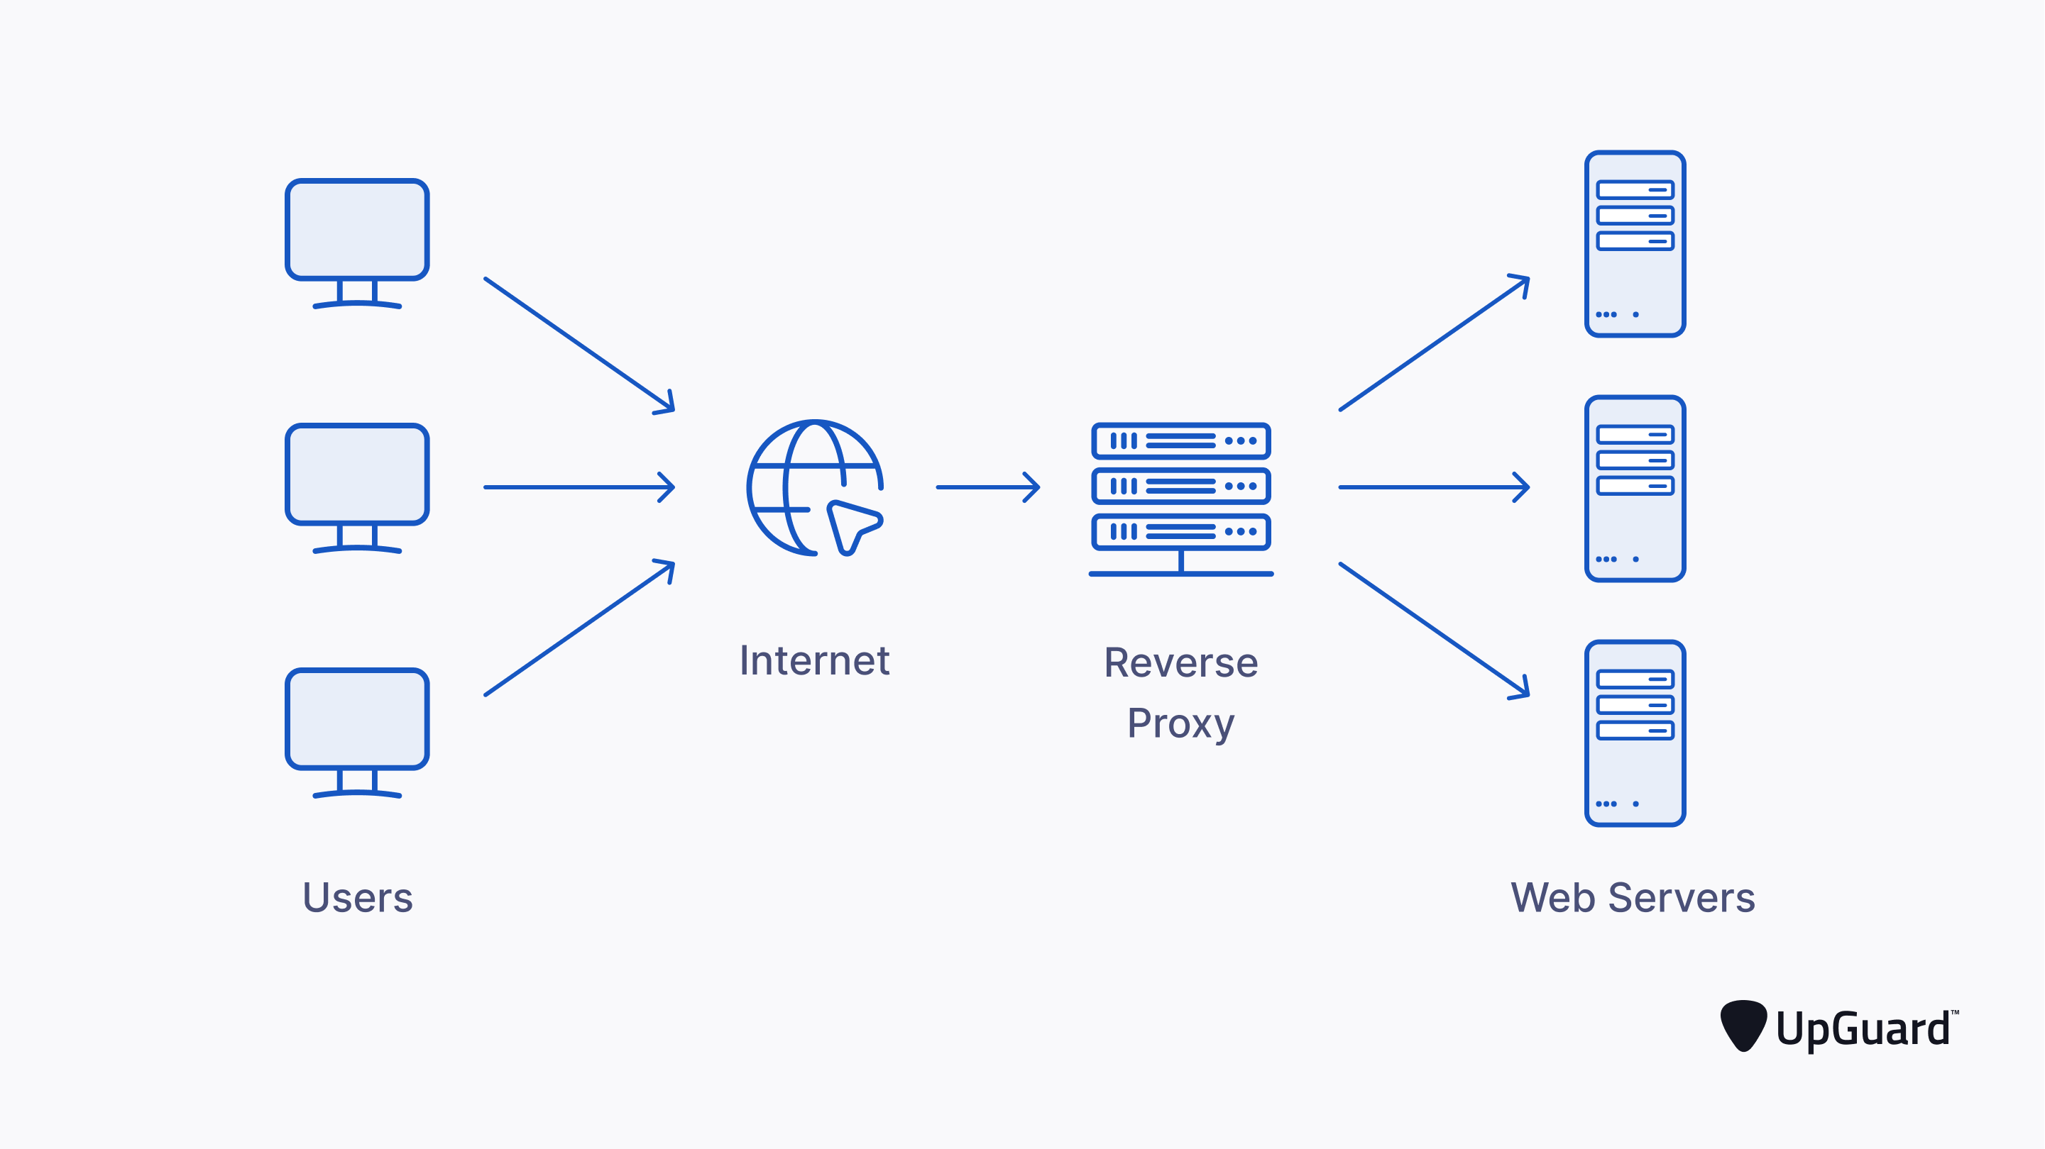

By serving as a gateway for internal client computers to the Internet, this proxy tool enables you to connect a private network or LAN to a public network, such as the Internet. A secure gateway called a proxy server can be used to link IP-based networks to the Internet. A gateway is a computer that enables communication between two networks. On a single computer that is connected to both the private network and the public network, proxy tool services should be running.

**2.2 Project Functions**

**Blocking URL**: The website's IP address and URL are recorded in the file when banning URLs. The banned URL file contains the URL or website that the administrator wishes to prohibit. The website or URL for the client is blocked if the IP matches a record in the prohibited URL file.

**Client Managing:** When clients are connected to the proxy tool the status of request and response is maintained with all client details.

**2.3 Main Characteristics**

The characteristics of the proxy tool is:

* Blocking and Unblocking URL
* Client managing
* Log Viewing

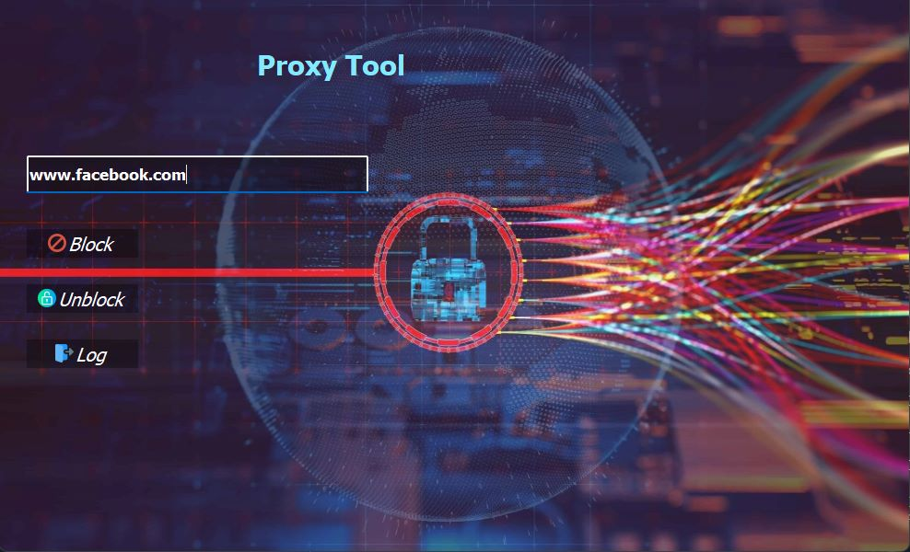

**Figure 1: Start Page with All Features**

**Figure 2: Accessing Blocked Site on Client Side**

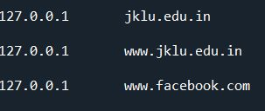

**Figure 3: Blocked URL List Viewing**



**Figure 4: Website Blocked Message**

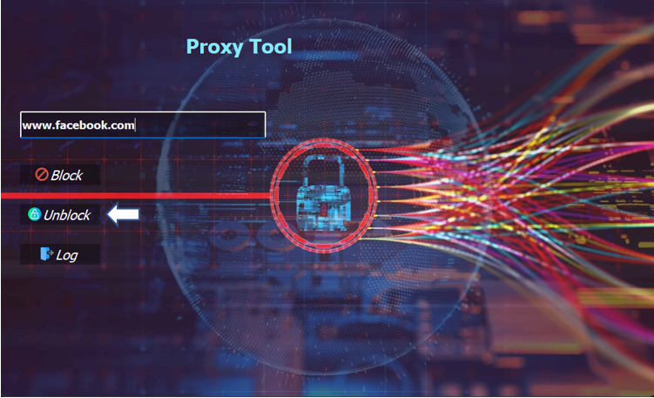



**Figure 5: Website Unblock Message**