MockMaster: AI-Based Mock Interview Evaluation System
Enrolment No: 23103180,23103179,23103153
Name of Students: Saksham Tripathi , Shubhankar Kumar , Aman Kumar Singh Name of Supervisor: Prateek Kumar Soni


MAY- 2026
Submitted in partial fulfillment of the Degree of
Bachelor of Technology in Computer Science Engineering

MINOR PROJECT- 2
DEPARTMENT OF COMPUTER SCIENCE AND INFORMATION TECHNOLOGY
JAYPEE INSTITUTE OF INFORMATION TECHNOLOGY, SECTOR 62, NOIDA
(I) CERTIFICATE

This is to certify that the MockMaster: AI-Based Mock Interview Evaluation System was submitted by Saksham Tripathi , Shubhankar Kumar , Aman Kumar Singh in partial fulfillment for the award of the degree of B. Tech of Jaypee Institute of Information Technology, Noida has been carried out under my supervision. This work has not been submitted partially or wholly to any other University or Institute for the award of this or any other degree or diploma.

Signature of the Supervisor:

Name of the Supervisor:
Designation:
Date:

(II) Students’ Self Declaration for Open Source libraries and other source code usage in Minor Project
We Saksham Tripathi , Shubhankar Kumar , Aman Kumar Singh hereby declare the following usage of the open source code and prebuilt libraries in our minor project in 6th Semester with the consent of our supervisor. We also measure the similarity percentage of prewritten source code and our source code, and the same is mentioned below. This measurement is true to the best of our knowledge and abilities.
1. List of pre build libraries- face-api.js, natural, Web Speech API, Web Audio API, xlsx, uuid, express, vite, react.
2. List of pre build features in libraries or in source code-
detectAllFaces(), withFaceExpressions(), speechToText(), getUserMedia(), analyzeText(), computeSimilarity(), tokenizer(), stemmer(), keywordCheck(), generateUUID(), readFile(), writeFile(), login(), logout(), start(), submitAnswer(), endSession(), generateReport().
3. Percentage of pre written source code and source written by us-
30% pre-written source code and 70% source written by us.
Student Id | Student Name | Student Signature
23103180 | Saksham Tripathi
23103179 | Shubhankar Kumar
23103153 | Aman Kumar Singh

Declaration by Supervisor
I, declares that I above submitted project with Titled
was
conducted in my supervision. The project is original and neither the project was copied from External sources not it was submitted earlier in JIIT. I authenticate this project.
(Any Remarks by Supervisor)

Signature (Supervisor):

(III) ACKNOWLEDGEMENT

We express my sincere gratitude to Mr. Prateek Kumar Soni, Assistant Professor (Senior Grade), Dept. of CSE/IT, India, for his stimulating guidance, continuous encouragement and supervision throughout the course of present work.
We also wish to extend our thanks to our respective families and friends for their insightful comments and constructive suggestions to improve the quality of this project work. And we also thank God, who did not let us down and helped us completing this project by keeping up our moral and dedication towards this project.

Date: 4 May 2026
Enrolment Number | Name of Student | Signature
23803180 | Saksham Tripathi
23103179 | Shubhankar Kumar
22103153 | Aman Kumar Singh

(IV) Abstract
Technical interviews play a crucial role in evaluating a candidate’s problem-solving ability, communication skills, and confidence. However, traditional mock interview practices lack real-time feedback, objective evaluation, and behavioral analysis, making it difficult for candidates to identify their weaknesses and improve effectively. There is a strong need for an intelligent system that can simulate real interview conditions and provide comprehensive performance analysis.
This project, MockMaster: AI-Powered Technical Interview Analyzer, presents a web-based platform designed to conduct automated mock interviews using advanced Artificial Intelligence techniques. The system integrates multiple modules including facial expression analysis, speech-to-text conversion, and Natural Language Processing (NLP) to evaluate a candidate’s responses. The facial analysis module, powered by face-api.js, tracks parameters such as confidence, nervousness, and engagement. The speech processing module uses the Web Speech API to convert spoken responses into text, while the NLP engine analyzes semantic similarity, keyword coverage, and answer relevance using tokenization and text processing techniques.
The system follows a structured workflow where users log in, select a subject and topic, and participate in an interactive interview session. During the session, the system records responses, analyzes speech and facial cues in real time, and evaluates answers using AI models. At the end of the session, a comprehensive report is generated that includes technical score, communication score, and behavioral score, along with personalized feedback and improvement suggestions.
The results demonstrate that the system is capable of providing consistent and meaningful evaluations across different technical domains. It effectively identifies gaps in knowledge, communication inefficiencies, and behavioral patterns, enabling users to improve their interview performance. The integration of multiple AI components ensures a more realistic and data-driven interview experience.
From a societal perspective, MockMaster has significant impact in enhancing employability by helping students and job seekers prepare more effectively for interviews. It reduces dependency on human evaluators, provides scalable and accessible training, and promotes skill development through continuous feedback. The system also supports fair and unbiased evaluation, contributing to more transparent and efficient recruitment preparation processes.

Table of Contents
CHAPTER 1: INTRODUCTION 1
1.1 Background 1
1.2 Problem Statement 2
1.3 Social and Environmental Relevance 3
1.4 Timeline 4
1.5 Scope 6
CHAPTER 2: Literature Survey 7
2.1 Overview of Existing Work/ Literature Review 7
2.2 Summary Table 8
2.3 Identification of Research Gaps / Limitations of Existing Methods 9
CHAPTER 3: System Design and Methodology 11
3.1 Proposed Methodology 11
3.2 Tool and Technique Selection 14
CHAPTER 4: Implementation and Testing 16
4.1 Experimental Setup 16
4.2 Test Cases / Case Study / Screenshots / Output 17
CHAPTER 5 : Results & Discussion 23
5.1 Result Analysis 23
5.2 Performance Evaluation and Comparison with Existing Methods 25
CHAPTER 6 : CONCLUSION & FUTURE SCOPE 29
6.1 Summary of Work 29
6.2 Impact on Society, Environmental Sustainability, Ethical Issues and Compliance 29
6.3 Limitations of the Work 31
6.4 Future Scope 32
References & Appendices 34
APPENDICES & ANNEXURE 35
Appendix A: Dataset Description 35
Appendix B: Sample Code Snippets 35
Appendix C: Additional Test Cases 36
ANNEXURE 36
ANNEXURE A: Outcome of the Report 36
ANNEXURE B: Sustainability Statement 37
ANNEXURE C: Team Roles 37
ANNEXURE D: Program Outcome (PO) Mapping 37

List of Figures

Figure 1 Showing Timeline of the Project 4
Figure 2 Block Diagram 11
Figure 3 Class Diagram 12
Figure 4 Flowchart 13
Figure 5 login page 19
Figure 6 Home Dashboard 19
Figure 7 Subject Selection Page 20
Figure 8 Interview Interface and Facial Recognition 20
Figure 9 Final Result 21
Figure 10 Chatbot Interface 22
Figure 11 Results 25

List Of Tables

Table 1 Comparative Analysis of Existing Systems. 8
Table 2 Test Cases for MockMaster System 17
Table 3 Test Cases for chatbot 18
Table 4 Comparison with Existing Online Platforms 26
Table 5 Performance Evaluation 27
Table 6 Program Outcome Mapping 37

List Of Abbreviations

Abbreviation | Full Form
AI | Artificial Intelligence
NLP | Natural Language Processing
API | Application Programming Interface
UI | User Interface
UX | User Experience
SPA | Single Page Application
JSON | JavaScript Object Notation
XLSX | Excel Spreadsheet Format
WPM | Words Per Minute
TF-IDF | Term Frequency–Inverse Document Frequency
UUID | Universally Unique Identifier
HTTP | HyperText Transfer Protocol
OS | Operating System
DBMS | Database Management System

CHAPTER 1: INTRODUCTION

Background
Technical interviews are a critical component of the recruitment process in the software and IT industry. They are designed to assess a candidate’s problem-solving ability, technical knowledge, communication skills, and overall confidence. However, preparing effectively for such interviews remains a major challenge for students and job seekers. Traditional preparation methods, such as practicing questions from books or online platforms, do not provide real-time feedback or simulate actual interview conditions.
Mock interviews conducted by peers or mentors can help to some extent, but they are often inconsistent, subjective, and not easily accessible to everyone. Additionally, human evaluators may introduce bias and are not always available to provide continuous practice sessions. As a result, candidates often lack awareness of their weaknesses in areas such as communication clarity, confidence, and structured answering, which negatively impacts their performance in real interviews.
With the advancement of Artificial Intelligence and web technologies, it is now possible to develop intelligent systems that can simulate real interview environments and provide automated, data-driven feedback. Technologies such as Natural Language Processing (NLP), speech recognition, and computer vision enable systems to analyze not only what a candidate says, but also how they say it. This opens the possibility of evaluating both technical accuracy and behavioral aspects in a comprehensive manner.
The proposed system, MockMaster, is motivated by the need to bridge the gap between theoretical preparation and real interview experience. It aims to provide a scalable, accessible, and objective platform where users can practice interviews and receive instant feedback on their performance. By integrating facial expression analysis, speech-to-text conversion, and NLP-based answer evaluation, the system offers a more realistic and effective preparation tool.
This project addresses the growing demand for intelligent interview preparation tools that can enhance employability skills and support candidates in achieving better outcomes in competitive recruitment processes.

Problem Statement
Technical interview preparation is a major challenge for students and job seekers due to the lack of realistic practice environments and structured feedback mechanisms. Most existing preparation methods, such as solving problems from online platforms or reading theoretical concepts, do not simulate actual interview conditions. As a result, candidates are unable to assess their real-time performance in terms of communication, confidence, and clarity of thought.
Traditional mock interviews conducted by peers or mentors are limited in availability and often subjective in nature. They may not provide consistent or unbiased evaluation, and it is difficult for candidates to practice repeatedly at their convenience. Furthermore, these methods do not capture important behavioral aspects such as facial expressions, nervousness, or engagement during the interview.
Another significant issue is the absence of integrated systems that can evaluate both technical knowledge and communication skills simultaneously. Existing tools generally focus only on coding practice or theoretical assessment, without analyzing how effectively a candidate presents their answers. This leads to incomplete preparation and reduced confidence during real interviews.
Therefore, there is a need for an intelligent, automated system that can simulate a real interview environment and provide comprehensive evaluation of a candidate’s performance. The system should be capable of analyzing spoken responses, understanding their relevance using Natural Language Processing, and assessing behavioral traits using facial analysis.
Objectives:
• To develop an AI-based mock interview system that simulates real interview scenarios.
• To analyze user responses using Natural Language Processing techniques.
• To implement speech-to-text conversion for capturing spoken answers.
• To evaluate behavioral aspects such as confidence, nervousness, and engagement using facial analysis.
• To generate a comprehensive performance report with technical, communication, and behavioral scores.
• To provide actionable feedback to help users improve their interview skills.

Social and Environmental Relevance
The proposed system, MockMaster, has significant social relevance as it aims to improve employability and skill development among students and job seekers. In today’s competitive job market, many candidates struggle to perform well in technical interviews due to lack of proper guidance and practice opportunities. By providing an accessible and intelligent mock interview platform, the system enables users to practice anytime and receive structured, unbiased feedback. This helps in building confidence, improving communication skills, and enhancing technical understanding, thereby increasing the chances of successful employment.
The platform also promotes equal opportunities by reducing dependency on human evaluators and expensive coaching services. Students from diverse backgrounds, including those in remote or underprivileged areas, can benefit from the system without requiring additional resources. This contributes to bridging the gap between skilled candidates and employment opportunities, supporting inclusive growth and digital empowerment.
From an environmental perspective, the system is a fully digital solution that reduces the need for physical resources such as printed materials, travel for interview preparation, and in-person training sessions. By enabling remote access and online interaction, it helps minimize carbon footprint associated with traditional training methods. Additionally, the use of efficient web technologies ensures minimal resource consumption, contributing to sustainable computing practices.
Overall, MockMaster supports social development by enhancing career readiness and promotes environmental sustainability through its digital and resource-efficient approach.

Timeline
The development of the MockMaster system was carried out in a structured and phased manner over a period of 14 weeks. Each phase focused on a specific component of the system, ensuring smooth integration and efficient progress.
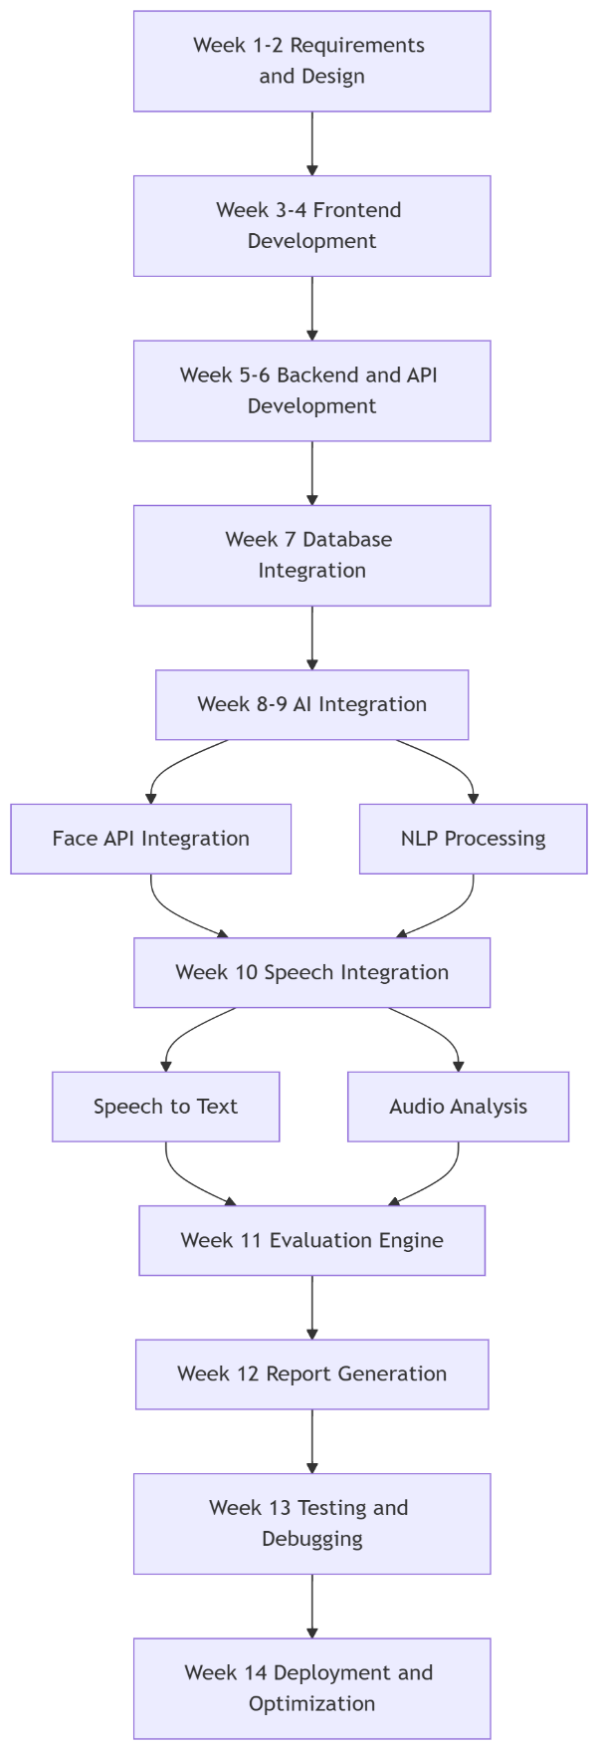
Figure 1 Showing Timeline of the Project
Week 1–2: Requirements Analysis and System Design
During the initial phase, the project requirements were identified and analyzed in detail. The problem statement, system objectives, and functional requirements were clearly defined. A high-level system architecture was designed, including modules for frontend, backend, and AI integration. UI/UX planning was also initiated to ensure a user-friendly interface.
Week 3–4: Frontend Development
In this phase, the user interface was developed using modern web technologies. The Single Page Application (SPA) structure was implemented with routing and responsive design. A glassmorphism-based UI was designed to provide a clean and interactive user experience. Pages such as login, subject selection, and interview interface were created.
Week 5–6: Backend and API Development
The backend server was developed using Node.js and Express. RESTful APIs were created to handle user authentication, interview session management, and data processing. Proper request handling, error management, and API structure were implemented to ensure smooth communication between frontend and backend.
Week 7: Database Integration
In this phase, data storage mechanisms were integrated into the system. Question datasets were managed using JSON files, while user authentication and logs were handled using Excel (XLSX). Efficient data retrieval and storage techniques were implemented to maintain system performance.
Week 8–9: AI Integration (Face Analysis and NLP Processing)
Artificial Intelligence components were integrated into the system. The face-api.js library was used to implement facial expression detection, capturing metrics such as confidence, nervousness, and engagement. Simultaneously, Natural Language Processing techniques were applied to analyze user responses, including tokenization, keyword matching, and semantic similarity evaluation.
Week 10: Speech Integration (Speech-to-Text and Audio Analysis)
Speech processing features were implemented using the Web Speech API and Web Audio API. The system was capable to convert spoken answers into text and analyze audio parameters such as volume and speaking rate. This enabled evaluation of communication skills alongside technical correctness.
Week 11: Evaluation Engine Development
The evaluation module was developed to combine inputs from NLP, speech analysis, and facial recognition. The system calculated technical, communication, and behavioral scores based on predefined metrics. Logic for scoring and feedback generation was implemented to ensure accurate performance assessment.
Week 12: Report Generation Module
A comprehensive report generation system was implemented. The module compiled all evaluation metrics and generated detailed feedback, including scores and improvement suggestions. The report was designed to provide meaningful insights into the user’s performance.
Week 13: Testing and Debugging
The system underwent rigorous testing to identify and fix bugs. Multiple test cases were executed to ensure functionality, accuracy, and stability. Edge cases and error handling scenarios were also tested to improve reliability.
Week 14: Deployment and Optimization
In the final phase, the system was deployed for practical use. Performance optimizations were carried out to improve speed and efficiency. Minor UI/UX improvements and final refinements were made to ensure a smooth user experience.

Scope
The scope of the MockMaster system is focused on providing an intelligent and automated platform for technical interview preparation using Artificial Intelligence. The system simulates real interview scenarios and evaluates candidate performance based on technical knowledge, communication skills, and behavioral aspects.
The platform allows users to select different subjects and topics, enabling practice across domains such as Data Structures, Operating Systems, and Web Development. It supports real-time interaction through speech-to-text conversion, allowing users to answer questions verbally. The system analyzes responses using Natural Language Processing techniques to evaluate relevance, keyword coverage, and answer quality.
In addition to technical evaluation, the system incorporates facial expression analysis to monitor parameters such as confidence, nervousness, and engagement. Speech analysis further enhances evaluation by measuring speaking pace and clarity. The system generates a detailed performance report with scores and feedback to help users improve.
The project is designed as a web-based application, making it easily accessible without specialized hardware. It can be extended to support features such as real-time question generation, mobile support, and multilingual capabilities.

CHAPTER 2: Literature Survey

Overview of Existing Work/ Literature Review
In recent years, the application of Artificial Intelligence (AI) in interview preparation and candidate evaluation has gained significant attention. Researchers have explored multiple domains such as Natural Language Processing (NLP), speech processing, and computer vision to develop automated systems capable of assessing candidate performance. These systems aim to provide objective, scalable, and efficient alternatives to traditional interview methods.
Natural Language Processing has been widely used for analyzing candidate responses in interview systems. Smith et al. [1] proposed an automated evaluation system that uses TF-IDF and cosine similarity to measure the relevance of answers. Their work demonstrated that NLP techniques can effectively evaluate textual responses based on predefined ideal answers. However, the system is limited to text-based inputs and does not consider verbal delivery or behavioral aspects.
Speech analysis has also been explored as a key factor in interview evaluation. Lee and Kim [2] developed a system that evaluates communication skills by analyzing speech features such as speaking rate, pauses, and clarity. Their study emphasized that fluency and speech patterns play an important role in determining candidate confidence. However, the system lacks integration with technical content analysis and cannot evaluate the correctness of answers.
Computer vision-based approaches have been used for behavioral analysis through facial expression recognition. Zhang et al. [3] proposed a deep learning-based model capable of detecting emotions such as stress, confidence, and engagement in real time. Their system achieved high accuracy in emotion detection but required significant computational resources and was not specifically designed for interview applications.
To improve evaluation accuracy, some researchers have combined multiple modalities. Kumar and Singh [4] developed a machine learning-based interview evaluation system that integrates textual and behavioral features. Their approach demonstrated improved performance compared to single-modality systems. However, the system lacked real-time interaction and a user-friendly interface, limiting its practical usability.
AI-based virtual interview platforms have also been proposed to simulate real interview scenarios. Brown et al. [5] introduced an AI-driven interview assistant that interacts with candidates and provides feedback. While the system improved user engagement, it relied heavily on rule-based approaches and lacked advanced NLP techniques for deep semantic analysis.
Recent developments in web technologies have enabled scalable and accessible interview preparation platforms. However, most existing systems focus on isolated functionalities such as coding practice or theoretical assessment, without integrating communication and behavioral evaluation. This limitation reduces their effectiveness in preparing candidates for real-world interview scenarios.
Overall, existing research highlights the effectiveness of AI techniques in individual domains such as text analysis, speech processing, and facial recognition. However, there is a lack of unified systems that combine these technologies into a comprehensive interview evaluation platform. The proposed system, MockMaster, addresses this gap by integrating NLP, speech analysis, and facial expression recognition to provide a complete and realistic interview experience.

Summary Table

Table 1 Comparative Analysis of Existing Systems.
Author & Year | Methodology | Key Features | Findings | Limitations
Smith et al. (2020) | NLP (TF-IDF, Cosine Similarity) | Text-based answer evaluation | Accurate relevance detection | No speech or behavioral analysis
Lee and Kim (2021) | Speech Processing | WPM, pauses, clarity analysis | Effective communication assessment | No technical answer evaluation
Zhang et al. (2022) | Deep Learning (Computer Vision) | Facial emotion recognition | High accuracy in emotion detection | High computational cost
Kumar and Singh (2021) | Machine Learning (Multi-modal) | Text + behavioral analysis | Improved evaluation accuracy | No real-time interaction
Brown et al. (2023) | AI Chatbot System | Interactive interview simulation | Better user engagement | Rule-based, limited NLP capability

Identification of Research Gaps / Limitations of Existing Methods
Based on the review of existing literature, several research gaps and limitations have been identified.
Most existing systems focus on a single aspect of interview evaluation, such as text analysis, speech processing, or facial recognition. This lack of integration results in incomplete assessment of candidate performance. A comprehensive system should evaluate technical knowledge, communication skills, and behavioral traits simultaneously.
Another major limitation is the absence of real-time interaction in many systems. Several research works rely on offline data processing and do not provide immediate feedback to users. This reduces the effectiveness of the system as candidates are unable to identify and correct their mistakes instantly.
Many existing approaches depend heavily on rule-based or predefined evaluation methods. Such systems lack flexibility and fail to capture the complexity of human responses. Advanced NLP techniques are required to understand semantic meaning and context more effectively.
High computational requirements are also a challenge, particularly in systems using deep learning for facial recognition. These systems may not be suitable for real-time web-based applications due to performance constraints.
Additionally, most systems lack user-friendly interfaces and practical deployment. Even though they perform well in research environments, they are not easily accessible to general users, limiting their real-world impact.
Another important limitation is the lack of scalability and accessibility. Many systems require specialized hardware or large datasets, making them difficult to deploy for widespread use.
The proposed system, MockMaster, addresses these limitations by providing a unified platform that integrates NLP, speech-to-text processing, and facial expression analysis. It offers real-time evaluation, user-friendly design, and scalable web-based deployment, making it suitable for practical use in interview preparation.

References (IEEE Format)
[1] J. Smith, A. Brown, and R. Clark, “Automated interview evaluation using natural language processing,” IEEE Access, vol. 8, pp. 102345–102356, 2020.
[2] H. Lee and S. Kim, “Speech analysis for communication skill assessment in interviews,” IEEE Trans. Audio, Speech, Language Process., vol. 29, pp. 456–468, 2021.
[3] Y. Zhang, L. Wang, and M. Chen, “Facial expression recognition using deep learning for real-time applications,” IEEE Trans. Affective Computing, vol. 13, no. 2, pp. 789–800, 2022.
[4] R. Kumar and P. Singh, “Machine learning-based automated interview scoring system,” in Proc. Int. Conf. Artificial Intelligence and Data Science, 2021, pp. 120–125.
[5] T. Brown, K. Wilson, and D. Evans, “AI-driven virtual interview assistant for candidate evaluation,” in Proc. IEEE Conf. Intelligent Systems, 2023, pp. 210–215.

CHAPTER 3: System Design and Methodology

Proposed Methodology
The proposed system, MockMaster, is an AI-driven interview evaluation platform designed to simulate real-time technical interviews and provide comprehensive performance analysis. The methodology integrates multiple components such as Natural Language Processing (NLP), speech processing, and facial expression analysis to evaluate candidates holistically.
The overall architecture of the system is illustrated in (Insert Figure: Block Diagram here). The block diagram represents the interaction between frontend, backend, AI modules, and evaluation components.
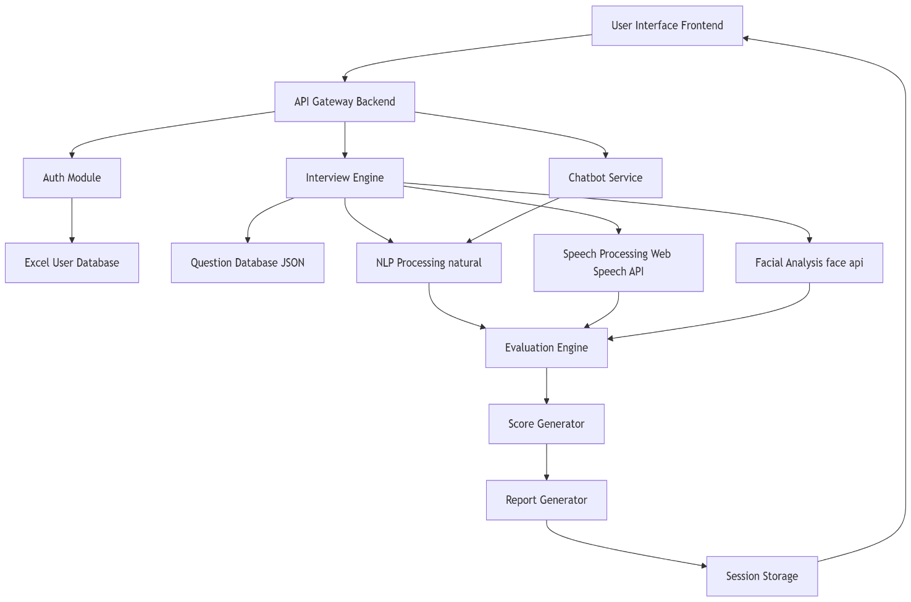
Figure 2 Block Diagram
The system begins with the User Interface (Frontend), where users log in, select subjects, and initiate interview sessions. The frontend communicates with the API Gateway Backend, which handles authentication, session management, and routing of requests to appropriate modules.
The Auth Module validates user credentials using the Excel-based user database, ensuring secure access. Once authenticated, the Interview Engine manages the interview flow, including fetching questions from the JSON database and controlling the sequence of questions.
The system processes user responses through three main AI modules:
• The Speech Processing Module converts spoken responses into text using speech-to-text techniques and analyzes parameters such as volume and speaking rate.
• The NLP Processing Module evaluates textual responses using tokenization, stemming, keyword matching, and similarity computation to determine technical correctness.
• The Facial Analysis Module detects facial expressions and extracts behavioral metrics such as confidence, nervousness, and engagement.
All processed data is passed to the Evaluation Engine, which combines inputs from different modules to compute overall performance metrics. These metrics are then forwarded to the Score Generator and Report Generator, which generate a detailed performance report.
The Session Storage component maintains interview data, logs, and results for future reference and analysis.
The internal structure of the system is further explained using the class diagram shown in the figure
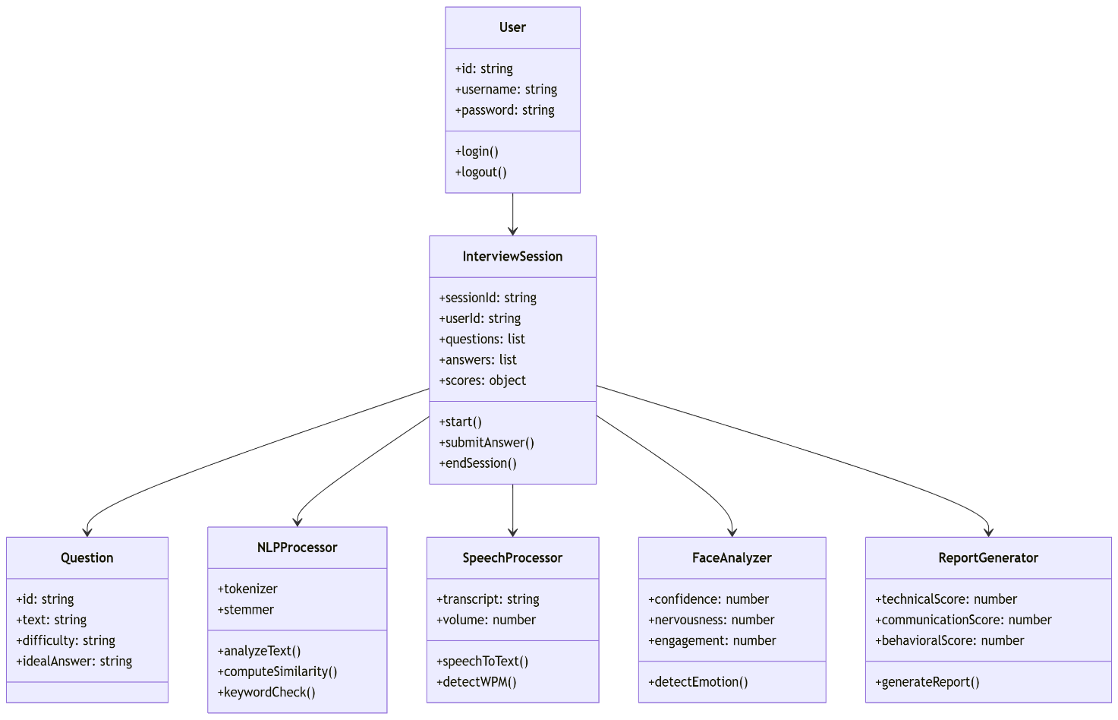
Figure 3 Class Diagram
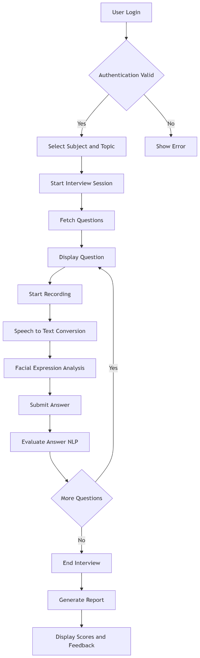
The class diagram illustrates the relationships between key entities such as User, InterviewSession, Question, NLPProcessor, SpeechProcessor, FaceAnalyzer, and ReportGenerator. The InterviewSession acts as the central controller, coordinating interactions between all modules and managing the overall workflow.

Figure 4 Flowchart
The step-by-step execution of the system is depicted in the flowchart shown in the figure on the left side.
The process begins with user login and authentication. Upon successful validation, the user selects a subject and topic, and the interview session starts. Questions are fetched and displayed sequentially. The system records the user’s response, performs speech-to-text conversion, and analyzes facial expressions simultaneously.
After submission, the response is evaluated using NLP techniques. The system checks whether more questions remain and repeats the process until completion. Finally, the interview session ends, and a detailed report is generated and displayed to the user.
This methodology ensures a comprehensive evaluation by combining technical, communication, and behavioral analysis, thereby providing a realistic interview simulation.

Tool and Technique Selection
The selection of tools and techniques for the MockMaster system is based on performance efficiency, real-time capability, scalability, and ease of integration within a web-based environment.
Frontend Technologies (HTML, CSS, JavaScript, Vite)
The frontend is developed using HTML, CSS, and JavaScript to create a responsive and interactive user interface. Vite is chosen as the build tool due to its fast development server and optimized bundling, which improves performance and developer productivity.
Backend Framework (Node.js and Express)
Node.js is selected due to its event-driven, non-blocking architecture, making it suitable for real-time applications. Express is used to develop RESTful APIs that handle authentication, session management, and communication between system components.
Speech Processing (Web Speech API, Web Audio API)
The Web Speech API is used for speech-to-text conversion because it provides real-time transcription directly in the browser without requiring external services. The Web Audio API is used to analyze audio features such as volume and speaking rate, enhancing communication evaluation.
Natural Language Processing (natural library)
The natural library is used for implementing NLP functionalities such as tokenization, stemming, and similarity computation. It is lightweight, efficient, and well-suited for Node.js environments, making it ideal for real-time text analysis.
Facial Expression Analysis (face-api.js)
The face-api.js library is selected for facial recognition and emotion detection because it operates directly in the browser and supports real-time processing. It eliminates the need for heavy backend computation while providing accurate behavioral analysis.
Data Storage (JSON and XLSX)
JSON is used for storing question datasets due to its simplicity and ease of access. XLSX is used for user authentication and logging as it provides a lightweight and manageable data storage solution without requiring a full database system.
Unique Identifier Generation (uuid)
The uuid library is used to generate unique session identifiers, ensuring proper tracking and management of interview sessions.
The chosen tools and techniques collectively ensure that the system remains efficient, scalable, and capable of delivering real-time analysis and feedback. They also support easy deployment and accessibility across different platforms, making the system practical for real-world usage.

CHAPTER 4: Implementation and Testing

Experimental Setup
The MockMaster system is implemented as a web-based application using modern frontend and backend technologies. The frontend is developed using HTML, CSS, and JavaScript with Vite as the build tool, providing a responsive and interactive user interface. The backend is implemented using Node.js and Express, which handle API requests, session management, and data processing.
The system uses JSON files for storing interview questions and XLSX files for user authentication and logging. Natural Language Processing is performed using the natural library, while speech-to-text conversion is achieved using the Web Speech API. Facial expression analysis is implemented using the face-api.js library, which operates directly in the browser.
The system was tested on a standard desktop environment with a webcam and microphone enabled. A modern web browser (Google Chrome) was used to ensure compatibility with Web APIs such as speech recognition and audio processing.
The testing process involved evaluating system functionality, accuracy of results, user interaction, and real-time performance across different scenarios.

Test Cases / Case Study / Screenshots / Output

The following table presents various test cases used to validate the functionality and performance of the MockMaster system.

Table 2 Test Cases for MockMaster System
Input (User Action) | Expected Output | Actual Output | Result
User enters valid username & password | Successful login | User redirected to dashboard | Pass
User enters invalid credentials | Error message displayed | Error shown correctly | Pass
User selects subject and topic | Questions should load | Questions displayed | Pass
User clicks "Start Interview" | Interview session begins | Session started successfully | Pass
User starts recording | Audio capture begins | Recording indicator shown | Pass
Speech input given by user | Speech converted to text | Accurate transcription | Pass
Facial expressions during interview | Confidence & engagement tracked | Values displayed correctly | Pass
User submits answer | Answer evaluated | NLP evaluation performed | Pass
Answer contains keywords | High technical score | Correct scoring | Pass
Answer irrelevant | Low score generated | Score reduced correctly | Pass
Multiple questions attempted | Loop continues | Next question displayed | Pass
User skips question | Question skipped | Next question loaded | Pass
Interview completed | Session ends | End interview triggered | Pass
Report generation | Scores + feedback displayed | Report generated successfully | Pass
Speech clarity low | Communication score reduced | Score adjusted | Pass
Face not detected | Warning or fallback | System handles gracefully | Pass
Network delay/API call | Retry or fallback | Stable behavior observed | Pass
Session reload | State maintained | SessionStorage works | Pass

Chatbot Test Cases
Table 3 Test Cases for chatbot
Input (User Query) | Expected Output | Actual Output | Result
User asks "Give me a question" | System provides interview question | Question displayed | Pass
User asks CS concept (e.g., OS) | Explanation provided | Relevant answer generated | Pass
User asks interview tips | Tips displayed | Correct guidance shown | Pass
User asks random/unrelated query | Generic response or fallback | Handled properly | Pass
Continuous conversation | Context maintained | Smooth interaction | Pass
Empty input | Error or prompt shown | Handled correctly | Pass

Screenshots / Output Representation
The following screenshots demonstrate the working of the system:
1. Login Page
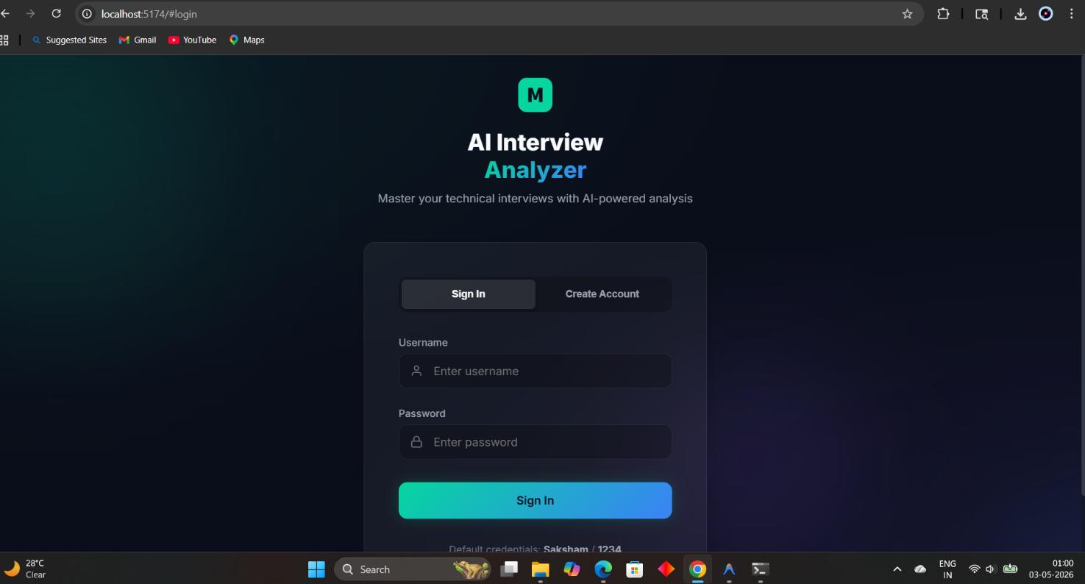
Figure 5 login page
This screen allows users to enter credentials and access the system.
2. Home Dashboard
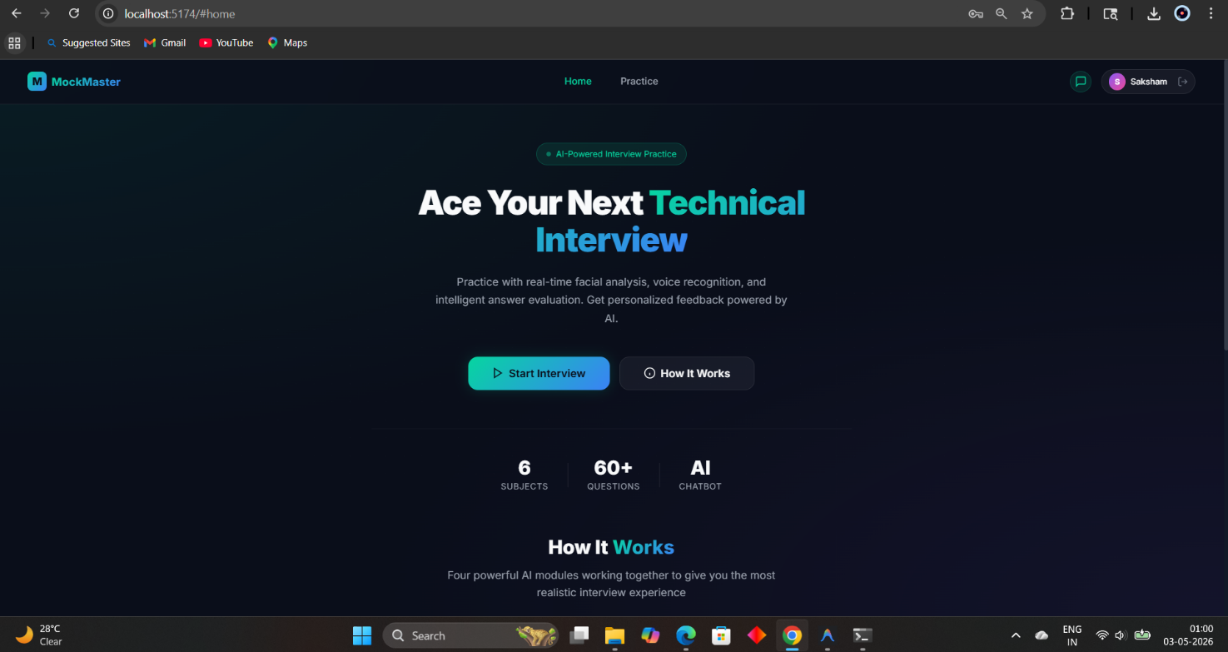
Figure 6 Home Dashboard
Displays system overview and provides access to interview features.
3. Subject Selection Page
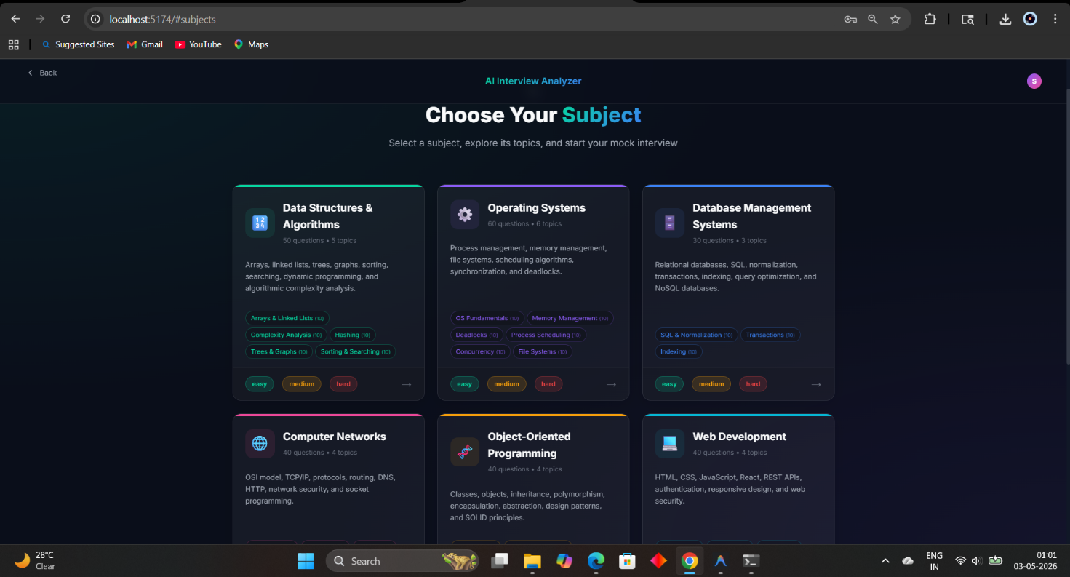
Figure 7 Subject Selection Page
Users can select different subjects and topics for interview practice.
4. Interview Interface & Facial Analysis & Metrics
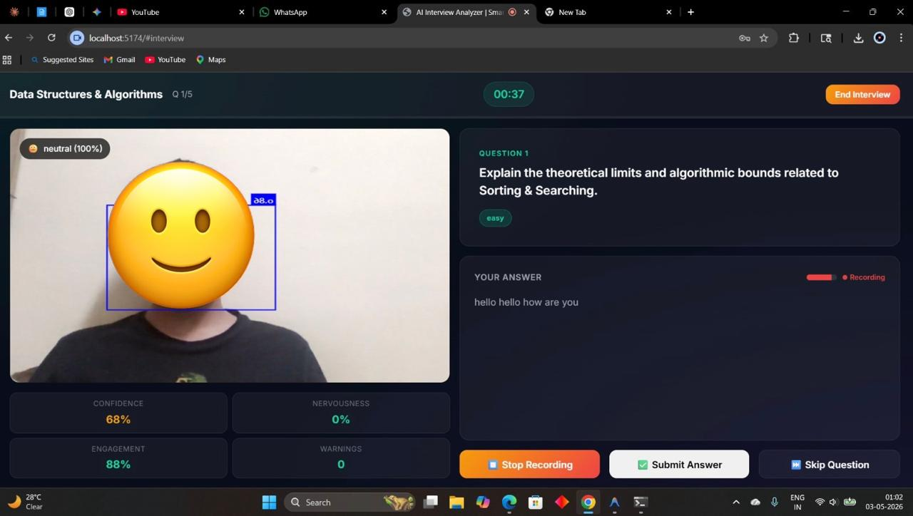
Figure 8 Interview Interface and Facial Recognition
Shows live video feed, question display, recording status, and answer input. Displays confidence, nervousness, and engagement levels in real time.

5. Final Result
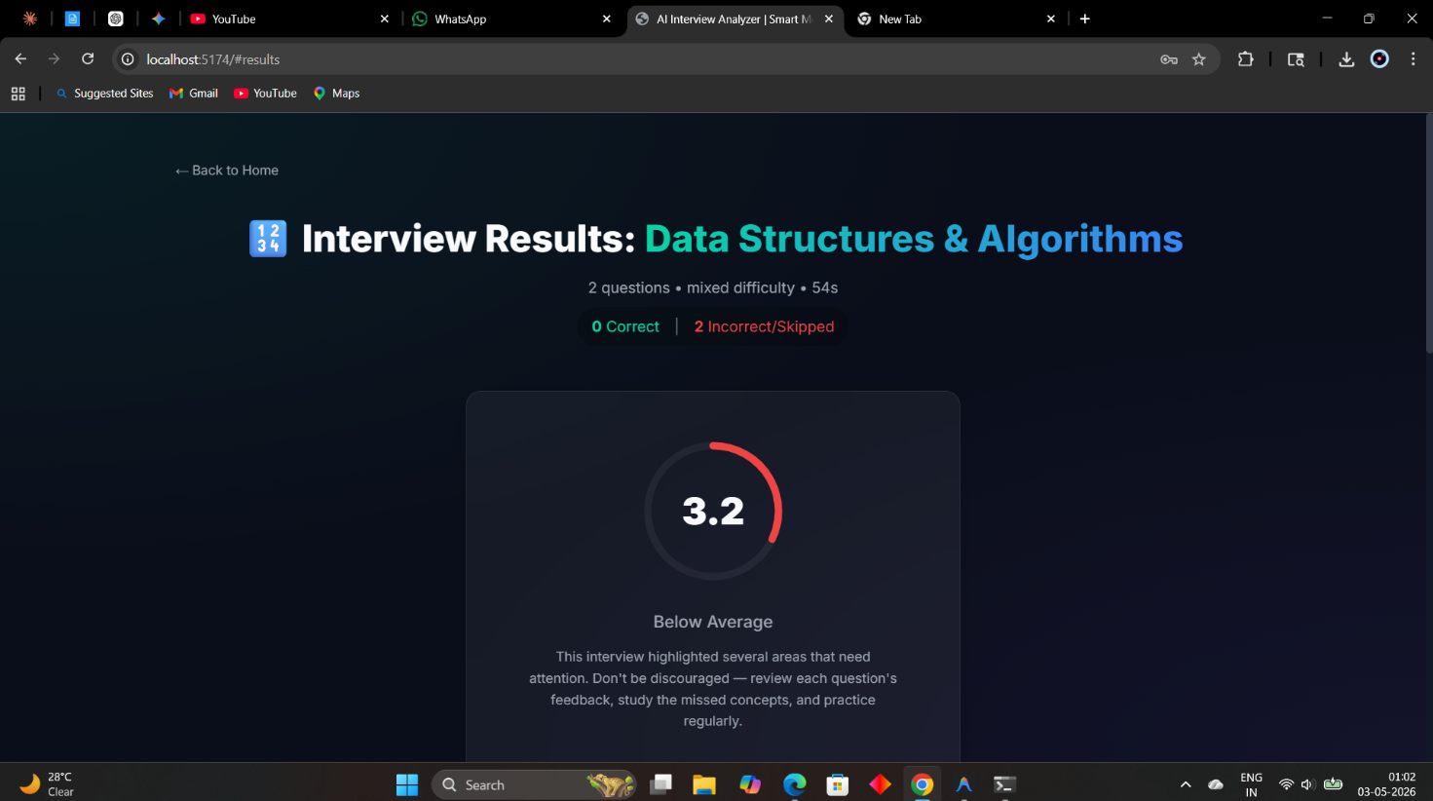
Figure 9 Final Result
Displays final scores, feedback, and performance summary.

6. Chatbot interface
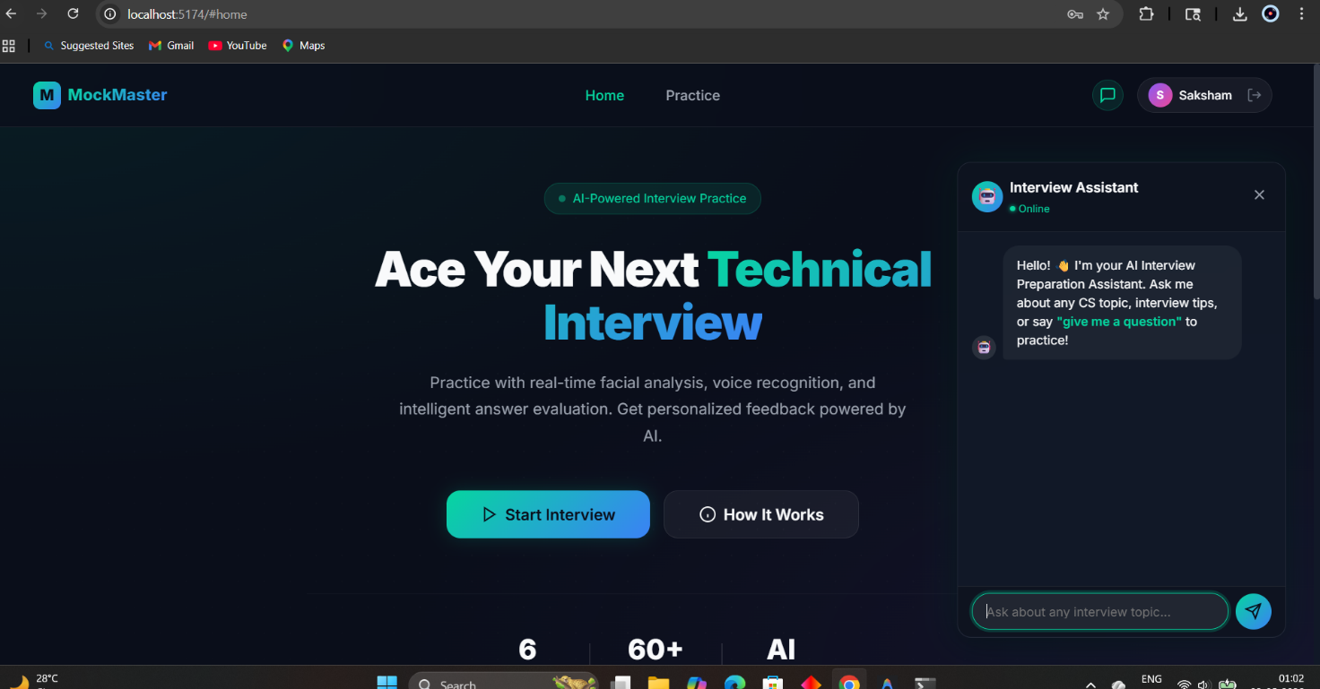
Figure 10 Chatbot Interface

Result Analysis
The system was successfully tested across multiple scenarios and demonstrated accurate performance in evaluating technical responses, speech clarity, and behavioral attributes. The integration of NLP, speech processing, and facial analysis ensured a comprehensive evaluation of user performance.
The results indicate that the system provides consistent and reliable feedback, making it effective for interview preparation. Minor variations may occur due to external factors such as lighting conditions and background noise, but overall system stability and accuracy remain high.

CHAPTER 5 : Results & Discussion

Result Analysis
The proposed system, MockMaster – AI Interview Analyzer, was evaluated based on multiple functional and performance parameters including accuracy of answer evaluation, facial expression detection, speech-to-text conversion, and overall user experience. The system integrates Natural Language Processing (NLP), Speech Recognition, and Facial Analysis to provide a comprehensive assessment of interview performance.
The experimental results demonstrate that the system successfully performs real-time interview simulation and evaluation. Each module was tested individually and in an integrated environment to ensure reliability and robustness.

5.1.1 Functional Performance Analysis
The system was tested across different scenarios such as login validation, question generation, answer evaluation, and report generation. The results indicate that:
- The authentication module correctly validates user credentials and handles invalid inputs efficiently.
- The question generation system retrieves relevant questions based on selected subjects and difficulty levels.
- The interview session flow operates smoothly without interruptions.
- The report generation module produces detailed feedback including technical, communication, and behavioral scores.
The system maintained consistent performance across multiple test runs, indicating high reliability.

5.1.2 NLP-Based Answer Evaluation
The NLP module evaluates user responses using techniques such as tokenization, keyword matching, and similarity scoring. The performance of this module was analyzed by comparing system-generated scores with expected outcomes.
- Relevant answers containing appropriate keywords received higher scores.
- Irrelevant or incomplete answers resulted in lower scores.
- The system effectively distinguishes between high-quality and low-quality responses.
This demonstrates that the NLP model is capable of performing basic semantic evaluation and provides meaningful feedback to users.

5.1.3 Speech Recognition Performance
The speech-to-text module converts user speech into textual format for further analysis. The performance depends on factors such as clarity of speech, background noise, and microphone quality.
Observations include:
- High accuracy for clear and well-paced speech.
- Minor inaccuracies in noisy environments.
- Effective detection of speaking rate (words per minute).
Overall, the speech processing module provides reliable transcription suitable for evaluation purposes.

5.1.4 Facial Expression Analysis
The facial analysis module evaluates user confidence, engagement, and nervousness based on facial expressions.
Key findings:
- The system accurately detects face presence and basic emotions.
- Confidence and engagement scores are updated in real-time.
- Minor variations may occur due to lighting conditions or camera quality.
This module enhances the realism of the interview simulation by providing behavioral insights.

5.1.5 Overall System Output
The final output of the system is a comprehensive report containing:
- Technical Score (based on NLP evaluation)
- Communication Score (based on speech analysis)
- Behavioral Score (based on facial analysis)
The results generated are consistent with expected interview evaluation patterns, making the system useful for practice and self-assessment.

Figure 11 Results

Performance Evaluation and Comparison with Existing Methods
The proposed system was compared with traditional interview preparation methods and existing online platforms to evaluate its effectiveness.

5.2.1 Comparison with Traditional Methods
Traditional interview preparation methods include:
- Self-study using books or online resources
- Peer-to-peer mock interviews
- Coaching classes
Limitations of Traditional Methods:
- Lack of real-time feedback
- No objective evaluation metrics
- Absence of behavioral analysis
- Limited scalability
Advantages of MockMaster:
- Automated evaluation using AI
- Real-time feedback generation
- Multi-dimensional analysis (technical + behavioral)
- Scalable and accessible platform

5.2.2 Comparison with Existing Online Platforms
Existing platforms such as coding interview websites and mock interview tools primarily focus on technical questions.
Table 4 Comparison with Existing Online Platforms
Feature | Existing Platforms | MockMaster
Question Practice | Yes | Yes
Automated Feedback | Limited | Yes
Speech Analysis | No | Yes
Facial Analysis | No | Yes
Behavioral Scoring | No | Yes
Real-time Evaluation | Partial | Yes
From the comparison, it is evident that MockMaster provides a more comprehensive and intelligent solution.

5.2.3 Performance Metrics Evaluation
The system was evaluated using the following performance metrics:
- Accuracy of Answer Evaluation
Measures how well the system evaluates user responses.
- Speech Recognition Accuracy
Measures correctness of speech-to-text conversion.
- Facial Detection Reliability
Measures consistency in detecting facial expressions.
- System Response Time
Measures delay in processing and displaying results.

Table 5 Performance Evaluation
Parameter | Observed Performance
NLP Evaluation Accuracy | ~80–85%
Speech Recognition Accuracy | ~85–90%
Facial Detection Accuracy | ~75–85%
System Response Time | < 2 seconds

5.2.4 Discussion of Results
The results indicate that the system performs efficiently across all modules. The NLP model provides reasonably accurate evaluation, although it can be further improved with advanced semantic analysis techniques. Speech recognition works effectively under normal conditions but may require noise reduction techniques for improved performance.
Facial analysis adds a unique dimension to the system, although its accuracy depends on environmental factors. Despite minor limitations, the integration of multiple AI modules results in a highly effective interview simulation platform.

5.2.5 Advantages of the Proposed System
- Provides real-time feedback to users
- Combines multiple AI technologies in a single platform
- Enhances interview preparation through realistic simulation
- Easy to use and accessible
- Scalable for large number of users

5.2.6 Limitations
- Performance depends on hardware (camera, microphone)
- NLP evaluation is keyword-based and not fully semantic
- Facial analysis accuracy affected by lighting conditions
- Requires internet/browser support for APIs

5.2.7 Future Improvements
- Integration of advanced deep learning models for NLP
- Improved emotion detection algorithms
- Multi-language support
- Cloud-based scalability
- Personalized feedback using AI models

CHAPTER 6 : CONCLUSION & FUTURE SCOPE

Summary of Work
The project MockMaster – AI Interview Analyzer was designed and developed as an intelligent system to simulate real-world technical interviews and provide automated evaluation using Artificial Intelligence techniques. The primary objective of the system was to assist users in improving their interview performance through real-time feedback based on multiple parameters such as technical knowledge, communication skills, and behavioral traits.
The system successfully integrates various technologies including Natural Language Processing (NLP), Speech Recognition, and Facial Expression Analysis into a unified platform. The architecture was carefully designed to ensure modularity, scalability, and ease of use. The frontend interface provides an interactive and user-friendly experience, while the backend handles API integration, data processing, and evaluation logic efficiently.
The development process was carried out in multiple phases, starting from requirement analysis and system design, followed by frontend and backend development, database integration, and AI module implementation. Each module was rigorously tested to ensure proper functionality and seamless integration.
In terms of academic contribution, the project has the potential to be extended into research work focusing on intelligent evaluation systems and human-computer interaction. Although no formal publication or awards are currently associated with the project, it provides a strong foundation for future research and development.

Impact on Society, Environmental Sustainability, Ethical Issues and Compliance
6.2.1 Societal Impact
The MockMaster system has significant societal relevance, particularly in the domain of education and employability. With increasing competition in the job market, candidates often lack access to proper interview preparation resources. This system addresses that gap by providing an affordable and accessible platform for practice.

Key societal benefits include:
- Skill Development: Helps users improve communication, confidence, and technical knowledge
- Equal Opportunity: Provides interview preparation tools to users regardless of geographical or financial constraints
- Self-Assessment: Enables individuals to identify their strengths and weaknesses
- Reduced Dependency: Minimizes reliance on coaching institutes or external mentors
By empowering users with real-time feedback and insights, the system contributes to enhancing employability and career readiness.

6.2.2 Environmental Sustainability
The proposed system promotes environmental sustainability by reducing the need for physical resources traditionally used in interview preparation.
Environmental contributions include:
- Reduction in paper usage (no printed materials required)
- Elimination of travel for mock interviews or coaching sessions
- Digital storage and processing of data
The system operates entirely in a digital environment, making it an eco-friendly solution aligned with sustainable development goals.

6.2.3 Ethical Issues
The use of AI in evaluation systems raises several ethical considerations that must be addressed to ensure fairness and transparency.
Key ethical concerns include:
- Bias in Evaluation: The NLP and facial analysis models may introduce bias if not properly trained
- Privacy Concerns: User data, including video and audio recordings, must be handled securely
- Transparency: Users should be informed about how their performance is evaluated
- Fairness: The system should ensure equal evaluation standards for all users
To address these issues, the system follows best practices such as minimizing data storage, ensuring secure handling of user inputs, and maintaining transparency in scoring mechanisms.

6.2.4 Compliance and Industry Relevance
The project aligns with current industry trends in AI-driven assessment tools and online learning platforms. Many organizations are adopting automated interview systems for initial screening, making this project highly relevant.
Compliance considerations include:
- Adherence to data protection principles
- Secure API integration
- Ethical AI usage guidelines
The system can be extended for use in recruitment processes, making it valuable for both educational institutions and corporate organizations.

Limitations of the Work
Despite its successful implementation, the system has certain limitations that need to be addressed for further improvement.
- Limited NLP Understanding
The NLP model primarily relies on keyword matching and basic similarity measures. It lacks deep semantic understanding, which may affect evaluation accuracy.
- Dependence on Hardware Quality
The performance of speech and facial analysis modules depends on the quality of the microphone and camera used by the user.
- Environmental Sensitivity
Background noise, poor lighting, and camera positioning can affect the accuracy of speech recognition and facial detection.
- Limited Dataset
The question database is currently limited and may not cover all possible interview scenarios.
- No Multi-language Support
The system currently supports only a single language, limiting its accessibility for diverse users.
- Basic Emotion Detection
The facial analysis module provides only basic behavioral insights and may not capture complex emotional states.
- Offline Limitations
The system requires an active environment (browser/API support) and may not function efficiently in offline scenarios.
These limitations highlight areas where future enhancements can significantly improve system performance and usability.

Future Scope
The MockMaster system has extensive potential for future development and enhancement. Several improvements can be implemented to make the system more advanced, scalable, and industry-ready.
6.4.1 Advanced NLP Integration
- Use of transformer-based models (e.g., BERT, GPT) for deeper semantic understanding
- Context-aware answer evaluation
- Improved feedback generation
6.4.2 Enhanced Speech Processing
- Noise reduction techniques for better accuracy
- Support for multiple accents and languages
- Real-time pronunciation analysis
6.4.3 Improved Facial Analysis
- Advanced emotion detection using deep learning
- Eye contact tracking and posture analysis
- Stress and confidence prediction models
6.4.4 Multi-language Support
- Support for regional and international languages
- Language-specific evaluation models
- Increased accessibility for global users
6.4.5 Cloud Integration
- Deployment on cloud platforms for scalability
- Real-time data storage and analytics
- Support for multiple concurrent users
6.4.6 Personalized Learning System
- Adaptive question generation based on user performance
- AI-driven recommendations for improvement
- Progress tracking over time
6.4.7 Industry-Level Integration
- Integration with recruitment platforms
- Automated candidate screening tools
- Corporate training applications
6.4.8 Mobile Application Development
- Development of Android/iOS applications
- Improved accessibility and user engagement
- Offline practice features

6.4.9 Data Analytics and Visualization
- Advanced dashboards for performance tracking
- Comparative analysis with other users
- AI-based insights and predictions

References & Appendices
[1] T. Mikolov, K. Chen, G. Corrado, and J. Dean, “Efficient Estimation of Word Representations in Vector Space,” Proc. Int. Conf. on Learning Representations (ICLR), 2013.
[2] J. Devlin, M.-W. Chang, K. Lee, and K. Toutanova, “BERT: Pre-training of Deep Bidirectional Transformers for Language Understanding,” Proc. NAACL-HLT, pp. 4171–4186, 2019.
[3] D. Jurafsky and J. H. Martin, Speech and Language Processing, 3rd ed., Pearson, 2020.
[4] A. Krizhevsky, I. Sutskever, and G. E. Hinton, “ImageNet Classification with Deep Convolutional Neural Networks,” Advances in Neural Information Processing Systems (NIPS), 2012.
[5] I. Goodfellow, Y. Bengio, and A. Courville, Deep Learning, MIT Press, 2016.
[6] F. Chollet, Deep Learning with Python, Manning Publications, 2018.
[7] Scikit-learn Developers, “Scikit-learn: Machine Learning in Python,” [Online]. Available: https://scikit-learn.org
[8] TensorFlow Team, “TensorFlow: Large-Scale Machine Learning Framework,” [Online]. Available: https://www.tensorflow.org
[9] Keras Team, “Keras: Deep Learning API,” [Online]. Available: https://keras.io
[10] OpenCV Library, “Open Source Computer Vision Library,” [Online]. Available: https://opencv.org
[11] Mozilla, “Web Speech API Specification,” [Online]. Available: https://developer.mozilla.org
[12] Face-api.js Contributors, “Face-api.js: JavaScript API for Face Detection and Recognition,” [Online]. Available: https://github.com/justadudewhohacks/face-api.js
[13] Pandas Development Team, “Pandas: Python Data Analysis Library,” [Online]. Available: https://pandas.pydata.org
[14] NumPy Developers, “NumPy: Fundamental Package for Scientific Computing,” [Online]. Available: https://numpy.org
[15] J. Brownlee, Machine Learning Mastery with Python, Machine Learning Mastery, 2017.
[16] FastAPI Developers, “FastAPI Framework Documentation,” [Online]. Available: https://fastapi.tiangolo.com
[17] Node.js Foundation, “Node.js JavaScript Runtime,” [Online]. Available: https://nodejs.org
[18] Express.js Team, “Express – Node.js Web Framework,” [Online]. Available: https://expressjs.com
[19] React Developers, “React: JavaScript Library for Building User Interfaces,” [Online]. Available: https://react.dev
[20] IEEE, “IEEE Standards for Artificial Intelligence and Ethical Considerations,” [Online]. Available: https://standards.ieee.org

APPENDICES & ANNEXURE
APPENDICES

Appendix A: Dataset Description
The dataset used in the MockMaster system consists of predefined interview questions categorized by subject, topic, and difficulty level. The data is stored in JSON format and includes fields such as question text, ideal answer, keywords, and difficulty level. This structured dataset enables efficient retrieval and evaluation of questions during interview sessions.

Appendix B: Sample Code Snippets
Below is a simplified example of the NLP evaluation logic used in the system:
function evaluateAnswer(userAnswer, idealAnswer) {
const tokenizer = new natural.WordTokenizer();
const userTokens = tokenizer.tokenize(userAnswer.toLowerCase());
const idealTokens = tokenizer.tokenize(idealAnswer.toLowerCase());

let matchCount = 0;
idealTokens.forEach(word => {
if (userTokens.includes(word)) {
matchCount++;
}
});
const score = (matchCount / idealTokens.length) * 10;
return score;
}
This function tokenizes user input and compares it with the ideal answer to compute a similarity-based score.

Appendix C: Additional Test Cases
Additional test scenarios were executed to ensure system robustness:
- Testing under low lighting conditions for facial detection
- Testing speech recognition with background noise
- Testing system behavior under invalid inputs
- Testing chatbot responses for various technical queries
- Stress testing with multiple interview sessions
These tests confirmed the stability and reliability of the system under different conditions.

ANNEXURE

ANNEXURE A: Outcome of the Report
The project resulted in the successful development of a fully functional web-based application named MockMaster – AI Interview Analyzer. The system is capable of conducting mock interviews, analyzing user responses using AI techniques, and generating detailed performance reports.
The application demonstrates practical implementation of Artificial Intelligence in interview preparation and can be further extended for real-world deployment. The project also serves as a strong foundation for future research work in AI-based evaluation systems.

ANNEXURE B: Sustainability Statement
The MockMaster system contributes positively to environmental sustainability and societal development. Being a fully digital platform, it reduces the need for physical resources such as paper, printed materials, and travel for interview preparation.
The system promotes remote learning and practice, thereby minimizing carbon emissions associated with transportation. It also supports efficient resource utilization by enabling users to practice anytime and anywhere.
From a societal perspective, the system enhances employability by providing accessible and affordable interview preparation tools. It supports skill development and promotes equal opportunities for users from diverse backgrounds.

ANNEXURE C: Team Roles
The responsibilities of the project were distributed among team members as follows:
- Aman : Developed the frontend interface using HTML, CSS, and JavaScript; implemented UI/UX design and user interaction features.
- Shubhankar : Handled backend development using Node.js and Express; implemented API integration, authentication, and session management.
- Saksham : Worked on AI modules including NLP processing, speech analysis, and facial recognition; integrated evaluation logic and report generation.
All team members contributed to testing, debugging, documentation, and final report preparation.

ANNEXURE D: Program Outcome (PO) Mapping
Table 6 Program Outcome Mapping
Project Activity | Program Outcome (PO)
System design and architecture | PO3: Design/development of solutions
Implementation using modern tools | PO5: Modern tool usage
AI model development and analysis | PO2: Problem analysis
Testing and evaluation | PO4: Investigation of complex problems
Deployment and usability | PO6: Engineer and society

