# Case Study :-

Automated Notifications Using SNS

* Concepts Used: AWS Lambda, S3, SNS.
* Problem Statement: "Create a Lambda function that triggers when a new file is uploaded to an S3 bucket and sends an email notification using SNS with details of the

uploaded file."

* Tasks:
* Write a Python Lambda function that triggers on S3 upload events.
* Extract the file name and size from the event and format a notification message.
* Use SNS to send the notification to a configured email address.
* Test by uploading a file to the S3 bucket and verifying that an email is received.

1. Introduction :-

**Case Study Overview**:

This case study focuses on automating notifications for file uploads using AWS services. The system is designed to notify users when a new file is uploaded to an S3 bucket by leveraging AWS Lambda and Simple Notification Service (SNS). This automation ensures timely communication of important file uploads without manual intervention.

**Key Feature and Application**:

The key feature of this system is the use of an AWS Lambda function that triggers automatically whenever a file is uploaded to the S3 bucket. It extracts details such as the file name and size, formats them into a message, and sends an email notification using AWS SNS. This application is useful for scenarios requiring real-time alerts, such as file monitoring or data processing pipelines.

**Third-Year Project Integration (Optional)**:

In our third-year project, we implemented a similar feature where email notifications were sent to vaccination centers when a child was registered for a vaccine. This aligns with the current case study, where notifications are automated using AWS services. In both cases, automated notifications play a key role in ensuring timely updates to relevant parties, whether it’s notifying the vaccination center about a new registration or alerting users about file uploads in the S3 bucket. This demonstrates the practical application of event-driven notifications in different domains, enhancing communication and operational efficiency.

1. Step-by-Step Explanation :-

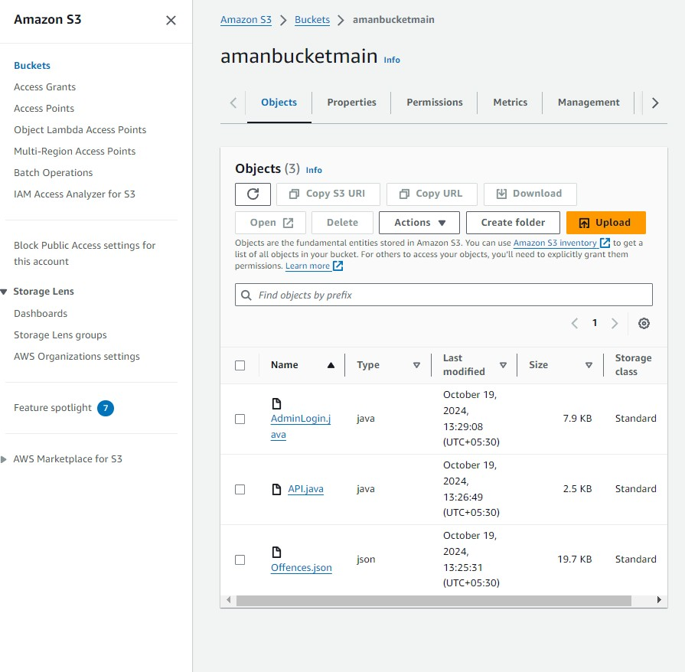Step 1 :- Create a s3 Bucket

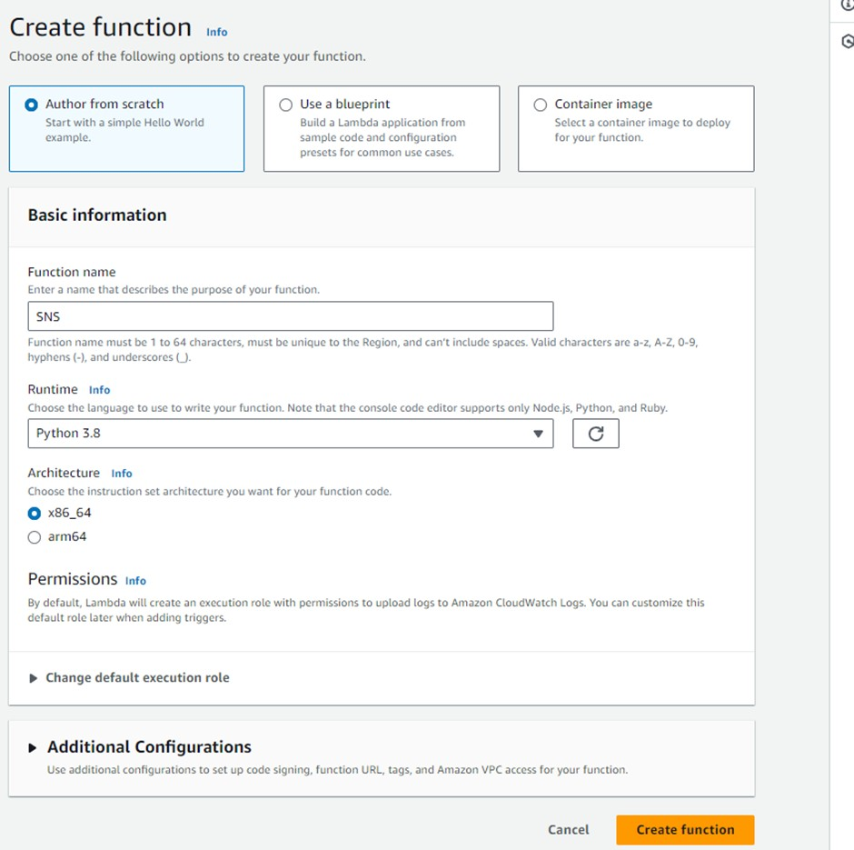Step 2:- Create a lambda function :-

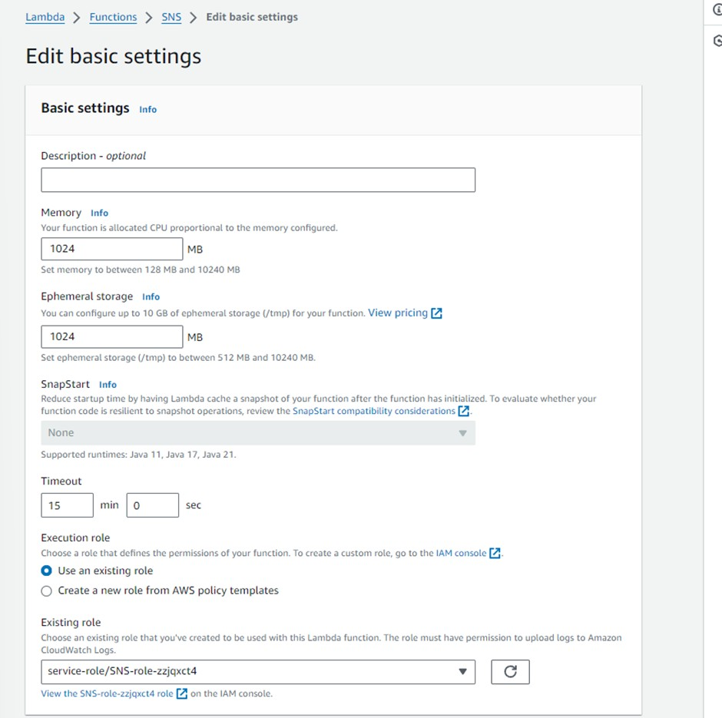Step 3:- Go to the sns lambda function -> configuration

Step 4: Add the trigger :-

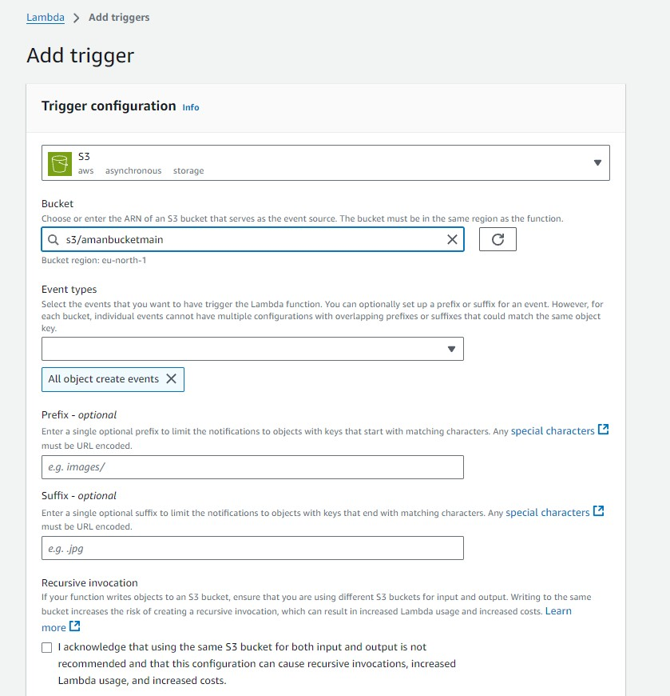

Step 5 :- After Configuration your Code look

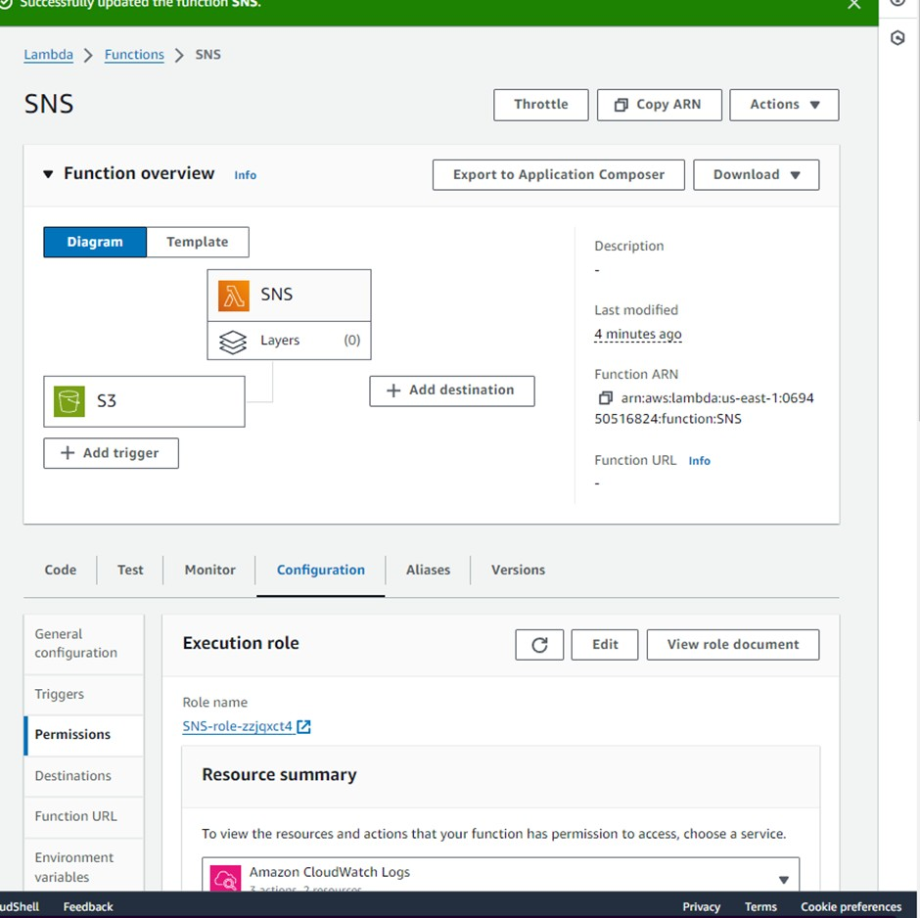Step 6 :- Go the permission

Step 7:- when you click on this link role name you will see the trust relationships do the changes in services

"Service": [

"lambda.amazonaws.com", "glue.amazonaws.com", "rds.amazonaws.com", "textract.amazonaws.com", "events.amazonaws.com", "transfer.amazonaws.com"

]

Step 8:- Save those changes

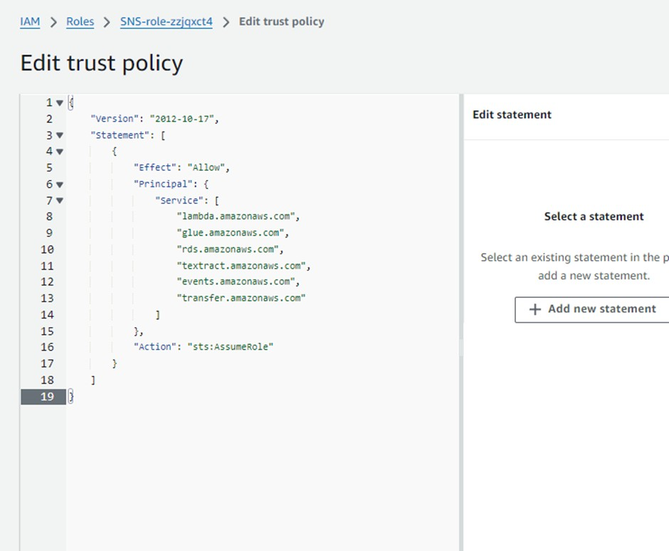

Step 9:- Now go the Amazon SNS create topic

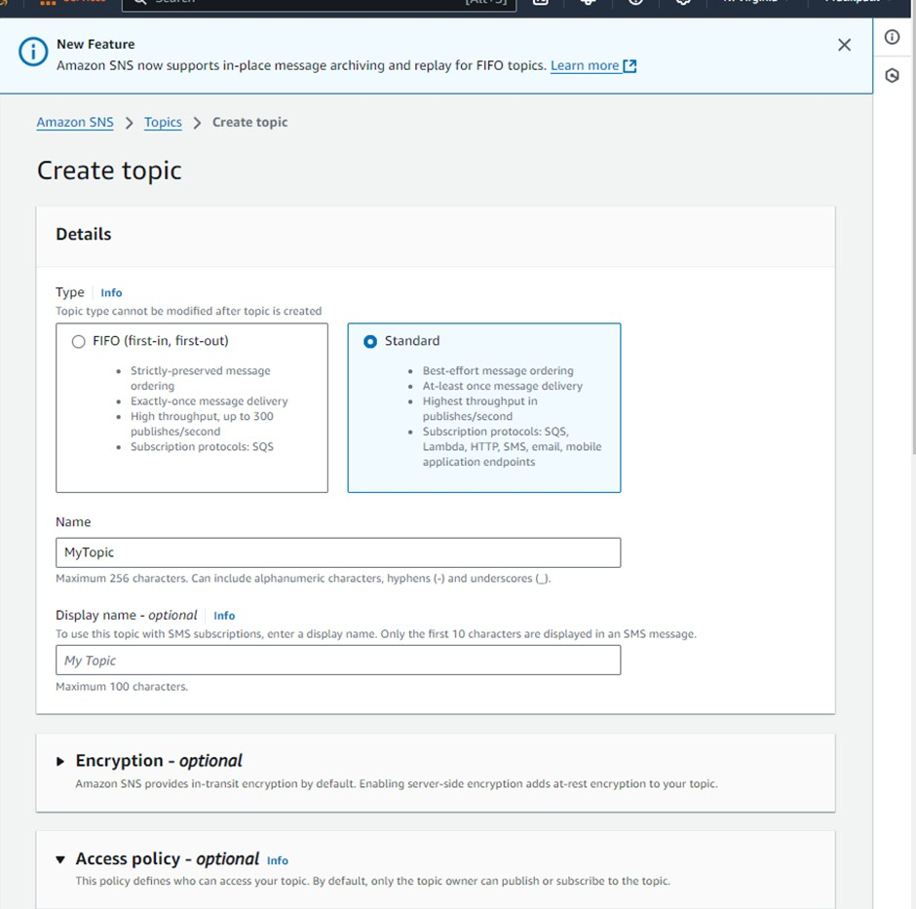

Step 10 :- Now edit access policy and delivery status logging

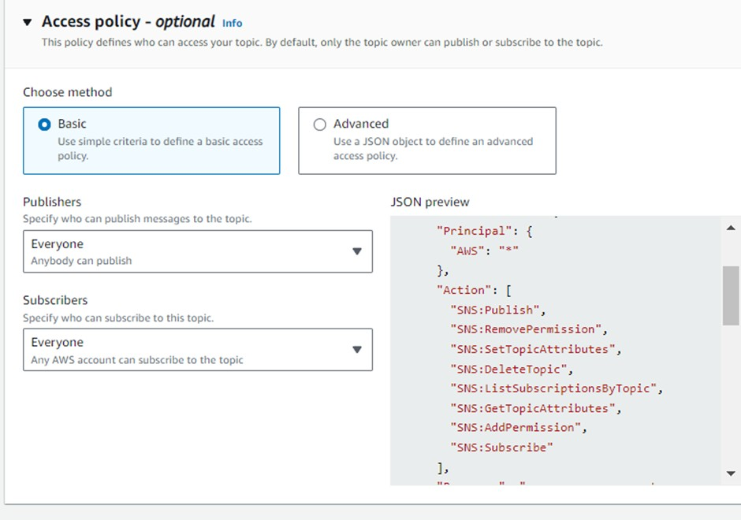

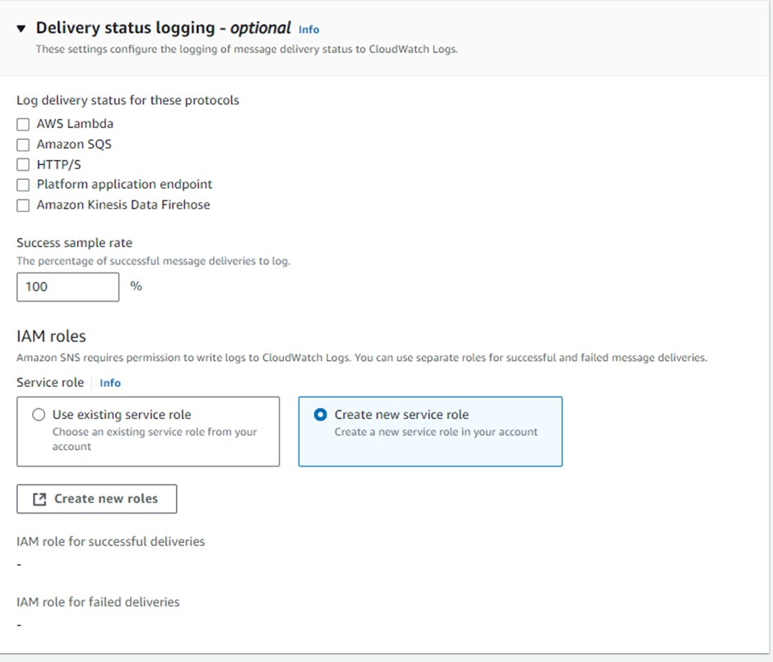

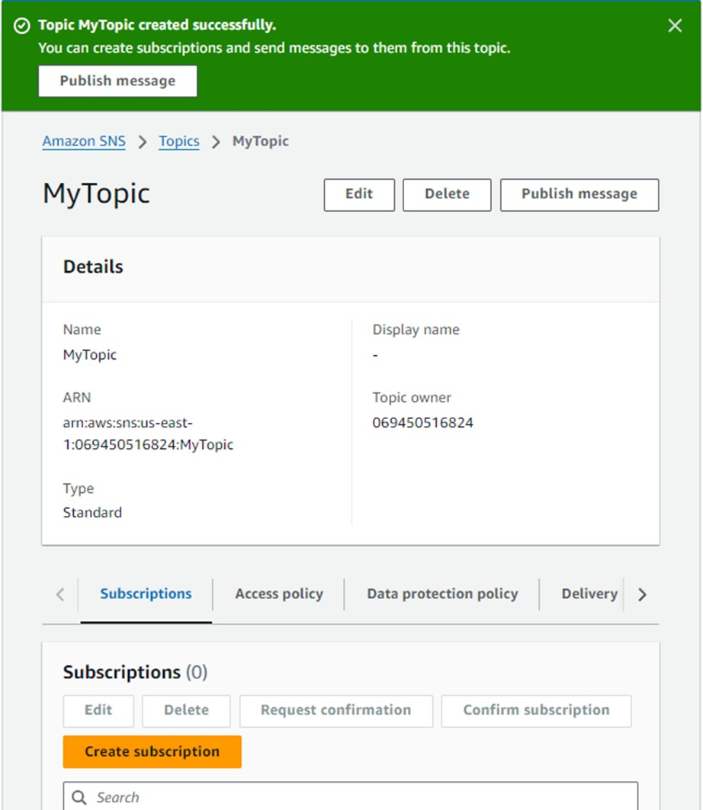

Step 11 :- Go to subscription in sns choose the topic then copy that topic arn paste in code in lambda function

import boto3

topic_arn = "arn:aws:sns:us-east-1:069450516824:PratikTopic" def send_sns(message, subject):

try:

client = boto3.client("sns")

result = client.publish(TopicArn=topic_arn, Message=message, Subject=subject) if result['ResponseMetadata']['HTTPStatusCode'] == 200:

print(result)

print("Notification sent successfully..!!!") return True

except Exception as e:

print("Error occurred while publishing notification: ", e) return False

def lambda_handler(event, context): print("Event collected: {}".format(event))

for record in event['Records']:

# Extract bucket name and key s3_bucket = record['s3']['bucket']['name'] s3_key = record['s3']['object']['key']

s3_size = record['s3']['object']['size']

print("Bucket name: {}".format(s3_bucket)) print("File key: {}".format(s3_key)) print("File size: {} bytes".format(s3_size))

from_path = "s3://{}/{}".format(s3_bucket, s3_key) # Construct message with file name and size

message = "A file has been uploaded at {}\nFilename: {}\nFile size: {}

bytes".format(from_path, s3_key, s3_size) subject = "S3 File Upload Notification"

# Send SNS notification

SNSResult = send_sns(message, subject) if SNSResult:

print("Notification Sent..") return SNSResult

else:

return False

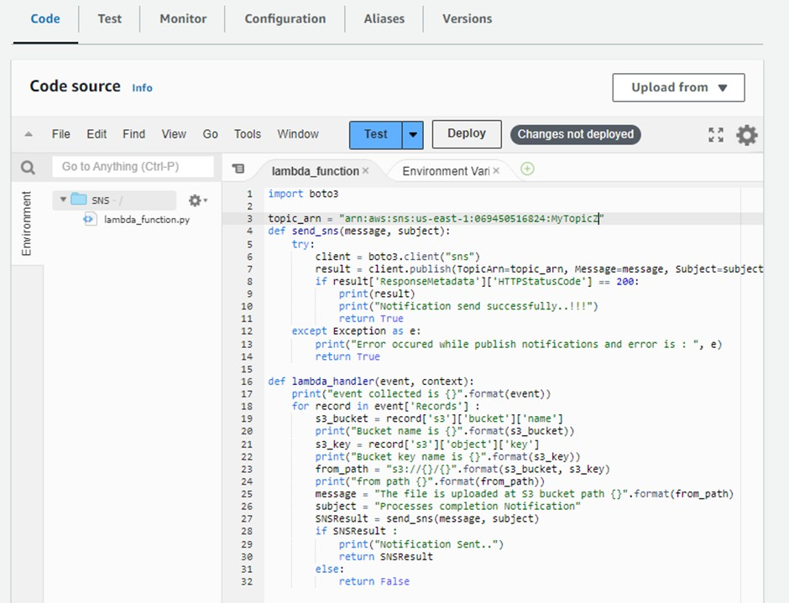

Step 12 :- Now Create a Subscription :

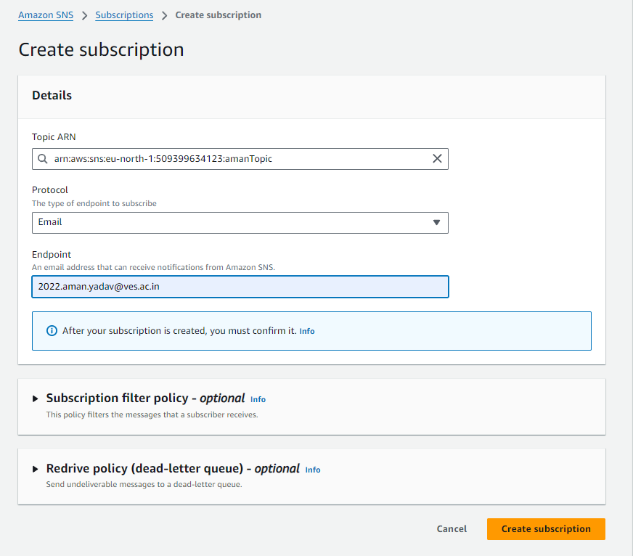

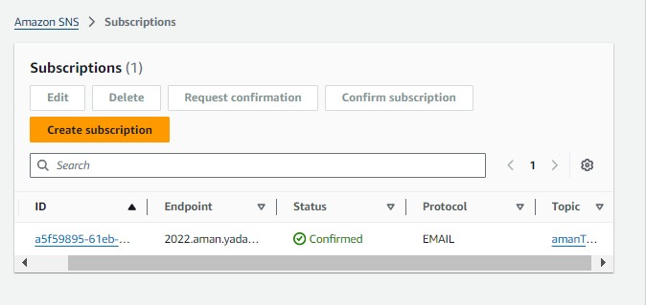

Step 13 :- Go to the email and verify it

Step 14 : - Upload files in S3 bucket You will get like this email

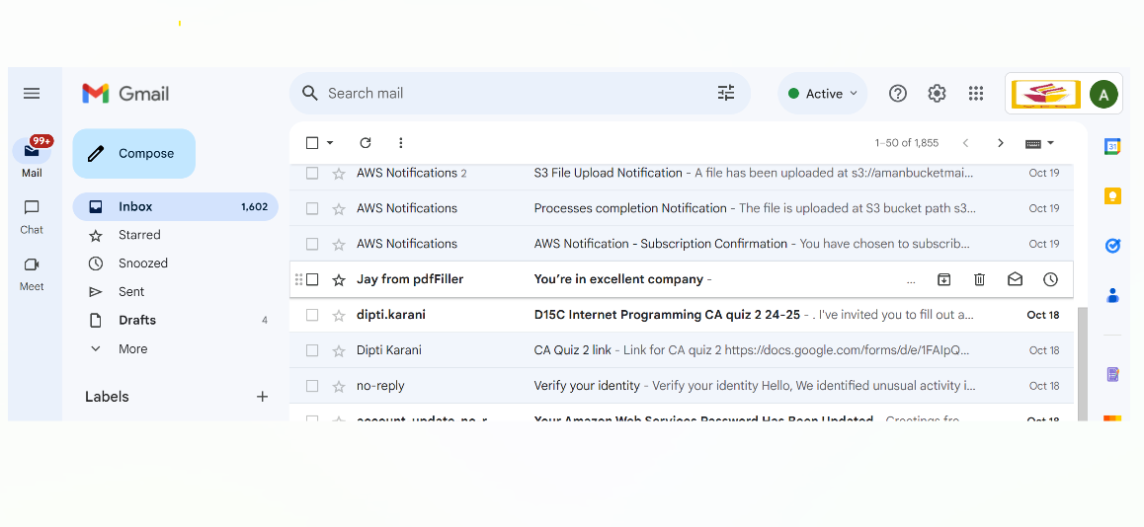

# Conclusion

In conclusion, this case study showcases the power of AWS services, such as Lambda, S3, and SNS, to automate notifications in a highly efficient manner. By triggering events based on file uploads and delivering real-time alerts via email, the system ensures timely communication without manual intervention. This approach can be adapted to various use cases, including those involving data pipelines, file monitoring, or real-time system notifications. Furthermore, the integration with the third-year project highlights how similar event-driven mechanisms, such as sending email notifications to vaccination centers, can enhance practical applications across different fields, making operations smoother and more efficient.