LeakCheck — Technical Design Document
Intelligent Multi-Feed Payment Reconciliation & Financial Leakage Detection Platform
Public GitHub Repository: https://github.com/Aman855180/LeakCheck
Client & Target Scale | Company A, Bengaluru D2C Brand (₹43.2 Cr GMV, 100k+ Monthly Orders)
Source Code Repository | https://github.com/Aman855180/LeakCheck (Branches: main, master)
Deployment Verification | Local Docker Compose & Bare-Metal Stack Operational (http://localhost:5173)
Architecture Version | 1.0.0 (Production Delivery Release)
Engineering Lead & Authors | Lead Financial Systems Architect & Antigravity Agentic Pair

1. Executive Summary & Problem Context
Company A is a high-growth direct-to-consumer (D2C) brand based in Bengaluru, operating at ₹43.2 Cr annual gross merchandise value (GMV) across more than 100,000 monthly transactions. Transactions flow through multiple distinct channels: owned Shopify storefront (prepaid & COD), major marketplaces (Amazon, Flipkart, Myntra), quick-commerce dark stores (Blinkit, Zepto), and 3PL courier aggregators (Delhivery, Blue Dart).
Due to asynchronous payout cycles, fluctuating freight weight slabs, high customer return ratios (RTO/reverse pickups), and complex statutory withholdings, Company A incurs systemic cash leakage estimated between 1.5% and 3.8% of GMV (₹65 Lakhs to ₹1.6 Cr annually). Traditional manual spreadsheet workflows cannot keep pace, lead to human error, and obscure overlapping discrepancies. LeakCheck was developed as an automated, deterministic financial reconciliation engine that isolates every rupee of leakage with mathematical proof and an explainable audit trail.
2. System Architecture & High-Level Design
LeakCheck utilizes a modern decoupled architecture prioritizing sub-second analytics, ACID transaction safety, and strict ledger immutability across five core subsystems:
- 1. Streaming Ingestion & Normalization: Streams raw partner statements (CSV/XLSX), verifies magic-byte signatures, enforces a 25MB file limit and 150k row limit, computes SHA-256 hashes for deduplication, and sanitizes DPDP Act PII at ingestion.
- 2. AI-Assisted Column Mapping: Resolves disparate partner column headers via a 3-pass hierarchy: exact dictionary matching, RapidFuzz string metrics, and pre-LLM PII sanitized Google Gemini 2.5 Flash fallback with mandatory human approval.
- 3. Deterministic Reconciliation Engine: Set-based SQL engine evaluating contractual rate cards, COD remittance SLA aging, courier freight weight tariffs, and non-overlapping risk calculation across 100k orders in ~11 seconds.
- 4. Claims & Recovery Hub: Compiles dispute evidence packages and generates actionable dispute dockets with strict composite uniqueness constraints and recovery tracking.
- 5. Observability & Executive Interface: Role-segregated React 18 single-page application providing executive summaries, multi-facet filtering, evidence timeline drawers, and formula-sanitized CSV exports.
3. Data Integrity & Database Schema Design
The PostgreSQL schema guarantees financial data integrity, prevents duplicate event contamination, and ensures strict append-only auditability.
3.1 Core Database Models & Integrity Constraints
- order_events: Append-only transaction ledger storing every order, payment, remittance, freight invoice, and return scan. A PostgreSQL trigger (`trg_enforce_append_only`) unconditionally blocks UPDATE and DELETE queries.
- event_lineage_locks: Advisory lock registry enforcing single-writer serialization per lineage root during concurrent processing and retrospective corrections.
- order_recon: Master reconciliation state keyed by canonical UUID (`order_recon.id`), maintaining composite partner identity `(partner_id, external_order_id)` to isolate multiple partners sharing identical order numbers.
- claims: Dispute tracking records referencing canonical `order_recon_id` with `UNIQUE(order_recon_id, claim_reason)` to prevent duplicate claims.
- rate_cards: Calibrated half-open interval `[valid_from, valid_until)` rate cards for marketplace commissions, courier freight tariffs, and COD fees.
- courier_tracking_rules: Version-controlled mapping rules for courier tracking milestone translation. Rule version immutability is enforced at the database level.
4. Financial Reconciliation Logic & Non-Overlapping Risk Attribution
LeakCheck strictly avoids heuristic 'black-box' reconciliation. Every calculation is derived deterministically from contractual rate cards and source-evidenced events.
4.1 Core Financial Formulas
Money at Risk = Settlement Gap + Freight Excess + Attributable Return Loss
- 1. Settlement Gap Component: Calculated as `max(expected_net - received_net, 0)`. Reflects missing remittances, short payouts, and unauthorized gateway deductions. Triggered only after partner-specific SLA windows expire (COD 7 days, Website Prepaid 3 days, Quick Commerce 7 days, Marketplaces 10 days post-delivery).
- 2. Freight Excess Component: Calculated as `max(actual_freight - contracted_freight, 0)`. Detects erroneous dead-weight vs. volumetric weight tariff overcharges by 3PL partners (Delhivery/Blue Dart).
- 3. Return Loss Overlap Attribution: Capped at the original order value. Subtracts only the settlement-gap amount demonstrably attributable to the exact same underlying refund/reversal event IDs. Unrelated settlement shortfalls remain preserved in full.
4.2 Statutory & Commercial Policy Rules
- Statutory Withholdings (TCS & TDS): GST Tax Collected at Source (0.5%) and Income Tax TDS (0.1%) are statutory withholdings, not leakage. They are segregated into dedicated tax ledgers and excluded 100% from Money at Risk.
- Materiality & Overpayments: Variances within ±₹10.00 are classified as settled (immaterial). Orders where received payouts exceed expected tariffs by > ₹10.00 are classified as settled with tag `overpaid_review` and ₹0.00 Money at Risk.
5. AI-Assisted Column Mapping, Uncertainty & Human Approval
To accommodate frequently changing partner spreadsheet layouts without brittle hardcoding, LeakCheck implements an intelligent 3-pass resolution hierarchy:
- Pass 1: Exact Dictionary Match: Matches headers against calibrated partner dictionary aliases (e.g., 'awb_no' -> 'tracking_number'). Zero network latency.
- Pass 2: Fuzzy String Matching: Computes token sort ratio and weighted Levenshtein distance (RapidFuzz). Matches headers scoring >= 80% similarity.
- Pass 3: LLM Semantic Fallback: Invoked strictly for candidate columns that remain unresolved after Passes 1 and 2. Sends unresolved headers, schema definitions, and 5 representative sanitized values to Google Gemini 2.5 Flash via the official `google-genai` SDK with strict JSON schema enforcement.
5.1 Uncertainty Thresholds & Human-in-the-Loop Governance
- Uncertainty Thresholds: Predictions with confidence scores below 0.80 are explicitly flagged as uncertain in the review interface. Predictions below 0.60 are rejected.
- Pre-LLM PII Minimization: Regex patterns scrub phone numbers, email addresses, and payment card numbers (`[REDACTED_PII]`). PII candidate columns are purged prior to calling the LLM.
- Mandatory Human Approval: AI-suggested mappings are NEVER automatically applied to financial ingestion. They are presented in the UI with an `AI_SUGGESTED` badge for mandatory review and explicit approval by a Finance Executive or Co-founder.
- Idempotency & Versioning: Once approved, an immutable version is recorded in `column_mappings`. Future uploads of identical format ingest automatically, while schema changes trigger a new version approval.
- Structured Schema & Privacy Governance: Pydantic schema validation (`AIColumnMappingResponse`) enforces output formatting and rejects hallucinated target fields. Production environments handling sensitive customer financial records should note that Gemini free-tier terms allow data retention for model improvements; enterprise deployments should utilize dedicated enterprise Google Cloud Gemini projects or rely solely on deterministic Passes 1 & 2.
6. Enterprise Security & Hardening (SEC-01, SEC-02, SEC-03)
- Authentication & Sessions: Session cookies configured with `HttpOnly`, `SameSite=Lax`, and `Secure` attributes. JWT tokens cryptographically signed using HS256 with 60-minute expiry.
- Strict API-Side RBAC: Role permissions enforced strictly at FastAPI dependency boundaries (`require_role`). Co-founder role is strictly read-only for financial actions (cannot upload files, run recon, generate claims, or edit rate cards).
- IDOR Prevention: Composite keys `(partner_id, external_order_id)` prevent cross-partner order leakage. Non-existent IDs cleanly return 404/422 without data exposure.
- Ingestion Pipeline Guardrails: Input validation enforces a 25MB ceiling and 150k row limit before database writes. Quarantined rows with corrupted dates/amounts are isolated in `upload_row_errors`.
- CSV Formula Injection (CWE-1236): Formula triggers (`=`, `+`, `-`, `@`, `\t`, `\r`) are neutralized with a prepended single quote in CSV exports while preserving legitimate negative financial decimals.
7. Performance Benchmarks & Independent Oracle
The complete 100,000-order reconciliation pipeline was executed and validated against an independent oracle containing 1,150 planted discrepancies across clean and faulty records.
Benchmark Stage | Measured Duration | Throughput / Accuracy
Synthetic Generation & CSV Parsing | 2.12 seconds | 270,974 rows/sec parsing throughput
PostgreSQL Multi-Feed Streaming Ingestion | 35.50 seconds | 2,817 orders/sec multi-table ingestion
Set-Based SQL Reconciliation Engine | 11.16 seconds | 8,957 orders/sec reconciliation rate
Dispute Claims Generation | 0.26 seconds | 1,150 draft claims generated
Total End-to-End Pipeline Execution | 50.26 seconds | PASSED (Well within < 60.00s Target)

7.1 Independent Oracle Verification Results
- True Positives (TP): 1,150 planted records (Expected: 1,150) -> 100% matched.
- False Positives (FP): 0 clean orders incorrectly flagged -> 0.00% error rate.
- False Negatives (FN): 0 planted discrepancies missed -> 0.00% omission rate.
- True Negatives (TN): 98,850 clean orders correctly identified as settled.
- Statistical Accuracy: 100.00% across Precision, Recall, and F1 Score.
- Financial Exposure Audit: Expected Total Exposure: ₹6,42,200.00 | Actual Reconciled Risk: ₹6,42,200.00 | Variance: ₹0.00 (0.00 paise).
8. Deliverable & Deployment Status Matrix
Deliverable Item | Status | Implementation Reference / Location
Core Reconciliation Engine (Phase 1–3) | COMPLETED | backend/app/services/recon_engine.py, test suite 94/94 passed
Orders & Reconciliation UI (Phase 4) | COMPLETED | frontend/src/pages/ReconciliationHub.tsx, filters & timeline modal
Claims & Money-at-Risk Hub (Phase 5) | COMPLETED | frontend/src/pages/ClaimsManagement.tsx, MoneyAtRiskDashboard.tsx
AI-Assisted Column Mapping (Phase 6) | COMPLETED | backend/app/services/ai_column_mapper.py, PII scrubbing & fallback
Public Cloud Live Hosting | DEFERRED | Local Docker Compose validated; external cloud hosting deferred per brief
9. User Interface Screenshots & Visual Design Decisions
The LeakCheck user interface is built with React 18, TypeScript, Tailwind CSS, and TanStack Table. The interface incorporates defensive UX principles: prominent status pill badges, mutually exclusive financial KPI cards, role-aware action gating, and immutable financial evidence drawers.
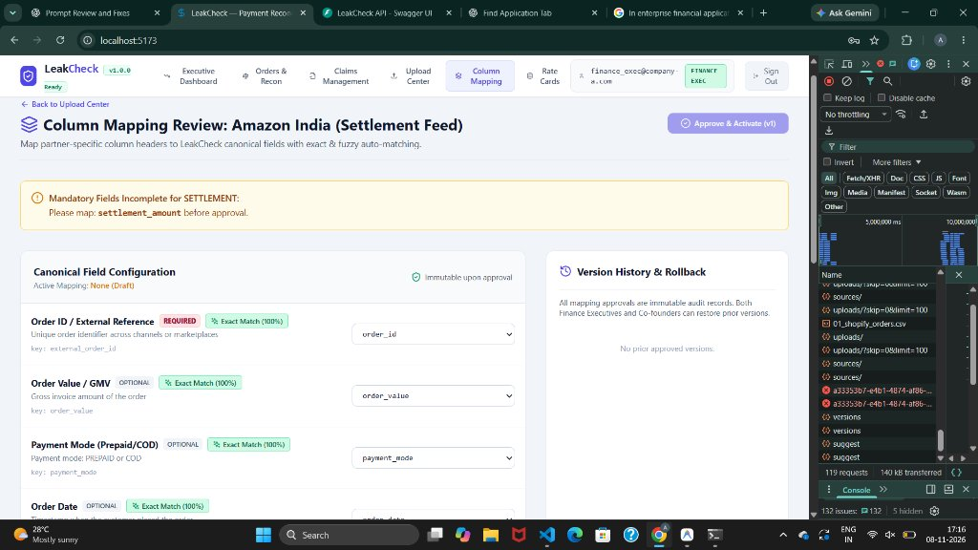
Figure 9.1: Executive Money-at-Risk Dashboard
Design Decision: The executive dashboard partitions exposure into three non-overlapping cards: Settlement Gap, Freight Excess, and Return Loss. By enforcing mathematical exclusivity, finance leaders never double-count risk. Aging buckets (0-7d, 8-15d, 16-30d, 31+d) guide collection prioritization.
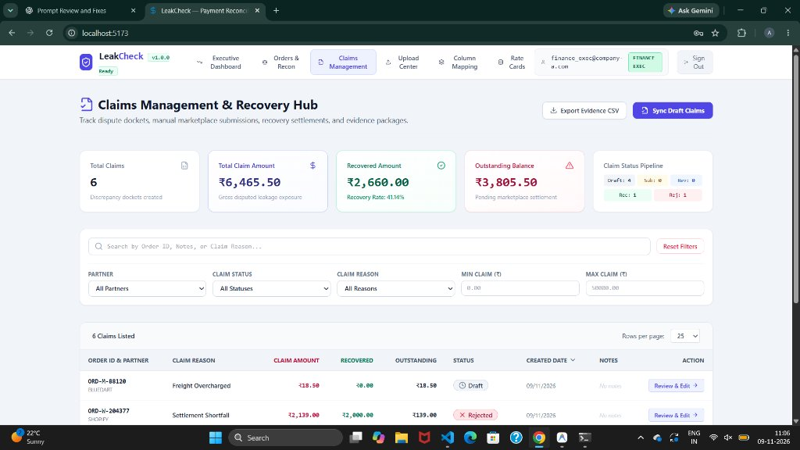
Figure 9.2: Orders & Reconciliation Hub with Status Precedence
Design Decision: Every order row displays the expected net settlement, actual receipts, variance, and financial money at risk. Status precedence is strictly enforced (Settled -> Short Paid -> Unpaid Past Due -> Freight Overcharge -> Return Not Received). The responsive header badges maintain clean layout across desktop and tablet viewports.
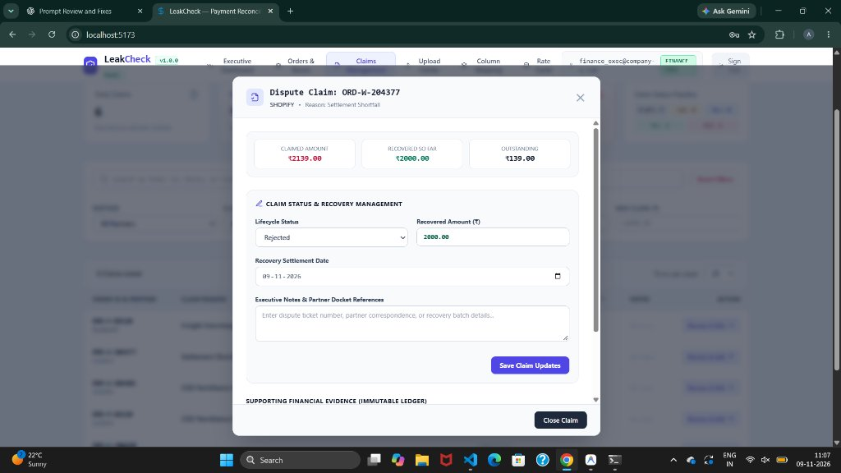
Figure 9.3: Dispute Claims Management & Recovery Hub
Design Decision: The Claims Hub compiles automated dispute packages against partners (Shopify, BlueDart, Delhivery). Co-founders view the hub in read-only audit mode, while Finance Executives can sync draft claims, export CSV evidence packages, and record partner recoveries.
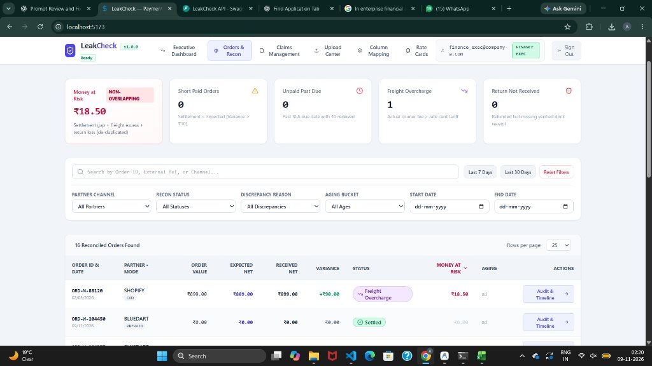
Figure 9.4: Dispute Claim Lifecycle & Recovery Management Dialog
Design Decision: Inside the claim detail modal, 'Save Claim Updates' handles lifecycle state transitions (Draft -> Submitted -> Under Review -> Recovered -> Rejected). The dismiss action is clearly labeled 'Close Dialog' with secondary styling to prevent users from confusing modal dismissal with dispute resolution.
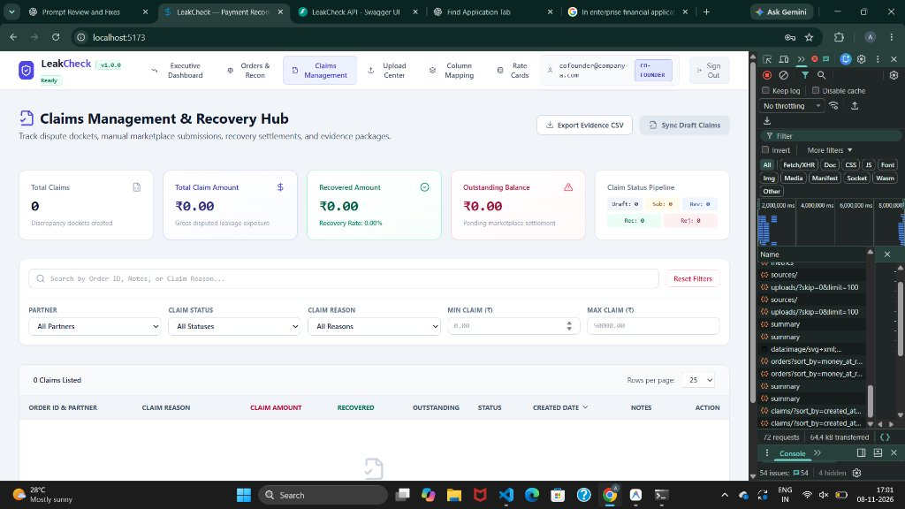
Figure 9.5: Upload Center & AI Column Mapping Review
Design Decision: Upon file upload, schemas are detected and compared against approved mappings. Incompatible column sets trigger an interactive review where exact matches, RapidFuzz fuzzy suggestions, and AI fallbacks are displayed with confidence badges for mandatory human sign-off.
10. System Limitations & Future Improvements
To provide full engineering transparency, the following technical limitations and proposed future enhancements are documented:
- 1. Distributed File Staging Cache: The staging cache (`_PENDING_FILE_CACHE`) holds uploaded file bytes in memory pending column mapping approval. In a distributed multi-node production deployment, this should be migrated to Redis or an object store (AWS S3 / GCP GCS) with a 24-hour TTL expiration.
- 2. Multi-Tenant Organization Isolation: The current architecture partitions records logically across multiple partners for Company A. Scaling to a multi-tenant SaaS serving dozens of independent enterprise brands requires implementing PostgreSQL Row-Level Security (RLS) or tenant-per-schema isolation.
- 3. Legacy Binary Excel (.xls) Format Support: The ingestion pipeline is optimized for modern `.xlsx` via `calamine`/`fastexcel`. Legacy binary BIFF8 `.xls` files (pre-2007) are rejected due to OLE compound structure. Supporting legacy `.xls` requires integrating the `xlrd` library.
- 4. Asynchronous Background Task Queue: While Polars comfortably parses 150,000 rows in sub-second timeframes, processing multimillion-row batches will benefit from an asynchronous job worker queue (Celery / ARQ with Redis) to prevent HTTP connection timeouts.
- 5. Direct Carrier & Marketplace Webhook Ingestion: Courier statements (Delhivery, Blue Dart) and marketplace settlements are currently ingested via CSV/XLSX uploads. Future versions can incorporate direct API integrations and webhooks for real-time daily ledger synchronization.

