WEEK 5 TASK
Deep Learning Application in Data Science
Deep Learning-Based Student Performance Prediction
Dataset: UCI Student Performance – Mathematics Course
Framework: TensorFlow / Keras
Prepared by: Aman Kumar Yadav
Year: 2026
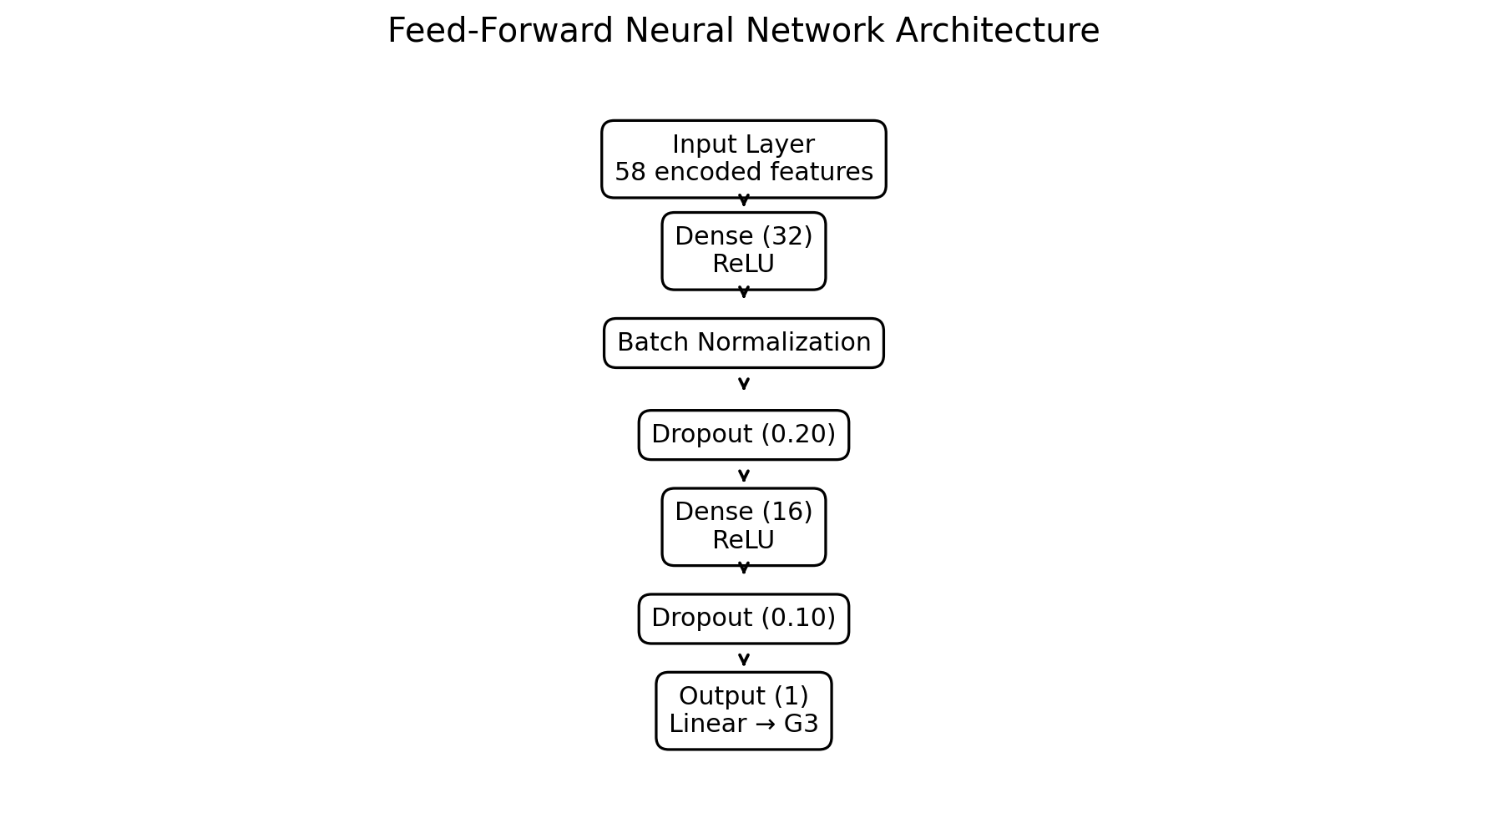

1. Executive Summary
This project applies a feed-forward neural network to the prediction of final Mathematics grades using the UCI Student Performance dataset. The Mathematics subset contains 395 students and 33 columns, with G3 representing the final grade on a 0–20 scale. The problem is formulated as supervised regression because the target is continuous/numeric.
The project deliberately addresses a key limitation identified during the earlier exploratory analysis: G1 and G2 are earlier-period grades from the same course and have very strong relationships with G3. Therefore, two experiments are documented: a full model that includes G1/G2 and an early-intervention model that excludes them. This makes the feature-selection decision explicit rather than treating correlation as automatic evidence of usefulness.
The reference benchmark used a deterministic 70/15/15 split: 276 training, 59 validation and 60 test observations. The full MLP achieved a test MAE of 2.45, RMSE of 3.06 and R² of 0.645. The early-intervention experiment was substantially harder, with MAE 4.32, RMSE 5.16 and R² -0.012. These results illustrate how much predictive information is carried by prior grades and why early prediction is a more challenging problem.

2. Objectives
- Understand the role of neural networks in tabular data science.
- Design and train a supervised deep-learning regression model.
- Use a leakage-aware preprocessing and evaluation pipeline.
- Justify feature selection using evidence from the earlier EDA.
- Evaluate the model using MAE, RMSE and R² rather than a single metric.
- Investigate overfitting and apply regularization techniques.
- Compare a full academic model with an early-intervention model.
- Document practical limitations and concrete future improvements.

3. Problem Statement
Educational institutions may want to estimate student performance from demographic, academic-history, study-behaviour and attendance information. The objective here is to predict G3, the final Mathematics grade, while critically examining how the availability of earlier grades affects the prediction task.
Research question: Can a small feed-forward neural network learn useful nonlinear relationships from student-level tabular data, and how does predictive performance change when G1 and G2 are removed to represent an earlier intervention setting?

4. Dataset Description
Item | Value
Dataset | UCI Student Performance – Mathematics
Records | 395
Columns | 33
Target | G3 – final Mathematics grade
Target scale | 0–20
Task | Supervised regression
Missing values | None reported in the standard dataset
Source | UCI Machine Learning Repository

The UCI documentation describes data collected from two Portuguese secondary schools using school reports and questionnaires. It supports both classification and regression tasks. The documentation also explicitly notes that G3 has a strong relationship with G1 and G2 because G1 and G2 are first- and second-period grades while G3 is the final grade.
Source: Cortez, P. (2008), Student Performance, UCI Machine Learning Repository, DOI: 10.24432/C5TG7T.

5. Findings Carried Forward from the Previous EDA
The previous exploratory analysis provides the evidence base for the Week 5 modeling decisions. The final-grade distribution had a mean of 10.42, median of 11 and standard deviation of 4.58. There were 38 students (9.6%) with G3 = 0 and 130 students (32.9%) below 10.
Variable | Observed association with G3 | Interpretation
G2 | +0.90 | Very strong; expected because it is an earlier grade
G1 | +0.80 | Strong; also an earlier grade from the same course
failures | −0.36 | Moderate negative association
studytime | +0.25 | Smaller positive association
absences | −0.09 | Weak negative association

These are descriptive associations, not causal effects. In particular, the strong G1/G2 relationships should not be interpreted as independent causal effects.

6. Feature Selection and Leakage Control

6.1 Why G1 and G2 are treated separately
G1 and G2 are highly informative because they directly represent earlier academic performance. However, using them changes the practical meaning of the prediction task. If the model is intended to identify students before those grades become available, G1 and G2 should not be used.
Therefore, the report does not simply select G1 and G2 because they have the largest correlations. Instead, it evaluates two scenarios: (1) a full academic model containing G1/G2 and (2) an early-intervention model excluding them.

6.2 Selected predictors
The modeling pipeline uses numerical variables such as age, parental education, travel time, study time, previous failures, family relationship quality, free time, social activity, alcohol consumption, health and absences. Binary/nominal variables such as school, sex, address, family size, parental status, jobs, support variables, higher-education intention, internet access and romantic relationship are one-hot encoded.

6.3 Leakage prevention
- G3 is never included as an input feature.
- Derived variables based on G3 are not used for training.
- The train/validation/test split is performed before fitting the scaler and encoder.
- Numerical scaling parameters are learned only from the training partition.
- Unknown categorical values at inference time are handled safely with handle_unknown='ignore'.

7. Data Preprocessing
The raw dataset mixes numerical, ordinal and categorical variables. Numerical variables are standardized using StandardScaler. Nominal categorical variables are transformed using one-hot encoding. The preprocessing object is fitted on the training data only and then applied to validation and test data.
A 70/15/15 split is used for training, validation and testing. The reference experiment therefore uses 276, 59 and 60 records respectively.

8. Neural Network Architecture
The architecture is intentionally compact. With only 395 observations, an excessively large network could memorize the training set rather than learn patterns that generalize.
Layer | Configuration | Purpose
Input | Encoded feature vector | Accept heterogeneous tabular predictors
Dense 1 | 32 neurons, ReLU | Learn nonlinear combinations
Batch Normalization | Default | Improve optimization stability
Dropout | 0.20 | Regularization
Dense 2 | 16 neurons, ReLU | Compress learned representation
Dropout | 0.10 | Additional regularization
Output | 1 neuron, linear | Continuous G3 prediction

9. Training Configuration
Parameter | Setting | Reason
Optimizer | Adam | Adaptive gradient optimization
Learning rate | 0.001 | Stable starting point for small tabular networks
Loss | Mean Squared Error | Standard regression objective
Metric | MAE | Directly interpretable grade-point error
Batch size | 16 | Small batch appropriate for 395 records
Maximum epochs | 150 | Allows sufficient optimization
Early stopping | Patience 15 | Stops training when validation loss stops improving
ReduceLROnPlateau | Factor 0.5, patience 7 | Reduces learning rate when validation progress stalls
Random seed | 42 | Improves reproducibility

10. Evaluation Metrics
MAE measures the average absolute difference between predicted and actual grades. RMSE gives greater weight to large errors. R² measures the proportion of target variance explained by the model relative to a mean-prediction baseline.
Lower MAE/RMSE is better; higher R² is better.

11. Results and Quantitative Analysis
Experiment | Input representation | MAE | RMSE | R²
Mean baseline | Mean of training G3 | 4.110 | 5.239 | -0.042
Full MLP | G1/G2 included | 2.453 | 3.056 | 0.645
Early MLP | G1/G2 excluded | 4.321 | 5.162 | -0.012

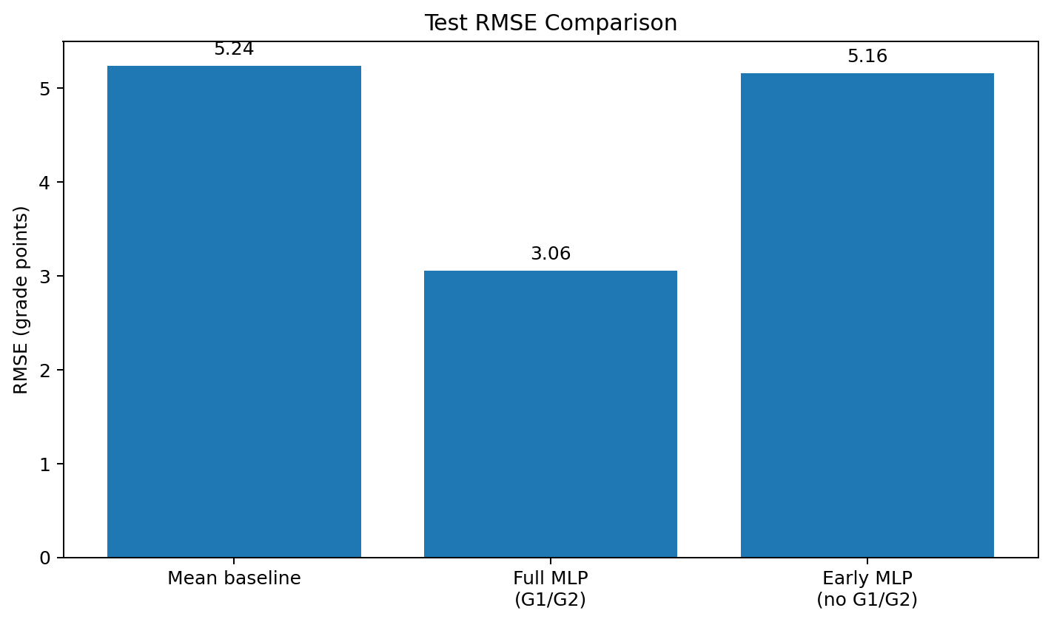
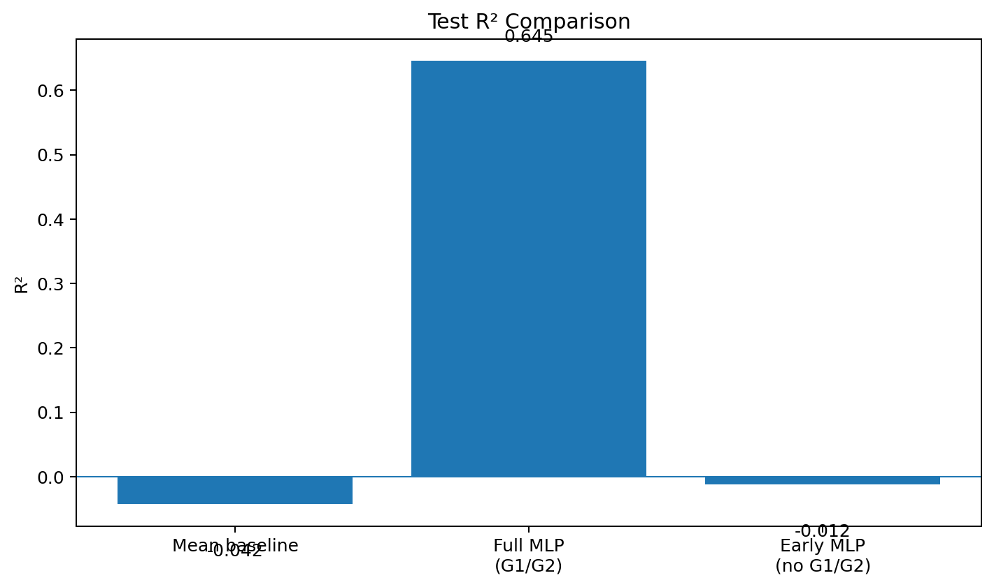

11.1 Interpretation
The full MLP reduced test RMSE from the mean baseline's 5.24 to 3.06 grade points and achieved R² = 0.645. This indicates that the model learned useful predictive structure when earlier grades were available.
When G1 and G2 were removed, test RMSE increased to 5.16 and R² became -0.012. In this reference experiment, the early-intervention feature set did not outperform the mean baseline. This is a useful negative result rather than something to hide: it shows that the non-grade demographic/behavioural variables in this small dataset contain substantially less directly predictive information than the earlier course grades.
Because the dataset is small and the reference run is a single deterministic split, these numbers should not be treated as a universal estimate of real-world performance. A future evaluation should use repeated or k-fold cross-validation.

11.2 Sample Test Predictions
Actual G3 | Predicted G3 | Absolute error
15 | 13.44 | 1.56
18 | 14.65 | 3.35
15 | 12.89 | 2.11
15 | 13.06 | 1.94
11 | 9.63 | 1.37
19 | 16.05 | 2.95
10 | 7.75 | 2.25
11 | 10.47 | 0.53

12. Challenges Encountered and Solutions
Challenge | Effect | Solution
Small sample size | High risk of overfitting | Compact MLP, Dropout, EarlyStopping
Mixed data types | Neural networks require numeric input | One-hot encoding + standardization
G1/G2 dominance | Can make the task artificially easy | Separate full and early-intervention experiments
Different feature scales | Can slow or destabilize optimization | StandardScaler on training data
Validation instability | Small validation set | Use validation monitoring and future k-fold validation
Interpretability | Neural networks are less transparent | Feature analysis, baseline comparison and future SHAP analysis
Resource constraints | Large architectures are unnecessary | Small tabular MLP suitable for CPU/cloud notebook execution

13. Critical Analysis
The results demonstrate both the usefulness and limitations of deep learning for small tabular datasets. The full model performs substantially better than a mean baseline because G1 and G2 provide strong information about the final grade. However, this does not prove that a neural network is inherently superior to classical machine-learning methods.
The early-intervention experiment is particularly important. Removing G1 and G2 changes the problem from 'predict the final grade with strong prior-grade information' to 'predict performance from demographic, behavioural and attendance context'. The reference model struggled in this setting, suggesting that the available variables may not contain enough signal for reliable individual-grade prediction on such a small sample.
The dataset represents students from two Portuguese schools, so external validity is limited. Associations found in this sample should not automatically be generalized to other countries, schools or educational systems.

14. Overfitting and Regularization
Overfitting occurs when a model learns the training examples too closely and loses performance on unseen data. The risk is especially relevant here because 395 observations are small relative to the number of encoded features.
- The network is intentionally small: 32 → 16 hidden units.
- Dropout randomly suppresses a fraction of hidden activations during training.
- Batch normalization can stabilize optimization.
- Early stopping restores the best validation weights rather than simply using the final epoch.
- ReduceLROnPlateau lowers the learning rate when validation loss stops improving.

15. Key Code Implementation

15.1 Model architecture
model = keras.Sequential([
layers.Input(shape=(input_dim,)),
layers.Dense(32, activation="relu"),
layers.BatchNormalization(),
layers.Dropout(0.20),
layers.Dense(16, activation="relu"),
layers.Dropout(0.10),
layers.Dense(1, activation="linear"),
])
model.compile(
optimizer=keras.optimizers.Adam(learning_rate=0.001),
loss="mse",
metrics=[keras.metrics.MeanAbsoluteError(name="mae")]
)

15.2 Training with callbacks
callbacks = [
keras.callbacks.EarlyStopping(
monitor="val_loss",
patience=15,
restore_best_weights=True
),
keras.callbacks.ReduceLROnPlateau(
monitor="val_loss",
factor=0.5,
patience=7,
min_lr=1e-5
)
]
history = model.fit(
X_train,
y_train,
validation_data=(X_val, y_val),
epochs=150,
batch_size=16,
callbacks=callbacks
)

15.3 Evaluation
predictions = model.predict(X_test).reshape(-1)
mae = mean_absolute_error(y_test, predictions)
rmse = np.sqrt(mean_squared_error(y_test, predictions))
r2 = r2_score(y_test, predictions)
print("MAE:", mae)
print("RMSE:", rmse)
print("R2:", r2)
The complete executable implementation is provided separately as week5_deep_learning_student_performance.py.

16. Future Work
- Use repeated k-fold cross-validation instead of relying on a single train/validation/test split.
- Compare the MLP with Linear Regression, Random Forest, Gradient Boosting and XGBoost on the same split.
- Perform systematic hyperparameter tuning for layer width, dropout, learning rate and batch size.
- Develop an explicit classification model for at-risk students, for example G3 < 10.
- Use SHAP or permutation importance to improve model interpretability.
- Collect a larger and more geographically diverse dataset to improve external validity.
- Evaluate whether school-specific effects remain after controlling for behavioural and academic variables.
- Build a practical early-warning system using only variables available before final-period grades.

17. Conclusion
This project demonstrates an end-to-end deep-learning workflow for tabular educational data: problem formulation, dataset validation, leakage-aware preprocessing, neural-network design, regularized training, quantitative evaluation and critical interpretation.
The reference full model achieved MAE 2.45, RMSE 3.06 and R² 0.645, while the early-intervention model achieved MAE 4.32, RMSE 5.16 and R² -0.012. The difference demonstrates the importance of feature availability and provides a concrete answer to the earlier feedback about feature-selection justification.
The most important methodological lesson is that a deep-learning model should not be evaluated only by a high score. The meaning of the features, the timing of information availability, the sample size, leakage risk and generalization limitations are equally important parts of a sound data-science solution.

18. References
- Cortez, P. (2008). Student Performance. UCI Machine Learning Repository. DOI: 10.24432/C5TG7T.
- UCI Machine Learning Repository. Student Performance dataset documentation.
- Géron, A. Hands-On Machine Learning with Scikit-Learn, Keras, and TensorFlow.
- TensorFlow/Keras documentation – Sequential models, Dense, Dropout, BatchNormalization and callbacks.
- Scikit-learn documentation – preprocessing, train_test_split and regression metrics.

Appendix A – Reproducibility Checklist
- Python 3.10+ recommended.
- Install dependencies from requirements.txt.
- Run the supplied Python script from the project root.
- If the dataset is absent, the script downloads the official UCI archive.
- The script creates figures/, outputs/ and models/ automatically.
- The final model is saved in Keras format.
- The fitted preprocessing pipeline is saved with pickle.
- The exact TensorFlow run may produce slightly different metrics from the deterministic reference benchmark because optimizer and callback implementations differ.

