**Lab - 2**

* Transport Layer: Port Number
* Network Layer: Router (IP Address)
* Data Link Layer: Bridge & Switch (MAC Address)
* Physical Layer: Hub

IP Addressing (Classful Addressing)

* IP Address: 32 bits (Divided into 4 octaves, each of 8 bit)
* Representation:
  + Dotted Decimal
  + Binary Representation
* During 1980s, 32 bits are represented as (8 bit - Network ID, 24 bit - Host ID)

Class A (1st bit is reserved as 0)

8 bit – Network ID

24 bit – Host ID

* Range = 0-127
* Number of networks = 27 i.e. 128-2 = 126
* Number of hosts in each network = 224 – 2
* Total number of IP Address = 231 
  + 1. (Network ID)

1.255.255.255 (Broadcast ID)

255.0.0.0 (Default Mask)

**Host ID AND Default Mask = Network ID**

Class B (1st and 2nd bit is reserved as 1 and 0 respectively)

16 bit – Network ID

16 bit – Host ID

Default Mask - 255.255.0.0

* Total number of IP Address = 230
* Number of networks = 214
* Range = 128-191
* Number of hosts in each network = 216 – 2

Class C (Reserved – 110)

* Range = 192-223
* Total number of IP Address = 229
* Number of networks = 221
* Number of hosts in each network = 28 -2
* Default Mask = 255.255.255.0

Class D (Reserved – 1110)

Class E (Reserved – 1111)

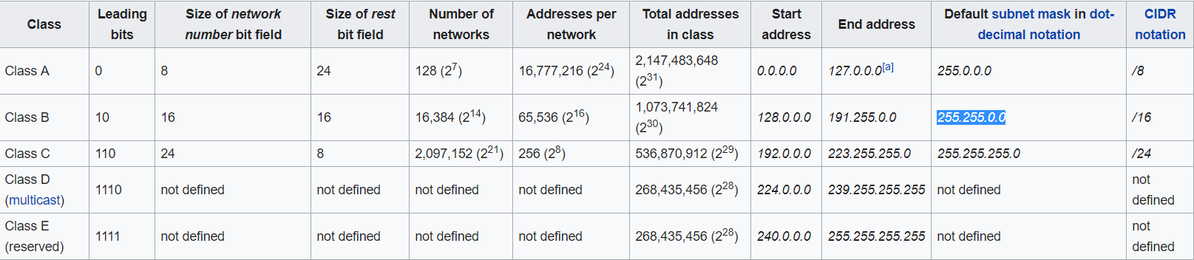

**Percentage Wise:**

* 50% - Class A
* 25% - Class B
* 12.5% - Class C