**Question Bank (Graph Theory)**

1. Consider the graph shown in figure.

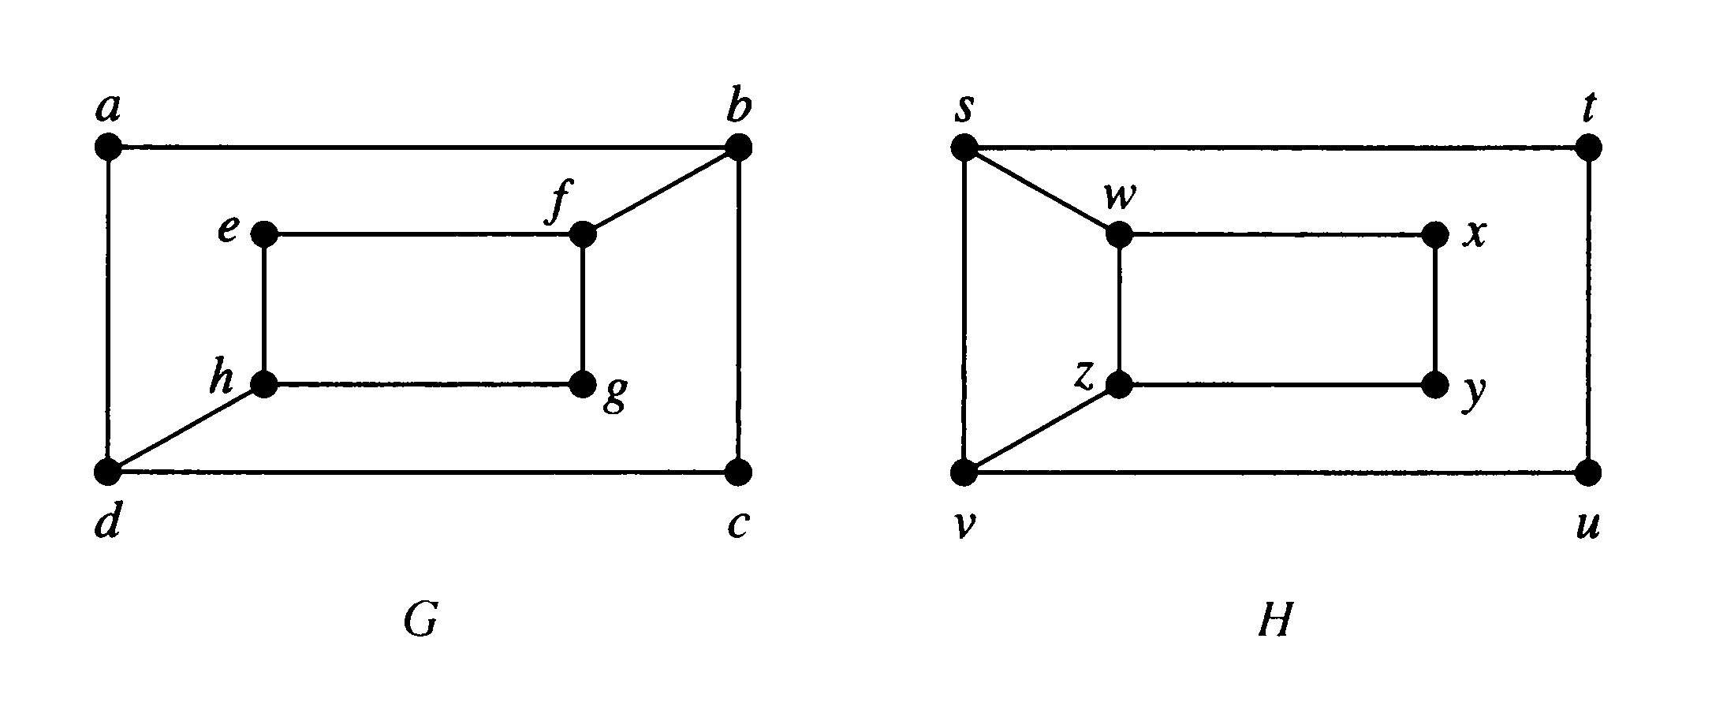

1. Determine whether the graphs (G and H) shown in figure are isomorphic or not.
2. Represent the graph shown in figure with an incidence matrix. You can take your own incidence names (if required) for computing incidence matrix.
3. Represent adjacency matrix for the graph shown in figure.

2. Consider the graph shown in figure.

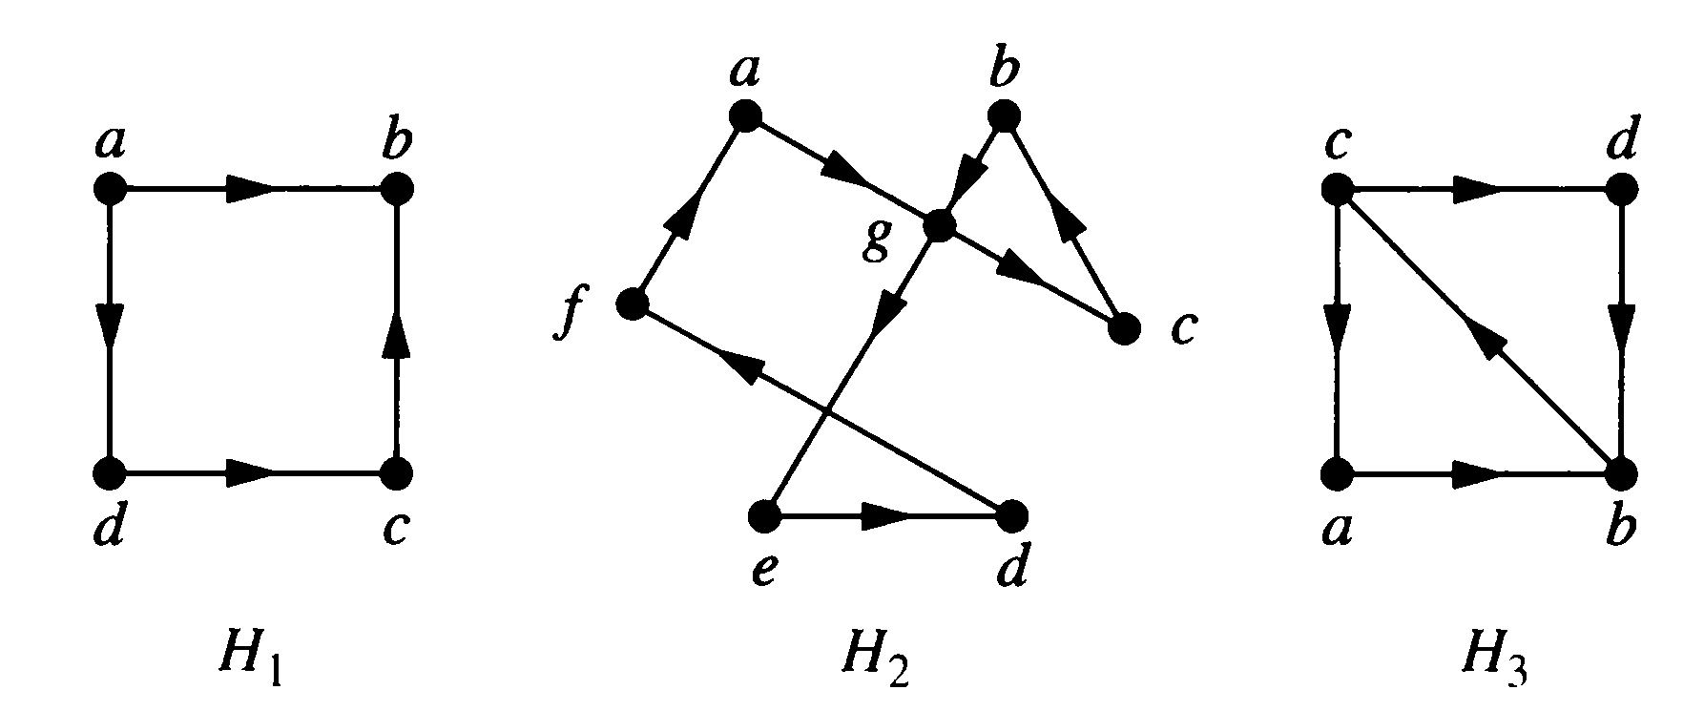

1. Which of the directed graph shown in figure have an Euler circuit? Of those that do not, which have an Euler path?
2. Represent adjacency matrix for H2 graph.
3. Find the in-degree and out-degree of each vertex in the graph H2 with directed edges shown in figure.
4. Out of H1, H2 and H3 graphs, identify strongly and weakly connected graphs.

3. Write short note on:

1. Complete graph

2. Complement graph

3. Subgraph

4. Cubic graph

5. Cyclic graph

6. Bipartite Graph

7. Wheel graph

8. Euler Graph

9. Hamiltonian Graph

10. Matrix Representation of Graph

4. Discuss the necessary and sufficient condition for Euler circuit with suitable example.

5. Discuss the sufficient condition **(Dirac and Ore theorems)** for Hamilton circuit with suitable example.

6. How many vertices and how many edges do these graphs have?

1. K3
2. C5
3. C3
4. W3
5. W4
6. K3,3
7. Q2
8. Q3

7. Apply Havel-Hakimi algorithm and determine whether each of these sequences is graphic. For those that are, draw a graph having the given degree sequence.

1. 3,3,3,3,2
2. 1,1,1,1,1

8. Prove the following:

1. Suppose that *v* is an endpoint of a cut edge. Prove that *v* is a cut vertex if and only if this vertex is not pendant.
2. A graph is called 5-regular if every vertex has degree 5. Prove that a 5-regular graph has an even number of vertices.

9. A sequence *d*1*, d*2*, . . . , dn* is called **graphic** if it is the degree sequence of a simple graph.

Determine whether each of these sequences is graphic. For those that are, draw a graph having the given degree sequence.

1. 5, 4, 3, 2, 1, 0
2. 6, 5, 4, 3, 2, 1
3. 2, 2, 2, 2, 2, 2
4. 3, 3, 3, 2, 2, 2

10. Find the union of the given pair of simple graphs. (Assume edges with the same endpoints are the same.)

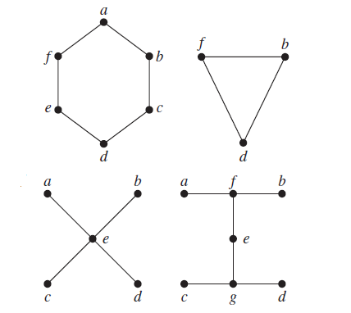

11. If the degree sequence of the simple graph *G* is 2*,* 2*,* 2*,* 1*,* 1, what is the degree sequence for complement of *G*?

12. Determine whether the given graph has an Euler circuit/Euler path.

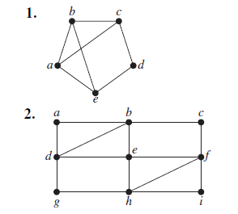

13. Determine whether the given graph has a Hamilton circuit.

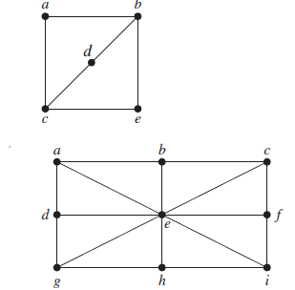

14. For each of these graphs, determine whether Dirac’s/ Ore’s theorem can be used to show that the graph has a Hamilton circuit.

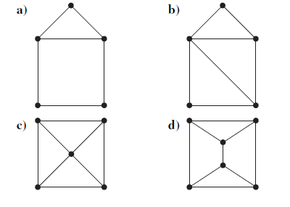

15. Prove undirected graph has even number of vertices with odd degree.

16. What are the degrees and what are the neighborhoods of the vertices in the graphs *G* and *H* displayed in Figure?

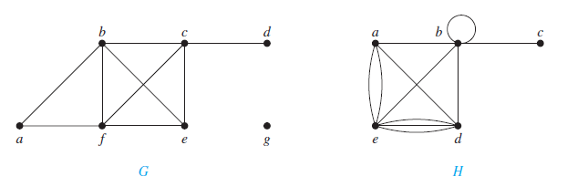

17. How many edges are there in a graph with 10 vertices each of degree six?

18. Find the in-degree and out-degree of each vertex in the graph *G* with directed edges shown in Figure.

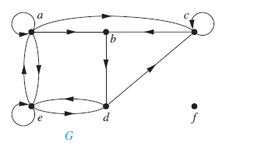

19. How many edges does a graph have if its degree sequence is 2, 2, 2, 1, 1? Draw such a graph.

20. 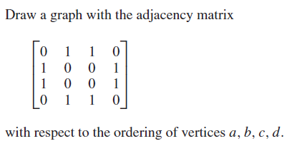

21. Represent the pseudograph shown in Figure using an incidence matrix.

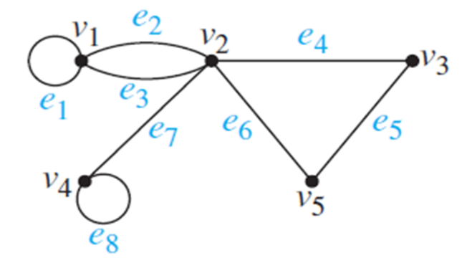

22. Find the degree sequence of each of the following graphs.

* **a)** *K*4
* **b)** *C*4
* **c)** *W*4
* **d)** *Q*3

23. Prove that in a full binary tree with n vertices, the number of pendant vertices is (n+1)/2.

24. Write short note on

a. Tree

b. pendant vertices

c. isolated vertices

b. Binary Tree

c. Cut set

d. cut vertices

24. Prove a graph G with n vertices, n−1 edges and no cycles is connected.

25. Draw the graph with vertices A, B, C, D and edge set {AB, AC, AD, BC, BD} Is your graph isomorphic to one of the graphs below?

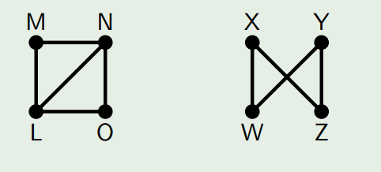

26. Are the two graphs below isomorphic?

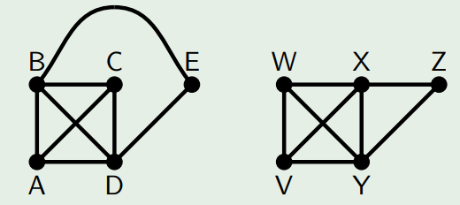

27. Show a connected graph on n vertices has at least (n - 1) edges.

28. An acyclic graph on n vertices has at most (n - 1) edges.

29. Show that in any digraph the sum of all the outdegrees is equal to the sum of all the in-degrees.

30. If a graph has 5 vertices, can each vertex have degree 3?

31. If T is a full binary tree with i internal vertices, then T has i + 1 terminal vertices and 2i + 1 total vertices. Prove by hand shaking lemma.