**CSEG 265 SEPM**

**HBO ASSIGNMENT 2 M.M. : 20**

**LAST DATE OF SUBMISSION:**

**(COMMON TO ALL B.TECH. CSE SEMESTER IV all BRANCHES)**

1. Give five differences between White Box and Black Box Testing in table form
2. Define and differentiate between validation and verification testing?compare the two with acceptance testing
3. What are Roles and responsibilities of Project manager and project stakeholders?
4. The cyclomatic complexity of each of the modules A & B shown below is 10. Compute cyclomatic complexity of the sequential integration shown on the right hand side?

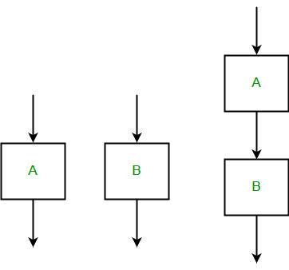

Q 5.Draw control flow graph for the program hence compute Cyclomatic complexity using any two methods, and draw the Graph matrix for the same.

int compute_gcd (int x, int y) {  
1 while (x ! = y) {

2 if (x>y) then

3 x = x-y;

4 else y = y-x;

5 }

6 return x; }