Experiment 2

Archiving Records
Aim: Create the archive files of all log files, compress them and take backup.
Code:
#!/bin/bash
read -p "Filename of archive to be created: " f
tar cvf $f.tar *.log
du -sh $f.tar
mv $f.tar /BackupFolder
Description:
*) “tar” or tape archive is a tool that is used for compression.
Tar flags:
C: create archive
V: verbose: Tell summary
F: File status
Du: Tells the disk usage
S: Summary
H: human readable form
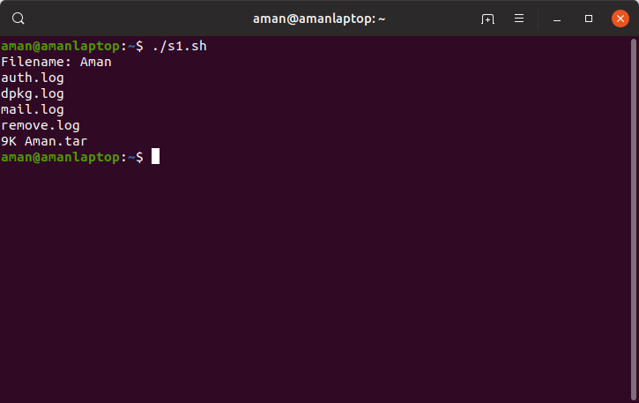
Output:

Auto Discard Old Archives
Aim: Delete old archive files (2 days or more) whose backup we have already taken via script and schedule it in cron.
Code:
#!/bin/bash
find "/home/ubuntu/Desktop/Automation-using-Shell-Scripts/ScenariosFullChapter2/BackupFolder/" -type f -mtime +2 -exec rm {} \;
Description:
*) find command is used to check for patterns and work on them simultaneously.
*) –type f is used to check whether locked file system is a file or not.
*) –mtime is used to check the timestamp in date order.
*) –exec: is used to execute a command after matched file is found.
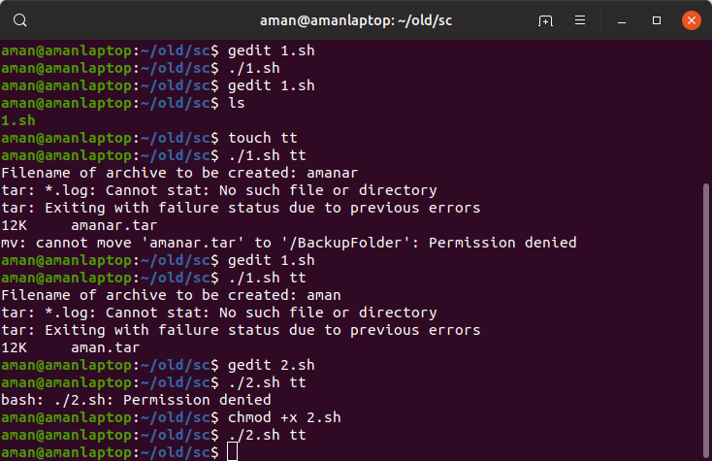
Output:

Ensure Web Server is running
Aim:A web server must be always running in order that our server always has uptime wrt network connectivity. If the web server is disconnected, restart it. Schedule a cron which does the same every minute.
Code:
backupfolder="/home/ubuntu/Desktop/Automation-using-Shell-Scripts/ScenariosFullChapter2/"
find /var/log/apache2/ -mtime +1 -exec mv{} $backupfolder \;
netstat -au
netstat -lu
Description:
*) netstat command is used to find the net (web server status)
*) In computing, netstat (network statistics) is a command-line network utility tool that displays network connections for the Transmission Control Protocol (both incoming and outgoing), routing tables, and a number of network interface (network interface controller or software-defined network interface) and network
*) –au flag is used to check only for internal server
*) –lu is used to check for servers and public connectivity as well.

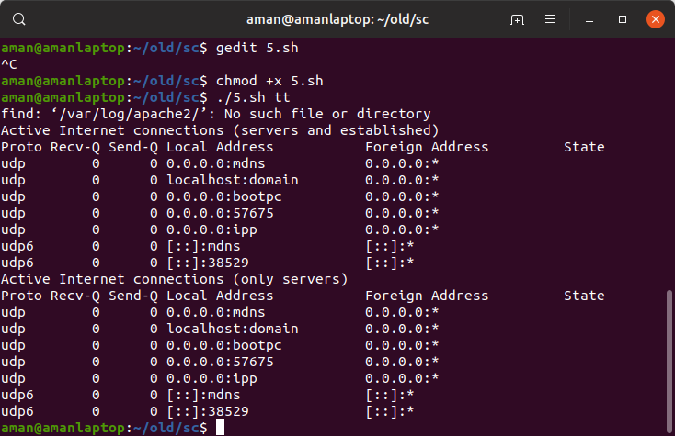
Output:

- User Command Validation-> Create a user
Aim: Create a new user and a new group and add the new user to the new group with the needed permissions.
Code:
#!/bin/bash
read -p "Enter the username of the new user you want to create: " usr
adduser $usr
cd
cd .. #Go to the absolute root
sudo usermod -aG sudo $usr #Give user all the root permissions
chmod 777 $usr #Give the user all rwx permissions
read -p "Enter a group name for your user: " grp
addgroup $grp
sudo usermod -aG $grp $usr #add the user to the new group
echo "The user has been created!!!!!"
Description:
*) adduser is used to create a new user with GUI and detail like password etc.
*) usermod gives the user permissions of specified group
*) addgroup is used to add a group

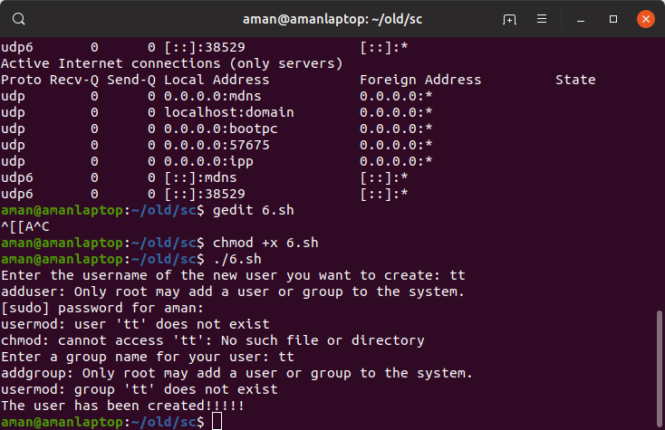
Output:

- Disk Usage Alarm
Aim: Create a trap check to monitor whether the disk usage of the machine is less than the specified threshold limit. If the trap catches a fault, send the mail about danger to all the concerned people.
Code:
#!/bin/bash
LIMIT='80'
dir_name='/var'
mailto="500060720@stu.upes.ac.in"
subject="Disk Usage of $dir_name in Ubuntu"
MAILX="mailx"
which $MAILX > /dev/null 2>&1
if [ $? -eq 0 ]
then
echo "Install mailx"
exit 1
fi
cd $dir_name
used=`df . | awk '{print $5}' | sed -ne 2p | cut -d"%" -f1`
if [ $used -gt $LIMIT ]
then
du -sh ${dir_name}/* | $MAILX -s "$subject" "$mailto"
fi
Description:
*) Limit keyword is used to check that whether the usage is in that percentage or above in 100 % value.
*) Mailx tool is used to send the mails via web server.
*) awk options 'selection _criteria {action }' input-file > output-file
*) The cut command in UNIX is a command for cutting out the sections from each line of files and writing the result to standard output. It can be used to cut parts of a line by byte position, character and field. Basically the cut command slices a line and extracts the text. It is necessary to specify option with command otherwise it gives error. If more than one file name is provided then data from each file is not precedes by its file name
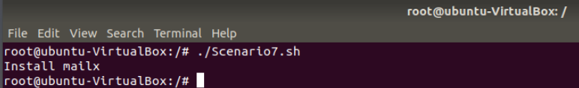
Output:

Sending files to Recycle Bin
Aim: Create a user defined recycle bin and on user command, move the file from said location to the recycle bin with confirmation message.
Code:
#!/bin/bash
read -p "Enter the path to delete files from: " path
path1="/home/ubuntu/Desktop/Automation-using-Shell-Scripts/ScenariosFullChapter2/RecycleBin/" #RecycleBin Path
echo "Following files are present on the path specified: "
ls $path
read -p "Enter the filename you want to delete: " f
read -p "Do you really want to delete the file: " res
case $res in
y|Y|yes|YES)
if [ -e $path/$f ]
then
mv $path/$f $path1
else
echo "File does not exist!!"
fi
;;
*) echo "File does not exist!!"
;;
esac
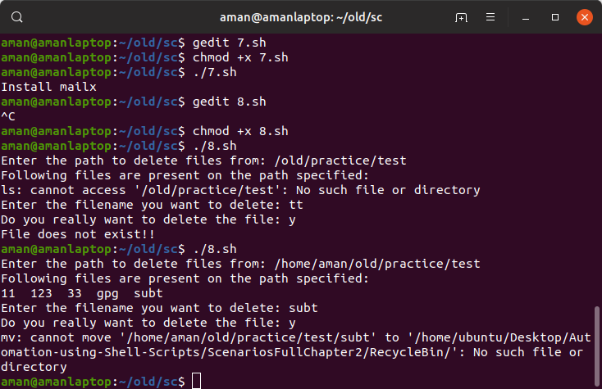
Output:

Restoring files from Recycle Bin
Aim: Show all the files in the recycle bin and ask the user with confirmation whether he wants to recover them and also ask the destination folder.
Code:
#!/bin/bash
path1="/home/ubuntu/Desktop/Automation-using-Shell-Scripts/ScenariosFullChapter2/RecycleBin"
echo "Following files are present on the Recycle Bin currently: "
ls $path1
read -p "Enter the filename you want to recover: " f
read -p "Do you really want to recover? " resp
case $resp in
y|Y|YES|yes)
read -p "Enter the Destination Path: " dest
mv $path1/$f $dest
echo "File recovered!!!"
;;
*) echo "No files recovered!!"
;;
Esac

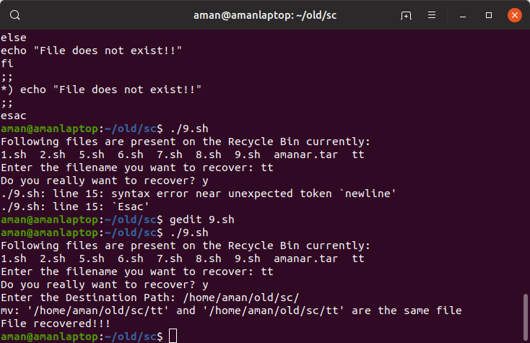
Output:

Logging Delete Actions
Aim: On deletion of any files, create a user defined log file and store the filename, path and time of deletion along with the user who deletes the file.
Code:
#!/bin/bash
if [ $# -eq 0 ]
then
echo "No inputs send via command line!! Exiting" >&2; exit 1;
fi
path=$1
path1="/home/ubuntu/Desktop/Automation-using-Shell-Scripts/ScenariosFullChapter2/"
if [ -d $path ]
then
rm -r $path
echo `date +%F` >> $path1/del.log
echo "$whoami" >> $path1/del.log
echo "$path" >> $path1/del.log
fi
if [ -f $path ]
then
rm $path
echo `date +%F` >> $path1/del.log
echo "$USERs" >> $path1/del.log
echo "$path" >> $path1/del.log
fi
Description:
*) “%F” flag along with date includes the full format of dates as yyyy-mm-dd format
*) “USER” command is the alternative to the “whoami” command.
*) rm –r does recursive deletion in the subfolders as well.
Output:
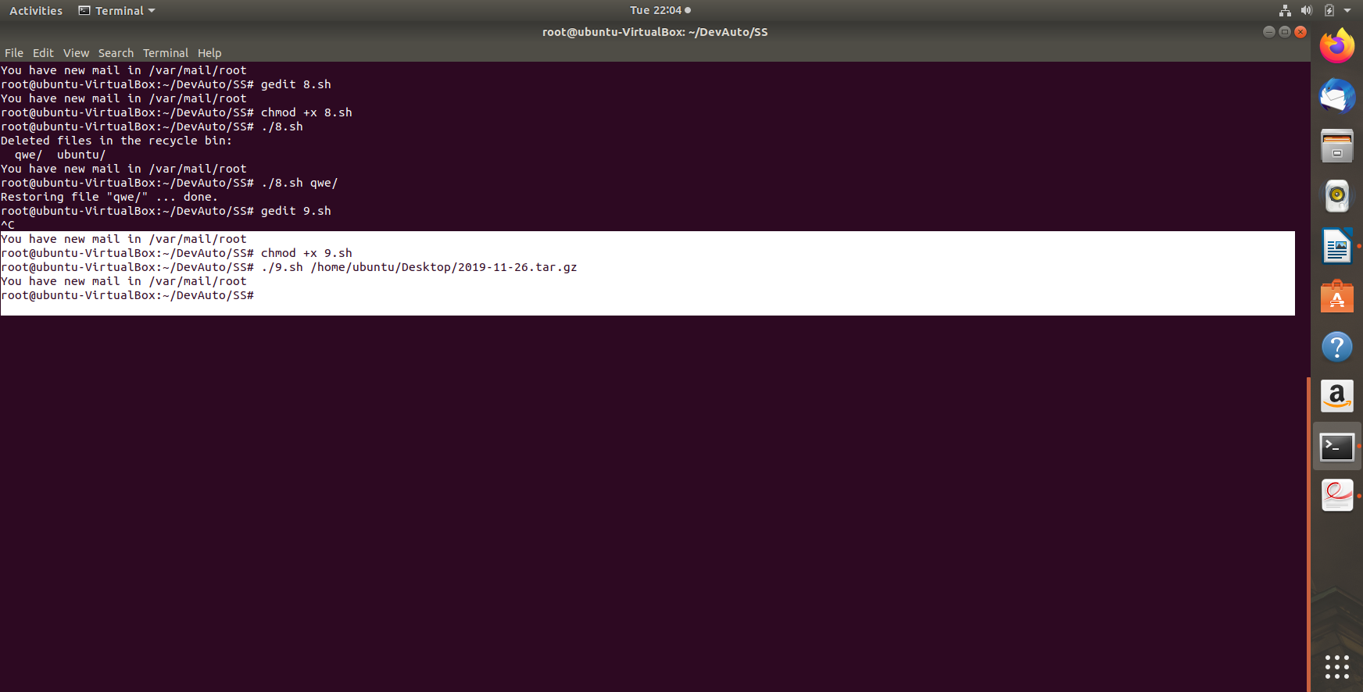

Encrypting and Decrypting files
Aim: Create and encryption on the folders with a symmetric password and also to decrypt them using the GPG tool.
Code:
#!/bin/bash
read -p "Enter the path of the folder to Encrypt: " f
gpg -c $f
echo "Folder encrypted!!"
read -p "Do you want to decrypt now? " res
case $res in
y|Y|yes|YES) gpg -d $f.gpg ;;
*) echo "Folder is still encrypted!!!" ;;
esac
Description: -c command is used to create encryption with a symmetric password.
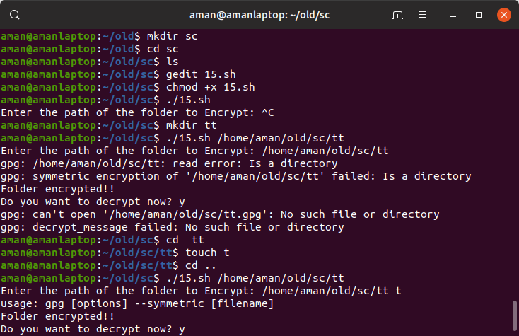
Output:
Bulk File Downloader
Aim: Using the wget command and for loop, create a shell script to download multiple related web pages recursively.
Code:
#!/bin/bash
downloads_directory="$HOME/Downloads"
if [ -z "$1" ]; then
echo "ERROR: Download List file is not specified in the arguments" >&2; exit 1;
fi
if ! [ -z "$2" ]; then
downloads_directory=$2
fi
if [ ! -d $downloads_directory ] ; then
mkdir -p $downloads_directory
fi
download_list=$1
cat $download_list | while read url; do
echo "----------------------------------------------------------------------------------------------------"
echo "$url"
wget -P $downloads_directory $url
done
exit 0
Description:
Wget is the non-interactive network downloader which is used to download files from the server even when the useer has not logged on o the system and it can work in background without hindering the current process.

Output:

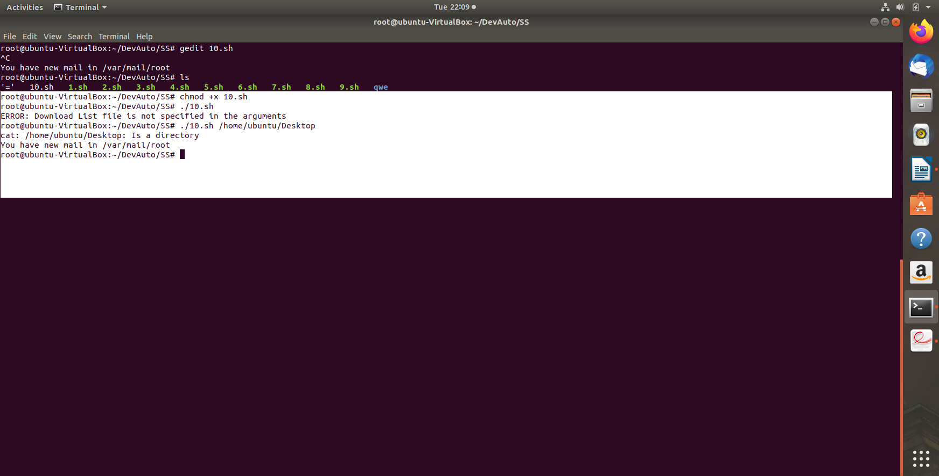
Install LAMP Stack
Aim: Create LAMP (Linux Apache MySQL PHP) combination on machine by installing and starting all the four services.
Code:
#!/bin/bash
echo -e "\n\nUpdating Apt Packages and upgrading latest patches\n"
sudo apt-get update -y && sudo apt-get upgrade -y
echo -e "\n\nInstalling Apache2 Web server\n"
sudo apt-get install apache2 apache2-doc apache2-mpm-prefork apache2-utils libexpat1 ssl-cert -y
echo -e "\n\nInstalling PHP & Requirements\n"
sudo apt-get install libapache2-mod-php7.0 php7.0 php7.0-common php7.0-curl php7.0-dev php7.0-gd php-pear php7.0-mcrypt php7.0-mysql -y
echo -e "\n\nInstalling MySQL\n"
sudo apt-get install mysql-server mysql-client -y
echo -e "\n\nPermissions for /var/www\n"
sudo chown -R www-data:www-data /var/www
echo -e "\n\n Permissions have been set\n"
echo -e "\n\nEnabling Modules\n"
sudo a2enmod rewrite
sudo phpenmod mcrypt
echo -e "\n\nRestarting Apache\n"
sudo service apache2 restart
echo -e "\n\nLAMP Installation Completed"
exit 0
Output:
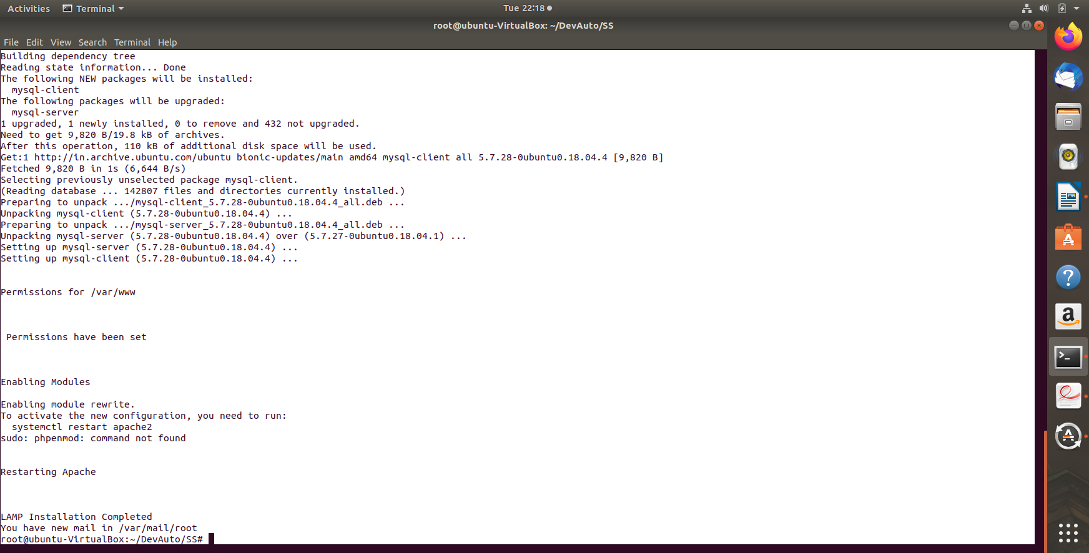

Make and Makefiles
- Basic Setup
Aim: To create the needed c codes of addition, subtraction, multiplication and division and also a user defined header file mymath.h
Code:
Add:
#include "mymath.h"

int add(int a, int b) {
return a + b;
}
Subtract:
#include "mymath.h"

int subtract(int a, int b) {
return a - b;
}
Multiply:
#include "mymath.h"

int multiply(int a, int b) {
return a * b;
}
Divide:
#include "mymath.h"

int divide(int a, int b) {
return a / b;
}
Main:
#include<stdio.h>
#include "mymath.h"

int main() {
int a, b;
printf("Hello World\n\n");

printf("Enter Two Numbers(A B): ");
scanf("%d %d", &a, &b);

printf("Addition: %d\n", add(a, b));
printf("Subtraction: %d\n", subtract(a, b));
printf("Multiplication: %d\n", multiply(a, b));
printf("Division: %d\n\n", divide(a, b));

return 0;
}
Mymath.h
int add(int a, int b);
int subtract(int a, int b);
int multiply(int a, int b);
int divide(int a, int b);
Description:
We have to create a calculator in modular fashion, say all independent micro services like add, subtract, divide, multiply etc. are to be created by different teams.
Thus, different functions are created along with the main() function and the header file that includes all the functions.
- Building Binary from Source code
Aim: To create a Makefile that specifies all the files whose object is to be made and then their merged build is to be done using make command that creates the required target file.
Code: (Makefile)
mycalculator: main.c mymath.h add.c subtract.c multiply.c divide.c
gcc -o mycalculator main.c mymath.h add.c subtract.c multiply.c divide.c
Description:
Makefile includes all the files that are to be compiled independently and then to be merged together to make the required object file mycalculator.
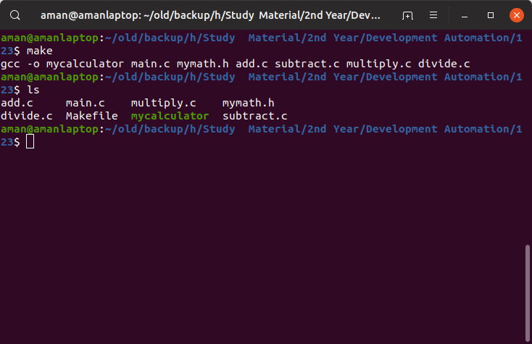
Output:

Transforming Makefile to adhere standard rules
Aim: Creating a dynamic Makefile that uses triggers to automatically rebuild the target file when any of the sub files are changed.
Code: (Makefile)

INCL = mymath.h
SRC = main.c add.c subtract.c multiply.c divide.c
OBJ = $(SRC:.c=.o)
EXE = mycalculator

# Compiler, Linker Defines
CC = /usr/bin/gcc
CFLAGS = -ansi -pedantic -Wall -O2
LIBPATH = -L.
LDFLAGS = -o $(EXE) $(LIBPATH) $(LIBS)
CFDEBUG = -ansi -pedantic -Wall -g -DDEBUG $(LDFLAGS)
RM = /bin/rm -f

# Compile and Assemble C Source Files into Object Files
%.o: %.c
$(CC) -c $(CFLAGS) $*.c

# Link all Object Files with external Libraries into Binaries
$(EXE): $(OBJ)
$(CC) $(LDFLAGS) $(OBJ)

# Objects depend on these Libraries
$(OBJ): $(INCL)

# Create a gdb/dbx Capable Executable with DEBUG flags turned on
debug:
$(CC) $(CFDEBUG) $(SRC)

# Clean Up Objects, Exectuables, Dumps out of source directory
clean:
$(RM) $(OBJ) $(EXE) core a.out

Description:
Creating a standard Makefile that adheres all the rules of professional build. Also, creating dynamic Makefile that detects any changes made to the sub files and trigger automatic rebuild of the target file.
*) First, we initialize the variables with dependencies and then we command the creation of objects.
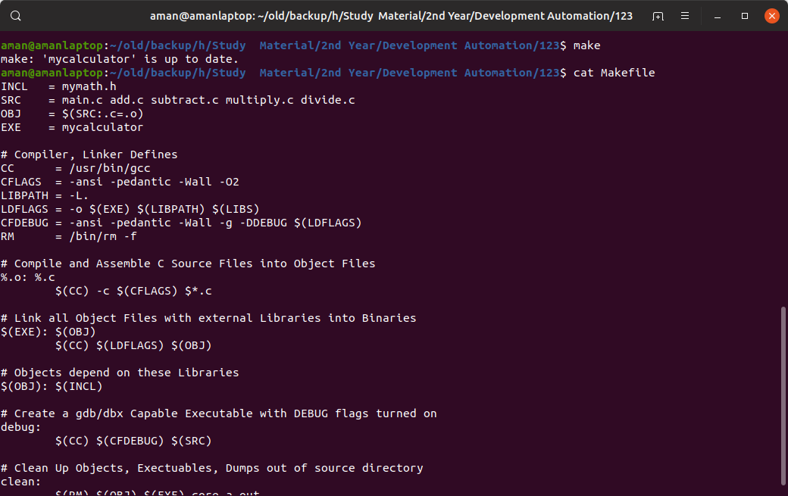
Output:

Archiving logs with Make
Aim: Creating logs using Makefile
Code:
SHELL = /bin/bash
LOGDIR = /var/log
LOGEXT = log
BACKUPDIR = /archives
start: createarchive movearchive deletelogs
echo "Logs files are archived and deleted"
createarchive:
tar czf archive.tar.gz $(shell find $(LOGDIR) -name "*.$(LOGEXT)")
movearchive:
mv archive.tar.gz $(BACKUPDIR)/$(shell date +%F).tar.gz
deletelogs:
rm $(shell find $(LOGDIR) -name "*.$(LOGEXT)")
Description:
Create a standard Makefile to create the archive file using tape archive.

Output:

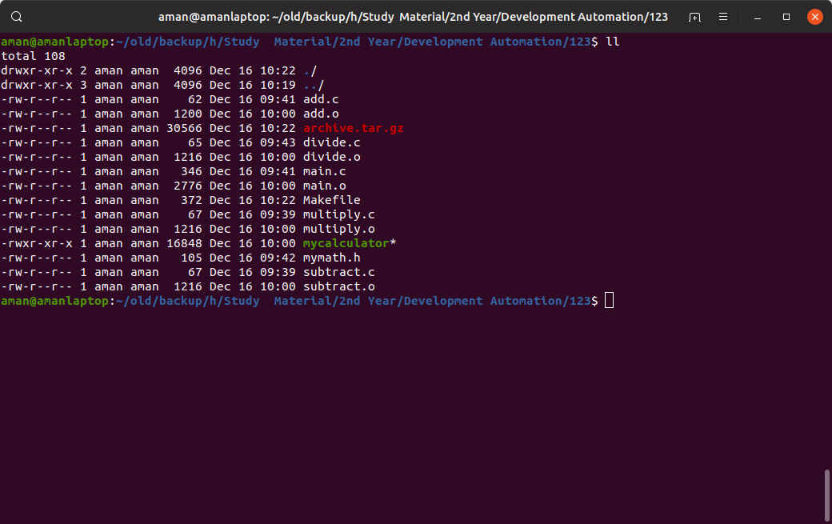

Conditionals in Make
Aim:
Using if else condition in Makefiles
Code:
DEBUG = False
SHELL = /bin/bash
CC = /usr/bin/gcc
OBJECTS = main.o add.o subtract.o multiply.o divide.o
ifeq ($(DEBUG),True)
CFLAG = -Wall -g
else
CFLAG =
endif
mycalculator: ${OBJECTS}
${CC} ${CFLAG} -o $@ ${OBJECTS}

%.o : %.c
${CC} ${CFLAG} -o $@ -c $<
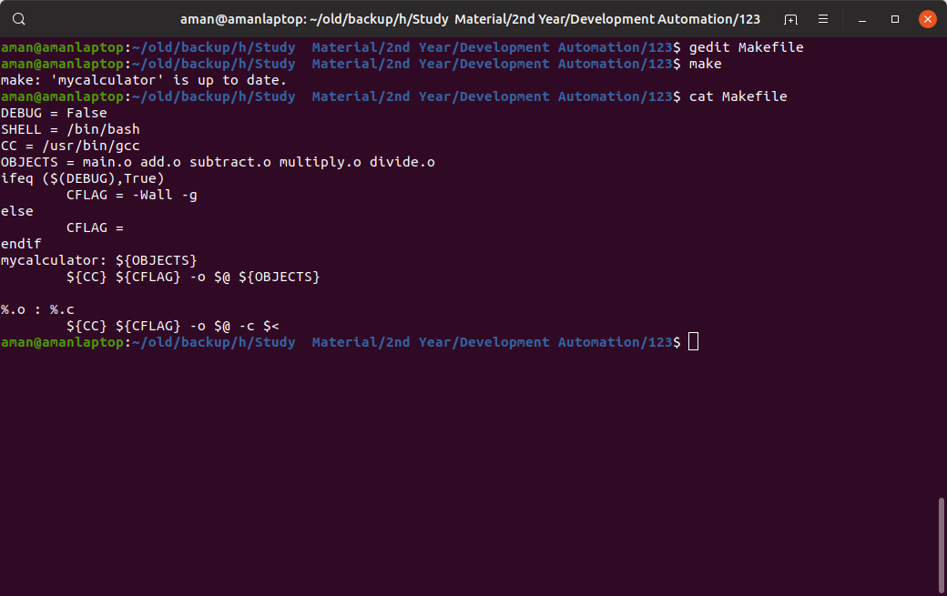
Output:

