

Mini Project Report

of

Database Systems Lab (CSE 2262)

TITLE

ART GALLERY MANAGEMENT

SUBMITTED

BY

Department of Computer Science and Engineering

**Manipal Institute of Technology, Manipal.**

**April 2024**



DEPARTMENT OF COMPUTER SCIENCE & ENGINEERING

Manipal

19/04/2024

CERTIFICATE

This is to certify that the project titled Art Gallery Database Management is a record of the Bonafide work done by Student(s) (Reg. No.) submitted in partial fulfilment of the requirements for the award of the Degree of Bachelor of Technology (B.Tech.) in COMPUTER SCIENCE & ENGINEERING of Manipal Institute of Technology, Manipal, Karnataka, (A Constituent Institute of Manipal Academy of Higher Education), during the academic year 2023-2024.

Name and Signature of Examiners:

1. Dr. Anup Bhat B, Assistant Professor, Dept. of CSE
2. Dr. Vijaya Arjunan, Additional Professor, Dept. of CSE
3. Dr. T Sujithra, Associate Professor, Dept. of CSE (A2 Batch)

4. Dr. Shwetha Rai, Assistant Professor-Senior Scale, Dept. of CSE (A1 Batch)

TABLE OF CONTENTS

ABSTRACT

**CHAPTER 1: INTRODUCTION**

**CHAPTER 2: PROBLEM STATEMENT & OBJECTIVES**

**CHAPTER 3: METHODOLOGY**

**CHAPTER 4: RESULTS & SNAPSHOTS**

**CHAPTER 5: CONCLUSION**

**CHAPTER 6: REFERENCES**

INTRODUCTION

A database is a modern information management system that provides the structured and organized repository for storing, managing, and retrieving data. In the terms of the Art Gallery Management system the Oracle Database acts as a central system that coordinates various activities, such as exhibition planning, artwork inventory management, customer relationship tracking, sales and other analysis.

We have used Oracle SQL as it is an RDBMS (Relational Database Management System). It is also scalable, reliable and has a robust platform for developing an integrated and efficient art gallery management system. The comprehensive database will not only streamline administrative tasks but also provide a foundation for sophisticated data analysis, enabling gallery managers to gain valuable insights into sales and trends.

In essence, “Art Gallery management system using Oracle Database” represents a leap towards modernization and efficiency in the management of art galleries. The project aims to elevate the operational capabilities of art galleries and enhance the overall functioning of the art gallery.

**PROBLEM STATEMENT & OBJECTIVES**

Art Galleries are essential cultural spaces for showcasing and preserving artistic works, requiring an efficient management system to handle different tasks effortlessly. The current art galleries have a manual process which leads to inefficiencies and hinders the optimal utilization of resources. To address these challenges, a solution is proposed that is the Art Gallery management System.

Art gallery Management plays a crucial role in organizing, managing, and preserving valuable arts and also facilitating sale and exhibition of them. In today’s era, there is a need for efficient and organized database systems to streamline the management of galleries, exhibitions, arts, artists, and sales. The project will facilitate the management of gallery details including information about the exhibitions going on, the artworks in the exhibition and for sale, as well as the artists and their artworks in the exhibition.

The database will track all the details of the sales of the artwork and the customers who have bought the artwork. It will help provide insights into sales and trends of the customers’ preferences, thereby will enhance the overall management of artworks in the gallery.

It will help maintain a centralized list of customers and their artwork purchases; the project also aims to ensure effective resource utilization. This will include tracking the investment that will be made by customers in artworks, hence helps in the smooth operation of the Art Gallery.

The objective of the Art Gallery Management Project using Oracle Database is to revolutionize the management of Art galleries from the old fashion manual way to a modern technological way. This not only reduces the manual work but also increases the efficiency and leads to smooth operation of the artwork gallery.

METHODOLOGY

E-R Diagram:

Converting the E-R Diagram to Schemas-

1. Identifying the Strong Entities-

ARTIST **(**ARTISTID, STYLE, BIRTHPLACE, FNAME, LNAME**)**

EXHIBITION **(**EID, ENDATE, STARTDATE**)**

GALLERY **(**GID, LOCATION, GNAME**)**

CUSTOMER(CUSTID, ARTID, FNAME1, LNAME1, DOB, ADDRESS, PHONE**)**

ARTWORK **(**ARTID, TITLE, PRICE, YEAR, ARTISTID, TYPE_OF_ART**)**

1. Identifying the Weak Entities-

No Weak entities present.

1. Identifying the Relationship sets-

EXHIBITS **(**EID, ARTISTID**)**

HAS **(**GID**,** ARTISTID**)**

CONDUCTS **(**GID, EID**)**

CONTAINS **(**GID, CUSTID**)**

BUYS **(**CUSTID, ARTID**)**

DISPLAYS (GID, ARTID)

EXPLORES (EID, ARTID)

1. Merging the relationship sets with entities-

Many to one relationship sets with total participation (HAS and EXHIBITS) is merged with the entity ARTIST which was the many-sided entity so now the new entity is-

**ARTIST (ARTISTID, STYLE, BIRTHPLACE, FNAME, LNAME, EID, GID)**

Many to one relationship sets with total participation (CONDUCTS) is merged with the entity EXHIBITION which was the many-sided entity so now the new entity is-

**EXHIBITION (EID, ENDATE, STARTDATE, GID)**

Many to one relationship sets with total participation (DISPLAYS and EXPLORES) is merged with the entity ARTWORK which was the many-sided entity so now the new entity is-

**ARTWORK (ARTID, TITLE, PRICE, YEAR, ARTISTID, TYPE_OF_ART, EID, GID)**

Many to one relationship sets with total participation (CONTAINS) is merged with the entity CUSTOMER which was the many-sided entity so now the new entity is-

**CUSTOMER (CUSTID, GID, FNAME1, LNAME1, DOB, ADDRESS, PHONE)**

1. Schema after Merging-

**ARTIST (ARTISTID, STYLE, BIRTHPLACE, FNAME, LNAME, EID, GID)**

**EXHIBITION (EID, ENDATE, STARTDATE, GID)**

**ARTWORK (ARTID, TITLE, PRICE, YEAR, ARTISTID, TYPE_OF_ART, EID, GID)**

**GALLERY (GID, LOCATION, GNAME)**

**CUSTOMER (CUSTID, GID, FNAME1, LNAME1, DOB, ADDRESS, PHONE)**

**BUYS (CUSTID, ARTID)**

**Schema Diagram-**

**Normalization-**

The **Gallery table** has following functional dependencies:

* GID -> Location, GName (GID uniquely determines the location and gallery name)

1NF satisfied: as no multivalued attributes.

2NF satisfied: as no partial dependency.

3NF satisfied: as no transitive dependency.

BCNF satisfied: as Candidate Key (GID) is on the left side of the functional dependency.

The **Exhibition table** has the following functional dependencies.

* EID-> EndDate, StartDate, GID (EID uniquely determines the start, end and GID)
* GID -> Location, GName (GID uniquely determines the location and gallery name)

1NF satisfied: as no multivalued attributes.

2NF satisfied: as no partial dependency.

3NF satisfied: as no transitive dependency.

BCNF satisfied: as Candidate Key (EID) is on the left side of the functional dependency.

The **Artist table** has the following functional dependencies.

* ARTISTID->Style, Birthplace,Fname,Lname,EID,GID
* EID-> EndDate, StartDate, GID
* GID -> Location, GName

1NF satisfied: as no multivalued attributes.

2NF satisfied: as no partial dependency.

3NF satisfied: as no transitive dependency.

BCNF satisfied: as Candidate Key (ARTISTID) is on the left side of the functional dependency and determines other attributes.

The **Artwork table** has the following functional dependencies.

* ARTID->Title,Price,year,ArtistID,Type_of_art,EID,GID
* ARTISTID->Style, Birthplace,Fname,Lname,EID,GID
* EID-> EndDate, StartDate, GID
* GID -> Location, GName

1NF satisfied: as no multivalued attributes.

2NF satisfied: as no partial dependency.

3NF satisfied: as no transitive dependency.

BCNF satisfied: as Candidate Key (ARTID) is on the left side of the functional dependency and determines other attributes.

The **Customer table** has the following functional dependencies.

* CUSTID->ARTID,Fname,Lname,DOB,Address,Phone,GID
* GID-> Location, GName

1NF satisfied: as no multivalued attributes.

2NF satisfied: as no partial dependency.

3NF satisfied: as no transitive dependency.

BCNF satisfied: as Candidate Key (CUSTID) is on the left side of the functional dependency.

The **Buys table** has the following functional dependencies.

* CUSTID, ARTID->Title,Price,Year,Type_of_art

1NF satisfied: as no multivalued attributes.

2NF satisfied: as no partial dependency.

3NF satisfied: as no transitive dependency.

BCNF satisfied: as Candidate Keys (CUSTID and ARTID) are on the left side of the functional dependency and determines all the attributes.

**RESULTS & SNAPSHOTS**

**Creating the tables-**

The commands to create all the tables in the database.

**PL/SQL COMMANDS-**

The procedure Search Artist helps the manager to search the details of an Artist and raises an exception if the artist does not exist in any of the galleries.

The procedure Search Artwork helps the manager to search the details of an Artwork and raises an exception if the artwork does not exist in any of the galleries.

The procedure Search Customer helps the manager to search the details of a customer and raises an exception if the Customer does not exist in any of the galleries.

This procedure, Artwork in Gallery gives us the details of all the Artworks that are present in a Gallery which is searched based on the Gallery ID.

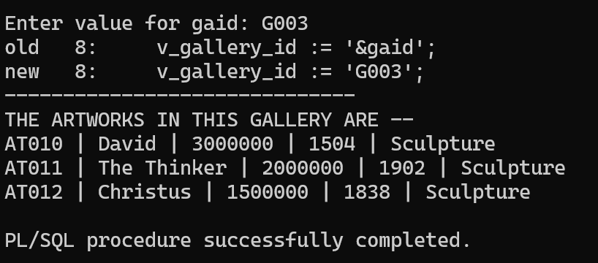

This procedure, Artwork in Exhibition gives us the details of all the Artworks that are present in an Exhibition which is searched based on the Exhibition ID.

This procedure, Artist in Gallery gives us the details of all the Artists that are associated with a Gallery which is searched based on the Gallery ID.

This procedure, Artist in Exhibition gives us the details of all the Artists that are associated with an Exhibition which is searched based on the Exhibition ID.

The procedure helps us find all the art which is sold by an artist using artistid.

A trigger is created to store the data of previous buyers in an history table who have resold the artwork to the gallery. This will be triggered by deletion in the Buys table.

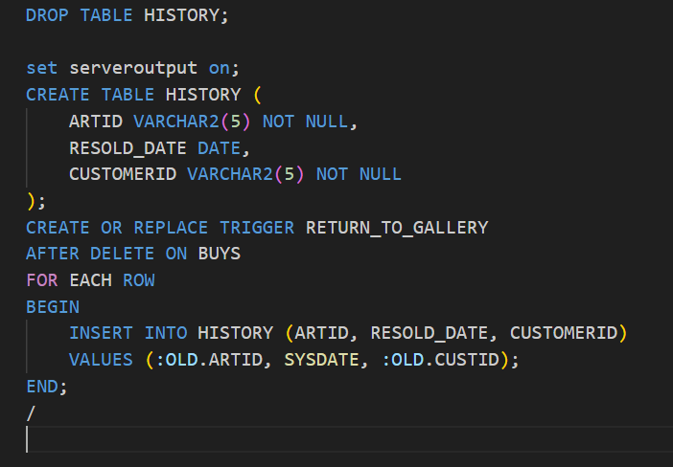

CONCLUSION

The Art Gallery Database Management Project, showcased above, embodies a sophisticated approach to manage art galleries effectively. By leveraging database technology into the project, it demonstrates a way to revolutionize the way art galleries operate and enhance overall efficiency. Through the integration of Oracle Database and the meticulous design showcased in the code repository, the project addresses the challenges faced by art galleries in managing artworks, tracking customers who have bought the artworks, and maintaining comprehensive records. This project not only enhances the administrative efficiency of art galleries but also paves the way for data-driven decision making, ultimately contributing to the success of art galleries in the Digital Age.

REFERENCES

<https://www.oracle.com/in/database/technologies/appdev/plsql.html>

<https://ijrpr.com/uploads/V4ISSUE5/IJRPR12884.pdf>

<https://docs.oracle.com/cd/F49540_01/DOC/server.815/a67772/create.html>

<https://docs.oracle.com/cd/B25329_01/doc/appdev.102/b25108/xedev_plsql.html>