CIRUS DEFENCE PRIVATE LIMITED



Paratrooper- Smoke Initiation Module (P-SIMTM)

TEAM PROJECT REPORT

Paratrooper- Smoke Initiation Module (P-SIMTM)

INTRODUCTION

Paratrooper - Smoke Initiation Module (P-SIM) is a modular, controlled initiation system designed for the automatic deployment of smoke bombs during camouflage or demonstration missions. The module is specifically designed for use in Combat Free Fall (CFF) and airborne demonstration jumps, the module can be leg-mounted, offering unmatched functionality and safety. As the first system of its kind globally, P-SIM is engineered with a strong focus on ergonomics and the unique safety requirements of skydivers. Its collapsible design shields the paratrooper from the high temperatures and heat generated during smoke bomb activation. Smoke deployment can be electronically initiated in multiple operational modes - Concurrent (simultaneous), Succession (sequential).

2. System Overview

The P-SIM (Paratrooper Smoke Initiation Module) is a modular, wireless-controlled smoke deployment system designed specifically for airborne defence operations, including Combat Free Fall (CFF) missions and demonstration jumps.
The system enables controlled, secure, and safe activation of smoke initiators mounted on a skydiver’s leg. It integrates wireless communication, safety interlocks, GNSS positioning, and long-range team coordination into a single integrated platform.

The P-SIM architecture consists of two primary subsystems:
- Remote Control Unit
- Leg-Mounted Initiation Module (LMU)
Both subsystems work together to ensure safe, authenticated, and mission-controlled smoke deployment.

2.1 System Purpose in Operational Context

During airborne operations, controlled smoke deployment is required for:
- Camouflage
- Visual signalling
- Tactical coordination
- Demonstration purposes
The P-SIM system provides a controlled ignition mechanism that ensures smoke activation occurs only after safety validation. The system prevents accidental deployment through multiple hardware and firmware safety layers.
The solution is specifically engineered for military skydivers operating in high-speed, high-altitude, and high-risk environments.

2.2 System Components
2.2.1 Remote Control Unit
The Remote Unit is the command interface of the system. It is built using:
- ESP32-S5 microcontroller
- 1.91-inch Wave share display
- Bluetooth Low Energy (BLE) interface
- GNSS module
- E-byte E22-900T33S LoRa module
- User input buttons (Fire, SOS, Role selection)
The Remote Unit performs the following functions:
- Sends fire commands via BLE
- Displays system status
- Monitors smoke channel status
- Transmits SOS alerts
- Shares GNSS position
- Broadcasts fire events (when in Team Leader mode)

2.2.2 Leg-Mounted Initiation Module (LMU)
The LMU is mounted on the user’s leg and directly controls the smoke initiators. It is built using:
- ESP32 microcontroller
- Three independent smoke initiator output channels
- Fire Safety Switch (hardware interlock)
- Manual Fire Switch
- BLE server interface

- Output driver circuitry
- Battery monitoring circuit
The LMU is responsible for:
- Receiving fire commands
- Validating safety conditions
- Activating smoke outputs
- Preventing unintended ignition
- Allowing manual activation (when safety conditions permit)

2.3 System Communication Architecture
The system uses two communication layers:
2.3.1 Short-Range Communication (Bluetooth)
Bluetooth Low Energy (BLE) is used for communication between the Remote Unit and the Leg-Mounted Module.

BLE is responsible for:
- Fire command transmission
- Acknowledgment handling
- Status synchronization
Smoke activation only occurs after BLE command validation and safety verification.

2.3.2 Long-Range Communication (LoRa)
The E-byte E22-900T33S LoRa module is used for team-level communication.
LoRa is responsible for:
- Fire event broadcasting
- SOS emergency alerts

- GNSS location sharing
- Team coordination
Role-based logic determines transmission behaviour.

2.4 Operational Workflow
The basic operational sequence is as follows:
- Remote establishes BLE connection with LMU.
- User selects operational mode (SEQ or CONC).
- Fire command is transmitted wirelessly.
- LMU verifies:
  - Safety switch status
  - Command validity
  - System health
- If all conditions are satisfied:
  - Smoke initiator(s) activated.
- Fire event is optionally broadcast via LoRa.
If the Safety Switch is ON, smoke activation is blocked regardless of command.

2.5 Safety Overview
The system integrates multiple safety layers:
- Hardware Fire Safety Switch
- Firmware command validation
- Manual fire protection
- Role-based authorization
- Communication timeout handling
- AES encryption for LoRa communication

The system is designed so that any failure results in a safe state (no ignition).
2.6 Key Features
The P-SIM (Paratrooper Smoke Initiation Module) system integrates multiple operational, safety, and communication features specifically designed for airborne defence missions. The following are the key features of the system:

1. Wireless Smoke Initiation
The system enables secure wireless smoke activation using Bluetooth Low Energy (BLE) communication between the Remote-Control Unit and the Leg-Mounted Module.
- Structured command-based activation
- Real-time acknowledgment handling
- Reliable short-range communication

2. Dual Smoke Initiator Channels
The Leg-Mounted Module supports Two independent smoke initiator outputs.
- Sequential activation mode
- Concurrent activation mode
This allows flexible smoke deployment based on mission requirements.

3. Hardware Fire Safety Switch
A dedicated physical safety switch is integrated into the Leg-Mounted Module.
- Blocks ignition when engaged
- Overrides remote commands
- Prevents accidental activation
- Independent of firmware state
This provides a primary hardware-level safety interlock.

4. Manual Fire Capability
The Leg-Mounted Module includes a manual fire switch.
- Long-press validation
- Debounce filtering
- Subject to safety switch status
This ensures redundancy in case of remote unavailability.

5. Sequential and Concurrent Modes
The system supports two firing modes:
- Sequential Mode (SEQ): Smoke channels activate incrementally.
- Concurrent Mode (CONC): All smoke channels activate simultaneously.
This provides operational flexibility during missions.

6. Role-Based Control (Team Leader / Team Member)
The Remote Unit allows configuration as:
- Team Leader (TL)
- Team Member (TM)
When configured as Team Leader:
- Fire events are broadcast to team members.
- GNSS data can be transmitted.
This enhances coordinated airborne deployment.

7. Long-Range LoRa Communication
The system integrates the E-byte E22-900T33S LoRa module for extended-range communication.
- Fire event broadcasting
- SOS transmission
- GNSS location sharing
- Team network communication
This ensures coordination beyond Bluetooth range.

8. GNSS Integration
The Remote Unit includes GNSS functionality for:
- Real-time latitude and longitude tracking
- Altitude measurement
- Speed monitoring
- Timestamp logging
GNSS data is used for operational awareness and emergency signalling.

9. SOS Emergency Function
The system supports emergency SOS transmission.
- Manual SOS activation
- GNSS location included in message
- LoRa broadcast to team network
- Encrypted communication
This improves safety during mission-critical scenarios.

10. AES-Encrypted LoRa Communication
LoRa messages are protected using AES-128 encryption.
- Prevents unauthorized interception
- Secures fire event transmission
- Protects GNSS location data
This enhances communication security in defence environments.

11. Multi-Layer Safety Architecture
The system incorporates:
- Hardware safety interlock
- Firmware command validation
- Role-based authorization
- Communication timeout handling
- Acknowledgment verification
Activation occurs only after all safety conditions are validated.

12. Battery Monitoring
Both Remote and Leg-Mounted Units include battery monitoring capability.
- ADC-based voltage measurement
- Status indication
- Low-voltage awareness
This prevents unreliable operation due to insufficient power.

13. Ergonomic Leg-Mounted Design
The Leg-Mounted Module is designed for:
- Secure attachment
- Balanced weight distribution
- Minimal interference with parachute gear
- Ease of access to controls
This ensures operational comfort during Combat Free Fall.

14. Fail-Safe Default Behaviour
The system is designed to default to a safe state under abnormal conditions.
- Communication failure → No ignition
- Safety switch engaged → No ignition
- Invalid command → No ignition
- Firmware error → No ignition
This minimizes risk during airborne operations.

2.7 System Advantages
The P-SIM system offers the following operational advantages:
- Reduced risk of accidental activation
- Improved team coordination
- Secure wireless command control

- Real-time location awareness
- Lightweight and ergonomic configuration
- Modular and scalable architecture
The system represents a first-of-its-kind integrated smoke initiation solution tailored specifically for airborne defence operations.

FLOW DIAGRAM OF PSIM REMOTE & LEGMOUNT

Part 1
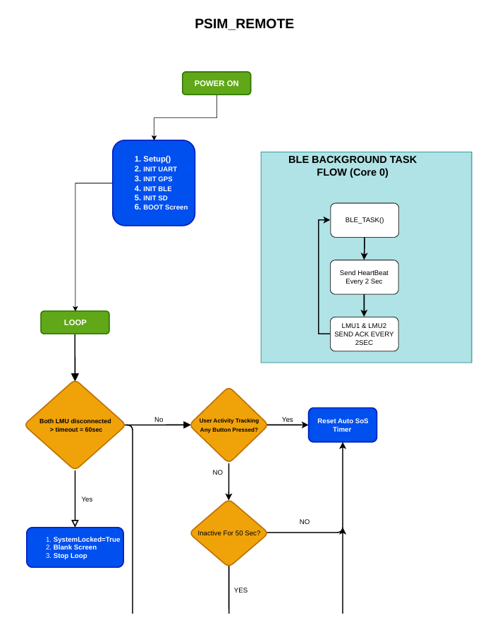

1️⃣ Power On
- The system is powered on.
- Initialization begins.

2️⃣ Setup Phase
The system runs the Setup () procedure with the following steps:
- INIT UART – Initializes the UART communication for serial data exchange.
- INIT GPS – Initializes the GPS module to acquire location data.
- INIT BLE – Sets up Bluetooth Low Energy (BLE) functionality.
- INIT SD – Initializes the SD card for storing logs or data.
- BOOT Screen – Displays the boot screen on the onboard display.
After setup, the system moves into the main loop.

3️⃣ Main Loop
The loop continuously monitors system states and user activity.
3.1 BLE Background Task (Core 0)
- Runs independently on Core 0 of ESP32-S3.
- Function: BLE_TASK ()
  - Sends a heartbeat every 2 seconds to connected LMUs.
  - Receives acknowledgment from LMU1 & LMU2 every 2 seconds.
- This ensures continuous communication with LMU devices in the background.

3.2 Main Loop Logic
Within the loop, the system checks:
Step 1: Both LMUs Disconnected?
- If both LMU1 and LMU2 are disconnected for more than 60 seconds:
  - Set System Locked = True
  - Display Blank Screen
  - Stop Loop – System stops further operations until reset.
- If LMUs are connected, move to the next check.

Step 2: User Activity Tracking
- Check if any button is pressed by the user.
- If Yes → Reset Auto SOS Timer.
  - This ensures the SOS timer does not trigger unnecessarily while the user is active.
- If no → check user inactivity.

Step 3: Inactive for 50 Seconds?
- If no activity detected for 50 seconds:
  - Reset Auto SOS Timer.
  - (This likely prevents false SOS signals due to inactivity.)
- If activity detected → loop continues monitoring.

Part 2
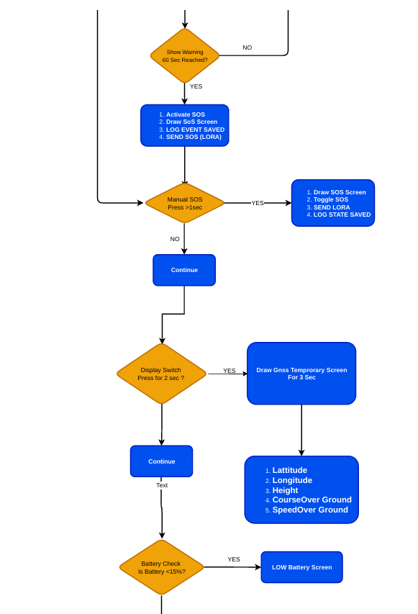

1️⃣ Show Warning – 60 Seconds Reached?
- The system checks if a warning timer has reached 60 seconds.
- If NO: continue normal operation.
- If YES: proceed to activate SOS procedures.

2️⃣ Activate SOS
When the 60-second warning is reached:
- Activate SOS – System triggers the SOS mode automatically.
- Draw SOS Screen – Display the SOS interface on the screen.
- Log Event Saved – Save the SOS event in the system log.
- Send SOS (LoRa) – Transmit SOS signal via LoRa communication module.

3️⃣ Manual SOS Button Press (>1 sec)
- The system checks if the user manually presses the SOS button for more than 1 second.
- If YES:
  - Draw SOS screen
  - Toggle SOS state (turn it on or off)
  - Send SOS via LoRa
  - Save SOS state in log
- If NO: system continues normal operation.

4️⃣ Display Switch Press for 2 sec
- The system checks if the Display Switch button is pressed for 2 seconds.
- If YES:
  - Draw a GNSS temporary screen for 3 seconds showing navigation info.
  - Display the following GNSS data:
    - Latitude
    - Longitude
    - Height (altitude)
    - Course Over Ground (COG)
    - Speed Over Ground (SOG)
- If NO: continue normal operation.

5️⃣ Battery Check
- System monitors the battery level.
- Checks if battery is less than 15%.
- If YES: display Low Battery Screen to alert the user.
- If NO: continue normal operation.

Part 3
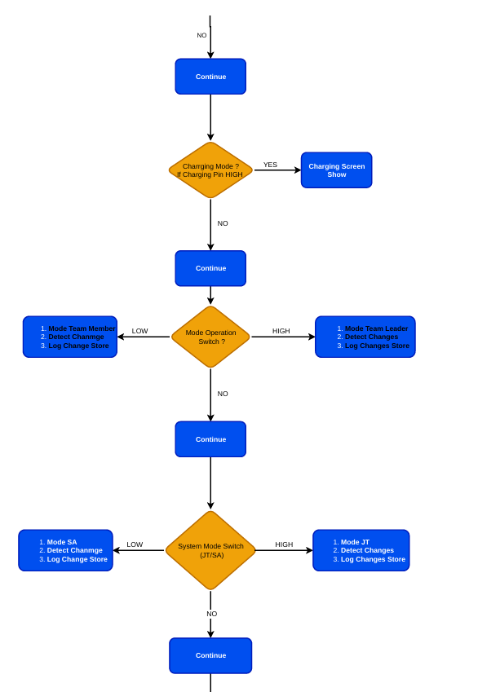

1️⃣ Charging Mode Detection
- The system first checks whether the device is in charging mode.
- It reads the Charging Pin status.
- If Charging Pin = HIGH (YES):
• Charging Screen Show – The system displays the charging screen.
• Operational functions are paused.
• No mission-related processing occurs during charging.
- If Charging Pin = LOW (NO):
• The system continues normal operational flow.
This ensures that no operational commands are processed while the device is charging.

2️⃣ Mode Operation Switch (Team Role Selection)
- The system checks the Mode Operation Switch.
- This determines whether the device operates as:
• Team Member (LOW)
• Team Leader (HIGH)
- If Switch = LOW (Team Member Mode)
• Mode set to Team Member
• Detect Change – The system checks if the role has changed from previous state.
• Log Change Store – The role change is saved in system memory for logging and traceability.
In Team Member mode:
• Limited transmission capability
• Does not broadcast primary fire commands

If Switch = HIGH (Team Leader Mode)
• Mode set to Team Leader
• Detect Changes – System verifies role transition.
• Log Changes Store – Role update is saved to log.
In Team Leader mode:
• Fire events can be broadcast
• GNSS data transmission enabled
• Team coordination authority enabled

3️⃣ System Mode Switch (JT / SA)
- The system then checks the secondary System Mode Switch.
- This determines operational configuration:
• LOW → Mode SA
• HIGH → Mode JT

- If Switch = LOW (SA Mode)
• Mode SA activated
• Detect Change
• Log Change Store

- If Switch = HIGH (JT Mode)
• Mode JT activated
• Detect Changes
• Log Changes Store

4️⃣ Continue Normal Execution
- After evaluating:
• Charging Mode
• Team Role Mode
• System Mode (JT/SA)
The system continues normal program execution.

Part 4
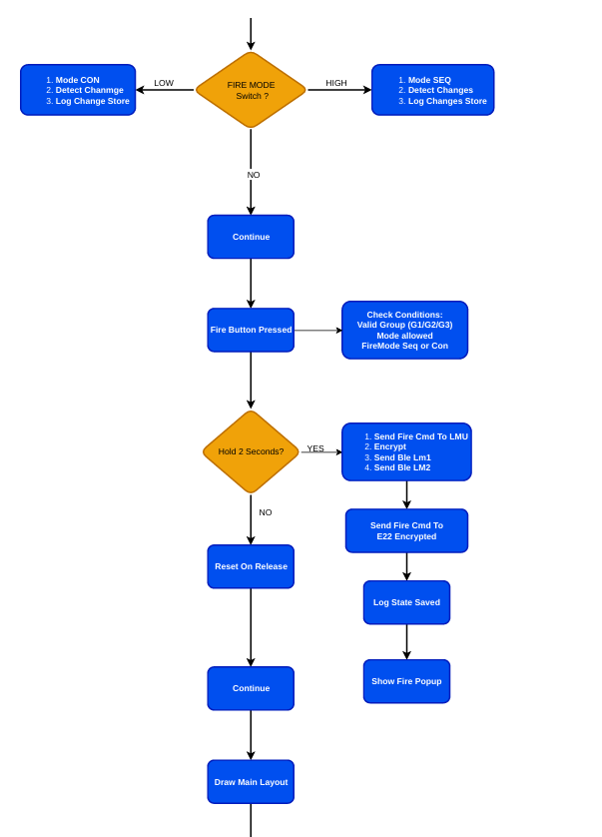

1️⃣ Fire Mode Selection
- The system first checks the FIRE MODE Switch.
- This determines the firing behaviour:
• LOW → Mode CON (Concurrent Mode)
• HIGH → Mode SEQ (Sequential Mode)

- If Switch = LOW (Concurrent Mode)
• Mode set to CON
• Detect Change – System verifies if mode changed
• Log Change Store – Mode change saved in memory
In Concurrent Mode:
• All selected smoke channels activate simultaneously.

- If Switch = HIGH (Sequential Mode)
• Mode set to SEQ
• Detect Changes
• Log Changes Store
- In Sequential Mode:
• Smoke channels activate incrementally (1 → 2 → 3).

2️⃣ Fire Button Press Detection
- The system continuously monitors the Fire Button.
- When the Fire Button is pressed:
• Proceed to condition validation stage.

3️⃣ Condition Verification Before Firing
Before any fire command is executed, the system checks:
- Valid Group Selected (G1 / G2 / G3)
- Mode Allowed (JT / SA restrictions if any)
- Fire Mode Selected (SEQ or CON)
If any condition fails:
- Fire command is not executed.
If conditions are valid:
- Proceed to long-press validation.

4️⃣ Hold 2 Seconds Validation
- The system checks if the Fire Button is held for 2 seconds.
This prevents accidental activation.

If YES (Button Held ≥ 2 Seconds)
The system performs the following sequence:
- Send Fire Command to LMU
- Encrypt Command
- Send BLE Command to LMU1
- Send BLE Command to LMU2

After BLE transmission:
- Send Fire Command via E22 (LoRa) – Encrypted
- Log State Saved – Fire event stored in system log
- Show Fire Popup – Visual confirmation displayed on screen
- This ensures:
• Fire command is executed
• Team network is informed
• Event is recorded
• User receives feedback

If NO (Button Released Before 2 Seconds)
• Reset on Release – Button state cleared
• No fire command executed
• Continue normal operation
This prevents accidental short presses from triggering ignition.

5️⃣ Post-Fire Flow
After processing:
- Continue normal execution
- Draw Main Layout – Refresh main screen interface
- System returns to monitoring state.

Part 5
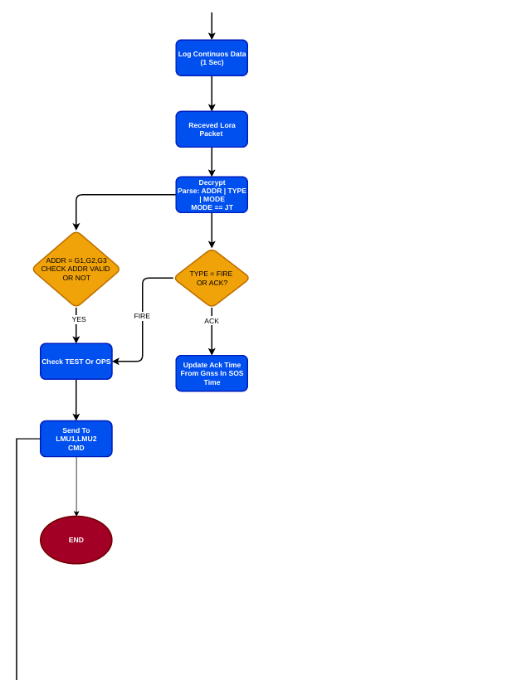

1️⃣ Continuous Data Logging (1 Second Interval)
¬ The system continuously logs operational data at a 1-second interval.
¬ This may include:
• GNSS data
• System state
• Communication status
• Mode information
This ensures traceability and mission data recording.

2️⃣ Receive LoRa Packet
¬ The system monitors the LoRa communication module (E22).
¬ When a LoRa packet is received:
• The packet is passed to the processing stage.

3️⃣ Decrypt and Parse Packet
¬ The received packet is decrypted using AES.
¬ After decryption, the system parses:
• ADDR (Address – G1, G2, G3)
• TYPE (FIRE or ACK)
• MODE (Example: JT mode)
This ensures structured and validated communication handling.

4️⃣ Address Validation
¬ The system checks whether the ADDR field matches:
• G1
• G2
• G3
¬ If the address is NOT valid:
• Packet is ignored
• No action is taken
¬ If the address is valid:
• Proceed to next validation stage
This prevents unintended command execution for wrong groups.

5️⃣ Check Packet Type (FIRE or ACK)
¬ The system checks the TYPE field.

If TYPE = FIRE
• Proceed to fire command handling
• Validate TEST or OPS mode

Check TEST or OPS Mode
¬ The system verifies whether the packet is:
• TEST mode (non-operational test)
• OPS mode (operational firing)
After validation:
¬ Send Command to LMU1 and LMU2
This ensures:
• Correct smoke activation mode
• Multi-LMU synchronization
After command transmission:
• Process ends

If TYPE = ACK
¬ Update Acknowledgment Time
• Update ACK time using GNSS timestamp
• Used in SOS timing logic
• Used for communication confirmation
No fire action is executed for ACK packets.

6️⃣ End of Processing
After handling either:
• FIRE command
• ACK update
The system returns to monitoring state.

Part 6
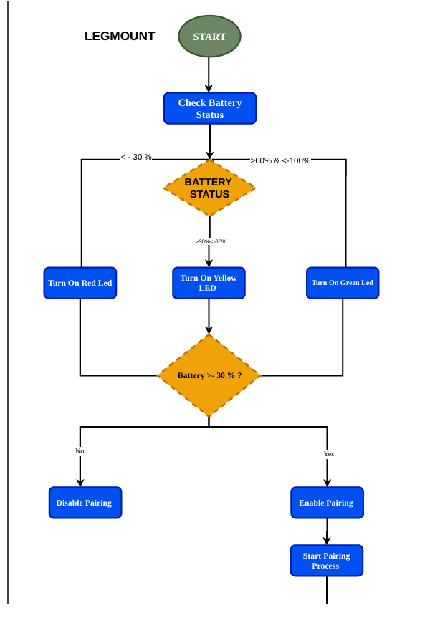

1️⃣ System Start
¬ The Leg-Mounted Unit (LMU) powers ON.
¬ The firmware begins initialization.
¬ The first operational step is battery verification.

2️⃣ Check Battery Status
¬ The system reads battery voltage using ADC.
¬ Battery percentage is calculated.
¬ The battery level is categorized into three ranges:
• Less than 30%
• Between 30% and 60%
• Greater than 60%

3️⃣ Battery Status Indication (LED Logic)
Based on battery percentage:

🔴 If Battery < 30%
• Turn ON Red LED
• Indicates Low Battery Condition
This signals insufficient power for reliable operation.

🟡 If Battery Between 30% and 60%
• Turn ON Yellow LED
• Indicates Medium Battery Level
System can operate but battery is not fully charged.

🟢 If Battery > 60%
• Turn ON Green LED
• Indicates Healthy Battery Level
System is fully operational.

4️⃣ Battery Threshold Validation (Battery > 30%?)
After LED indication, the system checks:
¬ Is Battery greater than 30%?

If NO (Battery ≤ 30%)
• Disable Pairing
• Bluetooth pairing is blocked
• System avoids entering active communication state
This prevents unreliable operation due to low battery.

If YES (Battery > 30%)
• Enable Pairing
• Allow Bluetooth pairing
• Start Pairing Process
The LMU becomes available for connection with the Remote Unit.

Part 7
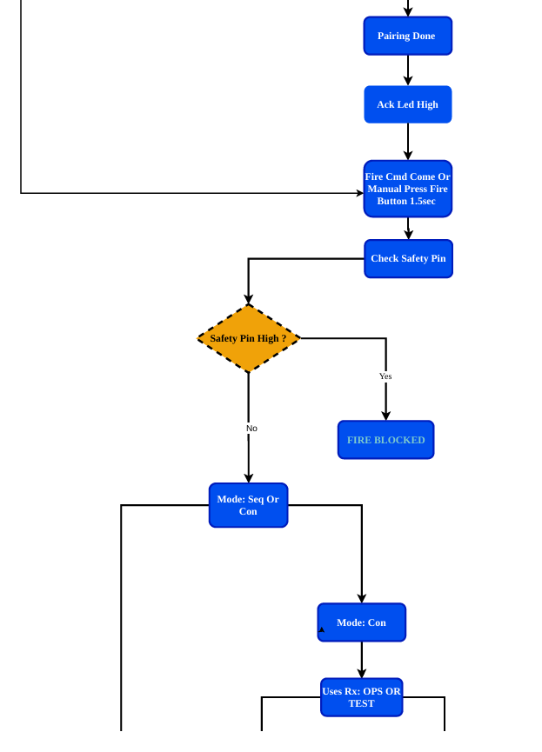

1️⃣ Pairing Completion

¬ After successful Bluetooth pairing:

• Pairing Done – Connection established with Remote Unit.
• ACK LED High – Acknowledgment LED is turned ON to indicate active connection.

The LMU is now ready to receive commands.

2️⃣ Fire Command Detection

¬ The LMU waits for one of the following events:

• Fire Command received via BLE
OR
• Manual Fire Button pressed for more than 1.5 seconds

This ensures both remote and manual firing capabilities are supported.

3️⃣ Check Safety Pin

¬ Before executing any fire command, the system checks the Safety Pin status.

This is a hardware-level safety validation.

Decision: Safety Pin High?

If YES (Safety Pin = HIGH)

• FIRE BLOCKED
• No ignition occurs
• Command is ignored
• System returns to monitoring state

This ensures that the physical safety interlock overrides all commands.

If NO (Safety Pin = LOW)

• System proceeds to mode validation
• Fire execution is allowed

4️⃣ Determine Fire Mode (SEQ or CON)

After safety validation, the system checks the configured fire mode:

• Sequential Mode (SEQ)
• Concurrent Mode (CON)

If Mode = CON (Concurrent Mode)

• All configured smoke channels are activated simultaneously
• Mode uses received command parameter: OPS or TEST

If Mode = SEQ (Sequential Mode)

• Smoke channels are activated incrementally
• Each fire command increases sequence count
• Mode respects TEST or OPS configuration

5️⃣ Operational Mode (OPS or TEST)

The system uses the received RX parameter:

• OPS Mode → Operational ignition (actual smoke deployment)
• TEST Mode → Test activation without full operational effect

This allows controlled testing without real deployment.

Part 8
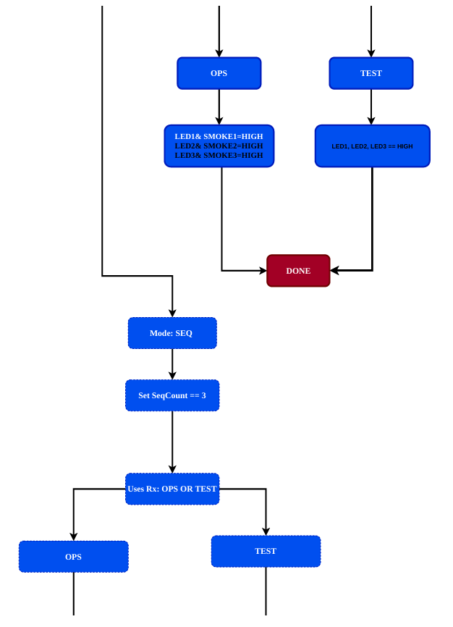

1️⃣ Concurrent Mode (CON)
In Concurrent Mode, all selected smoke channels are activated simultaneously.
After mode selection, the system checks the received RX parameter:
• OPS
• TEST

🔹 If Mode = CON and RX = OPS
The system performs:
• LED1 & SMOKE1 = HIGH
• LED2 & SMOKE2 = HIGH
• LED3 & SMOKE3 = HIGH
This means:
• All three smoke initiators are activated.
• Corresponding LEDs indicate active status.
• Full operational deployment occurs.
After execution:
• Process ends (DONE).

🔹 If Mode = CON and RX = TEST
The system performs:
• LED1 = HIGH
• LED2 = HIGH
• LED3 = HIGH
Smoke outputs are NOT activated.
This allows:
• System testing
• Visual verification
• No actual smoke ignition
After execution:
• Process ends (DONE).

2️⃣ Sequential Mode (SEQ)
In Sequential Mode, smoke channels activate incrementally.

🔹 Step 1: Mode = SEQ
• Sequential mode selected.

🔹 Step 2: Set SeqCount == 3
This indicates:
• Maximum sequence count = 3
• Supports G1 → G2 → G3 progression
Each fire command increases sequence level.

🔹 Step 3: Check RX (OPS or TEST)
System validates whether the received command is:
• OPS
• TEST

If RX = OPS
• Smoke channel activated based on sequence count
• Example:
- Seq 1 → SMOKE1
- Seq 2 → SMOKE1 + SMOKE2
- Seq 3 → SMOKE1 + SMOKE2 + SMOKE3
Operational smoke deployment occurs.

If RX = TEST
• Only LEDs are activated
• Smoke outputs remain OFF
Used for validation without actual ignition.

Part 9
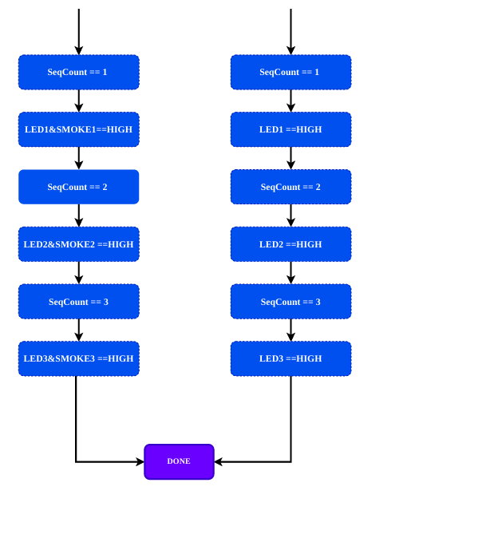

1️⃣ Sequential Mode – OPS (Operational Mode)
In OPS mode, both the LED indicator and the corresponding smoke output are activated.
The system uses a variable called SeqCount to determine which stage of firing is active.

🔹 Stage 1 – SeqCount == 1
• LED1 = HIGH
• SMOKE1 = HIGH
This activates Smoke Channel 1.

🔹 Stage 2 – SeqCount == 2
• LED2 = HIGH
• SMOKE2 = HIGH
Smoke Channel 2 is activated.

🔹 Stage 3 – SeqCount == 3
• LED3 = HIGH
• SMOKE3 = HIGH
Smoke Channel 3 is activated.

After SeqCount reaches 3:
• Process ends (DONE)
• No further increment allowed
• System returns to monitoring state
This ensures a controlled and stepwise ignition sequence.

2️⃣ Sequential Mode – TEST Mode
In TEST mode, only LEDs are activated.
Smoke outputs remain OFF.
This allows safe validation without actual smoke deployment.

🔹 Stage 1 – SeqCount == 1
• LED1 = HIGH
• SMOKE1 remains OFF

🔹 Stage 2 – SeqCount == 2
• LED2 = HIGH
• SMOKE2 remains OFF

🔹 Stage 3 – SeqCount == 3
• LED3 = HIGH
• SMOKE3 remains OFF

After SeqCount reaches 3:
• Process ends (DONE)
• No ignition occurs

Key Operational Difference
Mode | LED Activation | Smoke Activation
OPS | Yes | Yes
TEST | Yes | No

CIRCUIT DESIGN OF REMOTE AND LEGMOUNT

Remote Schematic

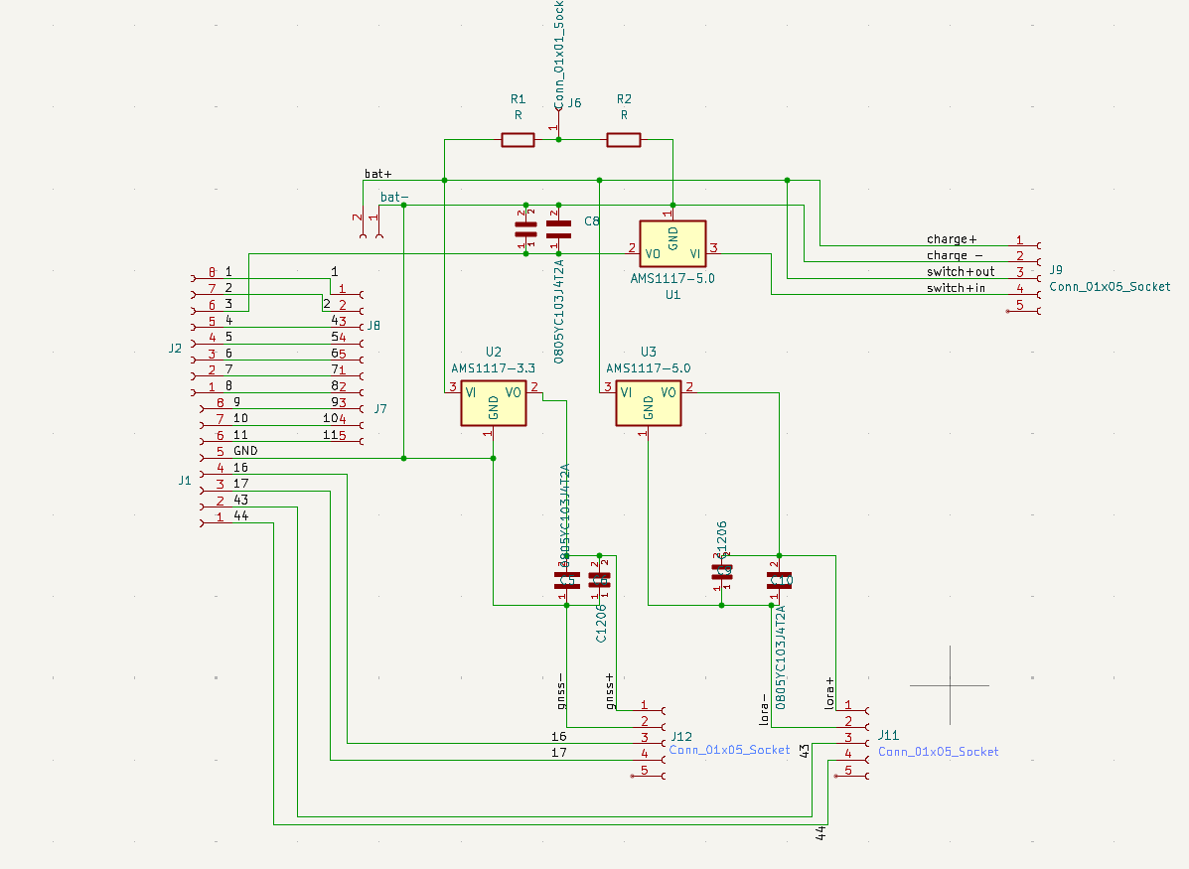

Circuit Description

Input and Output Capacitor Configuration for Voltage Regulator

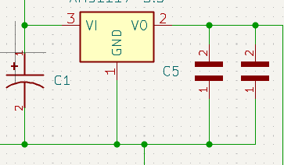

The design utilizes three voltage regulators (VRs), each configured with identical input and output capacitor networks to ensure consistent performance and stability.

Each regulator includes:
- 10µF tantalum capacitor at VIN (input ripple suppression and transient absorption)
- 22µF tantalum capacitor at VOUT (bulk output stabilization)
- 0.1µF ceramic capacitor at VOUT (high-frequency noise filtering)

The regulators are dedicated to individual subsystems:
- Regulator 1 → MCU supply
- Regulator 2 → GNSS module supply
- Regulator 3 → LoRa module supply
This separation improves power integrity, reduces noise coupling between subsystems, and enhances overall system reliability and performance.

GNSS Module for Position Data Transmission

The GNSS module is used to determine the device’s real-time geographic location. It receives signals from multiple satellites and calculates the current latitude and longitude coordinates.
The obtained position data is processed by the MCU and transmitted through the communication interface (e.g., LoRa) for remote monitoring and tracking applications.
This enables accurate location tracking, navigation support, and real-time position reporting of the system.

Battery Voltage Measurement Using Voltage Divider Circuit

To measure the 8.4V battery voltage using a 3.3V MCU ADC input, a voltage divider circuit is implemented to scale the voltage within the ADC input range.
Voltage Divider Design
Since the MCU ADC maximum input voltage is 3.3V, the 8.4V battery voltage must be reduced to a safe measurable level.

Voltage Divider Formula:
$$V_{out}=V_{in}×\frac{R2}{R1+R2}$$
Where:
- Vin = 8.4V (maximum battery voltage)
- V-out ≤ 3.3V (ADC limit)

Recommended Resistor Values
Example design:
- R1 = 100kΩ
- R2 = 47kΩ
Calculation:
$V_{out}=8.4V×\frac{47k}{100k+47k}$
$$V_{out}≈2.68V$$

This keeps the ADC input safely below 3.3V.

Purpose of Voltage Divider
The resistor divider:
- Scales 8.4V battery voltage to ADC-safe level
- Allows real-time battery monitoring

LoRa Communication for Remote Command – Smoke Initiation

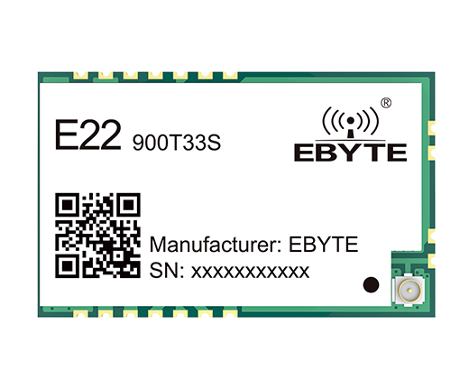

The E22-900T LoRa module is also used to receive remote control commands from the monitoring station.
In addition to transmitting GNSS latitude and longitude data, the module enables bidirectional communication. A specific command packet can be sent from the remote station to initiate the smoke mechanism.
Upon receiving the valid command via UART, the MCU verifies the data and activates the designated output pin to trigger the smoke system.
This functionality enables secure remote activation and monitoring, ensuring controlled operation of the smoke mechanism through long-range wireless communication.

ESP32-S3 1.9inch LCD Display Development Board

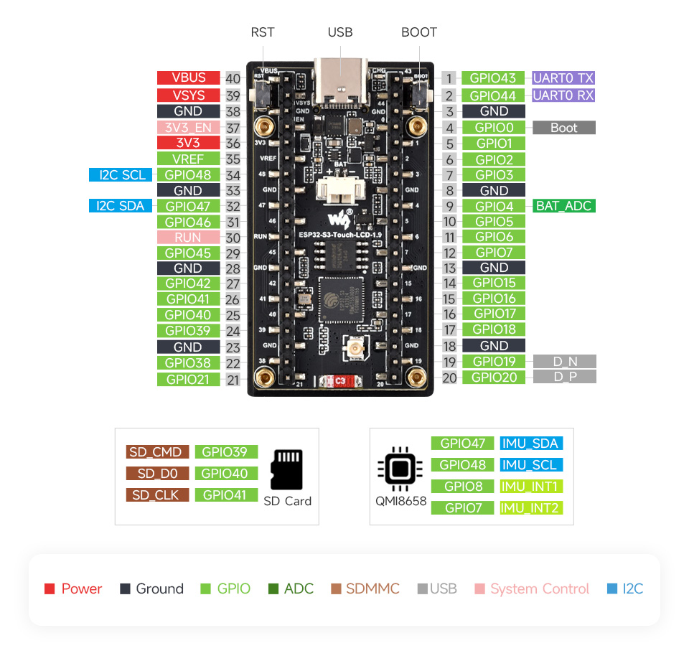

Key Features – ESP32-S3 Development Board
- High-performance Xtensa 32-bit LX7 dual-core processor, up to 240 MHz
- 2.4GHz Wi-Fi (802.11 b/g/n) and Bluetooth 5 (LE) with onboard antenna
- 512 KB SRAM and 384 KB ROM, with 16 MB Flash and 8 MB PSRAM
- 1.9-inch LCD display, 170 × 320 resolution, 262K colours, supports GUI libraries (e.g., LVGL)
- QMI8658 6-axis IMU (3-axis accelerometer + 3-axis gyroscope) for motion detection
- USB Type-C port for power, programming, and debugging
- 3.7V Lithium battery header for onboard battery connection and charging
- TF card slot for external storage of files and images
- Pico-compatible header with multiple peripheral interfaces for easy expansion
- Suitable for quick development of HMI and ESP32-S3 applications

Rotary Switch for LoRa Channel Selection

A 3-position rotary switch is used to manually select the communication channel of the LoRa module.
The rotary switch provides three discrete input states to the MCU. Based on the selected position, the MCU configures the LoRa module to operate on the corresponding predefined frequency channel.
Working Principle:
- Each switch position connects a specific GPIO input to GND or VCC.
- The MCU reads the switch state during startup (or continuously).

- According to the detected position, the MCU sets the LoRa module to:
  - Channel 1
  - Channel 2
  - Channel 3

Purpose:
- Allows manual frequency/channel selection
- Prevents interference between multiple systems
- Enables flexible field configuration without firmware changes
This design provides simple, reliable, and user-friendly channel selection for the LoRa communication system.

Stealth Switch for GNSS Control

A stealth switch is incorporated to enable or disable the GNSS module manually.
Working Principle:
- The switch is connected to a designated MCU input pin.
- ON position: MCU powers the GNSS module, allowing it to acquire and transmit location data.
- OFF position: MCU cuts power or disables GNSS, stopping location updates.
Purpose:
- Provides manual control over GNSS operation
- Enhances privacy and security by temporarily disabling location tracking
- Helps conserve power when GNSS functionality is not needed

This allows the user to control the GNSS module discreetly without affecting the operation of other subsystems.

Fire Switch – Mode-Dependent Smoke Command Activation
Component: Momentary Push Button
Function: Initiates smoke command with behaviour depending on system mode.
Modes
- TL (Transmitter + LoRa) Mode
  - Fire switch press triggers both communication channels:
    - E22 LoRa module → sends smoke command bytes
    - BLE → sends smoke command to leg mount

- TM (Transmitter + Mobile) Mode
  - Fire switch press triggers only BLE communication:
    - E22 LoRa module is inactive
    - BLE → sends smoke command to leg mount

Operation Description
- The fire switch is a momentary push button.
- The system measures the press duration and triggers the smoke command only if pressed for ≥1.5 seconds.

- The mode determines which communication channels are active when the switch is pressed.

Technical Details
- Button Type: Normally Open (Momentary)
- Press Duration Required: ≥1.5 seconds
- MCU Pin Configuration:
  - BUTTON_PIN: Digital input with pull-up resistor
  - E22_TX / RX: UART2 connection to LoRa module
- Command Message: "SMOKE"
- Communication Interfaces:
  - TL Mode: E22 LoRa + BLE notification
  - TM Mode: BLE notification only

Leg Mount Schematic

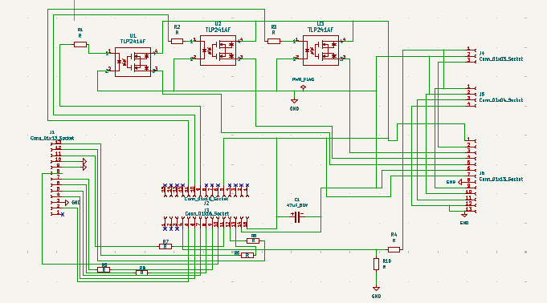

Circuit Description

1. Overview
The circuit consists of an ESP32 microcontroller, multiple TLP241A solid-state relays (Photo MOS type), five current-limiting resistors, two resistors configured as a voltage divider network, and decoupling capacitors for power stabilization.
The system is designed to provide isolated switching of external loads while ensuring proper signal conditioning and protection of the microcontroller.

2. Current-Limiting Resistors (Three Units)
Three resistors are implemented as current-limiting resistors on the input side of the TLP241A devices.

2.1 Purpose
Each resistor performs the following functions:
- Limits current flowing from the ESP32 GPIO pin to the internal LED of the TLP241A.
- Protects the ESP32 output driver from overcurrent conditions.
- Ensures the LED inside the TLP241A operates within its recommended forward current range.
- Provides stable and predictable switching performance.

2.2 Operating Principle
When the ESP32 GPIO output is set HIGH (3.3 V logic):
- Current flows through the current-limiting resistor.
- The internal LED of the TLP241A is forward biased.
The Photo MOS output stage activates, turning ON the internal MOSFET switch.
When the GPIO is LOW:
- No current flows through the LED.
- The PhotoMOS output remains OFF.
- The connected load is disconnected.
The resistor value is selected based on:
$$R=\frac{V_{GPIO}-V_{F}}{I_{LED}}$$
Where:
- $V_{GPIO}$= 3.3 V (ESP32 logic level)
- $V_{F}$= Forward voltage of TLP241A LED
- $I_{LED}$= Desired LED forward current
3. Voltage Divider Network (Two Resistors)
Two resistors are configured as a voltage divider circuit.
3.1 Purpose
The voltage divider is used to:
- Scale down a higher input voltage to a safe level.
- Provide a measurable voltage compatible with the ESP32 ADC input.
- Protect the microcontroller from overvoltage conditions.
3.2 Operating Principle
The output voltage of the divider is determined by:
$$V_{out}=V_{in}×\frac{R_{2}}{R_{1}+R_{2}}$$
Where:
- $V_{in}$= Input voltage
- $R_{1}$= Upper resistor
- $R_{2}$= Lower resistor
- $V_{out}$= Reduced voltage applied to ESP32
The resistor values are selected such that:
- $V_{out}$does not exceed 3.3 V (maximum ADC input level of ESP32).
- The divider does not draw excessive current.
- Measurement accuracy remains acceptable.

4. Capacitors
Capacitors are included for:
- Power supply filtering.
- Decoupling of the ESP32 supply rails.
- Noise suppression and transient stabilization.
Proper placement near the microcontroller power pins ensures stable operation during switching events.

5. System Functionality Summary
- The ESP32 generates control signals.
- Five current-limiting resistors regulate LED drive current for TLP241A inputs.
- The TLP241A devices provide optically isolated load switching.
- Two resistors form a voltage divider to scale input voltage safely for measurement.

- Capacitors stabilize the power supply and improve system reliability.
This architecture ensures electrical isolation, microcontroller protection, and controlled switching of external loads in a stable and safe manner.

SYSTEM INVENTORY

Item ID | Item Name | Quantity | Unit Price (₹) | Total Value (₹)
1 | 7.4V 2S 4A BMS Board | 4 | 34 | 136
2 | 1S 3A BMS Module | 15 | 19 | 285
3 | TP5100 Charging Module | 4 | 47 | 188
4 | Psim Remote PCB | 1 | 1600 | 1600
5 | Psim LegMount PCB | 1 | 1000 | 1000
6 | JST-SH 5Pin Socket | 30 | 19 | 570
7 | JST-SH 5Pin Female Housing | 30 | 20 | 600
8 | JST-SH 8Pin Male Connector | 15 | 6 | 90
9 | JST-SH 8Pin Female Housing | 15 | 31 | 465
10 | 22uF 25V Capacitor | 35 | 4 | 140
11 | 0.1uF Ceramic Capacitor | 35 | 3 | 105
12 | AMS1117-3.0V | 10 | 5 | 50
13 | AMS1117-5.0V | 10 | 7 | 70
14 | 62k Ohm Resistor | 4 | 6 | 24
15 | 39 Ohm Resistor | 4 | 5 | 20
16 | TLP241A | 12 | 112 | 1344
17 | Boost Converter | 6 | 26 | 156
18 | 26AWG Wire Black | 15 | 7 | 105
19 | 26AWG Wire Red | 15 | 7 | 105
20 | Slider Switch | 20 | 176 | 3520
21 | TAJA226M016RNJ-Kyocera AVX-22uF 16V 2.3Ω@100kHz ±20% 1206 Tantalum Capacitors ROHS | 15 | 39 | 600
22 | 5V 3A Buck Converter | 4 | 100 | 400
 |  |  | Grand Total | 11573

