Name-Aman Sudhakar Bhanse

Roll no – 20

Class-TYC

Gr no- 1710727

Subject-WT HA 1

=====================================================================================HTML FILE

====================================================================================

<!DOCTYPE html>

<html>

<head>

<title>IT COMPANY</title>

<script src="https://kit.fontawesome.com/a076d05399.js"></script>

<link href="https://fonts.googleapis.com/css?family=Montserrat&display=swap" rel="stylesheet">

<link rel="stylesheet" type="text/CSS" href="./style.css">

</head>

<body>

<div class="header">

<h1><i class="fas fa-cloud"></i> AmbY <span id="cloud">cloud</span></h1>

</div>

<div class="nav">

<a href="#" id="solution">Solution

<div class="subMenu">

<div>Internet of Things</div>

<div>AI platform</div>

<div>Blockchain</div>

</div>

</a>

<a href="#">Products

<div class="subMenu">

<div>Devops & test</div>

<div>Big Data analytics</div>

<div>Digital media</div>

</div>

</a>

<a href="#">Partners

<div class="subMenu">

<div>nVidia</div>

<div>Deuche Bank</div>

<div>Wippro</div>

</div>

</a>

<a href="#">About us</a>

</div>

<div class="conteiner">

<video src="./videos/bgVideo.mp4" id="videoBG" poster="./images/video_image.png" autoplay muted loop>

</video>

</div>

<div class="page">

<div class="cell">

<div id="item1">

<div>

<h1>What is cloud computing?</h1>

<section>Cloud computing is the on-demand delivery of IT resources over the Internet with pay-as-you-go pricing. Instead of buying, owning, and maintaining physical data centers and servers, you can access technology services, such as computing power, storage, and databases, on an as-needed basis from a cloud provider like Amby cloud</section>

</div>

<div id="imageConteiner">

<img src="./images/cloud.jpg">

</div>

</div>

<div id="item2">

<h1>Agility</h1>

<section> The cloud gives you easy access to a broad range of technologies so that you can innovate faster and build nearly anything that you can imagine. You can quickly spin up resources as you need them–from infrastructure services, such as compute, storage, and databases, to Internet of Things, machine learning, data lakes and analytics, and much more.

</section>

</div>

<div id="item2">

<h1>Elasticity</h1>

<section>With cloud computing, you don’t have to over-provision resources up front to handle peak levels of business activity in the future. Instead, you provision the amount of resources that you actually need. You can scale these resources up or down to instantly to grow and shrink capacity as your business needs change.</section>

</div>

<div id="item2">

<h1>Cost savings</h1>

<section>The cloud allows you to trade capital expenses (such as data centers and physical servers) for variable expenses, and only pay for IT as you consume it. Plus, the variable expenses are much lower than what you would pay to do it yourself because of the economies of scale.</section>

</div>

<div id="item2">

<h1>Cost Deploy globally in minutes</h1>

<section>With the cloud, you can expand to new geographic regions and deploy globally in minutes. For example, AWS has infrastructure all over the world, so you can deploy your application in multiple physical locations with just a few clicks. Putting applications in closer proximity to end users reduces latency and improves their experience. </section>

</div>

</div>

<div>

</html>

=====================================================================================HTML FILE ENDS

=====================================================================================

=====================================================================================CSS FILE

=====================================================================================

/*font-family: 'Montserrat', sans-serif;*/

*{

margin:0px;

padding: 0px;

text-decoration: none;

box-sizing: border-box;

}

/*font-family: 'Montserrat', sans-serif;*/

.header{

width: 100%;

height: 90px;

background-color: black;

color: white;

}

.header h1{

text-align: center;

line-height: 90px;

font-family: "Montserrat";

font-size: 3em;

font-weight: bold;

}

#cloud{

font-weight: normal;

}

.nav{

position: sticky;

top:0px;

display: grid;

grid-auto-flow: column;

background-color: purple;

grid-gap: 50px;

grid-auto-rows: 50px;

justify-content:start;

align-content: center;

font-size:1.3em;

}

.nav a{

color:white;

font-family: "Montserrat";

padding-top: 13px

}

.nav a:hover .subMenu{

display: grid;

grid-auto-flow: row;

grid-auto-rows: 50px;

grid-auto-columns: 200px;

color:green;

position: absolute;

top:50px;

grid-gap: 5px;

padding-top: 5px;

line-height: 50px

}

div.subMenu{

display: none;

}

.subMenu div:hover{

background-color: rgba(128,0,128,70%);

color: white;

}

.conteiner{

position: absolute;

height: 100vh;

width: 100%;

top:0px;

z-index: -1;

overflow: hidden;

}

#videoBG{

min-width: 100%;

min-height: 100vh;

position: fixed;

z-index: -1;

}

.page{

min-height: 100vh;

z-index: 1;

padding:auto;

}

.cell{

margin-top: 20px;

padding: 20px;

display: grid;

grid-template-columns: 1fr 1fr;

grid-gap: 20px;

}

.cell div{

background-color: rgba(128,0,128,40%);

border-radius: 5px;

padding: 5px;

color: white;

font-family: "Montserrat";

}

#item1{

grid-column-start: 1;

grid-column-end: 3;

display: grid;

grid-gap: 5px;

grid-template-columns: 2fr 1fr;

}

#item1 div{

background-color: transparent;

}

#item1 div h1{

margin:15px;

}

#item1 div section{

margin:15px;

letter-spacing: 1.5px;

line-height: 35px;

}

#imageConteiner{

padding: 15px;

}

#imageConteiner img{

max-height: 600px;

max-width: 400px;

border-radius: 5px;

overflow: hidden;

}

#item2 h1{

margin:15px;

}

#item2 section{

margin:15px;

letter-spacing: 1.5px;

line-height: 35px;

}

@media only screen and (max-width:1000px){

*{

margin:0px;

padding: 0px;

text-decoration: none;

}

/*font-family: 'Montserrat', sans-serif;*/

.header{

width: 100%;

height: 90px;

background-color: black;

color: white;

}

.header h1{

text-align: center;

line-height: 90px;

font-family: "Montserrat";

font-size: 3em;

font-weight: bold;

}

#cloud{

font-weight: normal;

}

.nav{

position: sticky;

top:0px;

display: grid;

grid-auto-flow: column;

background-color: green;

grid-gap: 40px;

grid-auto-rows: 50px;

justify-content:space-evenly;

align-content: center;

}

.nav a{

color:white;

font-family: "Montserrat";

padding-top: 15px

}

.nav a:hover .subMenu{

display: grid;

grid-auto-flow: row;

grid-auto-rows: 50px;

grid-auto-columns: 160px;

color:green;

position: absolute;

top:50px;

grid-gap: 5px;

padding-top: 5px;

line-height: 50px

}

div.subMenu{

display: none;

}

.subMenu div:hover{

background-color: rgba(16, 176, 123,70%);

color: white;

height: 50px;

}

#videoBG{

min-width: 100%;

min-height: 100vh;

position: fixed;

z-index: -1;

}

.cell{

margin-top: 20px;

padding: 20px;

display: inline-block;

grid-template-columns: 1fr;

grid-gap: 20px;

}

.cell div{

background-color: rgba(117, 201, 64,40%);

border-radius: 5px;

padding: 5px;

color: white;

font-family: "Montserrat";

}

#item1{

display: grid;

grid-gap: 5px;

grid-template-columns: 1fr;

}

#item1 div h1{

margin:15px;

}

#item1 div section{

margin:15px;

letter-spacing: 1.5px;

line-height: 35px;

}

#imageConteiner{

padding: 15px;

}

#imageConteiner img{

max-height: 600px;

max-width: 400px;

border-radius: 5px;

overflow: hidden;

}

div{

margin-bottom: 30px;

}

}

@media only screen and (max-width: 768px){

.header{

width: 100%;

height: 90px;

background-color: black;

color: white;

}

.header h1{

text-align: center;

line-height: 90px;

font-family: "Montserrat";

font-size: 2em;

font-weight: bold;

}

#cloud{

font-weight: normal;

}

.nav{

position: sticky;

top:0px;

display: grid;

grid-auto-flow: column;

background-color: tomato;

grid-gap: 40px;

grid-auto-rows: 50px;

justify-content:space-evenly;

align-content: center;

}

.nav a{

color:white;

font-family: "Montserrat";

padding-top: 15px

}

.nav a:hover .subMenu{

display: grid;

grid-auto-flow: row;

grid-auto-rows: 50px;

grid-auto-columns: 160px;

color:green;

position: absolute;

top:50px;

grid-gap: 5px;

padding-top: 5px;

line-height: 50px

}

div.subMenu{

display: none;

}

.subMenu div:hover{

background-color: rgba(255, 99, 71,70%);

color: white;

height: 50px;

}

#videoBG{

display: none;

}

body{

background-image: url("./images/video_image.png");

}

.cell div{

background-color: rgba(255,99,71,40%);

border-radius: 5px;

padding: 5px;

color: white;

font-family: "Montserrat";

}

}

=====================================================================================CSS FILE ENDS

====================================================================================

=====================================================================================OUTPUT

====================================================================================

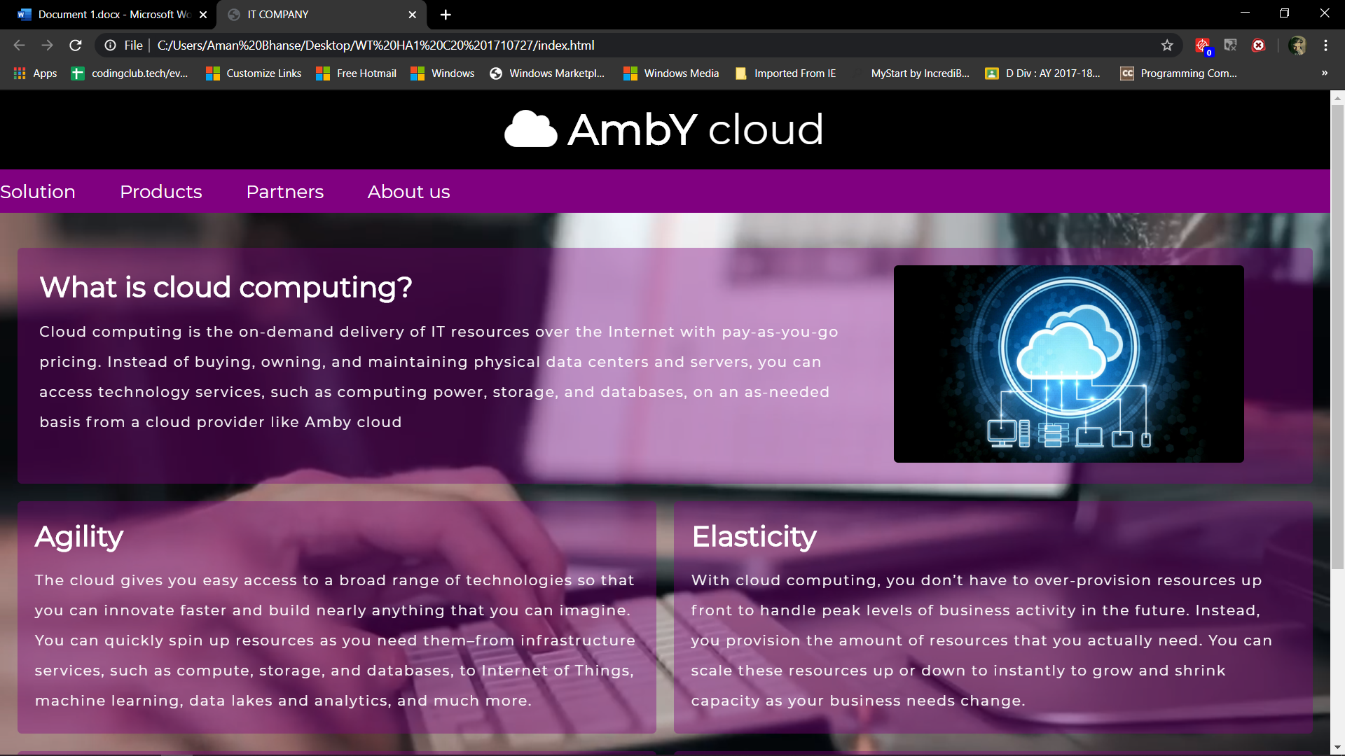

(1) Desktop



(2)Tablet

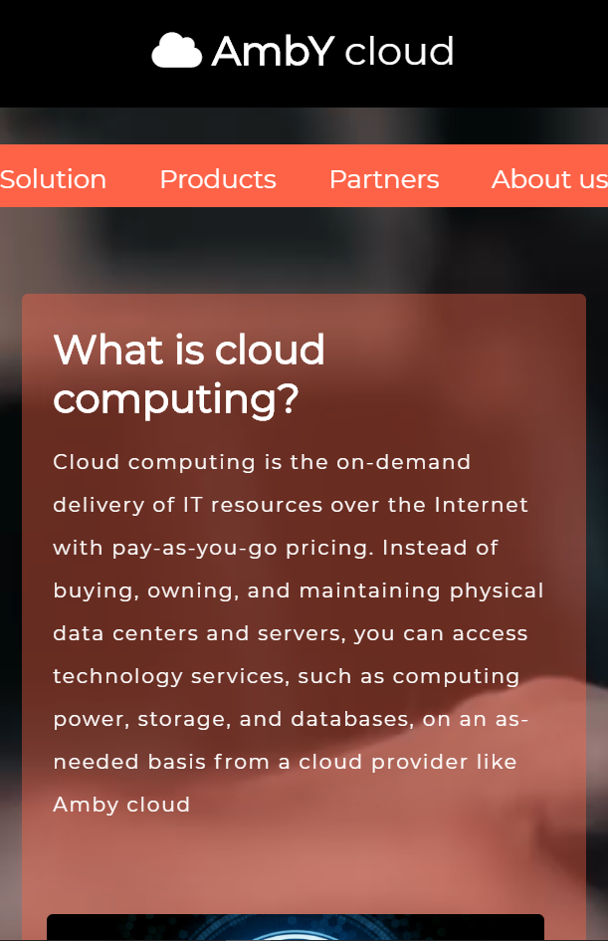

(3)Mobile

=====================================================================================OUTPUT ENDS

====================================================================================