Name: Aman Bhanse

Class: TYC

Roll no: 20

Gr:1710727

Subject: WT HA2

==========================================================

HTML CODE

==========================================================

<!DOCTYPE html>

<html>

<head>

<title>STUDENT FORM</title>

<link href="https://fonts.googleapis.com/css2?family=Open+Sans:wght@300&display=swap" rel="stylesheet">

<link rel="stylesheet" type="TEXT/CSS" href="./style.css">

</head>

<body>

<div>

<div><div class="heading"><h1>VIT Addmission Process</h1></div></div>

<div class="navbar">

<div class="navbar-item">HOME</div>

<div class="navbar-item">PLACEMENTS</div>

<div class="navbar-item">CONTACT</div>

</div>

<div class="conteiner">

<div></div>

<div id="Form-conteiner">

<form>

<label for="fname">First Name</label>

<input type="text" id="fname" name="fname">

<label for="lname">Last Name:</label>

<input type="text" id="lname" name="lname">

<label for="father_name">Father's Name</label>

<input type="text" id="father_name" name="father_name">

<label for="mother_name">Mother's Name</label>

<input type="text" id="mother_name" name="mother_name">

<label for="birthday">Birthday:</label>

<input type="date" id="birthday" name="birthday">

<label for="email">Enter your email:</label>

<input type="email" id="email" name="email">

<label for="phone">Enter your phone number:</label>

<input type="tel" id="phone" name="phone" pattern="[0-9]{4}-[0-9]{3}-[0-9]{4}" placeholder="1234-56-789">

<label for="application">Date of application:</label>

<input type="date" id="application" name="application">

<label for="caste">Caste:</label>

<input type="text" id="caste" name="caste">

<label for="stream">Stream</label>

<input list="stream">

<datalist id="stream">

<option value="Computer Science">

<option value="Electronic">

<option value="E&TC">

<option value="Instrumentation">

<option value="Chemical">

</datalist>

<label for="address">Address</label>

<textarea name="address" row="10" col="30"></textarea>

<label for="primary_school">Primary School Name</label>

<input type="text" id="primary_school" name="primary_school">

<label for="primary_marks">Primary Education Marks</label>

<input type="number" id="primary_marks" name="primary_marks" min="1" max="100">

<label for="secondary_school">Secondary School Name</label>

<input type="text" id="secondary_school" name="secondary_school">

<label for="secondary_marks">Secondary Education Marks</label>

<input type="number" id="secondary_marks" name="secondary_marks" min="1" max="100">

<label for="MHCET_marks">MH-CET Education Marks</label>

<input type="number" id="MHCET_marks" name="MHCET_marks" min="1" max="200">

<input type="SUBMIT" id="submit-button" value="SUBMIT">

</form>

</div>

<div></div>

</div>

</div>

</body>

</html>

==========================================================

HTML CODE ENDS

==========================================================

==========================================================

CSS CODE

==========================================================

*{

padding: 0px;

margin:0px;

}

body{

background-color: rgb(169, 204, 219); /* changes*/

}

.navbar{

display: grid;

grid-auto-flow: column;

justify-content: left;

grid-auto-rows: 50px;

background-color: black; /* changes*/

color: white;

align-content: center;

grid-gap: 10px;

padding: 10px;

}

.navbar-item{

background-color: black;

line-height: 30px;

font-size:20px;

font-family: "Open Sans",arial; /* changes*/

padding: 10px;

}

.navbar-item:hover{

background-color: rgb(4, 127, 176); /* changes*/

transition: 0.3s;

}

.heading{

background-color: rgb(4, 127, 176); /* changes*/

color: white;

padding: 10px;

}

.heading h1{

margin-left: 50vw;

font-size: 3em;

transform: translateX(-35%);

font-family: "Open Sans",arial;

word-spacing: 3px;

}

.conteiner{

padding: 10px;

display: grid;

grid-template-columns: 1fr 2fr 1fr;

grid-auto-rows: auto;

}

#Form-conteiner{

background-color: white;

border-radius: 10px;

padding: 20px;

}

label{

display: block;

text-align: center;

font-family: "open Sans";

font-size:20px;

margin-bottom: 4px;

}

input,textarea{

display:block;

width: 100%;

padding-top: 5px;

padding-bottom: 5px;

font-size: 20px;

margin-bottom: 20px;

text-align: center;

height: 30px;

font-family: "open Sans";

border-width: 1px;

border-color: rgba(110, 111, 112,0.5);

}

input:focus , textarea:focus{

border-style: solid;

border-color: rgb(4, 127, 176);

border-width: 5px;

}

::placeholder{

text-align: center;

transform: translateY(-20%);

}

#submit-button{

width: 40%;

margin-left: 30%;

margin-right: 30%;

background-color: rgb(4, 127, 176);

color:white;

padding: 10px;

cursor: pointer;

height: 50px;

}

#submit-button:hover{

background-color: purple;

*{

padding: 0px;

margin:0px;

}

body{

background-color: rgb(204, 213, 217); /* changes*/

}

.navbar{

display: grid;

grid-auto-flow: column;

justify-content: left;

grid-auto-rows: 50px;

background-color: black; /* changes*/

color: white;

align-content: center;

grid-gap: 10px;

padding: 10px;

}

.navbar-item{

background-color: black;

line-height: 30px;

font-size:20px;

font-family: "Open Sans",arial; /* changes*/

padding: 10px;

}

.navbar-item:hover{

background-color: rgb(4, 127, 176); /* changes*/

transition: 0.3s;

}

.heading{

background-color: rgb(4, 127, 176); /* changes*/

color: white;

padding: 10px;

}

.heading h1{

margin-left: 50vw;

font-size: 3em;

transform: translateX(-35%);

font-family: "Open Sans",arial;

word-spacing: 3px;

}

.conteiner{

padding: 10px;

display: grid;

grid-template-columns: 1fr 2fr 1fr;

grid-auto-rows: auto;

}

#Form-conteiner{

background-color: white;

border-radius: 10px;

padding: 20px;

}

label{

display: block;

text-align: center;

font-family: "open Sans";

font-size:20px;

margin-bottom: 4px;

}

input,textarea{

display:block;

width: 100%;

padding-top: 5px;

padding-bottom: 5px;

font-size: 20px;

margin-bottom: 20px;

text-align: center;

height: 30px;

font-family: "open Sans";

border-width: 1px;

border-color: rgba(110, 111, 112,0.5);

}

input:focus , textarea:focus{

border-style: solid;

border-color: rgb(4, 127, 176);

border-width: 5px;

}

::placeholder{

text-align: center;

transform: translateY(-20%);

}

#submit-button{

width: 40%;

margin-left: 30%;

margin-right: 30%;

background-color: rgb(4, 127, 176);

color:white;

padding: 10px;

cursor: pointer;

height: 50px;

}

#submit-button:hover{

background-color: purple;

}

==========================================================

CSS CODE ENDS

==========================================================

==========================================================

OUTPUT

==========================================================

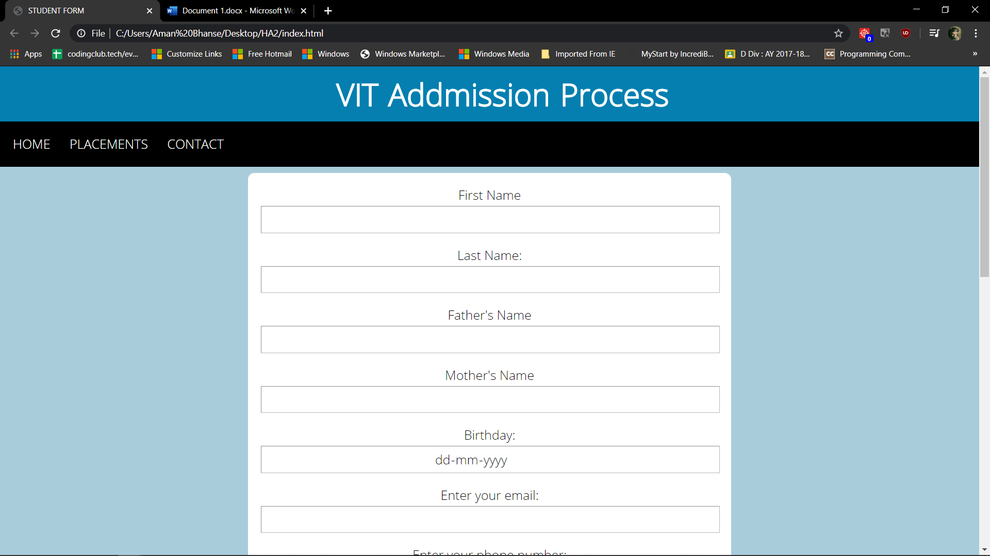

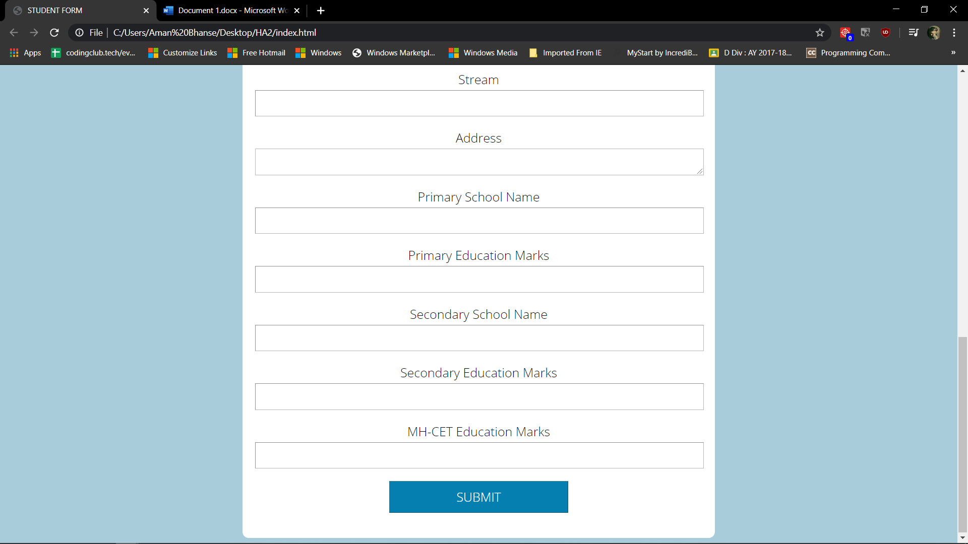

==========================================================

OUTPUT ENDS

==========================================================