**LiFi - TECHNOLOGIES:**

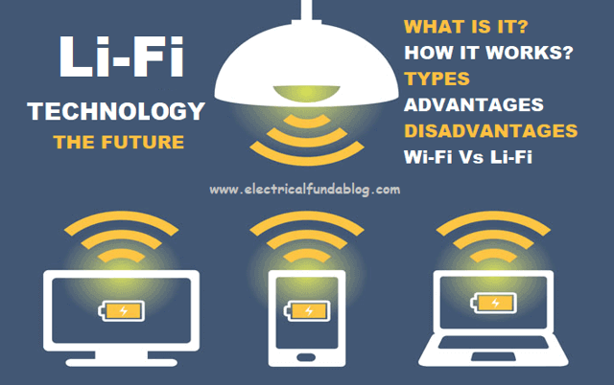

It is remarkable that LiFi replaces WiFi in upcoming days, LiFi (Light Fidelity) has internet speed with more than100 times than WiFi. It has the capacity to transfer data about 225 Gbps that means you can download 18 movies with in 1 second. In WiFi data is transferred through radio waves but in LiFi data is transferred through light waves, WiFi speed get decreased when it is shared among various devices, but in LiFi it is not like that data is transferred in devices with same speed and you can induce as many as devices where you can get light,LiFi is secured than WiFi and it does’nt emit radiation which is harm to us, LiFi is cheaper source, we get signals of LiFi in form of light that means where there is a light availability there we will receive signals, This light is emitted through specific LED’s which acts as source. Receivers meant to receive LiFi signals are not implemented currently in the devices, but in upcoming days this could be easily induced in the devices. The main disadvantage is you can’t use LiFi when there is no light that means for example you LED’s are kept in one room and you want to use it in another room where there is no penetration of LED light in that case you can’t avail LiFi and during day times sunlight may dominant over LED light, considering these issues scientists are working on this.

If we see the way of working of this LiFi, When an electrical current is applied to a LED light bulb a stream of light (photons) is emitted from the bulb. LED bulbs are semiconductor devices,which means that the brightness of the light flowing through them can be changed at extremely high speeds. This allows us to send a signal by modulating the light at different rates. The signal can then be received by a detector which interprets the changes in light intensity (the signal) as data.

It gives bandwidth with 1000 times more than WiFi. Since WiFi is not recommended to use in hospitals due to radiography, aeroplanes due to high altitude and destruction in signals in plane LiFi can be used at this places to access internet. Light bounces off of surfaces and therefore LiFi is not strictly a line-of-sight technology. LiFi is a cellular communication system and the data rate is not dependent on the line of sight but on the signal quality at the device. Signal quality can be defined by the ratio of the desired data vs any interfering data and noise. Today companies can speak to pure LiFi about working with us on proof of concept projects and other types of installations. These installations are priced based on individual requirements. There are also other options for using invisible parts of the light spectrum such as infra-red, which is currently already being used for sending information back to the light bulb (uplink) this infrared has penetrating power so that signals can be received through thin objects . No environmental factors can affect this LiFi since transfer of data is taken place through electromagnetic waves this can be used to communicate among Astronauts or Satellites.

**_ Dhanunjaya .**B