|  |  |
| --- | --- |
| PICTLOGO | **SCTR’s PUNE INSTITUTE OF COMPUTER TECHNOLOGY, PUNE - 411043** |
| **DEPARTMENT OF ELECTRONICS & TELECOMMUNICATION ENGINEERING** |

|  |  |  |  |  |  |  |  |
| --- | --- | --- | --- | --- | --- | --- | --- |
| **Lab Practice -2 [404184C] : ELECTIVE-III(C) - JavaScript** | | | | | | | |
| **ACADEMIC YEAR: 2024-25** | | | | | | | |
| **CLASS** | **: BE** | **DIV** | **: 7** | **Batch** | **: R-7** | **DATE** | **:** |
| **Roll No** | **42315** | **ABC ID** | **: 187-311-403-781** | | | **SEMESTER** | **: I** |

|  |
| --- |
| **Experiment No.: 1** |

HTML 🡺

<!DOCTYPE html>

<html lang="en">

<head>

  <meta charset="UTF-8">

  <meta name="viewport" content="width=device-width, initial-scale=1.0">

  <title>Area Calculator</title>

  <!-- Link to external CSS -->

  <link rel="stylesheet" href="style_1.css">

</head>

<body>

  <div class="container">

    <h2>Area Calculator</h2>

    <!-- Triangle -->

    <h3>Triangle (Heron's Formula)</h3>

    <input type="number" id="sideA" placeholder="Enter side A">

    <input type="number" id="sideB" placeholder="Enter side B">

    <input type="number" id="sideC" placeholder="Enter side C">

    <button onclick="calculateTriangleArea()">Calculate Triangle Area</button>

    <div class="result" id="triangleResult"></div>

    <!-- Rectangle -->

    <h3>Rectangle</h3>

<input type="number" id="length" placeholder="Enter length">

    <input type="number" id="width" placeholder="Enter width">

    <button onclick="calculateRectangleArea()">Calculate Rectangle Area</button>

    <div class="result" id="rectangleResult"></div>

    <!-- Circle -->

    <h3>Circle</h3>

    <input type="number" id="radius" placeholder="Enter radius">

    <button onclick="calculateCircleArea()">Calculate Circle Area</button>

    <div class="result" id="circleResult"></div>

  </div>

  <!-- Link to external JavaScript -->

  <script src="script_1.js"></script>

</body>

</html>

CSS 🡺

body {

  font-family: Arial, sans-serif;

  display: flex;

  justify-content: center;

  align-items: center;

  height: 100vh;

  margin: 0;

  background-color: #f4f4f4;

}

.container {

  text-align: center;

  padding: 20px;

  background-color: #ffffff;

  border-radius: 10px;

  box-shadow: 0 0 10px rgba(0, 0, 0, 0.1);

}

h2 {

  color: #333;

  margin-bottom: 20px;

}

input {

  margin: 10px 0;

  padding: 8px;

  width: 80%;

  border: 1px solid #ccc;

  border-radius: 5px;

}

button {

  padding: 10px 20px;

  background-color: #28a745;

  color: white;

  border: none;

  border-radius: 5px;

  cursor: pointer;

  margin-top: 10px;

}

button:hover {

  background-color: #218838;

}

.result {

  margin-top: 20px;

  font-size: 18px;

  color: #555;

}

.result.error {

  color: red;

}

.result.success {

  color: green;

}

JavaScript 🡺

// Function to check if the triangle is valid

function isValidTriangle(a, b, c) {

  return a + b > c && a + c > b && b + c > a;

}

// Function to calculate the area of the triangle using Heron's formula

function calculateTriangleArea() {

  const a = parseFloat(document.getElementById("sideA").value);

  const b = parseFloat(document.getElementById("sideB").value);

  const c = parseFloat(document.getElementById("sideC").value);

  if (isNaN(a) || isNaN(b) || isNaN(c)) {

    document.getElementById("triangleResult").innerHTML =

      "Please enter valid numbers for all sides.";

    document.getElementById("triangleResult").classList.add("error");

    return;

  }

  if (!isValidTriangle(a, b, c)) {

    document.getElementById("triangleResult").innerHTML =

      "The sides do not form a valid triangle.";

    document.getElementById("triangleResult").classList.add("error");

    return;

  }

  const s = (a + b + c) / 2;

  const area = Math.sqrt(s * (s - a) * (s - b) * (s - c));

document.getElementById(

    "triangleResult"

  ).innerHTML = `Area of the triangle is: ${area.toFixed(2)} square units`;

  document.getElementById("triangleResult").classList.remove("error");

  document.getElementById("triangleResult").classList.add("success");

}

// Function to calculate the area of a rectangle

function calculateRectangleArea() {

  const length = parseFloat(document.getElementById("length").value);

  const width = parseFloat(document.getElementById("width").value);

  if (isNaN(length) || isNaN(width)) {

    document.getElementById("rectangleResult").innerHTML =

      "Please enter valid numbers for length and width.";

    document.getElementById("rectangleResult").classList.add("error");

    return;

  }

  const area = length * width;

  document.getElementById(

    "rectangleResult"

  ).innerHTML = `Area of the rectangle is: ${area.toFixed(2)} square units`;

  document.getElementById("rectangleResult").classList.remove("error");

  document.getElementById("rectangleResult").classList.add("success");

}

// Function to calculate the area of a circle

function calculateCircleArea() {

  const radius = parseFloat(document.getElementById("radius").value)

  if (isNaN(radius)) {

    document.getElementById("circleResult").innerHTML =

      "Please enter a valid radius.";

    document.getElementById("circleResult").classList.add("error");

    return;

  }

  const area = Math.PI * Math.pow(radius, 2);

  document.getElementById(

    "circleResult"

  ).innerHTML = `Area of the circle is: ${area.toFixed(2)} square units`;

  document.getElementById("circleResult").classList.remove("error");

  document.getElementById("circleResult").classList.add("success");

}

**Output 🡺**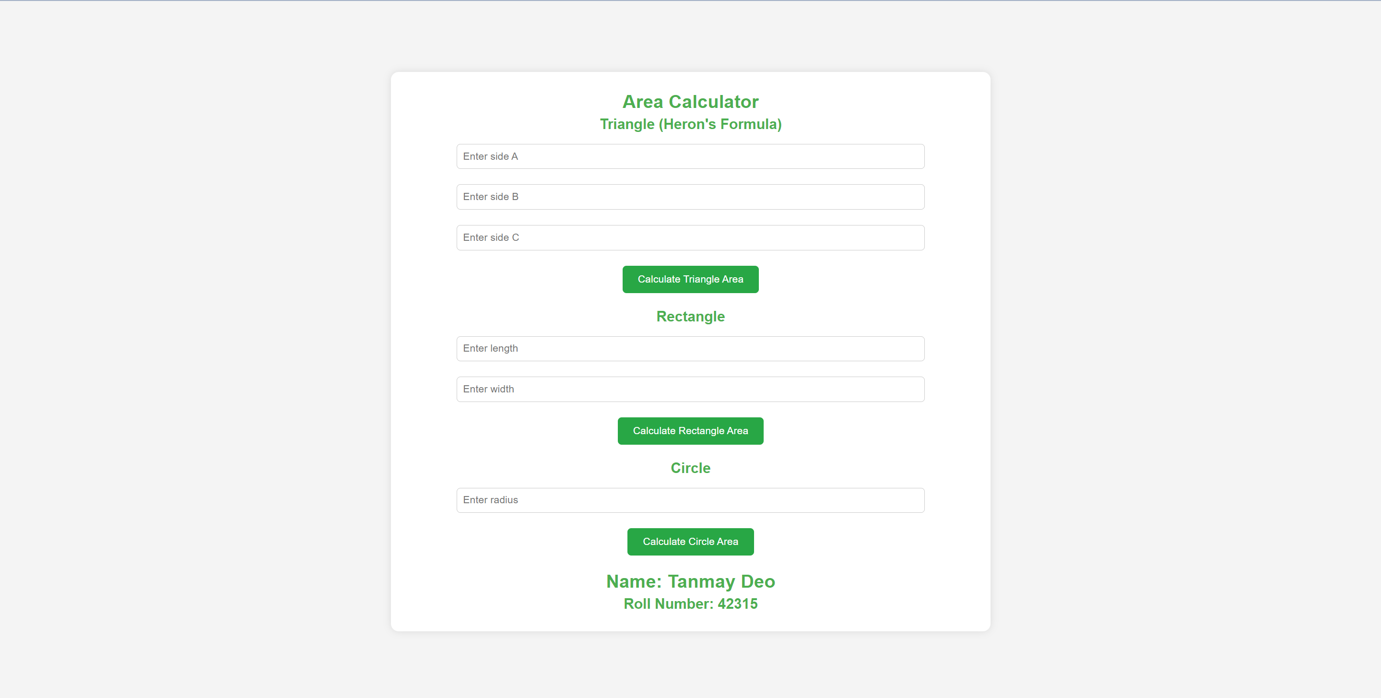

|  |  |  |
| --- | --- | --- |
|  | | |
| Date: |  | Course Teacher Sign |