|  |  |
| --- | --- |
| PICTLOGO | **SCTR’s PUNE INSTITUTE OF COMPUTER TECHNOLOGY, PUNE - 411043** |
| **DEPARTMENT OF ELECTRONICS & TELECOMMUNICATION ENGINEERING** |

|  |  |  |  |  |  |  |  |
| --- | --- | --- | --- | --- | --- | --- | --- |
| **Lab Practice -2 [404184C] : ELECTIVE-III(C) - JavaScript** | | | | | | | |
| **ACADEMIC YEAR: 2024-25** | | | | | | | |
| **CLASS** | **: BE** | **DIV** | **: 7** | **Batch** | **: R-7** | **DATE** | **:** |
| **Roll No** | **42315** | **ABC ID** | **: 187-311-403-781** | | | **SEMESTER** | **: I** |

|  |
| --- |
| **Experiment No.: 10** |

JS 🡺

const prompt = require("prompt-sync")();

const num = prompt("Enter a number to print its multiplication table: ");

console.log(`\nMultiplication Table of ${num} using For Loop:`);

for (let i = 1; i <= 10; i++) {

console.log(`${num} x ${i} = ${num * i}`);

}

console.log(`\nMultiplication Table of ${num} using While Loop:`);

let j = 1;

while (j <= 10) {

console.log(`${num} x ${j} = ${num * j}`);

j++;

}

console.log(`\nMultiplication Table of ${num} using Do-While Loop:`);

let k = 1;

do {

console.log(`${num} x ${k} = ${num * k}`);

k++;

} while (k <= 10);

Output 🡺

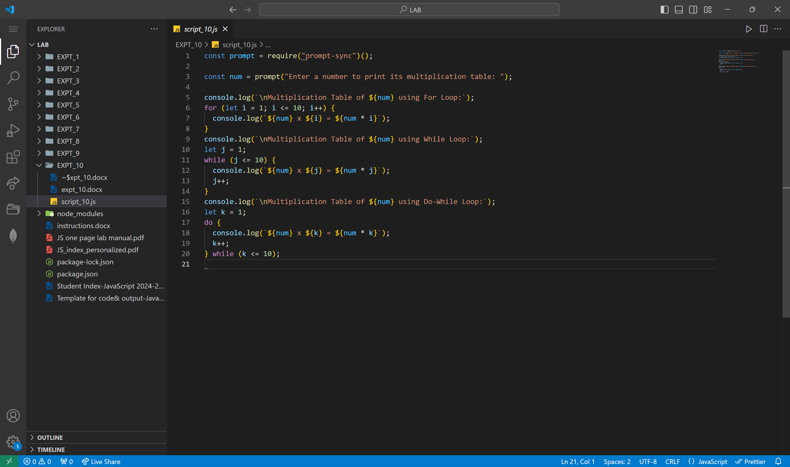

|  |  |  |
| --- | --- | --- |
|  | | |
| Date: |  | Course Teacher Sign |