|  |  |
| --- | --- |
| PICTLOGO | **SCTR’s PUNE INSTITUTE OF COMPUTER TECHNOLOGY, PUNE - 411043** |
| **DEPARTMENT OF ELECTRONICS & TELECOMMUNICATION ENGINEERING** |

|  |  |  |  |  |  |  |  |
| --- | --- | --- | --- | --- | --- | --- | --- |
| **Lab Practice -2 [404184C] : ELECTIVE-III(C) - JavaScript** | | | | | | | |
| **ACADEMIC YEAR: 2024-25** | | | | | | | |
| **CLASS** | **: BE** | **DIV** | **: 7** | **Batch** | **: R-7** | **DATE** | **:** |
| **Roll No** | **42315** | **ABC ID** | **: 187-311-403-781** | | | **SEMESTER** | **: I** |

|  |
| --- |
| **Experiment No.: 2** |

HTML 🡺

1. **Using for loop**

<!DOCTYPE html>

<html lang="en">

<head>

<meta charset="UTF-8">

<meta name="viewport" content="width=device-width, initial-scale=1.0">

<title>Multiplication Table Generator using for loop</title>

<link rel="stylesheet" href="style_2.css">

</head>

<body>

<div class="container">

<h1>Multiplication Table Generator Using For Loop</h1>

<label for="numberInput">Enter a number: </label>

<input type="number" id="numberInput" placeholder="Enter number">

<button onclick="generateTableUsingForLoop()">Generate Table</button>

<div id="tableResult"></div>

<div class="info">

<h2>Name: Tanmay Deo</h2>

<h3>Roll Number: 42315</h3>

</div>

</div>

<script src="script_2.js"></script>

</body>

</html>

1. **Using while loop**

<!DOCTYPE html>

<html lang="en">

<head>

<meta charset="UTF-8">

<meta name="viewport" content="width=device-width, initial-scale=1.0">

<title>Multiplication Table Generator using while loop</title>

<link rel="stylesheet" href="style_2.css">

</head>

<body>

<div class="container">

<h1>Multiplication Table Generator Using While Loop</h1>

<label for="numberInput">Enter a number: </label>

<input type="number" id="numberInput" placeholder="Enter number">

<button onclick="generateTableUsingWhileLoop()">Generate Table</button>

<div id="tableResult"></div>

<div class="info">

<h2>Name: Tanmay Deo</h2>

<h3>Roll Number: 42315</h3>

</div>

</div>

<script src="script_2.js"></script>

</body>

</html>

1. Using do-while loop

<!DOCTYPE html>

<html lang="en">

<head>

<meta charset="UTF-8">

<meta name="viewport" content="width=device-width, initial-scale=1.0">

<title>Multiplication Table Generator using do-while loop</title>

<link rel="stylesheet" href="style_2.css">

</head>

<body>

<div class="container">

<h1>Multiplication Table Generator Using Do-While Loop</h1>

<label for="numberInput">Enter a number: </label>

<input type="number" id="numberInput" placeholder="Enter number">

<button onclick="generateTableUsingDoWhileLoop()">Generate Table</button>

<div id="tableResult"></div>

<div class="info">

<h2>Name: Tanmay Deo</h2>

<h3>Roll Number: 42315</h3>

</div>

</div>

<script src="script_2.js"></script>

</body>

</html>

CSS 🡺

body {

  font-family: Arial, sans-serif;

  background-color: #f0f8ff;

  display: flex;

  justify-content: center;

  align-items: center;

  height: 100vh;

  margin: 0;

}

.container {

  background-color: white;

  padding: 20px;

  border-radius: 8px;

  box-shadow: 0px 4px 8px rgba(0, 0, 0, 0.1);

  text-align: center;

}

input {

  display: block;

  margin: 10px auto;

  padding: 10px;

  border: 1px solid #ccc;

  border-radius: 4px;

}

button {

  padding: 10px 20px;

  margin-top: 10px;

  background-color: #4caf50;

  color: white;

  border: none;

  border-radius: 4px;

  cursor: pointer;

}

button:hover {

  background-color: #45a049;

}

h1 {

  color: #333;

}

#tableResult {

  margin-top: 20px;

  color: #333;

  background-color: #e0f7fa;

  padding: 10px;

  border-radius: 4px;

}

table {

  margin: 0 auto;

  border-collapse: collapse;

  width: 50%;

}

td {

  border: 1px solid #333;

  padding: 10px;

  text-align: center;

}

h2,

h3 {

  margin: 5px;

  color: #4caf50;

}

JavaScript 🡺

function generateTableUsingForLoop() {

  let number = parseInt(document.getElementById("numberInput").value)

  if (isNaN(number)) {

    document.getElementById("tableResult").innerHTML =

      "Please enter a valid number.";

    return;

  }

  let tableHTML = `<table><tr><th>Multiplication Table of ${number}</th></tr>`;

  for (let i = 1; i <= 10; i++) {

    tableHTML += `<tr><td>${number} x ${i} = ${number * i}</td></tr>`;

  }

  tableHTML += "</table>";

  document.getElementById("tableResult").innerHTML = tableHTML;

}

function generateTableUsingWhileLoop() {

  let number = parseFloat(document.getElementById("numberInput").value);

  if (isNaN(number)) {

    document.getElementById("tableResult").innerHTML =

      "Please enter a valid number.";

    return;

  }

  let tableHTML = `<table><tr><th>Multiplication Table of ${number}</th></tr>`;

  let i = 1;

  while (i <= 10) {

    tableHTML += `<tr><td>${number} x ${i} = ${number * i}</td></tr>`;

    i++;

  }

  tableHTML += "</table>";

  document.getElementById("tableResult").innerHTML = tableHTML;

}

function generateTableUsingDoWhileLoop() {

  let number = parseFloat(document.getElementById("numberInput").value);

  if (isNaN(number)) {

    document.getElementById("tableResult").innerHTML =

      "Please enter a valid number.";

    return;

  }

  let tableHTML = `<table><tr><th>Multiplication Table of ${number}</th></tr>`;

  let i = 1;

  do {

    tableHTML += `<tr><td>${number} x ${i} = ${number * i}</td></tr>`;

    i++;

  } while (i <= 10);

  tableHTML += "</table>";

  document.getElementById("tableResult").innerHTML = tableHTML;

}

**Output 🡺**

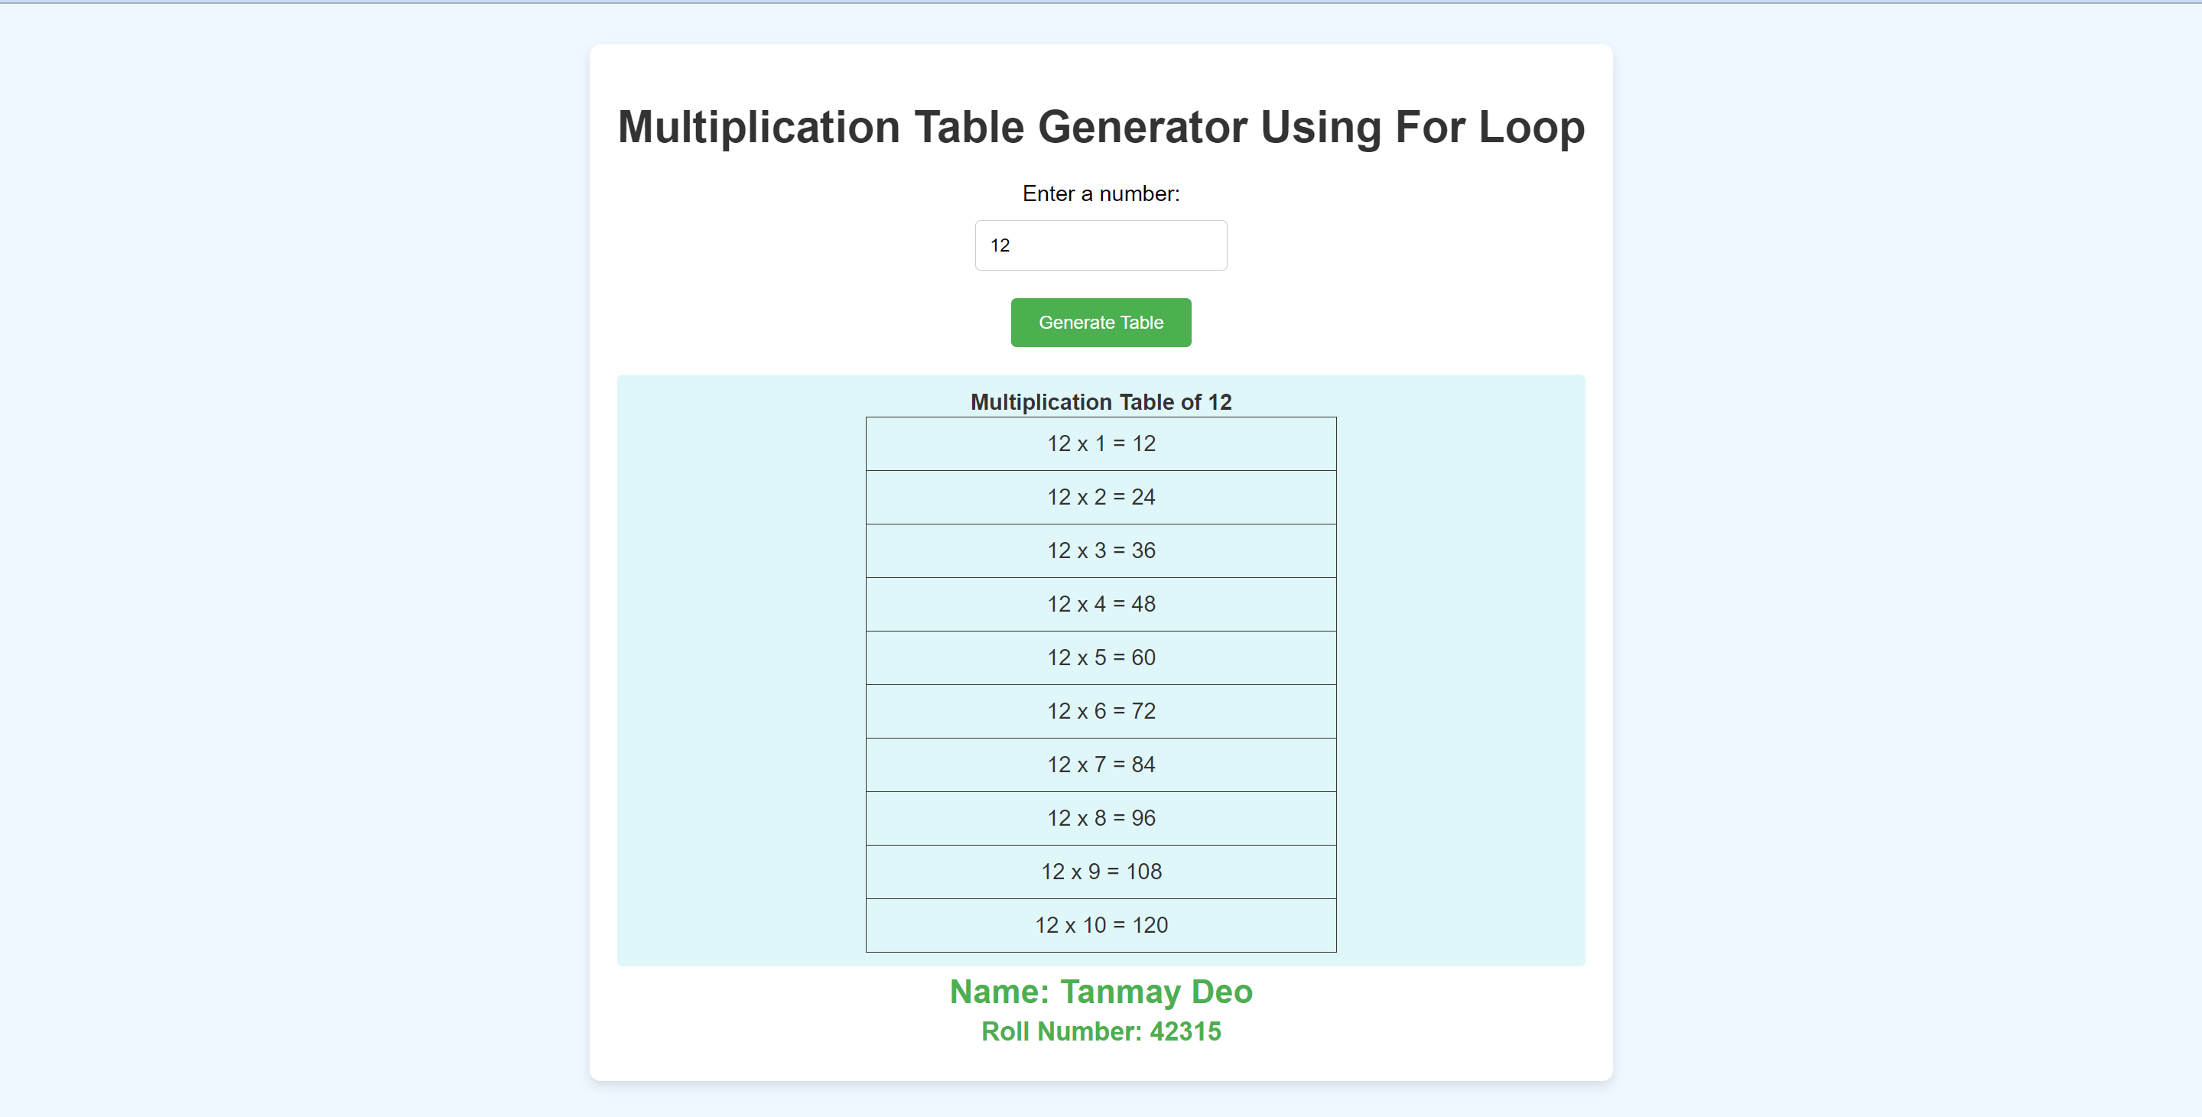

|  |  |  |
| --- | --- | --- |
|  | | |
| Date: |  | Course Teacher Sign |