|  |  |
| --- | --- |
| PICTLOGO | **SCTR’s PUNE INSTITUTE OF COMPUTER TECHNOLOGY, PUNE - 411043** |
| **DEPARTMENT OF ELECTRONICS & TELECOMMUNICATION ENGINEERING** |

|  |  |  |  |  |  |  |  |
| --- | --- | --- | --- | --- | --- | --- | --- |
| **Lab Practice -2 [404184C] : ELECTIVE-III(C) - JavaScript** | | | | | | | |
| **ACADEMIC YEAR: 2024-25** | | | | | | | |
| **CLASS** | **: BE** | **DIV** | **: 7** | **Batch** | **: R-7** | **DATE** | **:** |
| **Roll No** | **42315** | **ABC ID** | **: 187-311-403-781** | | | **SEMESTER** | **: I** |

|  |
| --- |
| **Experiment No.: 4** |

HTML 🡺

<!DOCTYPE html>

<html lang="en">

<head>

  <meta charset="UTF-8">

  <meta name="viewport" content="width=device-width, initial-scale=1.0">

  <title>String Comparison</title>

  <link rel="stylesheet" href="style_4.css">

</head>

<body>

  <div class="container">

    <h1>String Comparison</h1>

    <label for="string1">Enter First String: </label>

    <input type="text" id="string1" placeholder="Enter first string"><br><br>

    <label for="string2">Enter Second String: </label>

    <input type="text" id="string2" placeholder="Enter second string"><br><br>

    <button onclick="compareStrings()">Compare Strings</button>

    <div id="comparisonResults"></div>

    <div class="info">

      <h2>Name: Tanmay Deo</h2>

      <h3>Roll Number: 42315</h3>

    </div>

  </div>

  <script src="script_4.js"></script>

</body>

</html>

CSS 🡺

body {

  font-family: Arial, sans-serif;

  background-color: #f4f4f9;

  margin: 0;

  padding: 0;

  display: flex;

  justify-content: center;

  align-items: center;

  height: 100vh;

}

.container {

  text-align: center;

  background-color: #fff;

  padding: 20px;

  border-radius: 10px;

  box-shadow: 0px 0px 10px rgba(0, 0, 0, 0.1);

}

input[type="text"] {

  padding: 10px;

  width: 60%;

  margin-bottom: 10px;

  border: 1px solid #ccc;

  border-radius: 5px;

}

button {

  padding: 10px 20px;

background-color: #28a745;

  color: white;

  border: none;

  border-radius: 5px;

  cursor: pointer;

}

button:hover {

  background-color: #218838;

}

#comparisonResults {

  margin-top: 20px;

  font-size: 18px;

}

.info {

  margin-top: 30px;

}

h2,

h3 {

  margin: 5px;

  color: #4caf50;

}

JS 🡺

function compareStrings() {

  const string1 = document.getElementById("string1").value;

  const string2 = document.getElementById("string2").value;

  const resultDiv = document.getElementById("comparisonResults");

  resultDiv.innerHTML = "";

  if (!string1 || !string2) {

    resultDiv.innerHTML = "<p>Please enter both strings to compare.</p>";

    return;

  }

  // Strict equality (===) comparison

  const strictEqualResult = string1 === string2 ? "Equal" : "Not Equal";

  // Loose equality (==) comparison

  const looseEqualResult = string1 == string2 ? "Equal" : "Not Equal";

  // Length comparison

  let lengthCompareResult = "Equal";

  if (string1.length > string2.length) {

    lengthCompareResult = `"${string1}" is longer`;

  } else if (string1.length < string2.length) {

    lengthCompareResult = `"${string2}" is longer`;

  }

  // localeCompare for alphabetical order

  const localeCompareResult = string1.localeCompare(string2);

  let alphabeticOrderResult = "";

  if (localeCompareResult === 0) {

    alphabeticOrderResult = "Both strings are equal alphabetically";

  } else if (localeCompareResult < 0) {

    alphabeticOrderResult = `"${string1}" comes before "${string2}" alphabetically`;

} else {

    alphabeticOrderResult = `"${string1}" comes after "${string2}" alphabetically`;

  }

  // Displaying the results

  resultDiv.innerHTML = `

    <p><strong>Strict Equality (===):</strong> ${strictEqualResult}</p>

    <p><strong>Loose Equality (==):</strong> ${looseEqualResult}</p>

    <p><strong>Length Comparison:</strong> ${lengthCompareResult}</p>

    <p><strong>Alphabetical Comparison (localeCompare):</strong> ${alphabeticOrderResult}</p>

  `;

}

Output 🡺

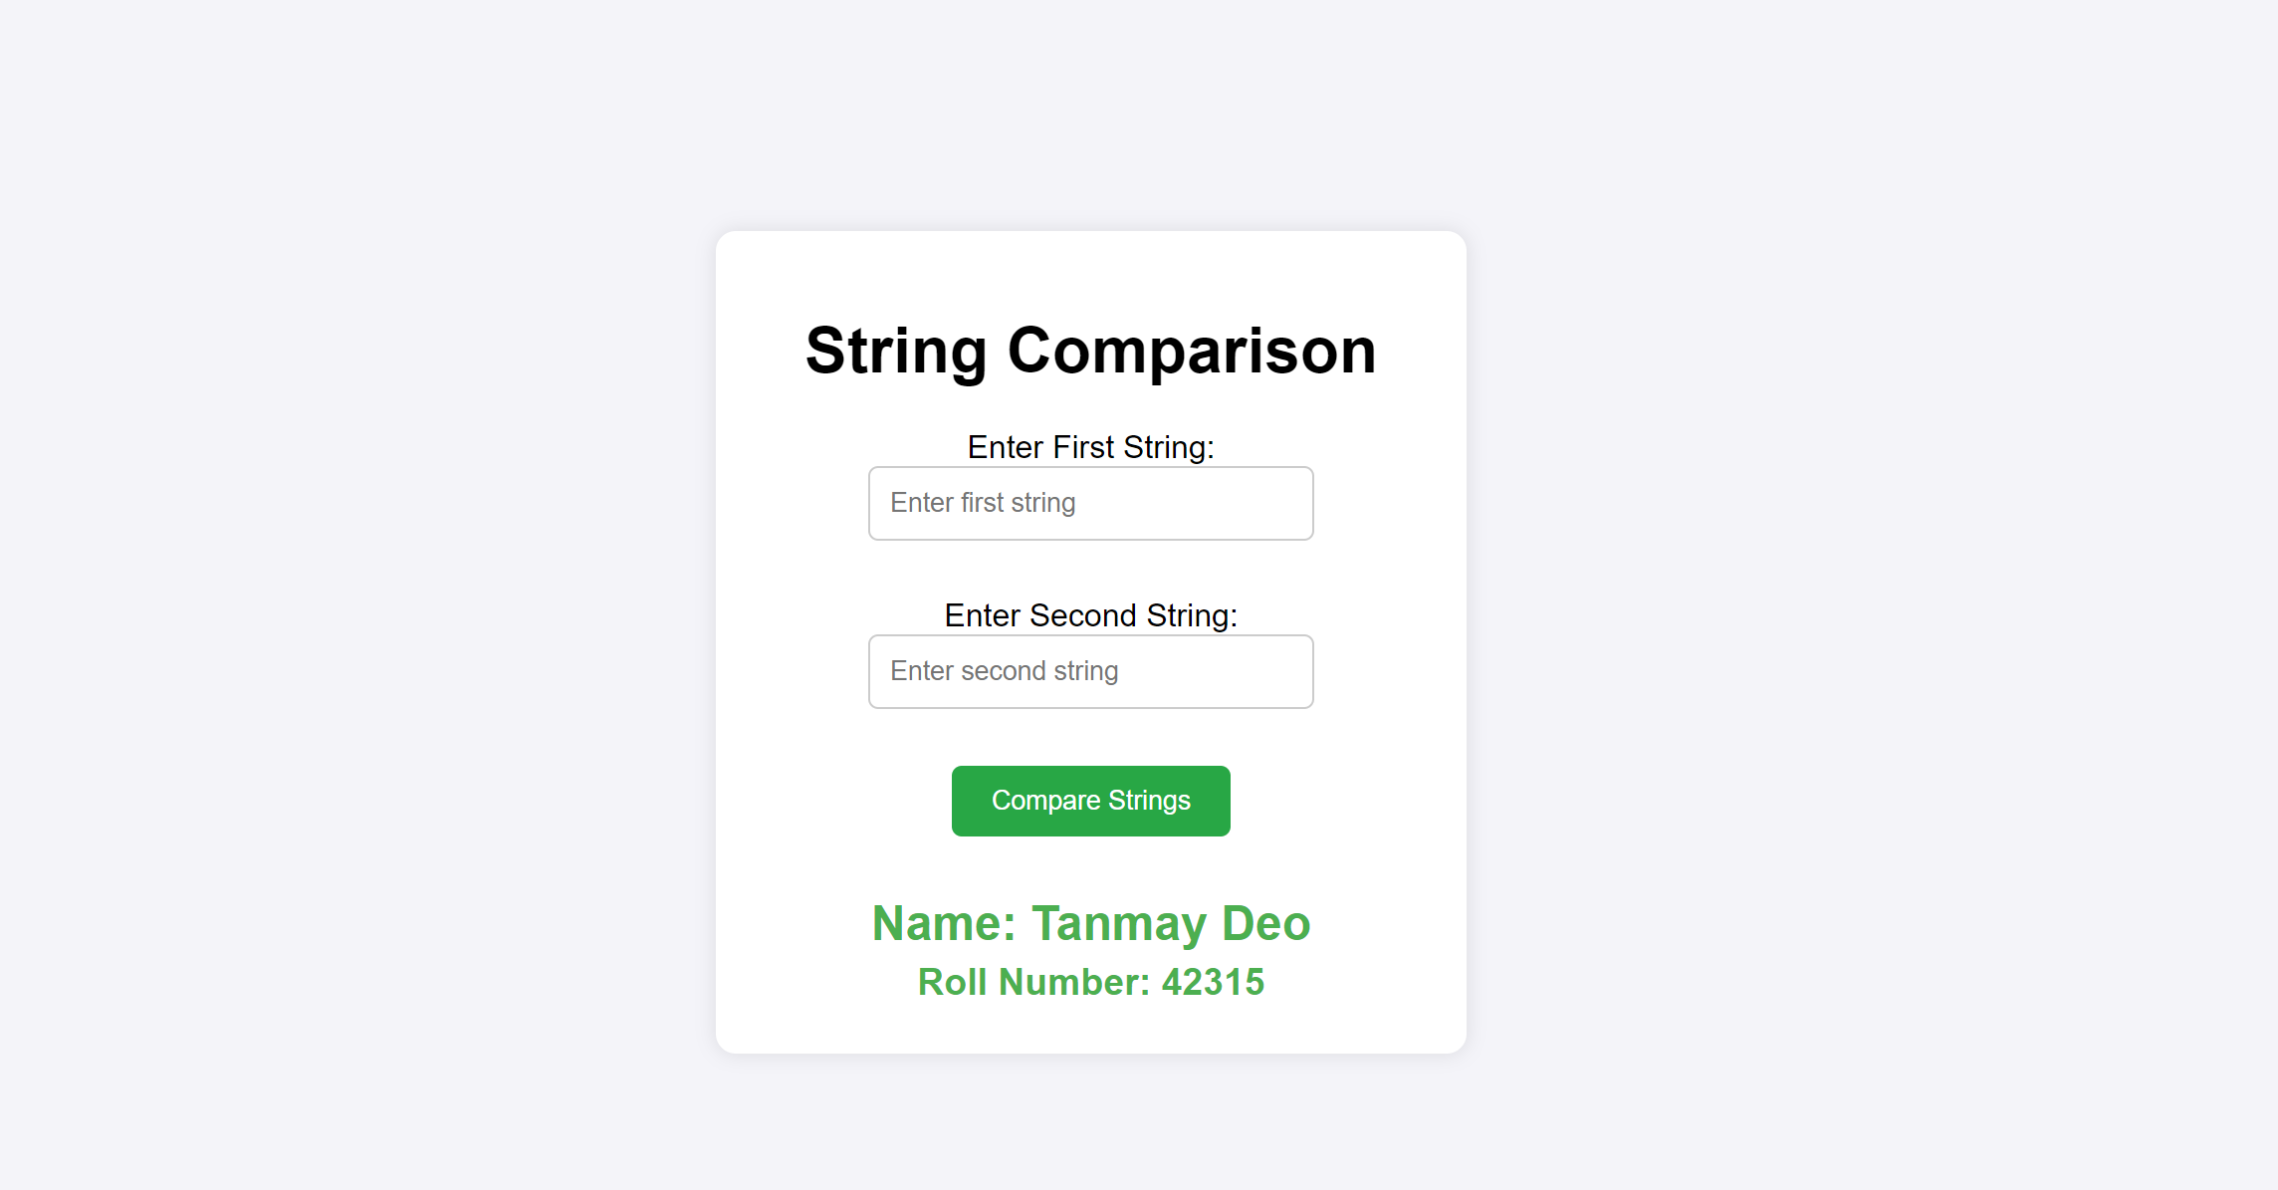

|  |  |  |
| --- | --- | --- |
|  | | |
| Date: |  | Course Teacher Sign |