|  |  |
| --- | --- |
| PICTLOGO | **SCTR’s PUNE INSTITUTE OF COMPUTER TECHNOLOGY, PUNE - 411043** |
| **DEPARTMENT OF ELECTRONICS & TELECOMMUNICATION ENGINEERING** |

|  |  |  |  |  |  |  |  |
| --- | --- | --- | --- | --- | --- | --- | --- |
| **Lab Practice -2 [404184C] : ELECTIVE-III(C) - JavaScript** | | | | | | | |
| **ACADEMIC YEAR: 2024-25** | | | | | | | |
| **CLASS** | **: BE** | **DIV** | **: 7** | **Batch** | **: R-7** | **DATE** | **:** |
| **Roll No** | **42315** | **ABC ID** | **: 187-311-403-781** | | | **SEMESTER** | **: I** |

|  |
| --- |
| **Experiment No.: 7** |

HTML 🡺

<!DOCTYPE html>

<html lang="en"

<head>

  <meta charset="UTF-8">

  <meta name="viewport" content="width=device-width, initial-scale=1.0">

  <title>Dynamic Array Input</title>

  <link rel="stylesheet" href="style_7.css">

</head>

<body>

  <div class="container">

    <h1>Dynamic Array Input</h1>

    <div id="inputFields"></div>

    <button onclick="addInputField()">Add More</button>

    <button onclick="submitArray()">Submit Array</button>

    <div id="arrayResult"></div>

    <div class="info">

      <h2>Name: Tanmay Deo</h2>

      <h3>Roll Number: 42315</h3>

    </div>

  </div>

  <script src="script_7.js"></script>

</body>

</html>

CSS 🡺

body {

  font-family: Arial, sans-serif;

  background-color: #f2f2f2;

  display: flex;

  justify-content: center;

  align-items: center;

  height: 100vh;

  margin: 0;

.container {

  background-color: white;

  padding: 20px;

  border-radius: 8px;

  box-shadow: 0px 4px 8px rgba(0, 0, 0, 0.1);

  text-align: center;

}

input {

  padding: 10px;

  margin-top: 10px;

  border: 1px solid #ccc;

  border-radius: 4px;

}

button {

  padding: 10px 20px;

  margin-top: 10px;

  background-color: #4caf50;

  color: white;

  border: none;

  border-radius: 4px;

  cursor: pointer;

}

button:hover {

  background-color: #45a049;

}

h1 {

  color: #333;

div {

  margin-top: 20px;

  color: #333;

}

h2,

h3 {

  margin: 5px;

  color: #4caf50;

}

JS 🡺

let myArray = [];

// Function to dynamically add input fields

function addInputField() {

  const inputFieldsContainer = document.getElementById("inputFields");

  const newInput = document.createElement("input");

  newInput.type = "text";

  newInput.placeholder =

    "Enter an element (e.g., 5, 'hello', [1,2,3], {key: 'value'})";

  inputFieldsContainer.appendChild(newInput);

}

// Function to submit the array

function submitArray() {

  const inputs = document.querySelectorAll("#inputFields input");

  myArray = [];

  inputs.forEach((input) => {

    const value = input.value.trim();

    try {

      const evaluatedValue = eval(value);

      myArray.push(evaluatedValue);

    } catch (error) {

      alert(

        `Invalid input: "${value}". Please enter a valid JavaScript expression.`

      );

    }

  });

  displayArrayResult();

}

// Function to display the result of the array

function displayArrayResult() {

  document.getElementById(

    "arrayResult"

  ).innerHTML = `Array created: [${JSON.stringify(myArray, null, 2)}]`;

  // Check if any object in the array is of type array

  const arrayObjects = myArray.filter((item) => Array.isArray(item));

  if (arrayObjects.length > 0) {

    document.getElementById(

      "arrayResult"

    ).innerHTML += `<br>The array contains the following array objects: [${JSON.stringify(

      arrayObjects,

      null,

      2

    )}]`;

  } else {

    document.getElementById("arrayResult").innerHTML +=

      "<br>The array does not contain any arrays.";

  }

}

Output 🡺

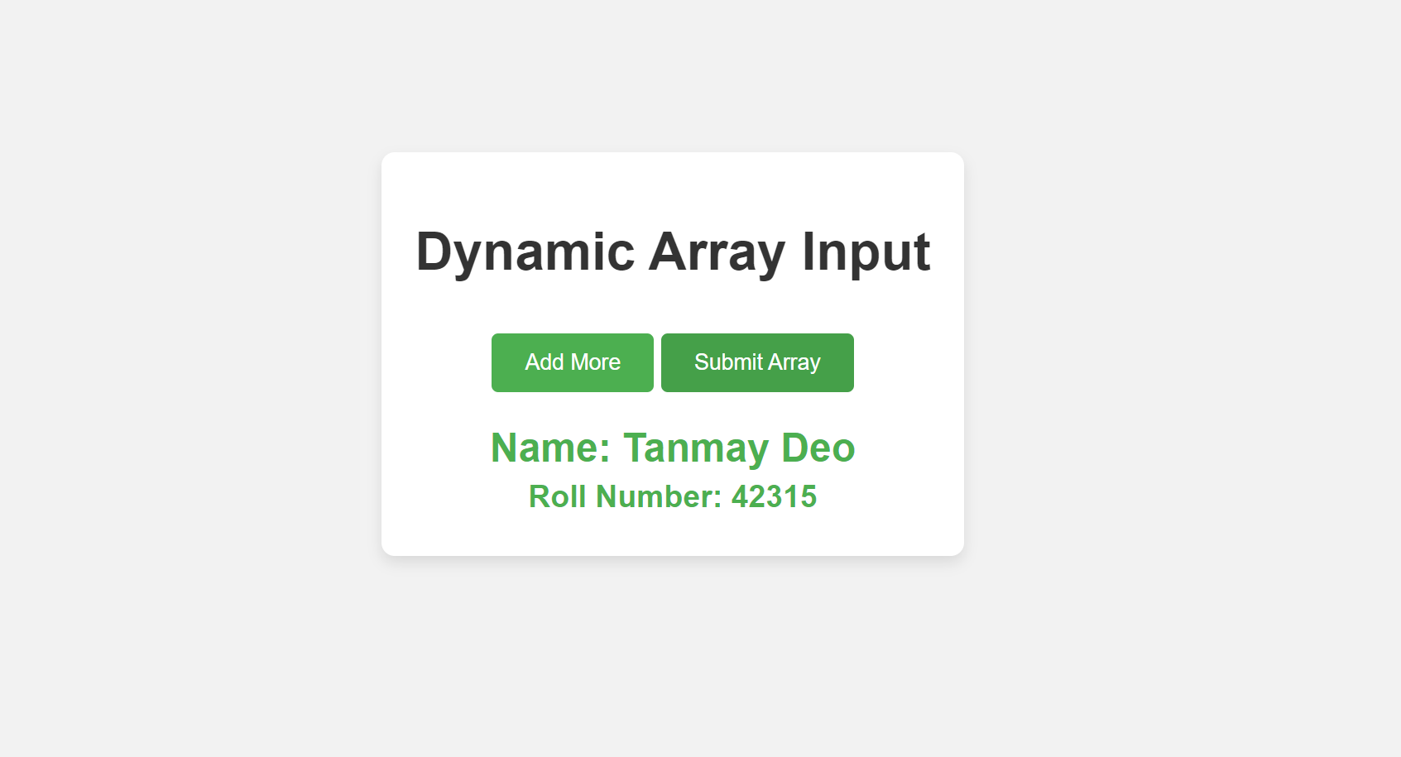

|  |  |  |
| --- | --- | --- |
|  | | |
| Date: |  | Course Teacher Sign |